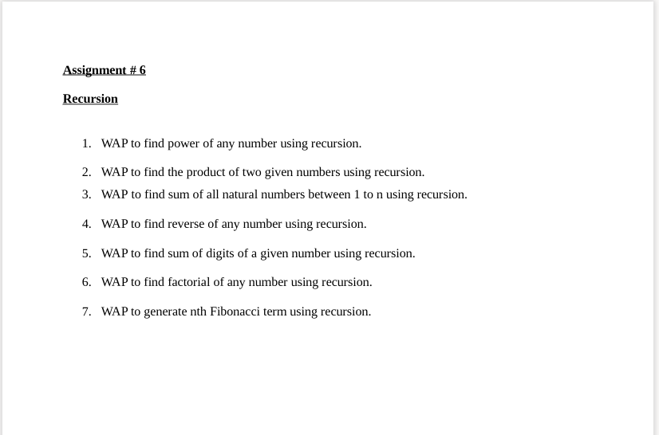

1).

#include<stdio.h>

int power(int,int);

int main()

{

int b,p,pow;

printf("enter a two number ");

scanf("%d%d",&b,&p);

pow=power(b,p);

printf("the power of %d is to %d is:%d",b,p,pow);

return 0;

}

int power(int b,int p)

{

int f;

if(p==0)

return 1;

else

{

f=b \* power(b,p-1);

}

return f;

}

2).

#include<stdio.h>

int product(int,int);

int main()

{

int a,b,ans;

printf("enter a two number");

scanf("%d%d",&a,&b);

ans=product(a,b);

printf("the product of two number is:%d",ans);

return 0;

}

int product(int a,int b)

{

int res;

if(b==1)

return a;

else

res= a + product(a,b-1);

return res;

}

3).

#include<stdio.h>

int num(int);

int main()

{

int n,res;

printf("enter a number ");

scanf("%d",&n);

res = num(n);

printf("the sum of natural number is %d\n",res);

return 0;

}

int num(int n)

{

int sum;

if(n==1)

return (1);

else

{

sum = n + num(n-1);

}

return sum;

}

4).

#include<stdio.h>

int rev(int);

int main()

{

int n,reverse;

printf("enter a number:");

scanf("%d",&n);

reverse = rev(n);

printf("the revese number is %d",reverse);

return 0;

}

int rev(int num)

{

int rem,z=1;

if(num==0)

return 0;

for(int i=num;i>0;i/=10){

rem = i % 10;

z\*=10;

}

return rem+rev(num%(z/10))\*10;

}

5).

#include<stdio.h>

int sum(int);

int main()

{

int a,res;

printf("enter a number :");

scanf("%d",&a);

res=sum(a);

printf("the sum of number is:%4d",res);

return 0;

}

int sum(int n )

{

int sums;

if (n ==0)

return 0;

else

sums =n % 10 + sum(n / 10);

return sums;

}

6).

#include<stdio.h>

int fact(int);

int main()

{

int n,facto;

printf("enter a number ");

scanf("%d",&n);

facto=fact(n);

printf("the factorial of %d is:%d",n,facto);

return 0;

}

int fact(int n)

{

if (n == 0) return 1;

else{

return (n\*fact(n-1));}

}

7).

#include<stdio.h>

int fibo(int);

int main()

{

int n, m= 0, i;

printf("Enter Total terms:");

scanf("%d", &n);

printf("Fibonacci series terms are:");

for(i = 1; i <= n; i++)

{

printf("%2d", fibo(m));

m++;

}

return 0;

}

int fibo(int n)

{

if(n == 0 || n == 1)

return n;

else

return(fibo(n-1) + fibo(n-2));

}