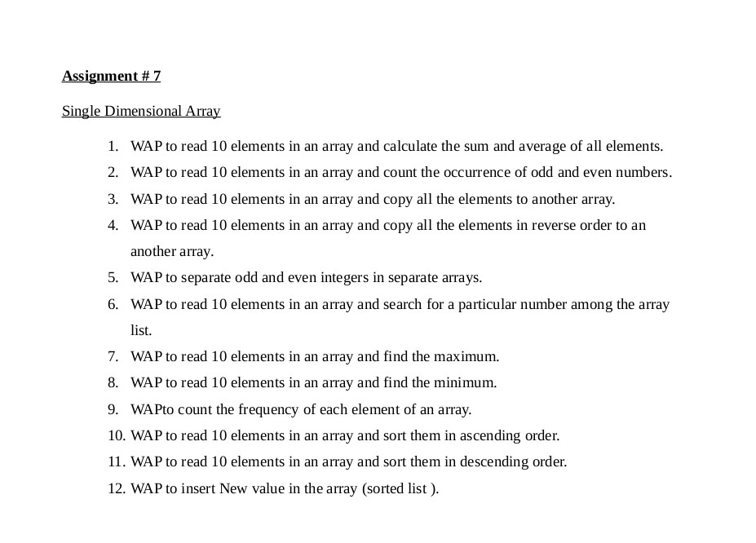

1).

#include<stdio.h>

int main()

{

int arr[10],i,sum=0;

for(i=0;i<10;i++)

{

printf("enter a number :");

scanf("%d",&arr[i]);

}

for(i=0;i<10;i++)

sum +=arr[i];

printf("the avg sum of number is: %d\n",sum);

return 0;

}

2).

#include<stdio.h>

int main()

{

int a[10],i,even=0,odd=0;

for(i=0;i<10;i++)

{

printf("enter a number :");

scanf("%d",&a[i]);

}

for(i=0;i<10;i++)

{

printf("%d",a[i]);

if (a[i]%2==0)

{

even ++;

}

else{

odd++;

}

}

printf("\nthe total even number is:%d\n",even);

printf("the total odd number is :%d\n",odd);

return 0;

}

3).

#include<stdio.h>

int main()

{

int a[10], i,b[10];

for(i=0;i<10;i++)

{

printf("enter a number:");

scanf("%d",&a[i]);

}

for(i=0;i<10;i++)

{

b[i]=a[i];

}

printf(" initial array number is:");

for(i=0;i<10;i++)

{

printf(" %d\t",a[i]);

}

printf("\nthe copied array number is :");

for(i=0;i<10;i++)

{

printf(" %d\t",b[i]);

}

return 0;

}

4).

#include<stdio.h>

int main()

{

int a[10],i,b[10];

for(i=0;i<10;i++)

{

printf("enter a number ");

scanf("%d",&a[i]);

}

for(i=0;i<10;i++)

{

b[i]=a[i];

}

printf("\n initial number is :");

for(i=0;i<10;i++)

{

printf("%d\t",a[i]);

}

printf("\nnumber in reverse order is :");

for(i=9;i>=0;i--)

{

printf("%d\t",b[i]);

}

return 0;

}

5).

#include<stdio.h>

int main()

{

int i,num[10],even[10],odd[10],j=0,k=0;

for(i=0;i<10;i++)

{

printf("enter a number %d :",i+1);

scanf("%d",&num[i]);

}

for (i=0;i<10;i++)

{

if(num[i] % 2 == 0)

{

even[j]=num[i];

j++;

}

else

{

odd[k]=num[i];

k++;

}

}

printf("the even number is :");

for(i=0;i<j;i++)

{

printf("%d\t",even[i]);

}

printf("\nthe odd number is :");

for(i=0;i<k;i++)

{

printf("%d\t",odd[i]);

}

printf("\n");

return 0;

}

6).

#include<stdio.h>

int main()

{

int num[10],i,a,store;

printf("enter a number for array\n");

for(i=0;i<10;i++)

{

printf("enter a number ");

scanf("%d",&num[i]);

}

printf("enter a paricular number for search ");

scanf("%d",&a);

for(i=0;i<10;i++)

{

if (a==num[i])

{

printf("element found %d:",num[i]);

return 0;

}

}

printf("there is no particular number ");

}

7).

#include<stdio.h>

int main()

{

int a[5],i;

for(i=0;i<5;i++)

{printf("enter a number %d :",i+1);

scanf("%d",&a[i]);}

for(i=0;i<5;i++)

{

if (a[0]<a[i])

{

a[0]=a[i];

}

}

printf("the max number is %d",a[0]);

return 0;

}

8).

#include<stdio.h>

int main()

{

int a[5],i;

for(i=0;i<5;i++)

{printf("enter a number %d :",i+1);

scanf("%d",&a[i]);}

for(i=0;i<5;i++)

{

if (a[0]>a[i])

{

a[0]=a[i];

}

}

printf("the min number is %d",a[0]);

return 0;

}

9).

#include <stdio.h>

int main()

{

int arr[10], i, j,size, Count = 0;

printf("enter the size of array :");

scanf("%d",&size);

for (i = 0; i < size; i++)

{

printf("enter a number :");

scanf("%d", &arr[i]);

}

for (i = 0; i <size; i++)

{

for(j = i + 1; j < size; j++)

{

if(arr[i] == arr[j])

{

Count++;

break;

}

}

}

printf("\n Total Number of repeated Elements in this Array = %d ", Count);

return 0;

}

10).

#include<stdio.h>

int main()

{

int n,i,j;

printf("enter a number of array");

scanf("%d",&n);

int arr[n];

for(i=0;i<n;i++)

{

printf("enter a number %d :",i+1);

scanf("%d",&arr[i]);

}

int temp=0;

int a = sizeof(arr)/sizeof(arr[0]); //length of array

for (i=0;i<a;i++)

{

for(j=i+1;j<a;j++)

{

if(arr[i]>arr[j])

{

temp=arr[i];

arr[i]=arr[j];

arr[j]=temp;

}

}

}

printf("\n");

printf("element in ascending order : ");

for(i=0;i<a;i++)

{

printf("%d \t",arr[i]);

}

return 0;

}

11).

#include<stdio.h>

int main()

{

int n,i,j;

printf("enter a number of array :");

scanf("%d",&n);

int arr[n];

for(i=0;i<n;i++)

{

printf("enter a number %d : ", i+1);

scanf("%d",&arr[i]);

}

int temp=0;

int length =sizeof(arr)/sizeof(arr[0]);

for(i=0;i<length;i++)

{

for(j=i+1;j<length;j++)

{

if(arr[i]<arr[j])

{

temp = arr[i];

arr[i] =arr[j];

arr[j]=temp;

}

}

}

printf(("\n"));

printf("the decending order is :");

for(i=0;i<length;i++)

{

printf("%d\t",arr[i]);

}

return 0;

}

12).

#include<stdio.h>

int main()

{

int ele,pos,i,n;

printf("enter a number of array ");

scanf("%d",&n);

int arr[n];

for(i=0;i<n;i++)

{

printf("enter a number ");

scanf("%d",&arr[i]);

}

printf("enter a element to enter :");

scanf("%d",&ele);

printf("enter a position to enter :");

scanf("%d",&pos);

for(i=n-1;i>=pos;i--)

{

arr[i+1] =arr[i];

}

arr[pos]=ele;

for(i=0;i<=n;i++)

{

printf("%d\t",arr[i]);

}

return 0;

}