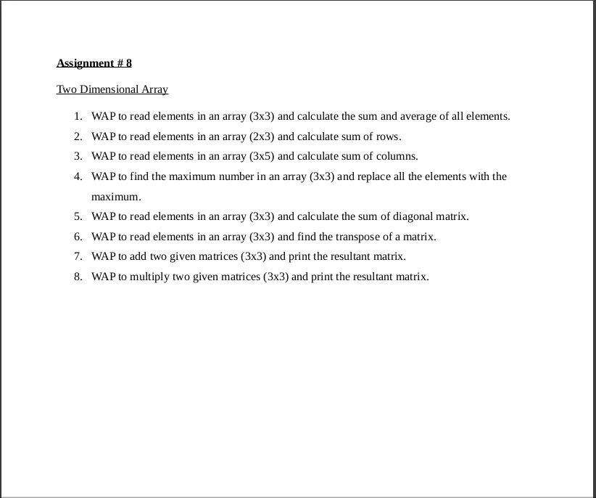

1).

#include<stdio.h>

int main()

{

int a[3][3],i,j,sum=0,avg;

printf("enter a number for 3x3\n");

for(i=0;i<=2;i++){

for(j=0;j<=2;j++)

{printf("a[%d%d]=",i,j);

scanf("%d",&a[i][j]);}

}

for(i=0;i<=2;i++)

{

for(j=0;j<=2;j++)

{

sum =sum + a[i][j];

avg =sum/9;

}

}

printf("sum is = %d ",sum);

printf("\nthe avg is =% d ",avg);

return 0;

}

2).

#include<stdio.h>

int main()

{

int a[2][3],i,j,sum=0,s=0;

printf("enter a number for 2 x 3\n");

for(i=0;i<=1;i++)

{

for(j=0;j<=2;j++)

{

printf("a[%d%d]=",i,j);

scanf("%d",&a[i][j]);

}

}

for(i=0;i<=1;i++)

{

for(j=0;j<=2;j++)

{

sum = sum +a[i][j];

}

printf("the sum of %d row is =%d\n",i+1,sum-s);

s=sum;

}

return 0;

}

3).

#include<stdio.h>

int main()

{

int a[3][5],i,j,sum=0,sum1=0;

printf("enter a number for 3 x 5\n");

for(i=0;i<=2;i++)

{

for (j=0;j<=4;j++)

{

printf("a[%d%d]=",i,j);

scanf("%d",&a[i][j]);

}

}

for(j=0;j<=4;j++)

{

for(i=0;i<=2;i++)

{

sum =sum +a[i][j];

}

printf("the sum of %d colom is =%d\n",j+1,sum-sum1);

sum1 = sum;

}

return 0;

}

4).

#include<stdio.h>

int main()

{

int a[3][3],i,j;

printf("enter a number for 3 x 3 :\n");

for(i=0;i<=2;i++)

{

for(j=0;j<=2;j++)

{

scanf("%d",&a[i][j]);

}

}

for(i=0;i<=2;i++){

for(j=0;j<=2;j++){

if(a[0][0] < a[i][j]){

a[0][0]=a[i][j];

}

}

}

printf("the max num is :%d\n",a[0][0]);printf("\n");

a[3][3]=a[0][0];

for(i=0;i<=2;i++){

for(j=0;j<=2;j++){

printf("%d\t",a[3][3]);

}

printf("\n");

}

return 0;

}

5).

#include<stdio.h>

int main()

{

int a[3][3],i,j,b[3][3],sum=0;

printf("enter a number for 3 x 3 :\n");

for(i=0;i<=2;i++)

{

for(j=0;j<=2;j++)

{

printf("a[%d%d]=",i,j);

scanf("%d",&a[i][j]);

}

}

printf("the matrix is :\n");

for(i=0;i<=2;i++)

{

for(j=0;j<=2;j++)

{

b[i][j] = a[i][j];

printf("%d\t",b[i][j]);

}

printf("\n");

}

for(i=0;i<=2;i++){

for(j=0;j<=2;j++){

sum = a[0][0] +a[0][2]+a[1][1]+a[2][2] +a[2][0];

}

}

printf("sum %d=",sum);

return 0;

}

6).

#include<stdio.h>

int main()

{

int a[3][3],i,j,b[3][3],sum=0;

printf("enter a number for 3 x 3 :\n");

for(i=0;i<=2;i++)

{

for(j=0;j<=2;j++)

{

printf("a[%d%d]=",i,j);

scanf("%d",&a[i][j]);

}

}

printf("the initial matrix is :\n");

for(i=0;i<=2;i++)

{

for(j=0;j<=2;j++)

{

b[i][j] = a[i][j];

printf("%d\t",b[i][j]);

}

printf("\n");

}

printf("the tranpose of matrix is :\n");

for(j=0;j<=2;j++)

{

for(i=0;i<=2;i++)

{

b[i][j] = a[i][j];

printf("%d\t",b[i][j]);

}

printf("\n");

}

return 0;

}

7).

#include<stdio.h>

int main()

{

int a[3][3],b[3][3],c[3][3],i,j;

printf("enter a number for matrix 1 :");

for(i=0;i<=2;i++){

for(j=0;j<=2;j++)

scanf(" %d",&a[i][j]);

}

printf("enter a number for matrix 2 :");

for(i=0;i<=2;i++){

for(j=0;j<=2;j++)

scanf("%d",&b[i][j]);

}

printf("the sum of matrix is :\n");

for(i=0;i<=2;i++)

{

for(j=0;j<=2;j++)

{

c[i][j]=a[i][j] +b[i][j];

printf(" %d\t",c[i][j]);

}

printf("\n");

}

return 0;

}

8).

#include<stdio.h>

int main()

{

int a[3][3],b[3][3],c[3][3],i,j;

printf("enter a number for matrix 1 :");

for(i=0;i<=2;i++){

for(j=0;j<=2;j++)

scanf(" %d",&a[i][j]);

}

printf("enter a number for matrix 2 :");

for(i=0;i<=2;i++){

for(j=0;j<=2;j++)

scanf("%d",&b[i][j]);

}

printf("the sum of matrix is :\n");

for(i=0;i<=2;i++)

{

for(j=0;j<=2;j++)

{

c[i][j]=a[i][j] \* b[i][j];

printf(" %d\t",c[i][j]);

}

printf("\n");

}

return 0;

}