CHITWAN | Terai Lowlands, Nepal | ~150–850m
General Overview Factsheet
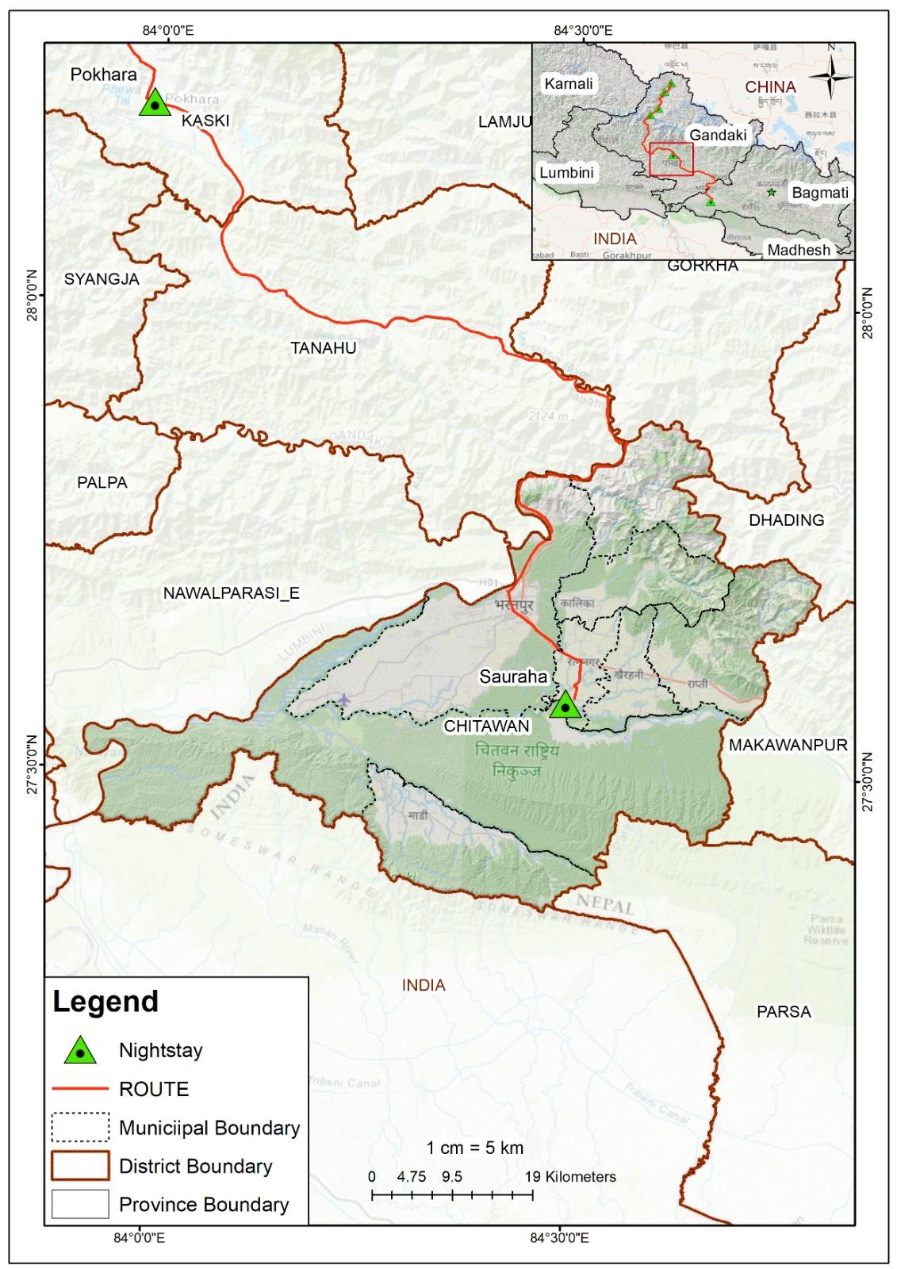
Planetary Health Transect
Fig. Geographical setting of Chitwan
Geography & Landscape
Chitwan lies in Nepal’s Terai lowlands (150–850m), forming part of the Chitwan–Annapurna Landscape (CHAL). The district spans ~2,350 sq. km and is bounded by the Narayani and Rapti river systems. Its ecological structure is a dynamic mosaic shaped by floods, riverbank erosion, and seasonal fires.
Vegetation follows a gradient:
- Sal (Shorea robusta) forest (~70% cover)
- Riverine forest
- Grasslands
- Mixed Churia hill forest
Notable sub-areas: Madi valley (218 sq km, enclosed on 3 sides by CNP) and the Sauraha corridor; southern boundary borders India's Valmiki Tiger Reserve.

Landscape is a dynamic mosaic; floods, fires, and riverine erosion continuously reshape the grassland-forest boundary.

Climate Trends (1970–2019)
Chitwan sits in the Lower Tropical Bioclimatic Zone (<500m) of the Chitwan-Annapurna Landscape (CHAL)
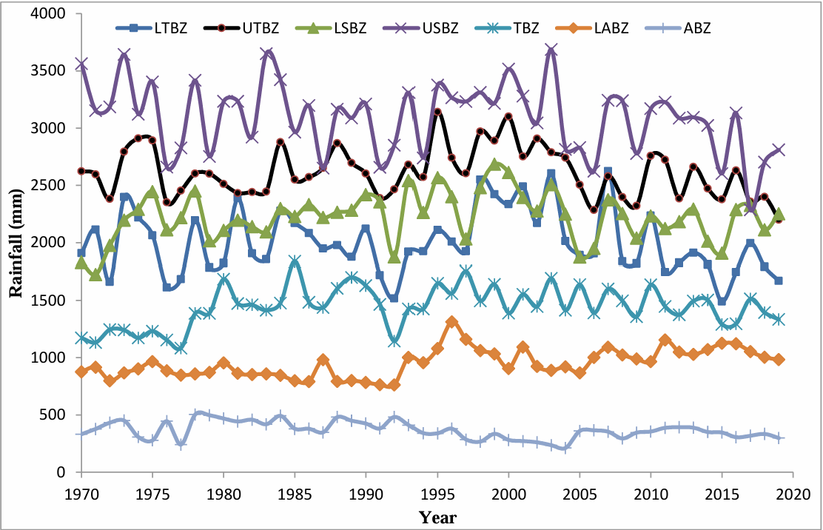
- Temperature rising at +0.022°C/year; average annual temperature ~24.1°C
Fig. Average annual rainfall trends in different bioclimatic zones in CHAL. We will be in lower tropical bioclimatic zone (<500m) (LTBZ)
- Precipitation declining at −1.8 mm/year; average ~2,002 mm/year; ~78% falls in monsoon (June–September)
- Hottest decade on record: 1999–2009; 2010–2019 was the driest lowland decade in 50 years
- Nepal warms at 0.056°C/year nationally — nearly 3× the global average (0.02°C/year)
- Altitude insight: warming accelerates with elevation — communities higher on the transect face faster, more severe change

Note: Farmers directly perceive these changes. In a 2023 ICIMOD baseline study across four municipalities (n=211), drought was the top climate risk (36%), followed by erratic rainfall (33%) and hailstorms (17%). Nearly two-thirds of farmers (63.5%) reported that climate variability has significantly affected crop production — with the worst losses in spring rice, main season rice, potato, and chilli. (Bajracharya et al., 2023)

Biodiversity
Fauna (Animal)  - ~515 bird species; 42 mammal species  - Great Indian One-Horned Rhinoceros and Royal Bengal Tiger, Asian Elephant, Gharial Crocodile, Spotted Deer, Wild Boar  - Four grassland-specialist birds (Bengal Florican, Lesser Florican, Slender-billed Babbler, Jerdon's Babbler) have disappeared from Chitwan following grassland loss  - Wildlife-human conflict is pervasive and year-round in communities bordering the park  - 111 fish species (9 orders, 27 families, 72 genera) recorded from the Trisuli, Rapti, and Narayani river systems. Catches of major food fish are declining due to overexploitation. (Jha, 2018) | Flora (Plant)  - 600+ plant species recorded (422 verified across 91 families; no complete park-wide inventory)  - 50+ grass species including elephant grass (Saccharum ravennae) and giant cane (Arundo donax)  - 100+ wild orchid species; medicinal plants including wild ginger and wild turmeric  - Key riverine species: Khair, Sissoo, Simal  - Invasive Mikania micrantha spreading in areas where Tharu controlled burning has ceased
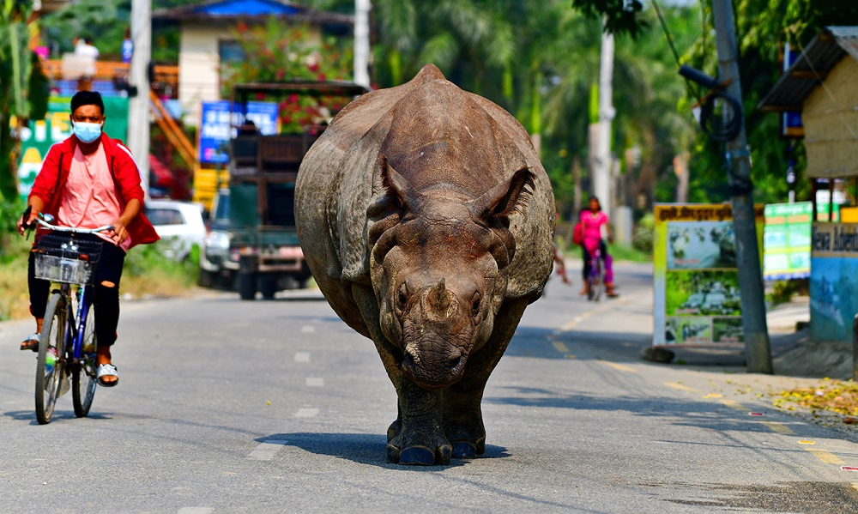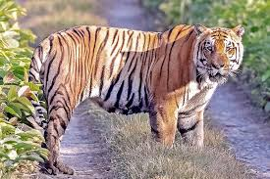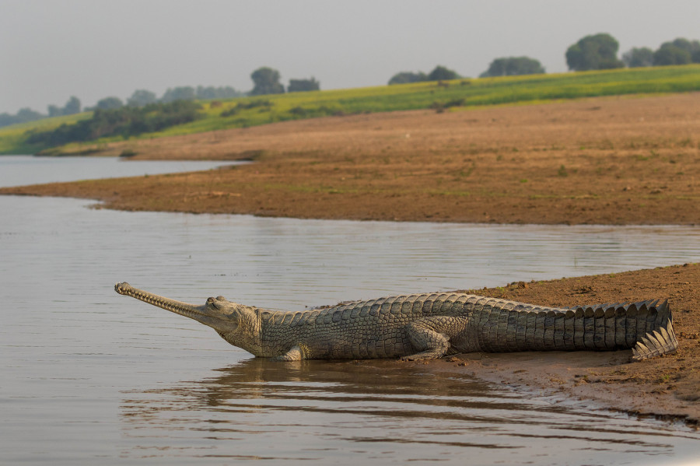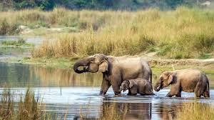
You might come across one horned rhinoceros casually roaming the streets of Sauraha Chitwan. The Guardian.
Chitwan has the highest density of Bengal tiger in the country. The Himalayan times.
Asian elephants can be found in the wild as well as in breeding centers. Travel Dudes.

Gharial is listed as Critically Endangered on the IUCN Red List. The Kathmandu post.
Agriculture
Chitwan's Terai supports a diverse cropping system dominated by rice, maize, mustard, legumes, and vegetables. The most common cropping pattern — Rice–Mustard–Maize — is practiced by nearly half of Tharu households. Over recent decades, cropping systems have shifted from rice–wheat–maize toward rice–vegetable–maize and maize–millet, driven by climate variability in temperature and rainfall. (Bajracharya et al., 2023)
🌾 Crops  Major crops: rice, maize, wheat, mustard, vegetables, banana. Climate-driven shift away from wheat and mustard as winter rainfall declines. | 🏡 Farm Structure  Most Tharu farmers operate at subsistence level on smallholdings <0.5 ha; only ~35% farm commercially. Land fragmentation limits mechanisation.
💰 Income  Average agricultural income ~NRs 107,000/household/year — significantly below off-farm income (~NRs 196,000), reflecting structural erosion of the Tharu agricultural base. (Sharma et al., 2021) | ⚠️ Climate & Access  Farmers report climate variability has significantly affected crop production. Language barriers and reported discrimination limit Tharu engagement with state agricultural extension services.
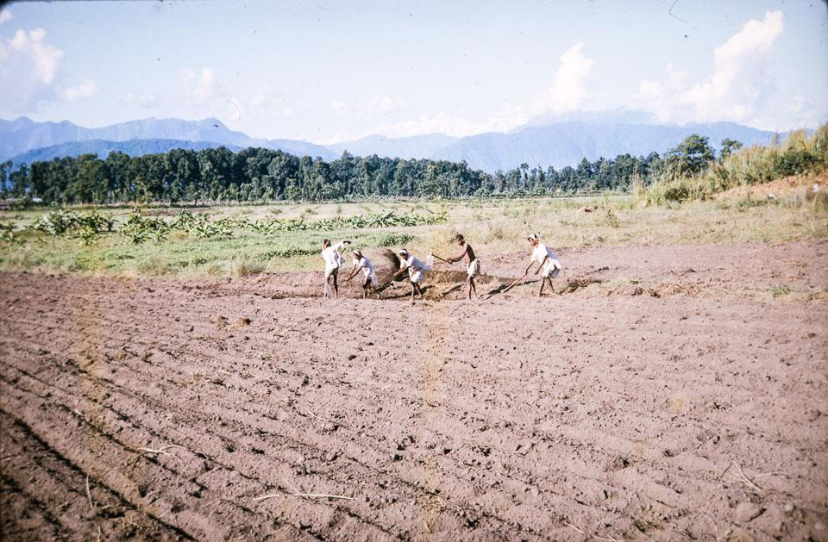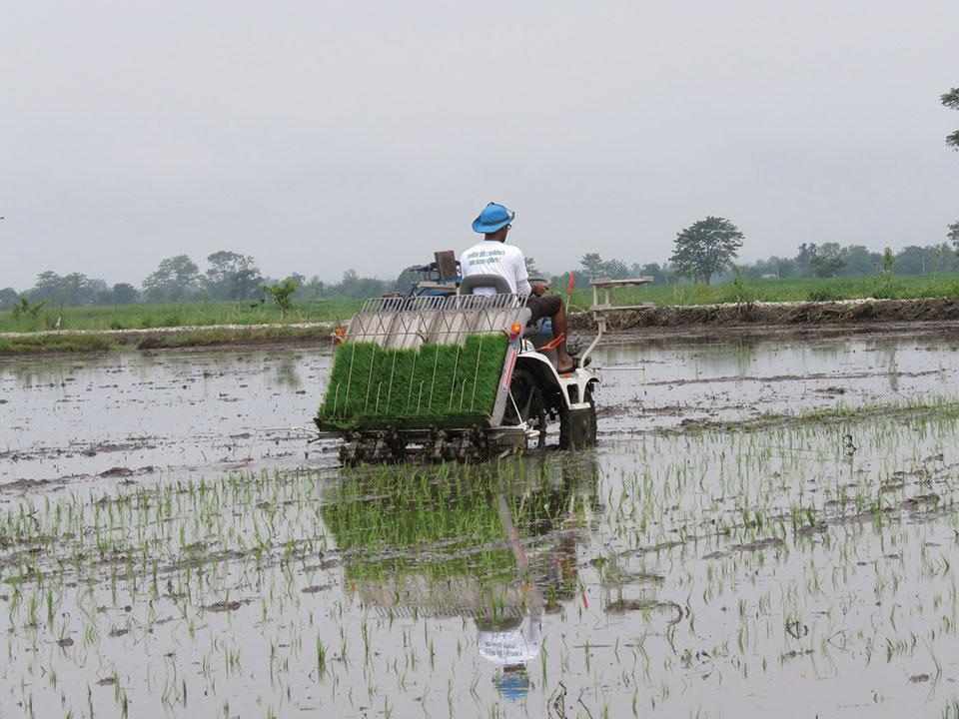
Fig. Men hoeing farm fields near Narayanghat, Chitwan, 1970, Photo by Bill Hanson, Nepal Photo History Project. Farsight Nepal Jounral.
Fig. A farmer operates a paddy transplanter in Dibyanagar in Bharatpur Metropolitan City in Chitwan on Sunday, 2019. My republica
1970
2019
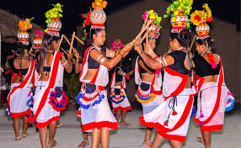
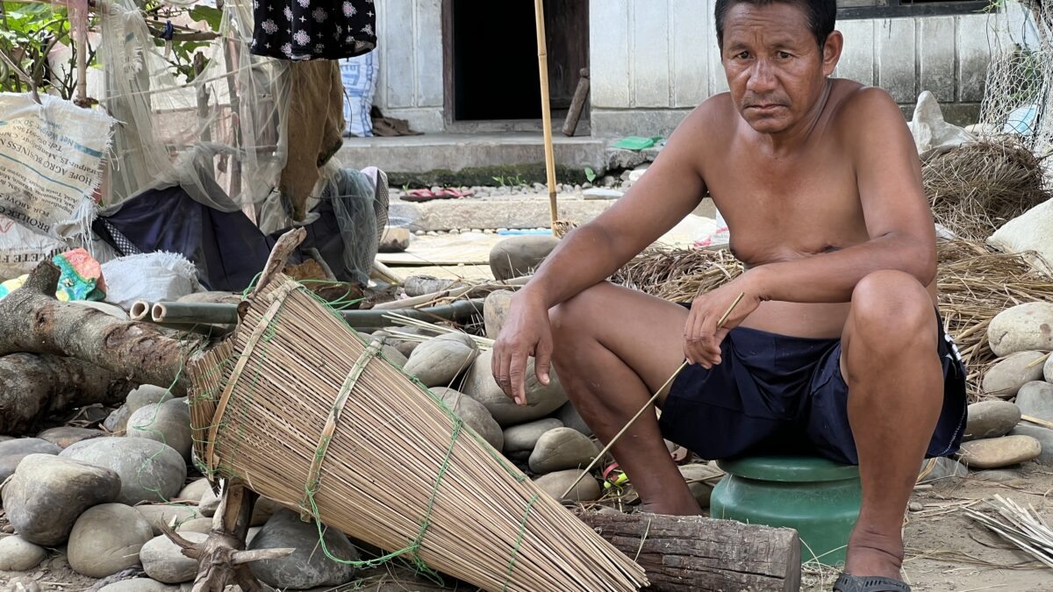
Demographics & Communities
Fig. Tharu dance.
Source: Nepal Trek Adventure
Fig. Bote fisherman with his tools.
Source: Global Voices
Key Statistics
- Population (2021): ~719,859
- Sex ratio: 95.6 males per 100 females
- Annual growth rate: 2.07% (2011–2021)
- Literacy rate: 83.7% (male 88.9%, female 78.7%)
- 40% of households are female-headed — driven by male out-migration
- Female youth employment (70%) exceeds male (63%), but wages remain low
- Primary occupation: subsistence farming — rice, maize, wheat, mustard

Peoples & Ethnicity
Indigenous Group: Tharu, Bote, Majhi, Darai, Chepang
Hill Migrant Group: Tamang, Magar, Gurung, Brahmin and Chhetri.
Note: In Chitwan, the Tharu and Majhi (also referred to as “Bote”) are two distinct indigenous groups with different ecological identities. The Tharu are often recognized as “people of the forest,” known for their rich cultural traditions, longhouse architecture, and agricultural practices. In contrast, the Bote are considered “river people,” a historically marginalized community whose livelihoods have long depended on fishing and navigating the Narayani and Rapti rivers. Before malaria eradication, the district was ~90% Tharu and 10% other indigenous river communities. Post-eradication Hill migration transformed it into one of Nepal's most ethnically diverse districts but land access and disaster exposure remain deeply unequal along caste and ethnic lines.

Tharu Indigenous Knowledge & Ecological Practices
Wetland Management  - Seasonal pond-digging (Chaitra–Jestha) maintained water depth and sustained productive fishing grounds  - Canal water from the Churia Hills was diverted into park wetlands after use — sustaining rhino and bird habitat  - After 1973: ponds dried up; wetland habitat degraded; fish and Ghonghi (freshwater snail) populations collapsed | Grassland Management  - Annual controlled burns (Mangsir–Magh) cleared dead biomass, returned nutrients (Ca, Mg, N) to soil, and triggered fresh grass growth after monsoon  - 300–400 cattle per village grazed grasslands, maintaining short siru structure and producing insect-sustaining dung for grassland birds  - After 1973: burning banned; grassland cover declined from ~20% to 6.42% (2016 CNP report); four bird species locally extinct

Culture linked to Environment
Tharu agricultural practice is inseparable from a festival calendar that encodes ecological knowledge. Sakoinii marks the completion of rice planting; Leuri Paith Barna follows the harvest and involves field cleaning that reduces pests and soil pathogens; during Deepawali, oil lamps attract and manage nocturnal field pests (consistent with light-trap pest management principles); Maghee Parva in January marks the ritual start of the ploughing season. (Sharma et al., 2021)

Traditional tools
clay-and-bamboo grain storage vessels (Dihuri, Kothi), bamboo fishing traps (Dhimmar), and jute-and-wood fishing nets (Khonga) — represent localised solutions to pest control, moisture regulation, and food harvesting predating synthetic alternatives.
Historical Context — Key Events
Period | Event
Pre-1769 | Dense malarial forest; Tharu only permanent inhabitants
Post-1769 | Post-unification settlement policies introduced but largely unsuccessful due to malaria (Ojha, 1983).  Chitwan's dense malarial forests inhabited only by the Tharu, whose biological resistance to malaria gave them sole claim to the land.
1920s | Organised settlement schemes in the Rapti Valley; largely failed
1958–60s | Rapti Valley Development Project with US aid; largely captured by Kathmandu elites. Nepal Malaria Eradication Organisation established. Malaria eliminated as local risk — removing the last ecological barrier to mass Hill migration into the Terai.
1960s–72 | Uncontrolled Hill migration: 2,500–7,000 households/year. ~340,000 ha of Tarai forest lost. Migrants settle ecologically unstable riverbank areas.
1973 | Royal Chitwan National Park designated (952 sq km). Tharu access was banned by the army; grazing, burning, and reed-cutting prohibited. Grassland and wetland decline begins.
1999/00 | Catastrophic flood in lowland Chitwan: 15–16 deaths, ~2.5 bigha of farmland converted to barren riverbed.
2001–06 | Maoist insurgency: conflict disrupts livelihoods, displaces communities, and suspends grass-cutting rights for Tharu. 39 killed in Bandarmude bus bombing (2005/06).
2003 | CNP expanded eastward. Padampur VDC removed — 10,000 people (mostly Tharu) displaced. Eastern wetland and grassland management ends entirely.
2015 | Madi declared eco-municipality. Early warning systems installed. Marks a shift toward local disaster risk governance.
2016 | CNP report: grassland cover at 6.42% — down from ~20% pre-1973. Four grassland bird species disappear from Chitwan entirely.
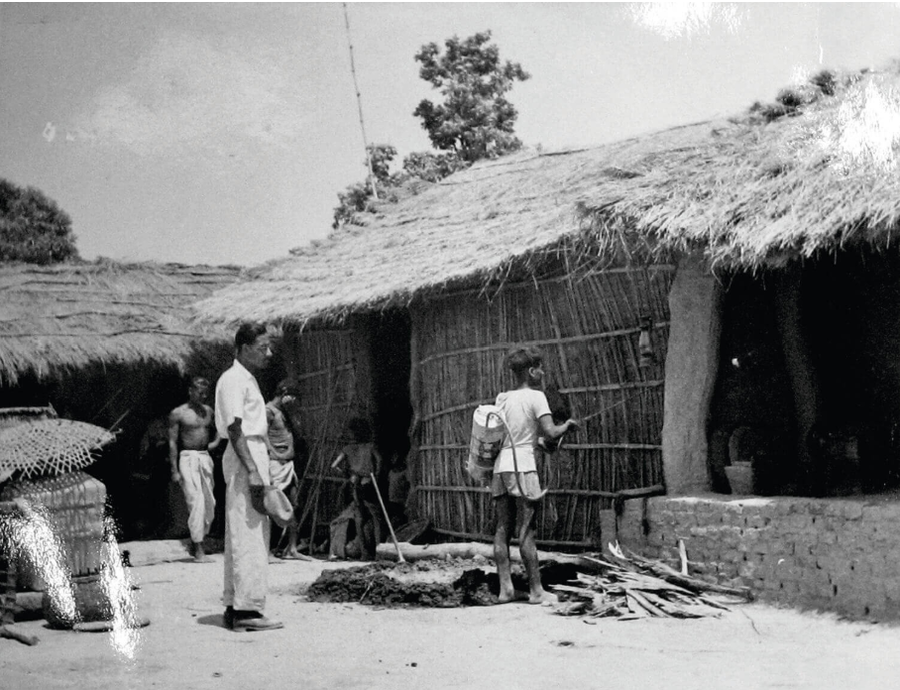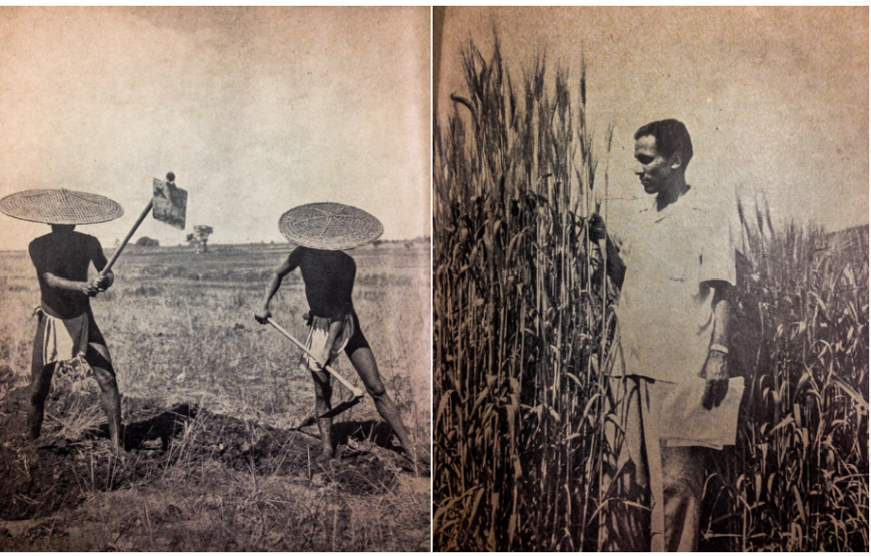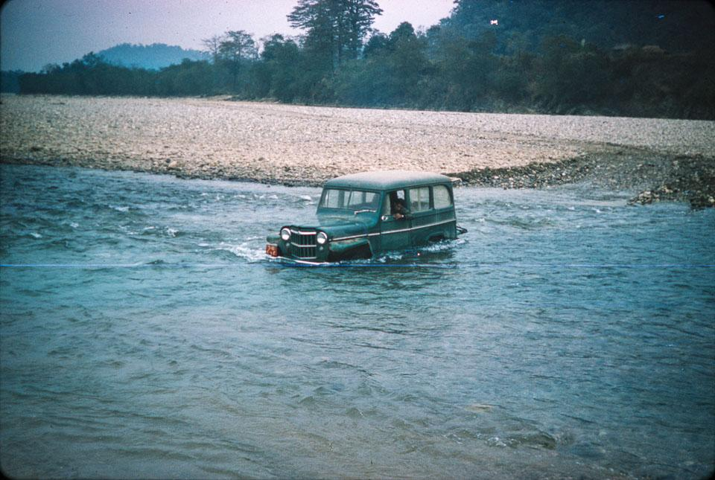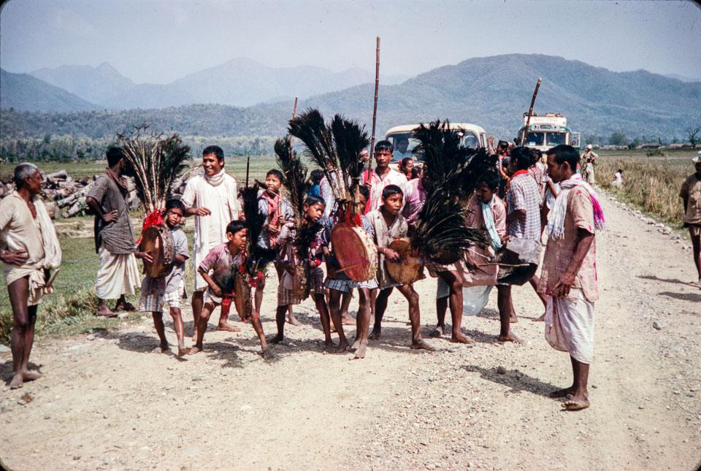
Fig. Malaria eradication campaign in Tharu Village, Chitwan, 1950s.
Fig. USAID publication, 1959: Traditional Tharu vs. 'modern' agriculture in Chitwan.
Fig. USAID jeep crossing the Rapti River near Bhalu Khola, 1967, Photo by Dave Hohl, Nepal Photo History Project. Farsight Nepal Journal
Fig. Tharu boys with drums and peacock feathers dancing on the Rapti River Road during Holi. 1967 Photo by Dave Hohl Nepal Photo History Project.
Farsight Nepal Journal

1950s
1967
1959
1967
Health Profile
Chitwan's health burden reflects a district in epidemiological transition — shifting from infectious to non-communicable disease, while mental health remains largely untreated. Seasonal thermal extremes compound the picture: Sheetlahar (cold waves) drives spikes in pneumonia, hypothermia, and respiratory illness each winter; loo (heatwaves) reduces outdoor labour capacity and agricultural productivity, with knock-on effects on food security and child nutrition.
🦟 Vector-borne Disease  Chitwan recorded Nepal's first dengue outbreak (2004–06) and remains a high-burden district, with fatalities reported as recently as 2016. Malaria has been nearly eliminated locally, though imported cases persist along the open border with India. In late 2025, Chitwan district experienced a significant Japanese Encephalitis (JE) outbreak, prompting a targeted vaccination drive: all residents aged 30 and above in Madi Municipality and Ward 19 of Bharatpur Metropolitan City will be vaccinated against JE. | 🐕 Zoonotic Disease  80% canine distemper virus (CDV) seroprevalence in free-roaming dogs in the CNP buffer zone signals elevated disease transmission risk at the human-domestic animal-wildlife interface. (McDermott et al., 2023)
🏙 Non-Communicable Disease  Rapid urbanisation in Bharatpur is driving a documented rise in NCD risk factors — hypertension, diabetes, obesity. NCDs account for 31% of national hospital presentations, with cardiovascular disease and COPD leading. | 🧠 Mental Health  Depression: 11–17% of adults. Alcohol use disorder: ~20% of adult men. Treatment gap: >90% — nine in ten people with depression receive no care. Barriers: cost, stigma, cultural mismatch in diagnostic tools. (Luitel et al., 2017; 2018)

Planetary Health — Key Themes
1. Urbanization & Pollution
Rapid urbanization in Chitwan is closely tied to state-led resettlement programs and external interventions following malaria eradication in the 1950s–60s. Supported in part by initiatives such as those of USAID, the Terai saw a large influx of hill migrants, transforming forested landscapes into agricultural and urban settlements. This transition accelerated after the establishment of Chitwan National Park (1973), which restricted Indigenous resource access, and its later expansion, which displaced communities such as the Tharu. While resettlement increased economic activity and urban growth (especially in Bharatpur), it also intensified land-use change, pollution, and pressure on natural resources, contributing to rising waste, water contamination, and air quality concerns in the district.
2. Environment, Ecosystem and Biodiversity
Chitwan was historically a co-managed landscape where Indigenous Tharu communities and wildlife coexisted through practices such as controlled burning, seasonal grazing, and wetland management, sustaining diverse forests, grasslands, and wetlands. Following the establishment and later expansion of Chitwan National Park (1973), restrictions on Indigenous access disrupted these systems, contributing to ecological shifts including grassland decline (from ~20% to 6.42%), wetland degradation, invasive species spread (e.g., Mikania), and loss of grassland-dependent species. At the same time, human–wildlife conflict has intensified in buffer zone communities, with frequent crop damage, livestock loss, and property destruction by species such as rhinos and elephants, compounded by inadequate mitigation measures. These interactions also produce psychosocial stress and anxiety (solastalgia), reflecting a broader tension where conservation successes coexist with ecological imbalance and livelihood insecurity.
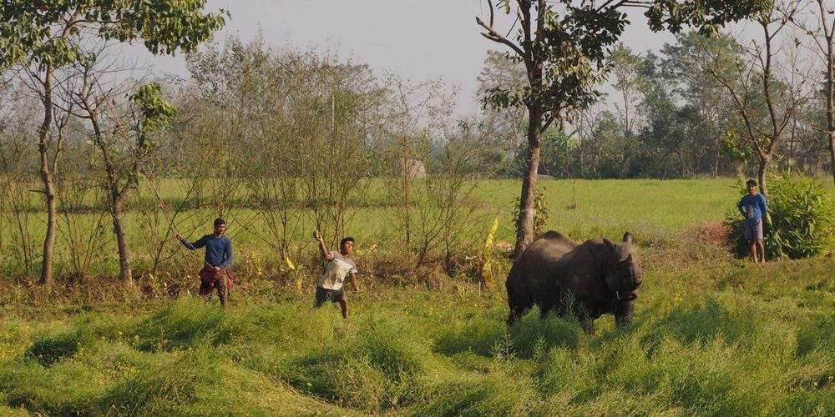
Fig. Locals throwing rocks at Rhino. Source: The Record
3. Climate change, Hazard and Resilience
Across Chitwan district, communities face a compound set of climate, ecological, and conflict-related hazards. Vulnerability is highest among ethnic and Dalit communities settled on riverbanks and forest edges; within those groups, women, youth, the elderly, and disabled people bear the greatest burden. (Maharjan et al., 2017)
🌊Flood & Riverbank Erosion  - Chitwan’s lowland geography makes it highly flood-prone, especially during the monsoon (June–October)  - The Narayani, Rapti, and Reu rivers carry heavy sediment from large Himalayan catchments, leading to frequent overflows  - 1999/00 flood: 15–16 deaths; ~2.5 bigha farmland converted into barren riverbed  - 2010–2013: riverbank erosion displaced ~20 households  - 2017 flood: fatalities reported; gabion (wire) dam constructed as a response | 🐘Human-Wildlife Conflict  - 64.6% of buffer zone households suffer crop damage annually; rhino, wild boar, chital, elephant are primary raiders (Dhakal, 2020)  - 206 livestock killed in 12 months; avg. loss NRs 11,498/household; 13 houses destroyed by elephant in one year  - Only 26% of electric fences operational; 13.7% of buffer zone budget reaches direct conflict mitigation
🌡Heatwave and Coldwave  - 262 cold wave events recorded 2001–2010; 376 deaths, 80 injured nationally; avg. 42 deaths/year; worst in 2004 (108 deaths) (Earth Journalism Network)  - 2009/10: cold wave causes complete crop failure in Chitwan  - Heatwave temperatures reaching 40°C+; reduces outdoor labour capacity and agricultural productivity  - Health impacts: pneumonia, hypothermia, respiratory illness (cold); heat stress, child malnutrition (heat) | 🟨Drought  - 1997/98: severe drought reduces crop production to near-zero; communities purchase food from markets  - 2004/05: near-total failure of maize and mustard; community changes food habits — indicating food insecurity  - 2016/17: winter crops not planted; residents travel 1km+ for drinking water
Cross-Cutting Themes
GEDSI  Around 40% of households in Chitwan are female-headed, largely as a result of male out-migration, which has shifted household responsibilities and decision-making roles onto women. While female youth participation in employment (70%) surpasses that of males (63%), this increased involvement is not matched by equitable pay, reflecting persistent gender-based wage disparities. | Mental Health and Well-being  Mental health in Chitwan is shaped by environmental stress, inequality, and limited care access. Human–wildlife conflict drives chronic stress (33%) and sleep disruption (21.5%), while food insecurity, especially among women, intensifies anxiety. Efforts like PRIME and StandStrong aim to expand care, but a large treatment gap persists. | Culture, Heritage and Human-Nature  Indigenous groups—especially the Tharu, along with Majhi (Bote), Darai, and Chepang—have long shaped Chitwan’s forests and rivers through cultural-ecological practices. The establishment of Chitwan National Park shifted this relationship by restricting access and displacing communities, transforming coexistence into a more exclusionary model where conservation and cultural livelihoods now coexist in tension.
Sources
Poudel, B., & Silwal, P. (2020). Demographic distribution by eco-belt in Nepal. Nepal Journal of Multidisciplinary Research, 3(3). https://doi.org/10.3126/njmr.v3i3.34861
Luitel, D. R., Jha, P. K., & Siwakot, M. (2020). Climatic trend in different bioclimatic zones in Chitwan Annapurna Landscape, Nepal. Preprints.org. https://doi.org/10.20944/preprints202010.0206.v1 [Preprint — not peer-reviewed]
Maharjan, S. K., Maharjan, K. L., Tiwari, U., & Sen, N. P. (2017). Participatory vulnerability assessment, Madi Valley, Chitwan. Cogent Food & Agriculture, 3(1), 1310078. https://doi.org/10.1080/23311932.2017.1310078
Adhikari, J. N., Bhattarai, B. P., Rokaya, M. B., & Thapa, T. B. (2022). Land use/land cover changes in the central part of the Chitwan Annapurna Landscape. PeerJ, 10, e13435. https://doi.org/10.7717/peerj.13435
Jha, D. K. (2018). Species diversity, distribution and status of fishes in Chitwan district. Journal of Natural History Museum, 30, 85–101. https://doi.org/10.3126/jnhm.v30i0.27539
Siwakoti, M., & Varma, S. K. (1996). Flora of western Chitwan. [Grey literature — verify with library copy]
NTNC. Species checklist, Chitwan National Park. [Institutional document — contact NTNC]
UNESCO & DNPWC. (2003). Chitwan National Park management plan. [Institutional document — verify with DNPWC]
Dhakal, K. R. (2020). Human-wildlife conflicts: The case of CNP buffer zone. American Journal of Zoology, 3(4), 65–71. https://doi.org/10.11648/j.ajz.20200304.11
Sharma, S., et al. (2021). Agriculture in relation to socioeconomic status of Tharu in Chitwan. Journal of Agriculture and Food Research, 6, 100243. https://doi.org/10.1016/j.jafr.2021.100243
Bajracharya, S., et al. (2023). Climate information services for resilient agriculture: Chitwan, Nepal. Climate Services, 32, 100421. https://doi.org/10.1016/j.cliser.2023.100421
McDermott, I., et al. (2023). Canine distemper virus seroprevalence in CNP buffer zone dogs. PLOS ONE, 18(2), e0281542.
Luitel, N. P., et al. (2017). Treatment gap and barriers for mental health care in Nepal. PLOS ONE, 12(8), e0183223. https://doi.org/10.1371/journal.pone.0183223
Luitel, N. P., et al. (2018). Prevalence of depression and AUD in primary health care, Nepal. BMC Health Services Research. https://doi.org/10.1186/s12913-018-3034-9
Jordans, M. J. D., et al. (2016). Development and pilot testing of a mental healthcare plan in Nepal. Epidemiology and Psychiatric Sciences, 25(2), 121–133.
Jordans, M. J. D., et al. (2020). Impact of district mental health care on depression and AUD, Nepal. BMC Psychiatry, 20, 375. https://doi.org/10.1186/s12888-020-02832-5
Earth Journalism Network. Cold waves add to health woes in Nepal's lowlands. https://earthjournalism.net/stories/cold-waves-add-to-health-woes-in-nepals-lowlands
Paudel, A. (2026, April 2). Chitwan to vaccinate 23,000 people above 30 against JE. The Kathmandu Post. https://kathmandupost.com/national/2026/04/02/chitwan-to-vaccinate-23-000-people-above-30-against-je

