1. The Lost Caves of Mustang documentary explores the cave temples found in Mustang, which is the former Kingdom of Lo, where Tibetan languages are still widely spoken and traditional Tibetan culture remains.
YouTube Link:
Lost Caves of Mustang - Ancient Tibet
2. Bon religion in Nepal
YouTube Link:
BON IN DOLPO- 2014 || Dolpo Documentary || Ancient Bon religion of Dolpo, Nepal || Archives Nepal
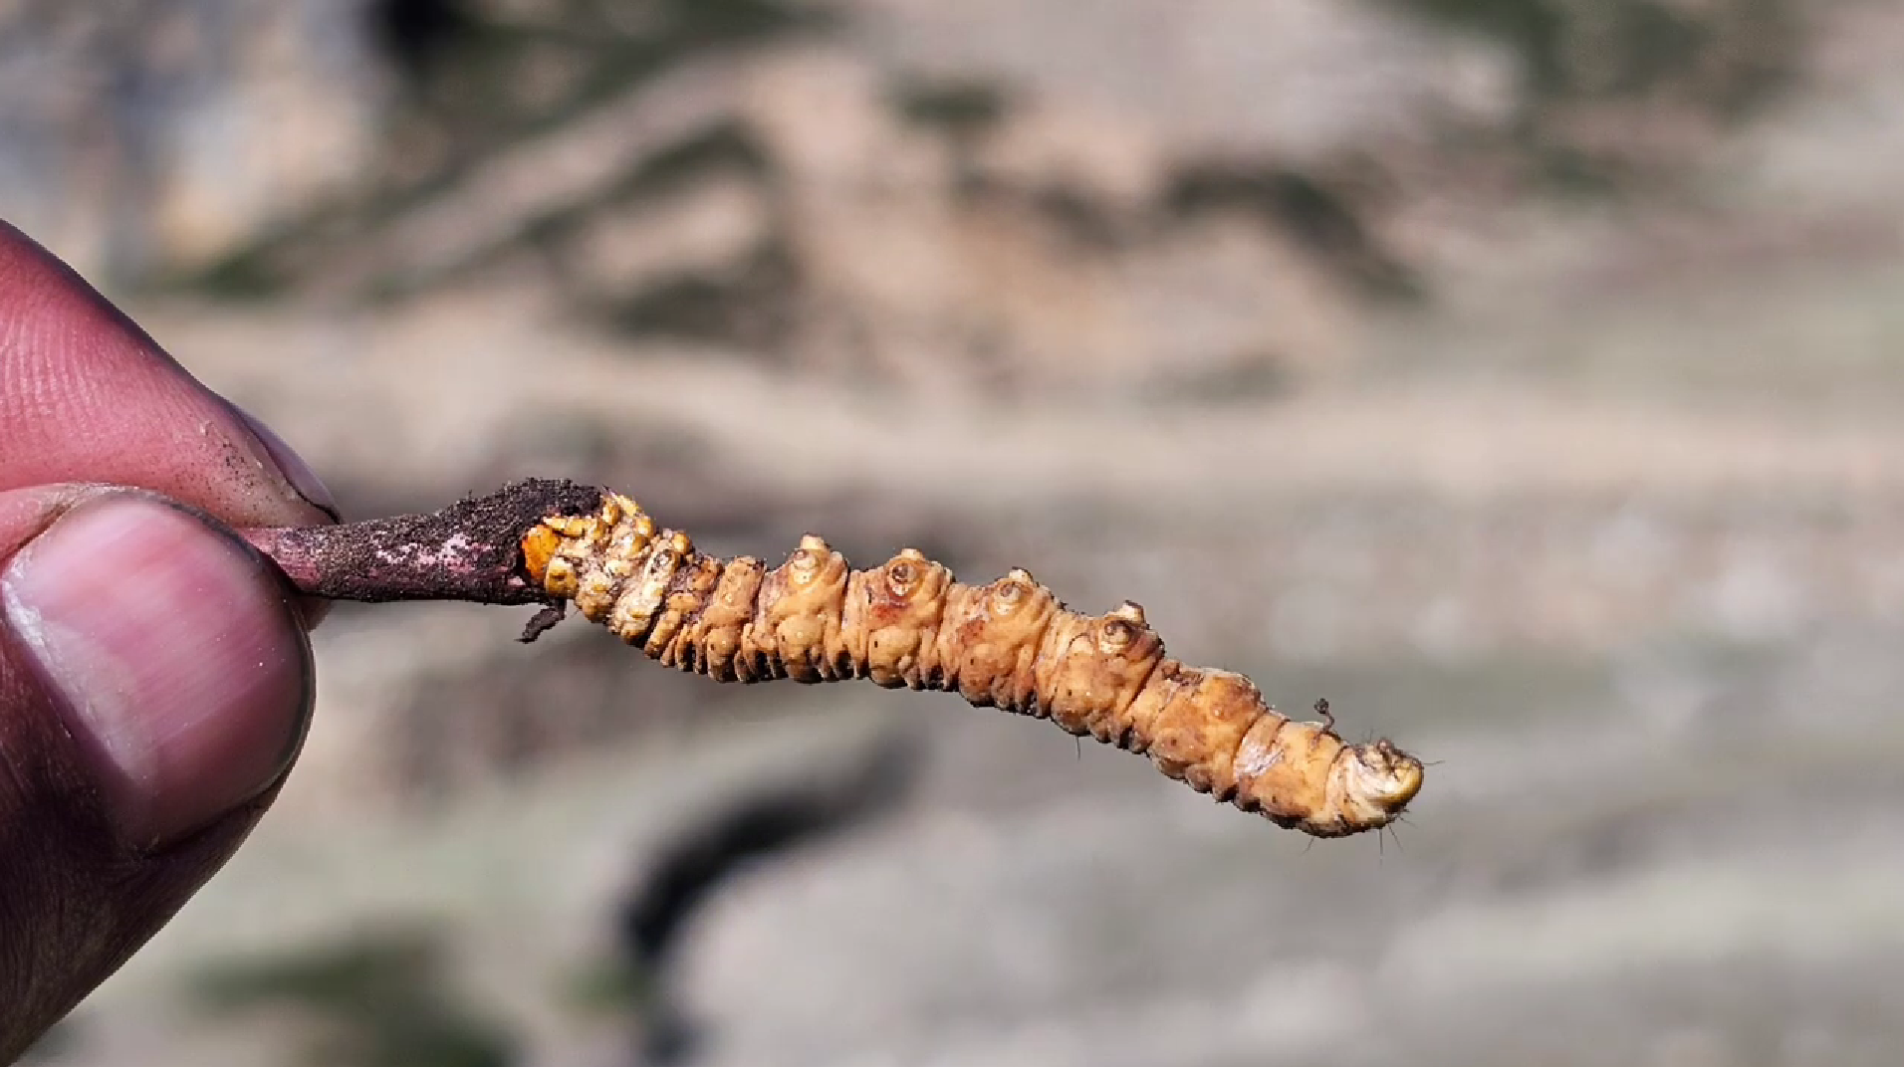
3. Ophiocordyceps sinensis (synonym Cordyceps sinensis), known colloquially as caterpillar fungus, is an entomopathogenic fungus (a fungus that grows on insects) in the family Ophiocordycipitaceae. It is mainly found in the meadows above 3,500 metres (11,500 ft) on the Tibetan Plateau in Tibet and the Himalayan regions of Bhutan, India, and Nepal. It parasitizes larvae of ghost moths and produces a fruiting body which is valued in traditional Chinese medicine as an aphrodisiac.[2] Caterpillar fungus contains the compound cordycepin, an adenosine derivative.[3] However, the fruiting bodies harvested in nature usually contain high amounts of arsenic and other heavy metals, so they are potentially toxic and sales have been strictly regulated by China's State Administration for Market Regulation since 2016
5. Goodbye Sisters (2025): Two Nepali sisters leave Kathmandu to harvest valuable yarsagumba in their mountain village. Jamuna hopes selling the rare fungus-insect hybrid will help support her family and fund studies abroad.
6. Far Beyond the Pasturelands review – on the trail of the ‘Himalayan Viagra’ | Documentary films | The Guardian
In Search Of Yarsagumba (Full Video) #ansabnepal #MAPs #NTFP #fungi
7. The real story behind Nepal’s wildlife conservation success | 101 East Documentary
8. I'm living with THARUS (Indigenous Tribe of NEPAL)🇳🇵

