Pokhara & Mid-Hills– | Gandaki Province, Nepal | ~800–1,740m
General Overview Planetary Health Transect 2026

Landscape
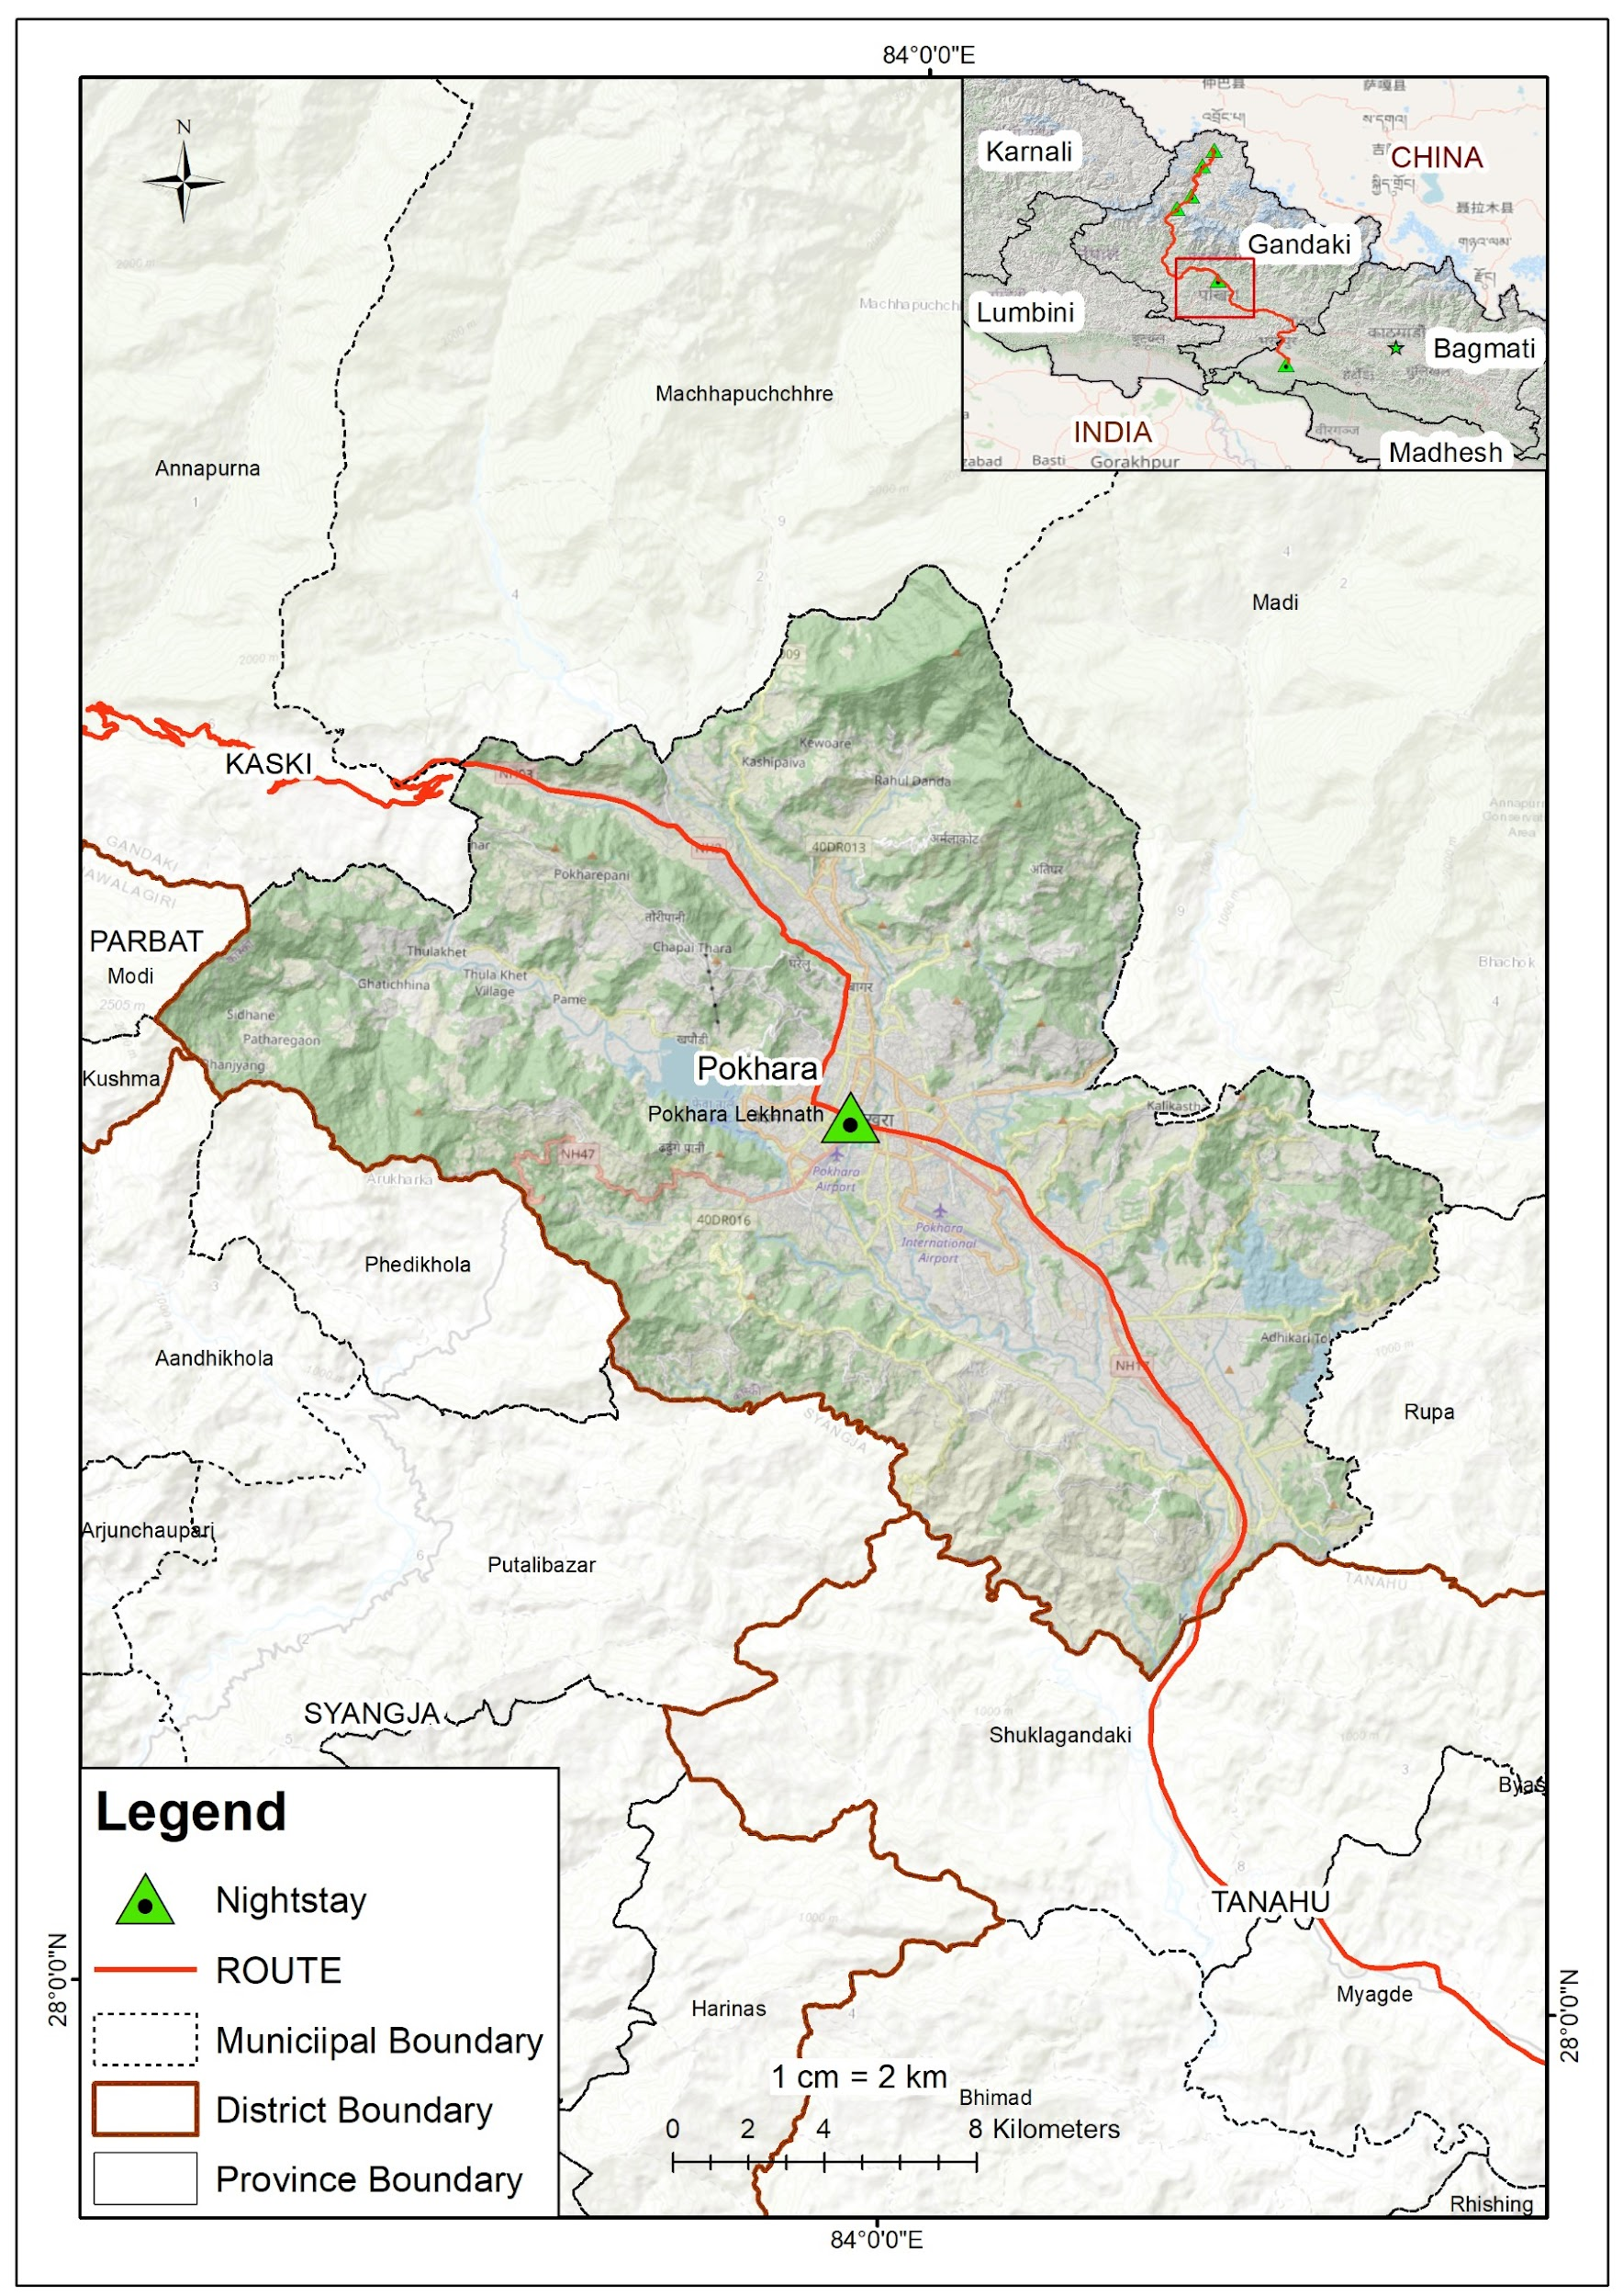
Geography & Landscape
Geographical Setting of Pokhara Valley
Pokhara lies in the Pokhara Valley of Gandaki Province — Nepal's mid-hill zone — at elevations ranging from 827m (lakeshore) to 1,740m on surrounding ridges. The valley is framed by the Annapurna Himalayan massif to the north, whose peaks rise abruptly to 8,091m (Annapurna I) within 30 km, creating one of the world's steepest elevation gradients. The Seti Gandaki River flows through the city, disappearing underground at Davis Falls before reappearing to the south.

The valley's geology — porous karst limestone — favours the formation of caves, sinkholes, and a network of springs. Phewa Lake (742m asl), Nepal's second-largest freshwater lake (4.43 km² in 2024), defines the urban waterfront and is the focal point of Pokhara's identity as Nepal's 'Tourism Capital'. Precipitation ranges from 3,350 mm/year in the valley to over 5,600 mm/year at Lumle — among the highest in Nepal — driven by orographic uplift of monsoon moisture from the Bay of Bengal.

Demographics & Communities
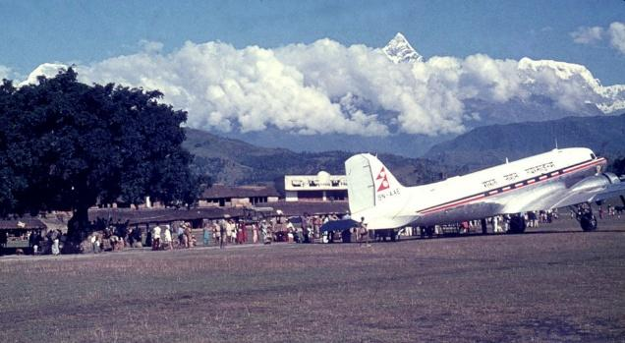
Key Statistics
Pokhara international airport
Population (2021) | 599,504 — Pokhara Metropolitan City; ~600,000 metro est. 2026
Area | 464.24 km² (Pokhara Metro); Kaski District: 2,017 km²
Elevation range | 827m (Phewa lakeshore) — 1,740m (surrounding ridges)
Annual precipitation | 3,350 mm/yr (valley) — 5,600 mm/yr (Lumle); ~80% in monsoon (Jun–Sep)
Sex ratio | 1,107 females per 1,000 males (Gandaki Province) — female-heavy due to male labour migration
Literacy rate | 81.65% (Gandaki Province); higher than national average of 76%
Annual growth rate | +3.36% (urban agglomeration) — one of Nepal's fastest-growing cities
Primary economy | Tourism, hospitality, trekking industry; also agropastoralism in peri-urban areas

Peoples & Ethnicity
Indigenous & Hill Communities:  - Gurung — primary indigenous group; hill villages north and west of city  - Magar — present in southern outlying hills  - Thakali — traditional traders of the Kali Gandaki corridor  - Brahmin–Chhetri (Khas) — 53% of Gandaki Province population  - Newar — merchant community; present in urban core  - Tibetan exiles — ~20,000 in 4 settlement camps (Jampaling, Paljorling, Tashi Ling, Tashi Palkhel) | Social Context  Post-road urbanisation has brought rapid in-migration from hill districts, producing a dense, ethnically diverse city. Gurung villages on surrounding hills retain traditional practices. Youth migration to Gulf states, Malaysia, and Europe has created female-headed households in peri-urban zones — mirroring national trends.

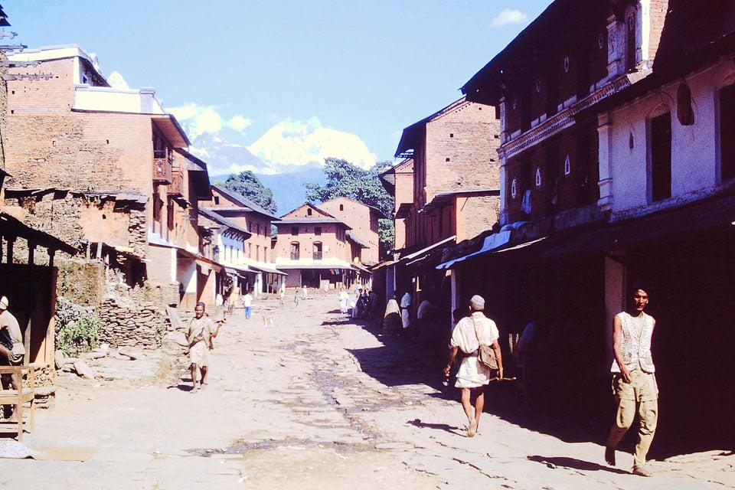
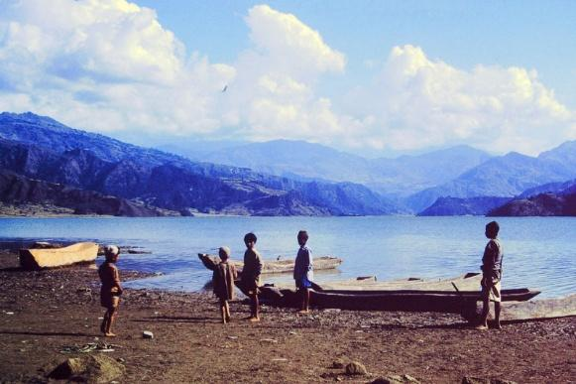
Historical Context — Key Events
Period | Event
1950s–60s | Tibet border closure ends trans-Himalayan trade through Pokhara Valley. Gurung, Magar and Thakali communities shift to agriculture and livestock herding. Pokhara remains a small market town.
2000s | Phewa Lake area shrinks from 10.35 km² to ~4.4 km² due to sedimentation and encroachment. Unplanned lakeside hotel and restaurant construction accelerates.
2015 | April–May earthquakes damage Pokhara valley infrastructure; intensify landslide risk on surrounding slopes. Population recovery and reconstruction drives new urban sprawl.
2017 | Pokhara declared Nepal's 'Tourism Capital'. Areal expansion of built-up zones from 1.76 km² (1990) to 11.15 km² (2020) documented by satellite data.
2022 | Post-COVID tourism rebound. New international airport inaugurated. Phewa Lake Ramsar wetland status (gazetted 2016) comes under scrutiny due to encroachments.
2023 | Supreme Court orders removal of all structures within 65m of Phewa high-flood line. Dengue transmission now thermally suitable for 6+ months/year in Pokhara — new climate signal.
2026 | PM Balendra Shah integrates Phewa conservation into 100-point reform agenda. Phewa buffer zone clearance begins. Pokhara population estimated at ~600,000 (metro).
Climate Trends (1970–2024)
Farmers and communities in the peri-urban hills directly perceive climate shifts: erratic monsoon onset, more intense rainfall bursts, extended dry spells in spring, and increasing hailstorm frequency. Landslide risk on deforested slopes is rising. The Seti Gandaki River's underground flow makes it prone to catastrophic flash floods when heavy rain saturates the karst system.

Pokhara sits in Nepal's Mid-Hill Humid Zone (800–2,000m asl) — Gandaki Province Subtropical Highlands
- Temperature rising at +0.056°C/year nationally (Nepal); mid-hills warming at ~0.04–0.06°C/yr
- Precipitation highly variable: 3,350 mm/yr in Pokhara valley; intense monsoon concentrates 80% of rain in Jun–Sep
- Extreme rainfall events intensifying — triggering landslides, debris flows, and Seti River flash floods
- Urban Heat Island (UHI) effect documented in Pokhara: urban max LST 39.13°C vs. suburban 34.43°C (2013–2022)
- Built-up area expanded from 1.76 km² (1990) to 11.15 km² (2020) — 6× increase driving SUHI intensification
- Dengue transmission now thermally suitable for 6+ months/year; first cases detected in Pokhara (2020s)

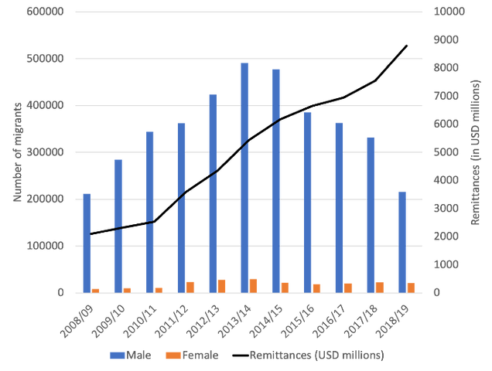

Pokhara & Mid-Hills | Gandaki Province, Nepal | ~800–1,740m
Planetary Health Aspects Planetary Health Transect 2026

Biodiversity
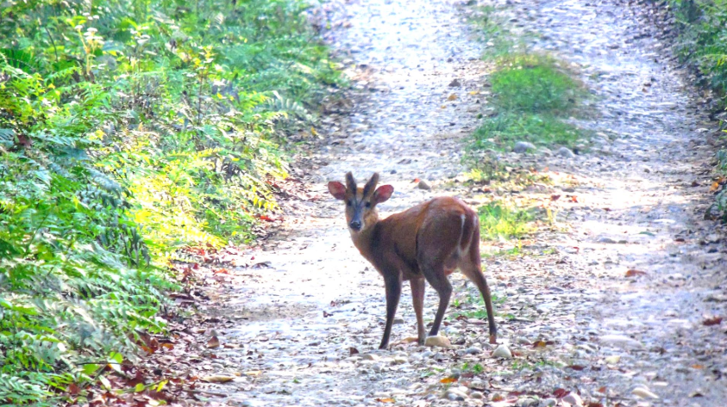
Fauna (Animal)
🌾 Crops  Rice, maize, millet, mustard, wheat. Vegetables: tomato, potato, cauliflower. Dual–triple crop cycle. | 🏡 Farm Structure  0.5–1.5ha. Mix of subsistence & commercial. Credit through cooperatives.
⚠ Climate Risks  Erratic monsoon, landslides, hailstorms cited by >65% of peri-urban farmers. Growing drought stress in spring. | 🌿 Invasives  Mikania and Parthenium spreading rapidly on disturbed slopes post-landslide. Major ecological threat.

- ~500 bird species recorded in Annapurna Conservation Area (ACA) — one of Asia's richest avian zones
- Snow Leopard, Common Leopard, Himalayan Black Bear, Red Panda in ACA uplands
- Spotted Deer (Chital) and Barking Deer in mid-hill community forests
- 225 butterfly species documented in Methlang Forest, Pokhara — including species new to Nepal (2024–2025 surveys)
- Phewa Lake: migratory waterfowl, fish (Asala/Snow Trout, Rohu, Catfish), amphibians — declining from sedimentation and pollution
Flora (Plant)
The mid-hills around Pokhara represent a transition zone from subtropical to warm-temperate forest. Sal (Shorea robusta) dominates lower community forests; Rhododendron, oak, and alder appear on higher ridges. The Panchase region (Phewa watershed) supports 6 endemic orchid species — including Eria pokharensis and Panisea panchaseensis — found nowhere else on Earth. The ACA hosts over 1,200 flowering plant species. Invasive species — particularly Mikania micrantha and Parthenium hysterophorus — are spreading rapidly in disturbed mid-hill areas post-landslide and road construction.
Agriculture
- Terraced rice–maize–millet dual/triple cycle (Apr–Nov) on hill slopes
- Smallholdings 0.5–1.5 ha; mix of subsistence and commercial
- Vegetables and fruits (citrus, banana, avocado) increasing as cash crops
- Traditional guthi and kipat communal land systems in Gurung areas
- Climate risks: erratic monsoon, hailstorms, and spring drought cited by >65% of peri-urban farmers
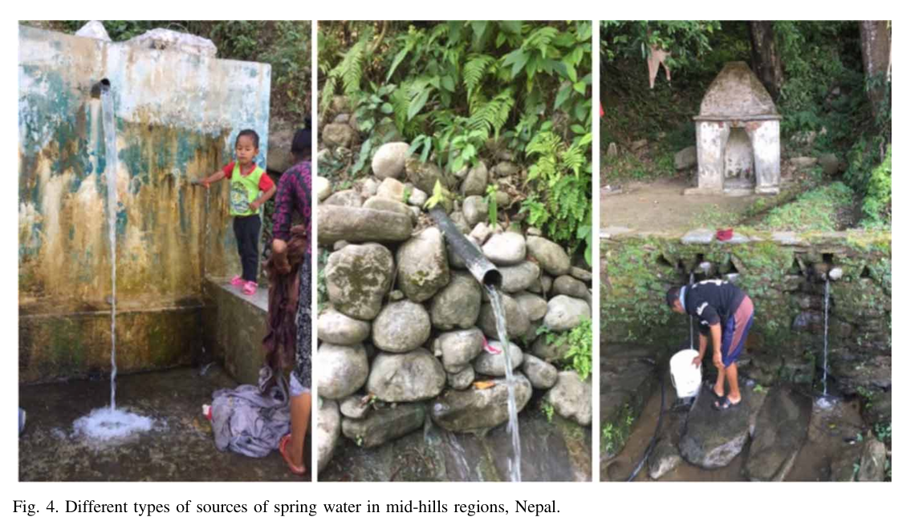
Planetary Health — Key Themes
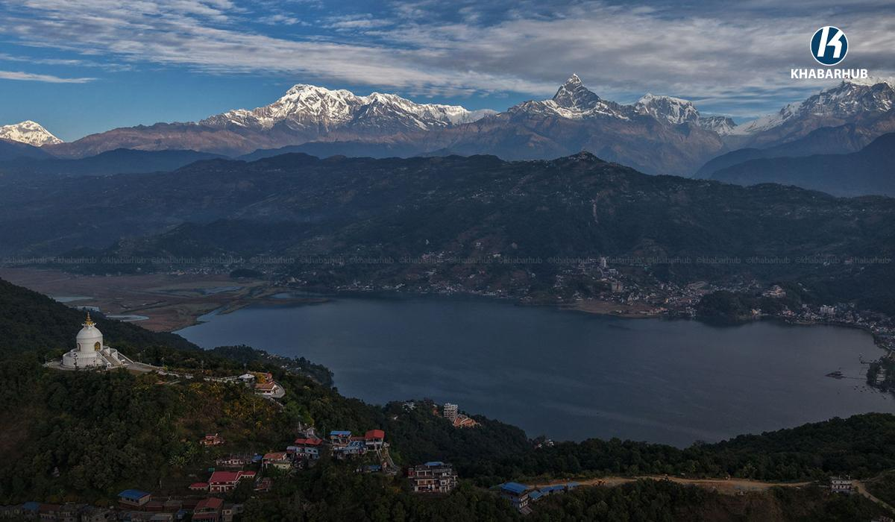
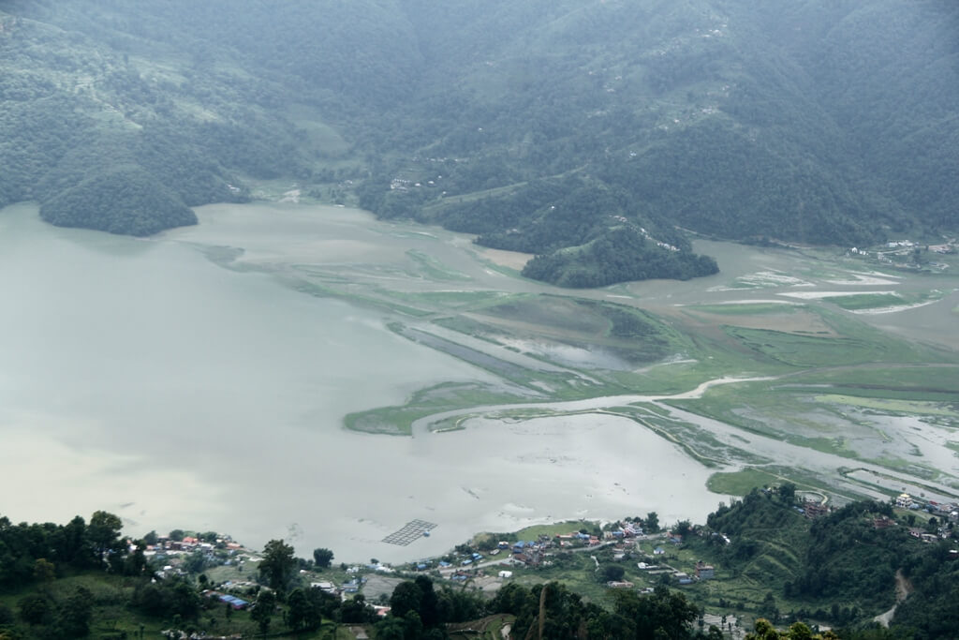
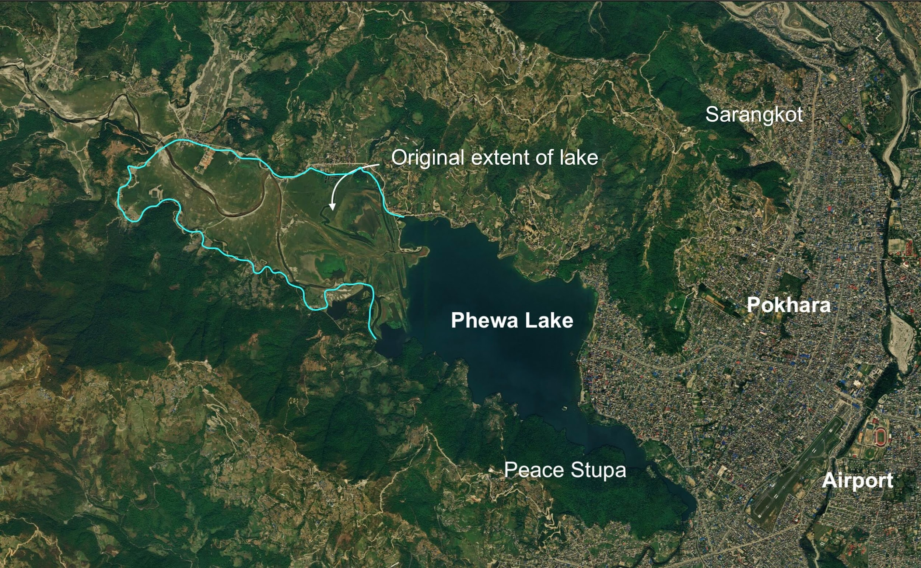
① Urbanization, Pollution & Lake Degradation
Pokhara's built-up area expanded 6× between 1990 and 2020, driven by tourism, in-migration, and road construction. The Lakeside zone along Phewa Lake became one of Nepal's most commercially intense corridors — with over 305 hotels and hundreds of restaurants discharging untreated wastewater directly into the lake catchment.  Urban Heat Island: Urban LST up to 39.1°C vs. suburban 34.4°C. Concrete-dominant construction in rapidly expanding zones replaces agricultural land and forest cover, amplifying heat stress. |  | Phewa Lake Crisis:  - Lake shrank from ~10.35 km² historically to 4.43 km² (2024) — driven by sedimentation and drainage  - Ramsar-listed wetland (2016) faces biodiversity collapse: fewer migratory birds, reduced fish stocks, invasive water hyacinth  - 500+ hotels encroached on protected 65m buffer zone; Supreme Court ordered removal in 2023  - 2026: Government under PM Balendra Shah integrates lake restoration in 100-point reform agenda
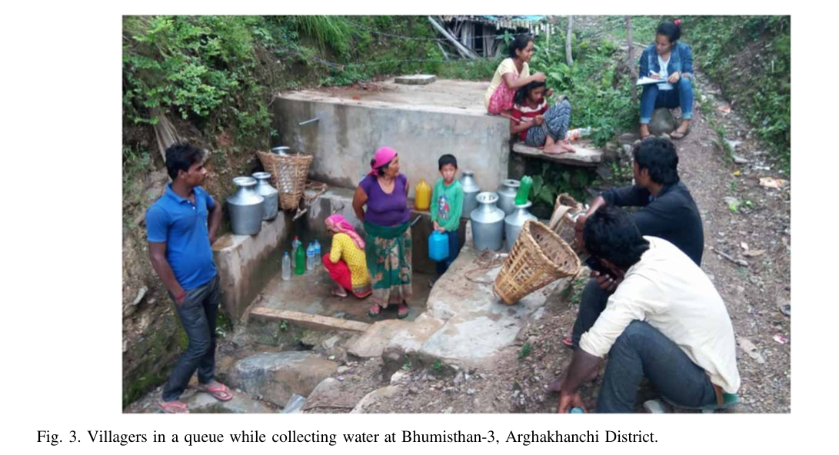
Water Pollution: Fecal coliform levels spike post-rainfall; nutrient enrichment (eutrophication) documented seasonally. No city-wide sewerage system. River contamination from hotel waste is a primary health risk.

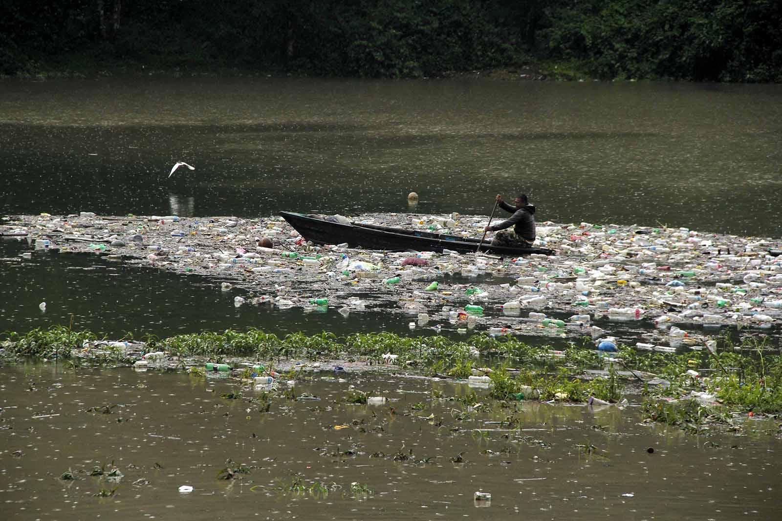
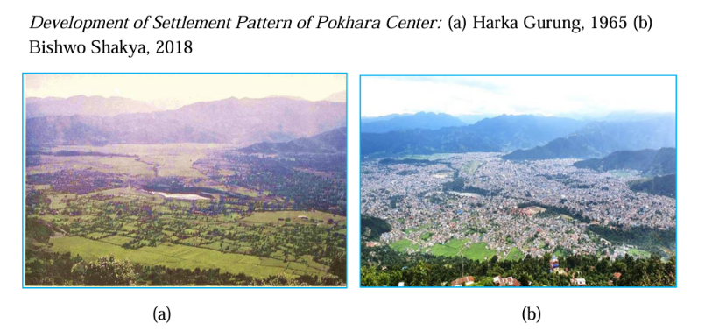
② Environment, Ecosystem & Biodiversity
The mid-hill zone around Pokhara is globally significant as a biodiversity transition corridor linking the lowland Terai with the Annapurna high mountains. The Panchase region functions as the critical north–south wildlife corridor between Chitwan National Park and Annapurna Conservation Area. Deforestation for fuelwood, road construction, and agricultural expansion has fragmented this corridor, increasing landslide risk and reducing habitat connectivity for wide-ranging species including leopard and bear.

Cave Heritage: The Pokhara valley and surrounding hills contain limestone cave systems — Mahendra Cave (200m) and Bat Cave (150m) — that are both tourist attractions and significant bat roost habitats. Loss of bat populations through tourism disturbance affects insect regulation and crop protection services.

③ Climate Change, Hazards & Resilience
🌊 Floods & Landslides  Seti Gandaki River: catastrophic underground flash floods (2012 event killed 72 people). Intense monsoon triggering landslides on deforested mid-hill slopes. Phewa Lake sedimentation accelerating from catchment erosion. 2015 earthquakes intensified slope instability across Kaski District. | 🌡 Heat & Urban Heat Island  Urban temperatures up to 5°C above rural surroundings (SUHI effect, 2013–2022). Highest recorded temperature: 38.5°C (May 2013). Heat stress risk rising for outdoor workers and elderly. Dengue vector now thermally active 6+ months/year.
🌿 Ecosystem Degradation  Invasive species (Mikania, Parthenium) spreading on disturbed slopes. Community forests under pressure from firewood demand and urban expansion. Butterfly range shift: lowland species advancing upslope — clear climate signal. | 🟨 Drought & Water Stress  Spring drought increasing as snowpack on surrounding hills declines. Tourism water demand competing with irrigation for Phewa-fed farmland. Wetland loss reduces natural flood buffering and groundwater recharge.

Indigenous Resilience Systems
- Community Forest User Groups (CFUGs) — legally autonomous institutions managing 55+ community forests in Kaski; legal basis for watershed protection
- Phewa Protected Watershed — designated February 2022; integrates upstream–downstream community management
- Guthi system (Newar) and Kipat (Gurung/Magar) — traditional communal land governance frameworks
- World Peace Biodiversity Park (WPBP), Panchase — SEPLS model integrating ecotourism, forest restoration, and community livelihood in Phewa watershed
- Tij Festival, Dashain, Tihar — cultural cohesion events reinforcing community bonds and indigenous identity
- Gurung Rodhi (youth gathering house) — traditional social institution maintaining intergenerational knowledge and marriage networks

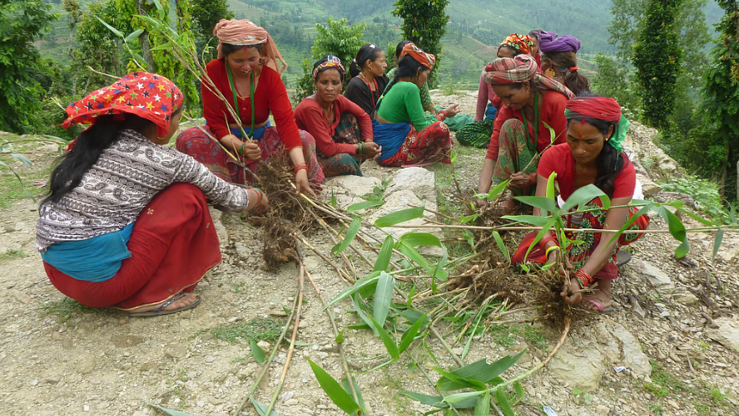
Health Profile
Pokhara's health burden reflects a rapidly urbanising mid-hill city in full epidemiological transition — non-communicable diseases now lead hospital presentations, while vector-borne diseases previously associated with the Terai lowlands are expanding upslope due to warming temperatures. Western Regional Hospital (WRH) is the primary tertiary referral centre for all of Gandaki and Lumbini Provinces, serving a catchment of over 5 million people. Air pollution and water quality remain critical environmental health concerns.
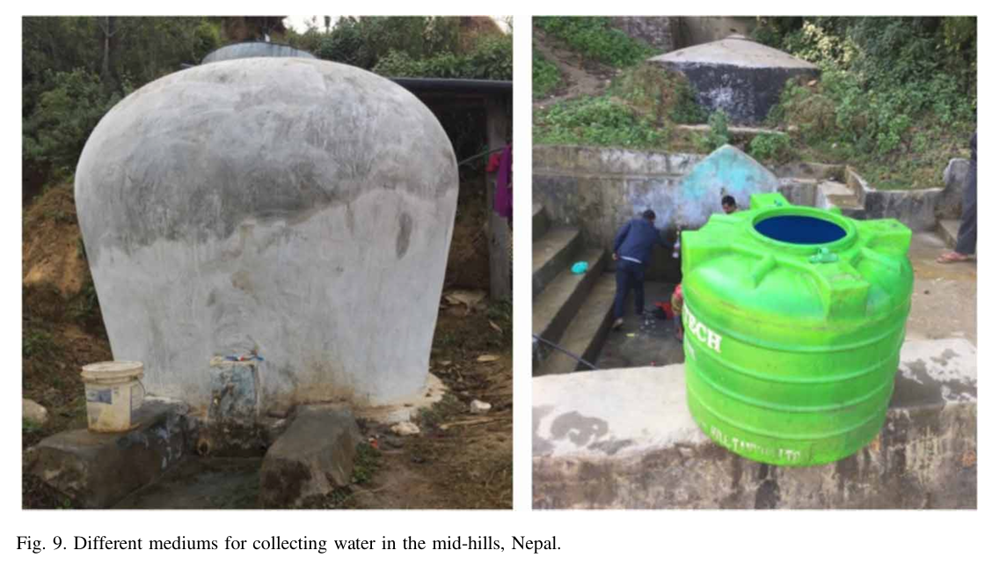

Public Health Highlights: Dengue now thermally suitable for 6+ months/year in Pokhara; COPD positively correlated with air pollution levels (WRH data); fecal contamination of Phewa lake posing recreational water health risk; landslide-related trauma a major acute care burden during monsoon.

Communicable Disease  COPD positively correlated with air pollution from biomass burning and vehicle emissions (WRH admissions data, 2021). NCDs account for 31% of national hospital presentations; Pokhara mirrors this trend. Hypertension, diabetes, and obesity rising with dietary change (processed foods) and reduced physical activity. UV radiation at altitude; still a cataract risk factor. | Vector-Borne & Infectious Disease  Dengue: thermally suitable 6+ months/year in Pokhara (Aedes albopictus primary vector in cooler climes). High-density urbanisation with poor sanitation amplifies transmission risk. Gastrointestinal disease from Phewa lake pollution; a seasonal burden. Zoonotic risk from livestock in peri-urban areas.
Mental Health  Depression: 11–17% adult prevalence (national estimate). Alcohol use disorder ~20% of adult men. Treatment gap >90% mirrors national trend. Rapid urbanisation, male labour migration, and cultural disruption drive psychosocial stress. Tourism-dependent economy creates economic anxiety. Buddhist monastery community and cultural festivals remain key protective factors. | Health System  Western Regional Hospital: primary tertiary referral centre for 5M+ population. Gandaki Medical College and associated teaching hospitals expanding capacity. Health post network in peri-urban wards variable in quality. Emergency trauma care for landslide and flood victims strained during monsoon. New Pokhara International Airport enables medical evacuation.
Cross-Cutting Themes
GEDSI  Female-heavy sex ratio (1,107 F:1,000 M) driven by male labour migration. Women manage households and agropastoral systems during extended male absence. Gurung women play key roles in community forest governance. Disability and elderly populations face barriers in a hilly city with limited accessible infrastructure. Post-road in-migration creates new social hierarchies. | Mental Health & Wellbeing  Rapid urbanisation and tourism economy create precarity and identity disruption. Male labour diaspora leaves behind psychological burden in families. Treatment gap >90% for mental health conditions. Gurung Rodhi system and Buddhist practice remain vital protective institutions. Economic anxiety from over-reliance on tourism (COVID impact was devastating). | Culture, Heritage & Human–Nature  Phewa Lake and the Annapurna panorama are not merely scenic — they are the foundation of Pokhara's cultural identity and economic life. Panchase endemic orchids (Eria pokharensis, Panisea panchaseensis) are place-specific natural heritage. Gurung and Tibetan cultural practices around lakes, forests and mountains encode ecological stewardship norms centuries old.

Sources
Nepal Census 2021 — Pokhara Metropolitan City & Kaski District • Gandaki Province Profile (2021) • Weather, Climate, and Society (2023): Air Pollution, Meteorology, and COPD in Pokhara • ScienceDirect (2025): Urban Heat Islands in Pokhara Metropolitan City • Ecology and Evolution (2025): Butterfly Diversity, Methlang Forest • Nepal News/Rising Nepal (2026): Phewa Lake encroachment • Springer Nature (2023): SEPLS / World Peace Biodiversity Park, Panchase • PLOS One (2025): Dengue thermal suitability, Nepal mid-hills • NAM/NAP (2024): Climate and Health Lessons from Nepal • UNDP Nepal: ACA Biodiversity and Tourism • DNPWC: Annapurna Conservation Area • Luitel et al. (2017; 2018) — Mental health treatment gap, Nepal • ICIMOD baseline data (2023) • Bajracharya et al. (2023) — Climate information services, Nepal
Planetary Health Transect 2026

