Upper - Mustang- | Upper Mustang, Nepal | ~3,500–3,840m
General Overview Planetary Health Transect

Landscape
Geography & Landscape  Trans-Himalayan arid plateau, altitude 3,500–4,400m, enclosed by the Annapurna massif (S) and Dhaulagiri (SW). The Kali Gandaki gorge — the world's deepest canyon — drains south from the plateau. Ochre wind-eroded badlands, cliff-face cave complexes, and irrigated river-terrace settlements create an extraordinary living cultural landscape unique in Nepal. Annual precipitation <200mm — a cold desert. Around half the land is pasture and only 1.2% is farmed, made possible through intricate irrigation systems channeling snowmelt water. | MAP PLACEHOLDER  Insert informative map of Mustang here.  Recommended: district boundary, CNP boundary, Madi valley, major rivers (Narayani, Rapti), Sauraha corridor, elevation gradient, key settlements.

Demographics & Communities
Key Statistics  - Population (2021 est.): ~6,000 — Lomanthang Rural Municipality; 569 in the walled city (172 households, 2011 census)  - Sex ratio: ~100 males per 100 females; male-biased migration to Japan, Europe and USA  - Annual growth rate: −1.2% (2011–2021) — net out-migration; more than 50% migrate to lower areas each winter  - Literacy rate: ~68% (male 78%, female 58%) — among Nepal's lowest rates  - ~40% of households are female-headed, driven by male overseas migration  - Primary occupation: trans-Himalayan trade (historically), now agropastoralism and tourism  - Area: 2,500 sq.km (Upper Mustang / Lo Tso Dun); elevation 3,000–6,000m; annual precipitation <200mm  Peoples & Ethnicity  Indigenous Group: Loba (Lo-pa) — culturally, linguistically and ethnically Tibetan; Loke dialect  Hill Migrant Group: Thakali, Gurung, Brahmin–Chhetri (post-2001 road in-migrants)  Note: Lo-pa society is divided into three classes — the ruling class (Ku-drag-pa), the working class (phal-pa) and the low class (gar-pa). Before road access, Lo Manthang was ~95% Loba. Post-2001 road construction triggered in-migration from hill communities. The younger generation increasingly migrates to Japan, Europe and the USA, and the 2011 census shows the walled city has only 569 residents. | 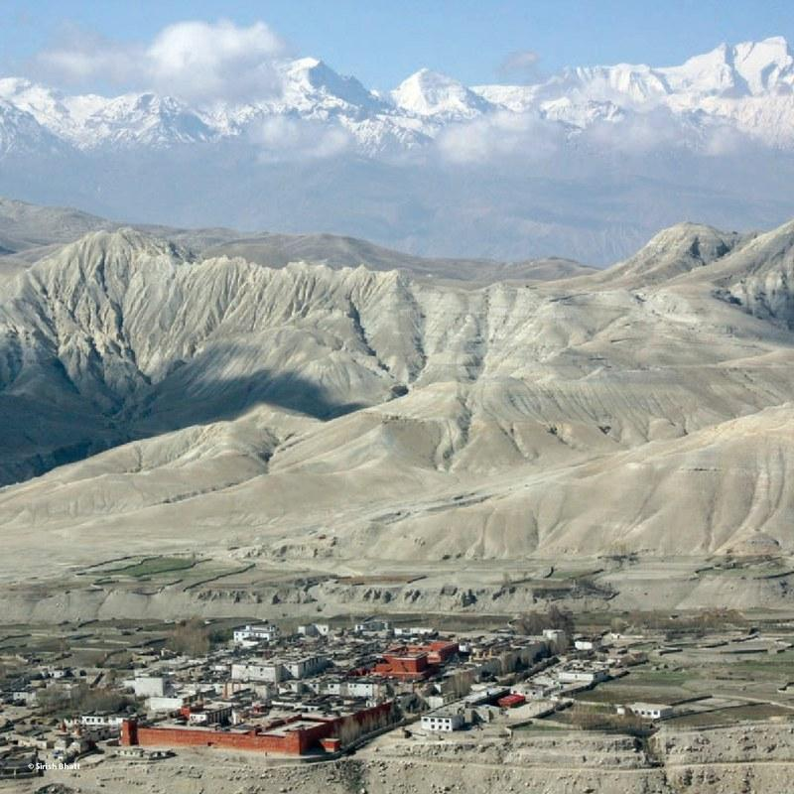  Aerial view of Lo Manthang walled city with Annapurna range.  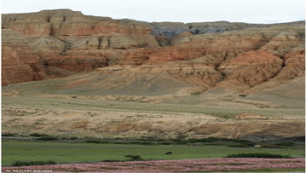  The distinctive ochre lunar landscape of Upper Mustang.

Historical Context — Key Events
Period | Event
1950s–60s | Tibet border closed due to political conflicts. Trans-Himalayan trade collapsed and Lo lost its main source of income. People shifted to herding yak, dzo, cow, horse, mule, goat and sheep.
1992 | Upper Mustang opened to controlled international tourism (1,000 visitors/year; USD 700 permit). 60% of revenues were promised for local development but never materialized.
2001–2015 | Chinese road connects Kora La border (2001); road from south completed (2015). Journey from Pokhara: 7-day trek → 1-day jeep drive. Rapid cultural and commercial change begins.
2008 | Lo Manthang inscribed on Nepal's World Heritage Tentative List as "The Medieval Earthen Walled City of Lo Manthang." Kingdom formally abolished; King Jigme Dorje Palbar Bista loses official title.
2015 | 2015 earthquakes severely damaged the Royal Palace (Tashi Gephel) and the southern chapel of Choede Gompa. Restoration is ongoing with support from HimalAsia Foundation and American Himalayan Foundation.

Climate Trends (1970–2019)
Lo Manthang sits in the Trans-Himalayan Arid Zone (>3,500m) of the Dhaulagiri–Annapurna Landscape (CHAL)
• Temperature rising at +0.09°C/year — the fastest warming zone in Nepal (3× the global average of 0.02°C/yr)
• Precipitation declining at −3 mm/year; average ~200 mm/year; ~80% falls in monsoon (July–August)
• Winters are warming faster than summers; January minimum temperatures have risen ~2°C since 1970
• Nepal warms at 0.056°C/year nationally — nearly 3× the global average (0.02°C/year)
• Altitude amplification: Trans-Himalaya warms 0.09°C/yr vs. Terai lowlands 0.022°C/yr — fastest change at highest elevations

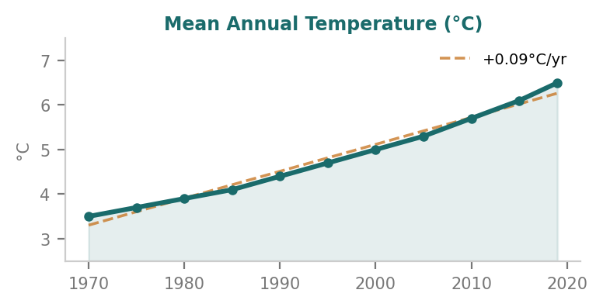 | 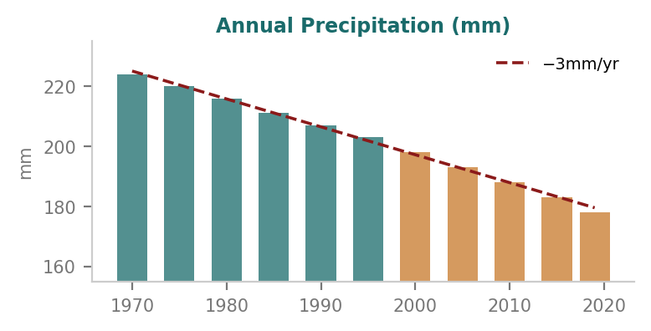

Farmers directly perceive these changes. In Lomanthang Municipality, drought and erratic snowfall are the top reported climate risks, followed by hailstorms — which can destroy entire barley harvests within minutes. Crop insurance is essentially nonexistent. (ICIMOD baseline data, 2023)

Upper - Mustang | Upper Mustang, Nepal | ~3,500–3,840m
Planetary Health Factsheet
Planetary Health Transect
Biodiversity
Fauna (Animal)  - ~150 bird species; ~28 mammal species recorded in Upper Mustang  - Snow Leopard, Himalayan Wolf, Tibetan Kiang (wild ass), Blue Sheep (Bharal)  - Lammergeier, Himalayan Griffon vulture; Kali Gandaki a globally significant raptor migration corridor  - House Crow advancing +136m/yr upward (1999–2011) — Nepal's clearest biological climate signal  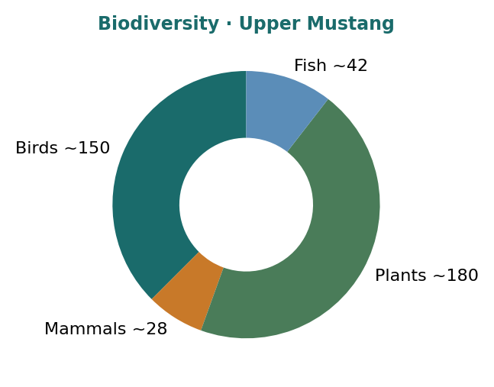  - Snow Trout populations in Kali Gandaki declining due to GLOF-driven flood pulses | 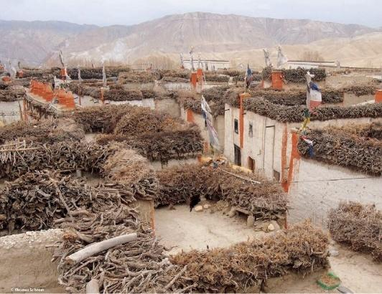  View over the rooftops of Lo Manthang. © Thomas Schrom  🌾 Crops Barley, buckwheat, potato, apple, turnip. Single cycle: Apr–Sep. 🏡 Farm Structure Smallholdings <0.3ha. Subsistence; ~10% commercial. No credit. ⚠ Climate & Access Spring frosts, hailstorms, drought cited by >70% of farmers. No agri extension services.

Flora (Plant)  - 180+ plant species; desert scrub dominates: Caragana, Artemisia, Ephedra  - Irrigated barley, buckwheat, potatoes on river terraces; apple orchards at Marpha–Kagbeni belt  - Juniper woodland above 4,000m; alpine meadows above 4,500m  - No invasive Mikania spread: harsh cold-arid climate prevents lowland invasive species | Agriculture  - Single crop cycle: Barley–Buckwheat–Potato (Apr–Sep); apple as cash crop  - Subsistence smallholdings <0.3ha; only ~10% commercially productive  - Traditional Ghenba rotational irrigation system mediates water rights between households

Planetary Health — Key Themes
① Urbanization & Pollution
The recent construction of roads connecting Lo Manthang with China (north) and Nepal's road network (south) is the main factor driving change. Most local people value road connectivity for more affordable goods, cheaper travel and easier hospital access — but negative effects include environmental degradation, rapid unplanned development, and import of non-traditional concrete building materials. Until the early 1990s the settlement was confined within the fortified wall; the town has since expanded rapidly with cafés, souvenir shops and guesthouses in incompatible design and style.  Water Pollution: All 9 functioning water taps in Lo Manthang exceeded WHO arsenic standards (79% of groundwater; 47% of surface water). Uranium detected at up to 19µg/L. No sewage infrastructure. River contamination rising with guesthouse proliferation. (McDermott et al., 2011)  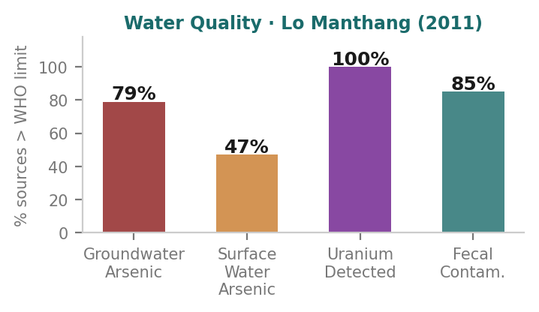  Water quality crisis — % of Lo Manthang sources exceeding WHO safe limits | 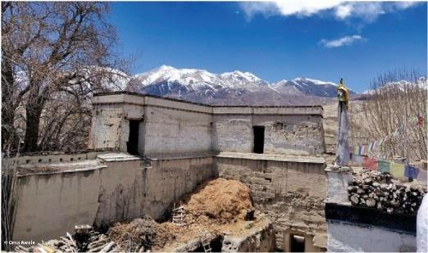  Southwest corner of the historic town wall. New construction visible outside. © Orna Awale  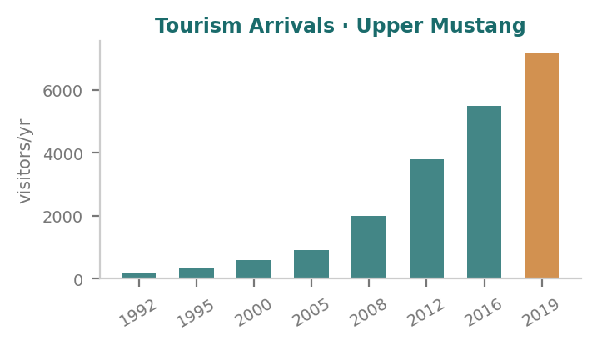  Tourism arrivals: 200/yr (1992) → 7,200/yr (2019) — 36× growth

② Environment, Ecosystem & Biodiversity
The trans-Himalayan cold desert supports unique species assemblages found nowhere else in Nepal. The Kali Gandaki corridor is a globally significant raptor migration highway. Land degradation from overgrazing, deforestation for fuel, and wind erosion is expanding the desert boundary. Post-salt-trade collapse reduced transhumance management; herders who once maintained pasture rotation have migrated.  Sky Caves: The high cliffs are dotted with man-made cave complexes dating back to prehistoric times — the oldest evidence of human settlement in the region. Used for funerary rituals, habitation, and monastic retreats. The Mardzong Cave yielded 2008 National Geographic discovery of Bon manuscripts. Most cliffs have undergone extensive erosion, leaving caves inaccessible. Luri Cave Monastery contains the earliest wall paintings documented in Nepal. | 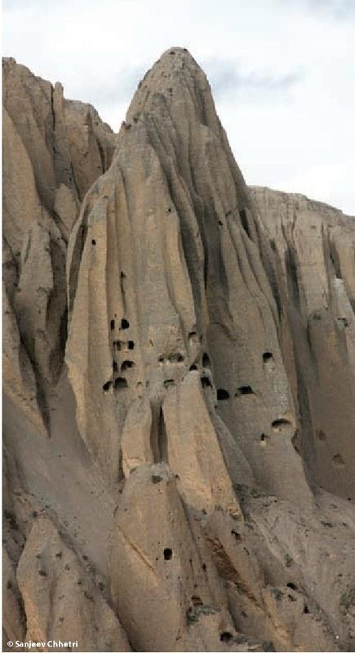  Sky caves — cliff-face cave complexes, oldest human settlements in the region. © Sanjeev Chhetri

③ Climate Change, Hazards & Resilience
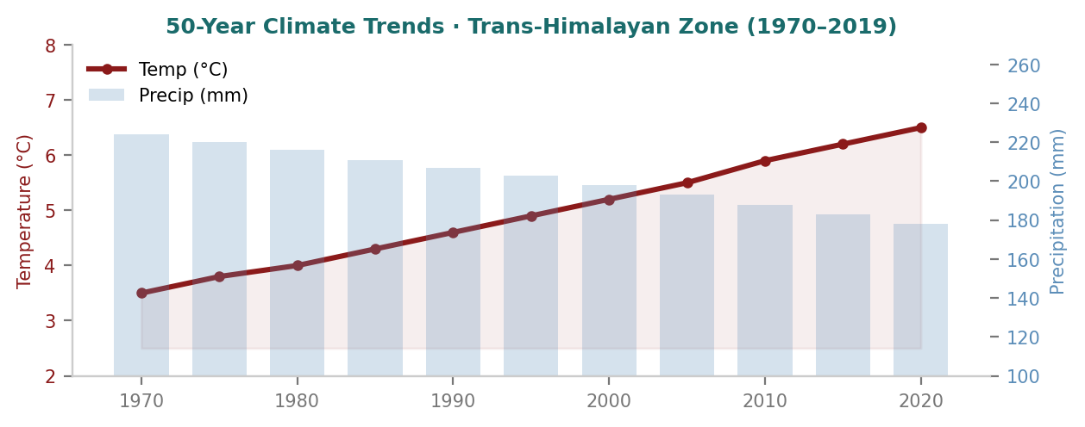
50-year climate trends: rising temperature (red) vs. declining precipitation (blue) · Trans-Himalayan Zone 1970–2019. Warming rate 0.09°C/yr — nearly 3× Nepal national average.

🌊 Flood & Glacial Melt (GLOF)  • Kali Gandaki headwaters fed by retreating glaciers; GLOF risk rising  • Irrigation channels dependent on glacier-fed streams face water insecurity  • Kali Gandaki river erosion accelerating — riverside settlements at risk  • Spring meltwater floods increasing in frequency and severity post-2000 | ⛰ Wind Erosion & Landslide  • Constant high-altitude winds (Nov–Mar) carve ochre cliffs, damage structures  • Cave heritage murals degrade year-round from temperature cycling and wind  • Wind shapes all agriculture, construction and daily outdoor movement  • Increasing erosion of cliff faces is destroying original cave access routes
🌡 Heatwave, Coldwave & UV  • January minimum −20°C; traditional mud-brick has superior thermal mass  • Modern concrete replacing traditional buildings — worse insulation paradox  • Summer UV radiation 3–4× sea-level intensity: cataracts and skin cancer risk  • Rapid diurnal temperature swings (>20°C daily range) stress cave murals | 🟨 Drought & Water Scarcity  • Annual precipitation <200mm — already a cold desert, declining at −3mm/yr  • Declining snowfall reduces soil moisture and spring irrigation supply  • Hailstorms can destroy entire barley harvest in minutes; increasing since 2000  • Growing tourism water demand threatening traditional irrigation availability

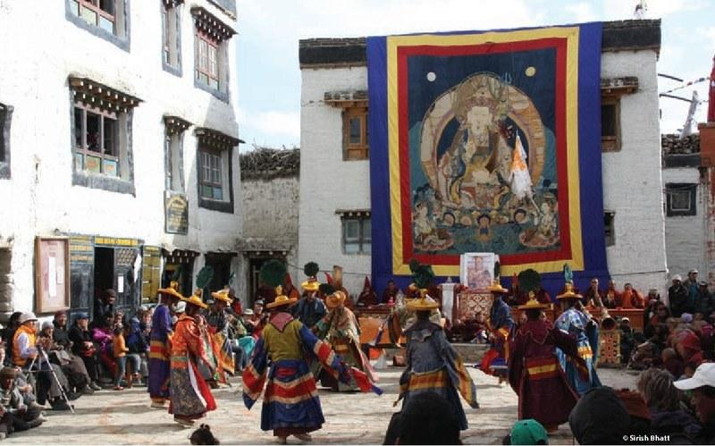  Monks of Choede Gompa performing Vajrakila dance  during Tiji Festival. © Sirish Bhatt | 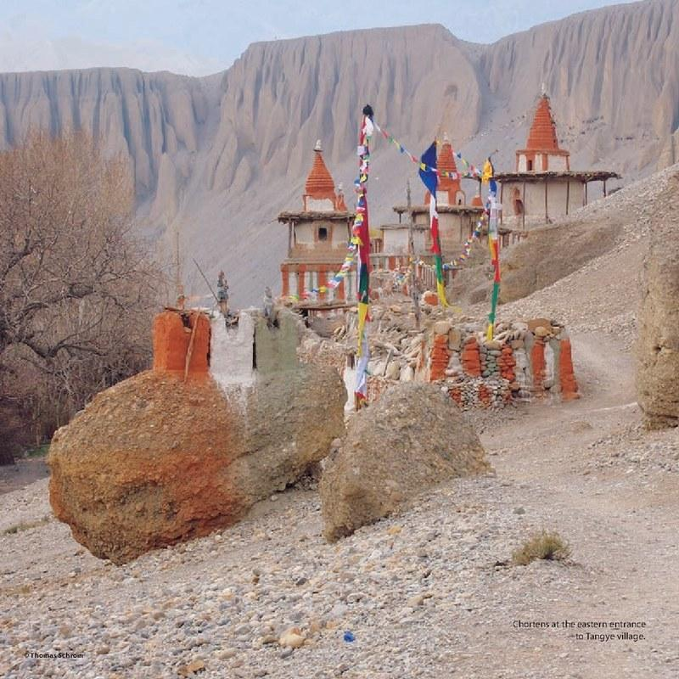  Chortens at the eastern entrance to Tangye village.  © Thomas Schrom

Indigenous Resilience Systems
• Ghenba system — rotational water management mediating irrigation rights between households; 800-year-old design still functional
• Sowa Rigpa (Amchi medicine) — Tibetan traditional medicine; Lo-Kunphen clinic founded by brothers Gyatso and Tenzin Bista trains new Amchis. Primary healthcare since government health care is unreliable
• Tiji Festival (May) — annual 3-day ritual defeat of the demon of water scarcity; a spring renewal festival and celebration of precious water; cultural reinforcement of conservation norms
• Yartong Festival (Aug/Sep) — horse racing, feasting, dancing; led by the Gyelpo (Lo King); maintains social cohesion and traditional governance structures

Health Profile
Lo Manthang's health burden reflects a remote high-altitude community in early epidemiological transition — shifting from infectious to non-communicable disease, while altitude-specific and environmental health risks remain severe. Since Lo Manthang lacks reliable government health care, traditional Tibetan medicine (Sowa Rigpa) and healing practices provide basic community health services. The treatment gap exceeds 90% for mental health conditions, mirroring national trends.  Public Health Highlights: AMS/HAPE at 3,810m; arsenic and uranium in all potable sources; UV radiation 3–4× sea-level intensity. Nearest hospital 50km away; helicopter-only emergency evacuation. Genetic altitude adaptation (EPAS1) in Loba people is a major high-altitude physiology research interest. Traditional Amchi medicine fills the primary healthcare gap left by absent government services. | 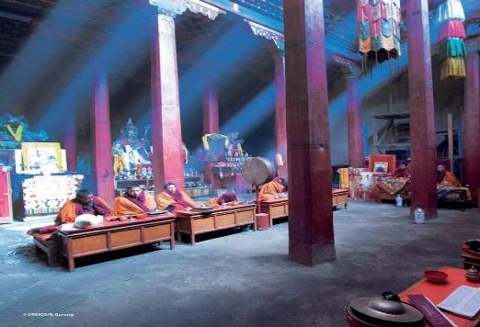  Monks inside Thubchen Lhakhang — spiritual practice as protective mental health factor. © UNESCO/K. Gurung

⛰ Altitude & AMS/HAPE  At 3,810m, Acute Mountain Sickness affects 25–40% of rapid-ascent visitors. HAPE is a medical emergency risk; acclimatization is obligatory. Loba people carry the EPAS1 ("super-athlete gene") variant conferring genetic adaptation to hypoxia — among the highest frequencies worldwide. Nearest hospital: Jomsom (~50km south). Emergency evacuation requires helicopter. | 💧 Water Quality & Zoonotic Risk  Arsenic exceeds WHO limits in 79% of groundwater taps; uranium detected at 19µg/L. All 9 functioning taps in Lo Manthang were unsafe in 2011. Fecal contamination documented in river and spring sources. Yak herding community has close livestock–human interface with ongoing zoonotic risk. Open border with Tibet creates cross-border disease transmission pathways.
🏙 Non-Communicable Disease  Post-road access (2015) is driving dietary change — increased processed food, salt, sugar from Chinese goods. NCD risk factors (hypertension, obesity, diabetes) are rising. NCDs account for 31% of national hospital presentations; cardiovascular disease and COPD lead. UV radiation 3–4× sea-level intensity elevates cataract and skin cancer risk. | 🧠 Mental Health  Depression: 11–17% of adults (national estimate). Alcohol use disorder: ~20% of adult men. Treatment gap: >90%. Rapid cultural disruption — loss of monarchy (2008), diaspora, Chinese goods — drives identity loss and community grief. Tibetan Buddhist practice, monastery community, and festivals remain key protective factors. Sowa Rigpa addresses psychological illness. (Luitel et al., 2017; 2018)

Cross-Cutting Themes
GEDSI  Gender, Equity, Disability, Social Inclusion: ~40% of households are female-headed due to male overseas migration. Literacy gap: male 78% vs. female 58%. Lo-pa social class structure (Ku-drag-pa / phal-pa / gar-pa) shapes access to resources and decision-making. Women manage agropastoral livelihoods during extended male absence. Disability and elderly populations face acute barriers to healthcare (50km to hospital). Post-road in-migration has introduced new social hierarchies. GEDSI lens essential for equitable development, heritage conservation, and climate adaptation planning. | Mental Health & Wellbeing  Rapid loss of cultural identity — monarchy abolished (2008), youth diaspora, commercialization — drives psychosocial disruption and ecological grief. Treatment gap >90% mirrors national trend. Tibetan Buddhist practice, monastery community structure, Yartong horse festival and Tiji remain key protective factors and sources of collective meaning. (Luitel et al., 2017; Jordans et al., 2020) | Culture, Heritage & Human–Nature  Lo Manthang: Nepal's most intact medieval walled city (layout unchanged since 1440 AD); World Heritage Tentative List (2008). Tiji myth encodes a water ethic — defeating the drought demon restores the hydrological cycle. Cave murals (14th–15th c.) at existential risk from erosion. Ghenba irrigation system is a UNESCO-recognised model of traditional ecological governance in mountain environments.

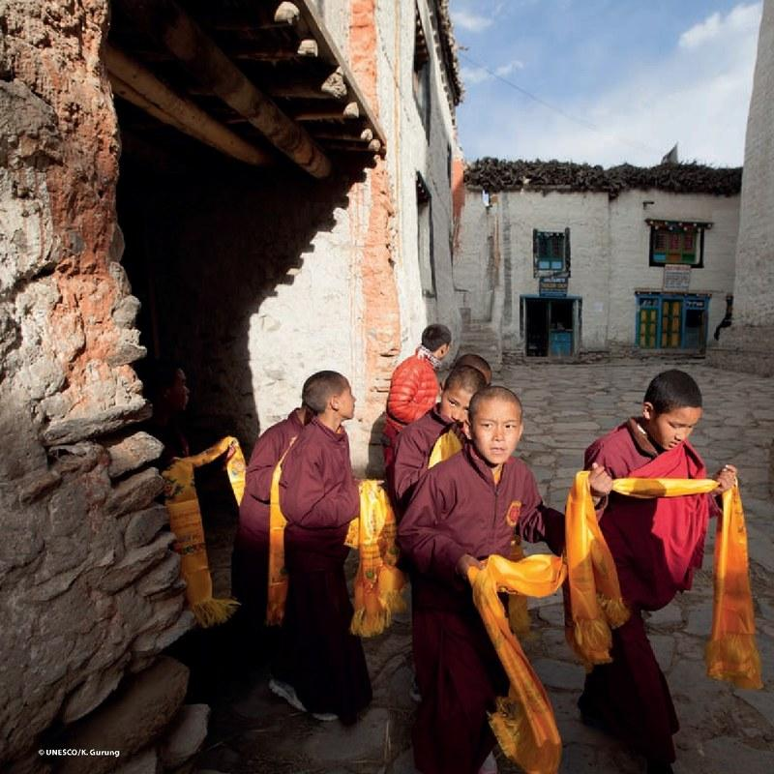  Young monks in Lo Manthang — continuity of Buddhist tradition.  © UNESCO/K. Gurung | 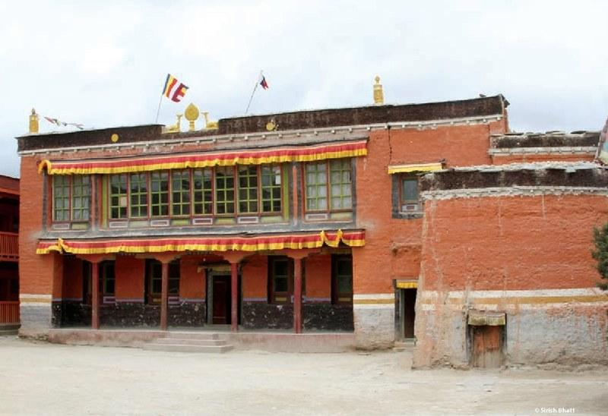  Choede Gompa (est. 1710) — the only living monastery in Lo Manthang with 100+ monks. © Sirish Bhatt

Sources
UNESCO / Department of Archaeology, Nepal (2020): Lo Manthang — A Diverse and Exuberant Cultural Heritage. KAT/2020/PI/H1 • Lomanthang Rural Municipality Profile (2021) • Khattri et al. (2021) — Climate trends, Trans-Himalayan zone • McDermott et al. (2011) — Arsenic in Lo Manthang water supply • Nepal Census 2001, 2011, 2021 — Mustang District • ACAP / NTNC / DNPWC documentation • Luitel et al. (2017; 2018) — Mental health treatment gap, Nepal • Bajracharya et al. (2023) — Climate information services, Nepal • American Himalayan Foundation — Conservation reports, Jampa and Thubchen Lhakhang restoration • Photography credits: © Sirish Bhatt, © UNESCO/K. Gurung, © Aneisha Gurung, © Thomas Schrom, © Sanjeev Chhetri, © Orna Awale

