Table of Contents

1. Recap (Start - 1:10) 2

2. Creating Post Invoice Deduction (1:10 - 13:29) 2

3. Creating “Net Sales” (13:29 - 14:34) 5

4. Creating “Cost of Goods Sold (COGS)” (14:34 - 23:00) 5

5. Creation of new column “Gross Margin” (23:00 - End) 8

# **1. Recap (Start - 1:10)**

In the process of creating P&L Table, you have created Gross Price, Pre-invoice deduction amount and Net invoice sales till now using Power Query. So, from now on, you will create the remaining columns required for P & L items using DAX (Data Analysis Expressions).



# **2. Creating Post Invoice Deduction (1:10 - 13:29)**

You need the Post Invoice Deduction amount appearing in the fact_actuals_estimate table as a new column which is the next time in our P & L.  
  
post_invoice_deduction_amount table

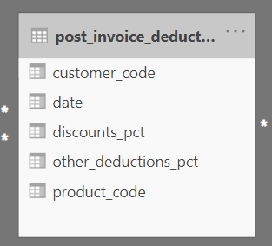

Steps for creatingpost_invoice_deduction_amount**:**

1. Firstly, you have two tables **Fact_actuals_estimate** and **post_invoice_deductions** and you are adding this “post_invoice_deduction_amount” column into the Fact_actuals_estimates.
2. As the data model and the relationships are perfectly set up, so for each customer_code and for that product_code on that particular date you need to get the discount_pct and other_deduction_pct from the post_invoice_deduction table. You need to multiply that with net_invoice_sales_amount to get post deduction amounts. It’s sort of performing a left outer join.
3. Before that, you need to understand the working of CALCULATE() function and how it achieving the desired functionality

CALCULATE(

Column_name, //desired column want to add from another table

RELATEDTABLE(table_name) //formula to fetch the desired column from related table

)

1. Now, Let’s decode the entire formula used for calculating “post_invoice_deduction_amount”

post_invoice_deduction_amount =

var res = CALCULATE(

MAX( // Aggregate function

post_invoice_deductions[discounts_pct]), // the column you need for P&L values **“discount_pct”**

RELATEDTABLE(post_invoice_deductions)) // the related table you want in which column resides

return res * fact_actuals_estimates[net_invoice_sales_amount] // getting the post invoice deduction amount by

Multiplying discount with net invoice sales.

1. You might wonder why you need to use **MAX ()** function and its very common doubt and important to know:

When you are joining 2 tables based on a condition, there is a possibility that the second table can return multiple rows.   
 **However, a DAX measure can return only one value as a final result. Hence, we use Max () or Min() to force it to return a single value.   
  
Experiment:**Try removing the MAX in the formulaand you will notice that a syntax error is thrown. This is because, a DAX measure cannot return multiple values in a single row.

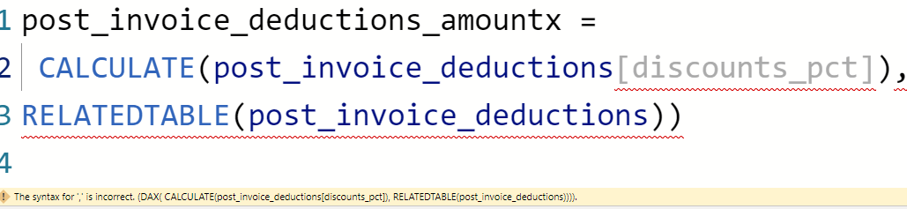  
  
So, you can understand that Min() or MAX() are also helpful in cases where there are multiple discounts and you need to select the minimum or maximum discount from the list.  
  
However, please be informed as per our data model and data set this formula will return only one row anyway.   
  
You can try filtering for a product 70008169, customer (A5119110303), Date (1st July 2020) in post_invoice_deduction table you can see that it returns only one value. Because for a same product with a same customer for a same month Atliq does not provide multiple discounts.  
  
  
  
However, DAX expects the syntax in such a way that only one value can be returned and we respect DAX. Hence you either use Min() or MAX() in this case, both will work as there is one match anyway.  
  
**Now, that you have learned this logic – it is going to be easier for you to calculate the rest of the P & L items which is built by using the same logic.**

**3. Creating “Net Sales” (13:29 - 14:34)**



We can derive the Net Sales by subtracting the Post Invoice Deduction amounts from Net Invoice sales.

net_sales_amount = //storing into variable net_sales_amount

fact_actuals_estimates[net_invoice_sales_amount] - // subtracting from net_invoice sales amount

(fact_actuals_estimates[post_invoice_deduction_amount] + //adding all the post deductions

fact_actuals_estimates[post_invoice_other_deduction_amount])

# **4. Creating “Cost of Goods Sold (COGS)” (14:34 - 23:00)**

* **1.** Manufacturing Cost

The creation of manufacturing cost follows the same strategy of what we have done in post_invoice_deduction amounts.

manufacturing_cost =

var res = //storing the result in res variable

CALCULATE(

MAX( //using the Aggregate function

Manufacturing_cost[manufacturing_cost] //using manufacturing cost column

),

RELATEDTABLE(manufacturing_cost)) // using manufacturing_cost table

return res * fact_actuals_estimates[Qty] // multiplying quantity with manufacturing cost as the cost is for only single product.

* 2. Freight Cost

Freight cost also be called as Transportation cost

freight_cost =

var res = //storing the result in res variable

CALCULATE(

MAX( //using the Aggregate function

freight_cost[freight_pct]), //using freight percentage column

RELATEDTABLE(freight_cost)) // using freight cost table

return res * fact_actuals_estimates[net_sales_amount] // multiplying freight pct with net sales

amount to get freight cost

* **3.** Other Cost

freight_other_cost = // naming the new column as freight_other_cost

var res =

CALCULATE

(

MAX( // Aggregate function

freight_cost[other_cost_pct]), //using ‘other cost pct’ column

RELATEDTABLE(freight_cost)) // using freight cost table

return res * fact_actuals_estimates[net_sales_amount] // multiplying other_cost_pct with

net sales amount to get freight cost

* 4. Total cogs amount

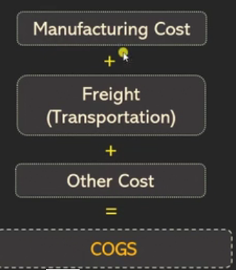

Total Cogs is the total summation of manufacturing cost, freight cost and other cost

total_cogs_amount = //adding all costs

fact_actuals_estimates[manufacturing_cost] + //manufacturing cost

fact_actuals_estimates[freight_cost] + //freight cost

fact_actuals_estimates[freight_other_cost] //freight other cost

# **5. Creation of new column “Gross Margin” (23:00 - End)**

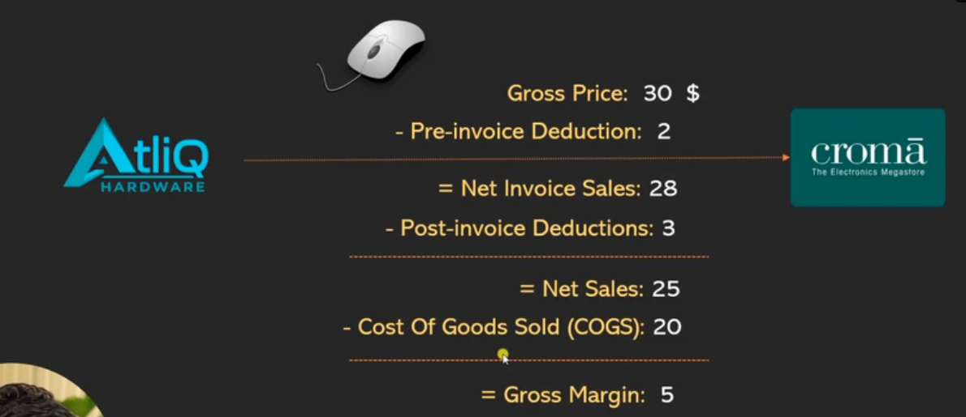

**Gross Margin is the difference between Net Sales and COGS:**

**gross_margin_amount =**

**fact_actuals_estimates[net_sales_amount] - //net sales amount**

**fact_actuals_estimates[total_cogs_amount] //total cogs amount**

**Happy Learning 😊**