**Theory:**

**Use Cases and Use-case Model:**

Use cases are text documents, not diagrams, and use cases modelling is primarily an act of writing text, not diagrams.Use cases specify desired behavior. A use case is a description of a set of sequences of actions, including variants, a system performs to yield an observable result of value to an actor. Each sequence represent an interaction of actors with the system.

Use case diagrams are a formal way of representing how a business system interacts with its environment. It illustrates the activities that are performed by the users of the systems. It defines what a system does from the standpoint of an external observer.

**Actor:**

An actor represents a set of roles that users of use case play when interacting with these use cases. Actors can be human or automated systems. Actors are entities which require help from the system to perform their task or are needed to execute the system’s functions. Actors are not part of the system.

**Relationships between usecases :**

**1. Generalization -** Use cases that are specialized versions of other use cases. The child use case inherits the behavior and meaning of the parent use case.

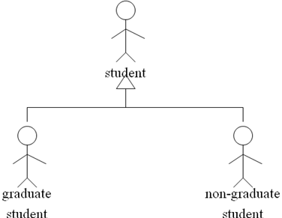

2. **Include -** Use cases that are included as parts of other use cases. They are enable to factor common behavior. The base use case explicitly incorporates the behavior of another use case at a location specified in the base. The included use case never stands alone. It only occurs as a part of some larger base that includes it.

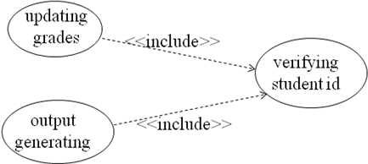

3. **Extend -** Use cases that extend the behavior of other core use cases. They are enable to factor variants. The base use case implicitly incorporates the behavior of another use case at certain points called extension points. The base use case may stand alone, but under certain conditions its behavior may be extended by the behavior of another use case.

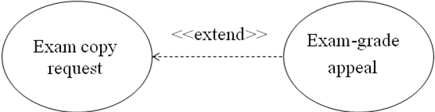

**Relationship between actors and usecases :**

Actors may be connected to use cases by associations, indicating that the actor and the use case communicate with one another using messages.

Eg:

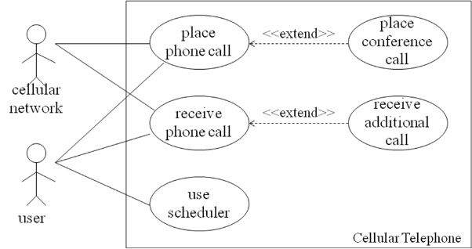

1. ATM or Automated Banking Machine (ABM) is a banking subsystem that provides bank customers with access to financial transactions in a public space without the need for a cashier, clerk or bank teller. Customer uses bank ATM to check balances of his/her bank account, deposit funds. ATM technician provides maintenance and repairs. All these use cases also involve bank actor whether it is related to customer transactions or the ATM servicing.

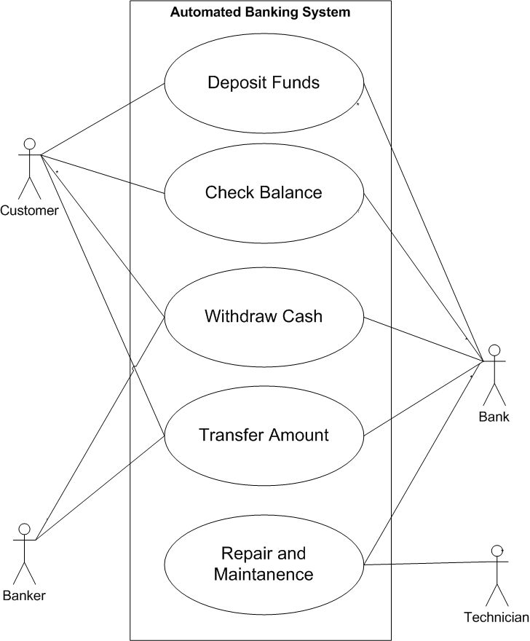

1. Hospital Management System is a large system including several subsystems is a large system including several subsystem or modules providing variety of functions.

Purpose: Describe major services (functionality) provided by a hospitals reception.

Hospital Reception subsystem or module supports some of the many jobs/ duties of hospital receptionist. Receptionist schedules patient’s appointments and admission to the hospital collects information from patient upon patient arrival and or by phone. For the patient they will stay in the hospital (“in-patient”) he/she should have a bed allotted in the ward. Receptionist might also receive patient’s payments, record them in a database and provide receipts file insurance claims and medical reports.

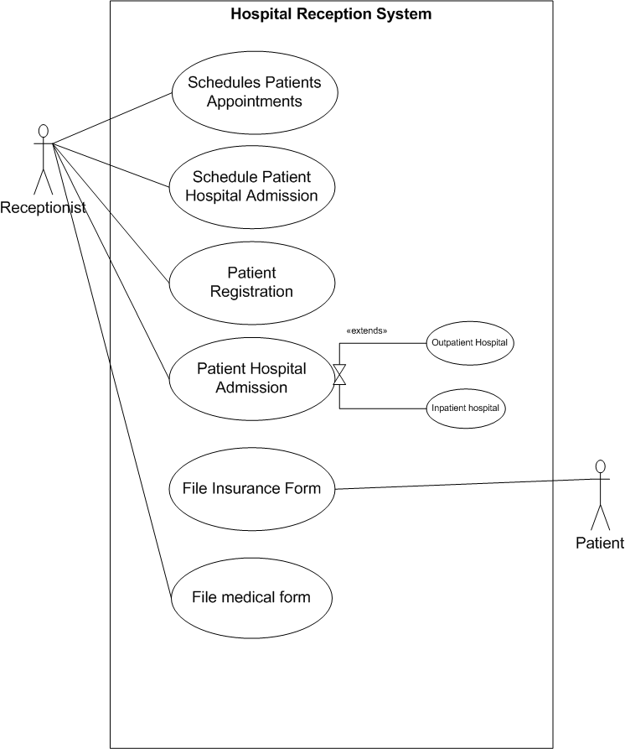

1. Restaurant Management System

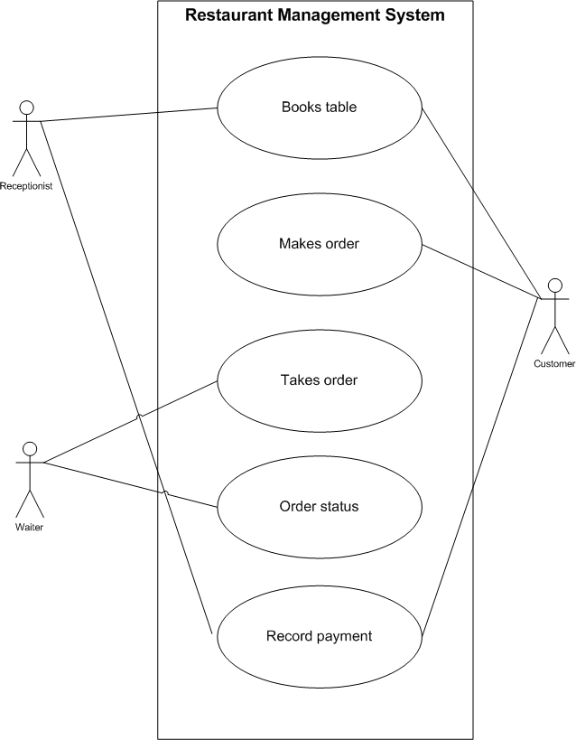

1. Draw use case diagram for your minor project