WHITE SWAN (6119)
SIZE: 2X, 3X, 4X, 5X is not listed in our databases , so size 2XL,3XL,3XL,5X is imported and discontinued size.
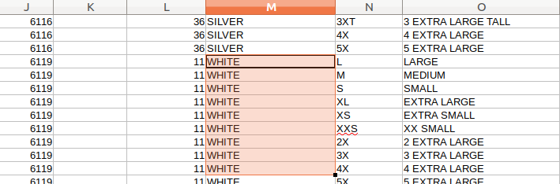

Colors to Color Code
#for example colors present in our database are in following format
color_name | color_cod | brand_id
Black | BLKV | 1
White | WHK | 2
White 504 |  | 2

2. copying color_name to color_code ,
color_name | color_code | brand_id
Black | BLK | 1
Black | BLKV | 2
White | WHK | 2
White 504 | White 504 | 2

3. renaming color_name (removing number and special characters)

color_name | color_code | brand_id
Black | BLK | 1
Black | BLKV | 2
White | WHK | 2
White | White 504 | 2

#. When importing products (if we get colors name, code combinations like this)
color_name | color_code | remarks
White | WHK | No issue in importing ,since color_code(WHK) is matched with our database
White |  | No issue(need to add this color to db as new color )
White 504 |  | No issue(need to add this color to db as new color )
White 504 | white | No issue(need to add this color to db as new color)
White/Black/Green | WBG | For three colors there is only one color code, since this type of color name format does not exist in our database ,  instead of color_code we have to consider color_name for all products with such a color format for comparing with database,  ( ignoring color_code)
White/Black/Green |  | No issue , since we can split color name and can get their id by comparing with separate color_code.

