Hands-On Lab 11
AWS Athena Analytics with S3, Glue & Crawler

Overview
This lab walks through setting up a serverless analytics pipeline on AWS:

Amazon S3 → AWS Glue Crawler → Glue Data Catalog → Amazon Athena → S3 (results)
Dataset: Amazon Sales Report — a real-world e-commerce CSV with order-level sales data.

Step 1 — Amazon S3 (Simple Storage Service)

What is Amazon S3?
Amazon S3 (Simple Storage Service) is an object storage service offered by AWS that lets you store and retrieve any amount of data from anywhere on the internet. It organizes data into buckets (like folders in the cloud), where each file is stored as an object with a unique key. S3 is highly durable (99.999999999% durability), scalable, and cost-effective. In this lab, we use S3 to store the raw CSV dataset as input and to hold Athena query output files.

S3 Bucket Setup
Only one bucket was used in this lab:
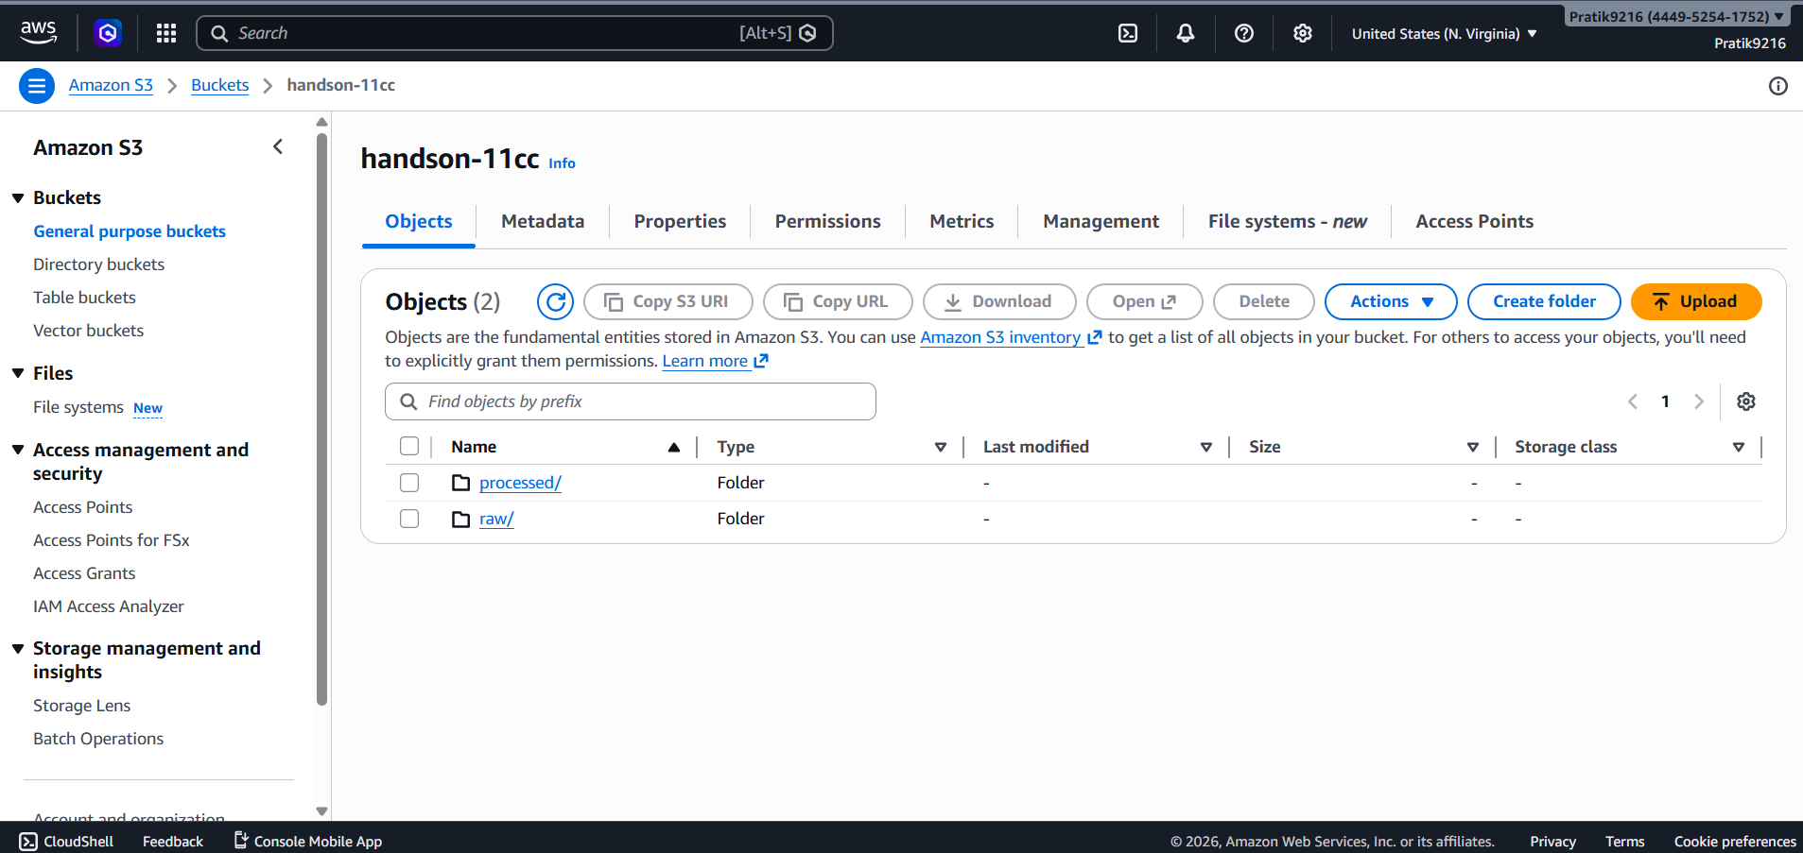
Bucket Name | Purpose
handson-11cc | Stores the raw CSV dataset (raw/ folder) and Athena-processed output (processed/ folder)

Instructions
- Open the AWS Console → S3 → Create bucket
- Name: handson-11cc | Region: us-east-1 (N. Virginia) | Block all public access: ✅ | Click Create bucket
- Open handson-11cc → Create folder → name it raw
- Upload Amazon Sale Report.csv into the raw/ folder (65.7 MB, uploaded April 7, 2026)
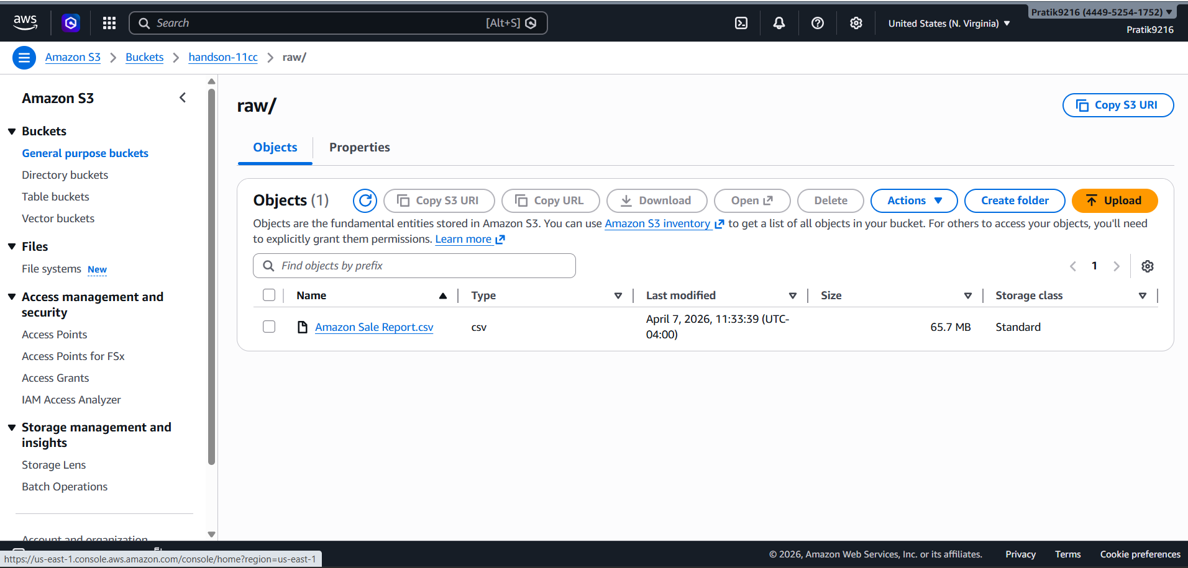

Below is the processed data in S3 bucket and this bucket also contains a processed/ folder (auto-created by Athena when saving query results.
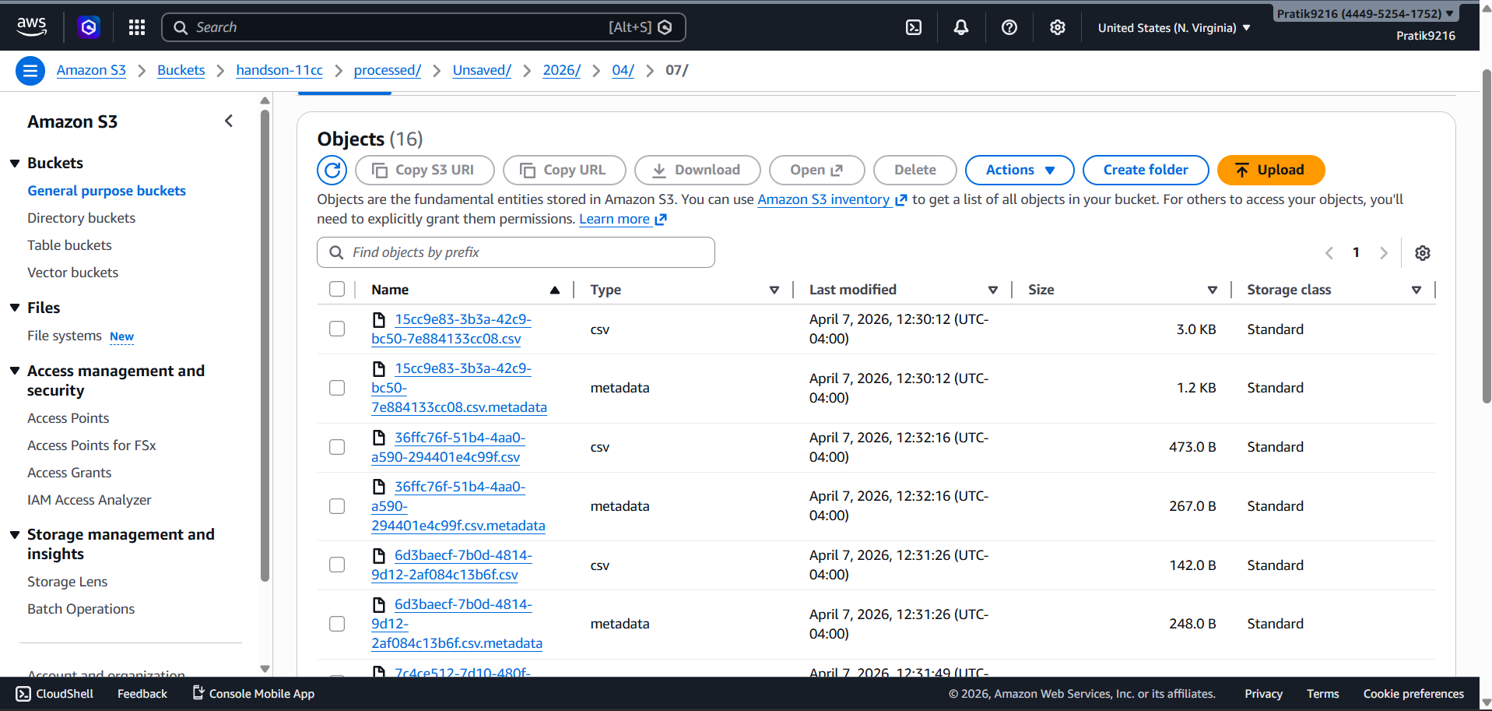

Step 2 — IAM Role (Identity and Access Management)

What is an IAM Role?
AWS IAM (Identity and Access Management) is the service that controls who or what can access AWS resources. An IAM Role is a set of permissions that can be assigned to AWS services so they can act on your behalf. In this lab, we create a Role so that AWS Glue can read data from S3 and register it in the Glue Catalog.

IAM Role Created

Property | Value
Role Name | chicken_roll
Trusted Entity | AWS Service — Glue
Creation Date | April 07, 2026, 11:40 (UTC-04:00)
Max Session Duration | 1 hour
ARN | arn:aws:iam::444952541752:role/chicken_roll

Attached Policies (3)

Policy Name | Type
AmazonS3FullAccess | AWS managed
AWSGlueConsoleFullAccess | AWS managed
AWSGlueServiceRole | AWS managed

How to Create the IAM Role
- Open AWS Console → IAM → Roles → Create role
- Trusted entity: AWS service → Glue
- Attach policies: AmazonS3FullAccess, AWSGlueConsoleFullAccess, AWSGlueServiceRole
- Role name: chicken_roll
- Click Create role
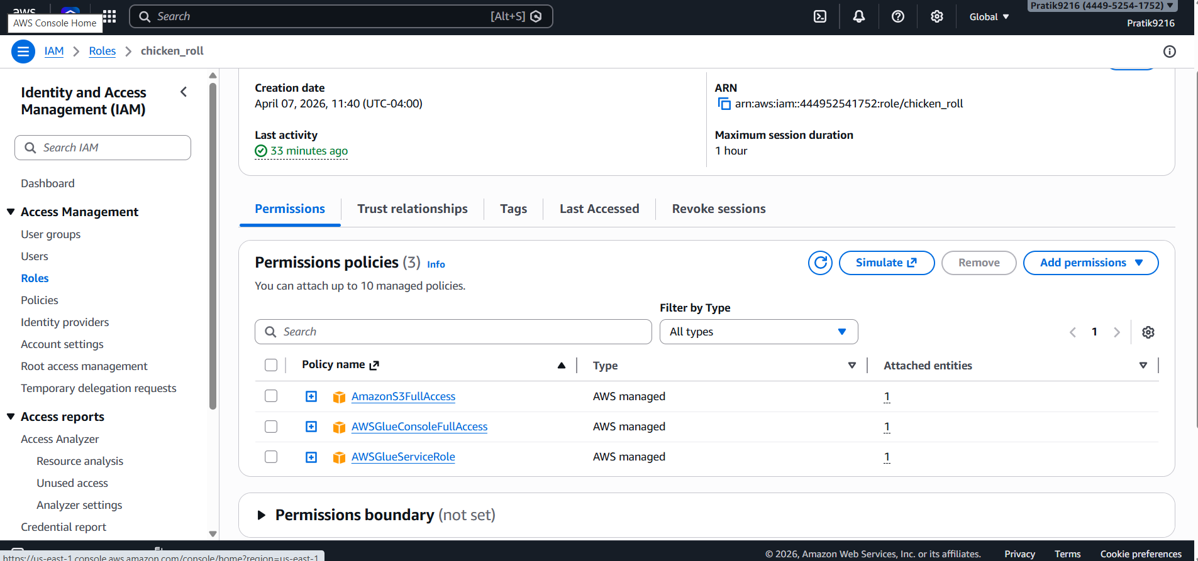

Step 3 — Create a Glue Database
- Open AWS Console → AWS Glue → Databases → Add database
- Database name: output_db
- Click Create

Step 4 — AWS Glue Crawler

What is a Glue Crawler?
AWS Glue is a fully managed ETL (Extract, Transform, Load) service. A Glue Crawler is a tool within Glue that automatically scans a data source (like an S3 bucket), detects the file format and column structure, and registers the schema as a table in the Glue Data Catalog. This catalog acts as a central metadata repository, making your data immediately queryable by services like Amazon Athena without writing any schema manually. The Crawler can be run on demand or on a schedule.

Crawler Configuration

Property | Value
Crawler Name | handsoncrawler
Data Source | S3 — s3://handson-11cc/raw/
IAM Role | chicken_roll
Target Database | output_db
Schedule | On demand
State | READY

How to Create and Run the Crawler
- Open AWS Glue → Crawlers → Create crawler
- Crawler name: handsoncrawler
- Data source: S3 | Path: s3://handson-11cc/raw/
- IAM role: chicken_roll
- Target database: output_db
- Schedule: On demand → Click Create crawler
- Select the crawler → click Run
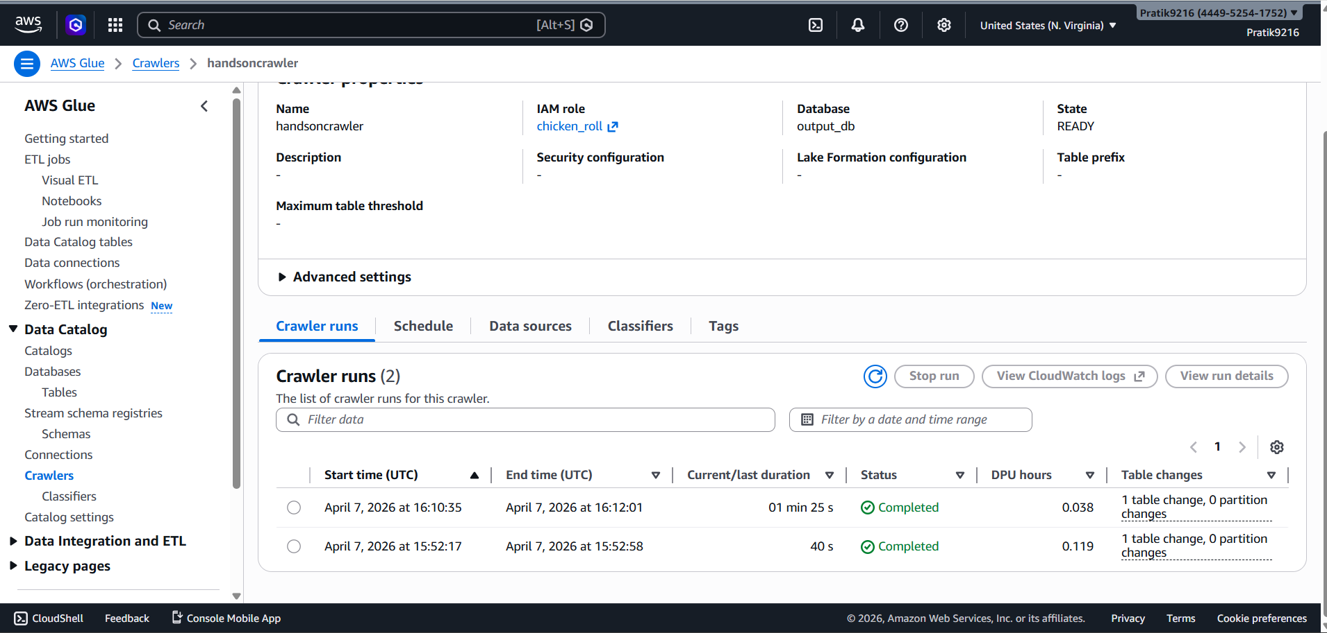

Crawler Run History

Run # | Start Time (UTC) | End Time (UTC) | Duration | Status | Table Changes
1 | April 7, 2026, 15:52:17 | April 7, 2026, 15:52:58 | ~40 sec | ✅ Completed | 1 table change, 0 partition changes
2 | April 7, 2026, 16:10:35 | April 7, 2026, 16:12:01 | ~1 min 25 sec | ✅ Completed | 1 table change, 0 partition changes

After the crawl completes, navigate to Glue → Tables. You will see the table amazon_sale_report_csv created under the output_db database.

CloudWatch Logs Confirmation
The CloudWatch log group /aws-glue/crawlers confirms the following key events for handsoncrawler:
- Running Start Crawl for Crawler handsoncrawler
- Classification complete, writing results to database output_db
- Crawler configured with CreatePartitionIndex:true
- Created table amazon_sale_report_csv in database output_db
- Finished writing to Catalog
- Crawler has finished running and is in state READY
- Run Summary: ADD: 1
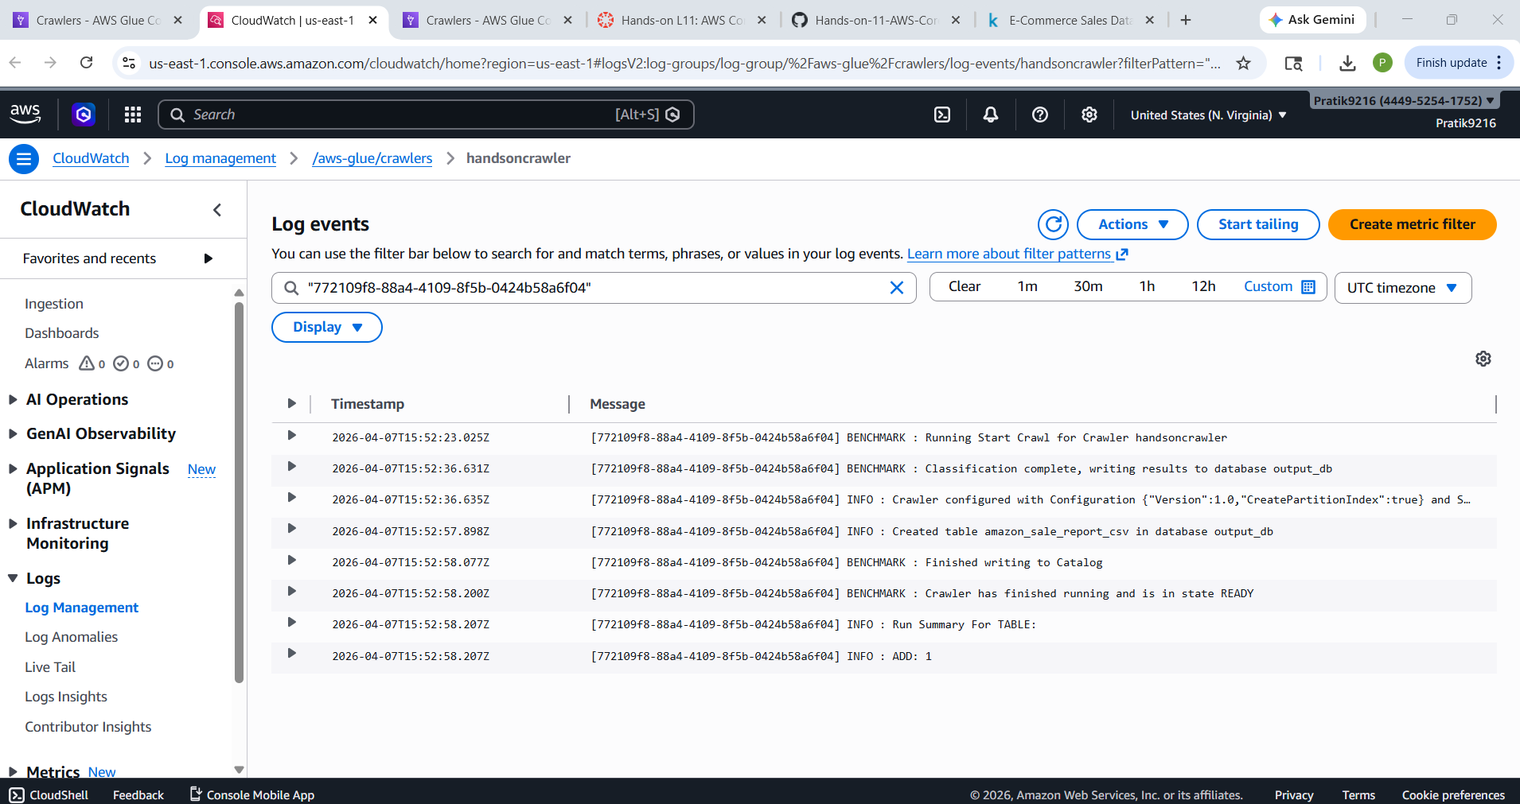

Step 5 — Configure Amazon Athena
- Open AWS Console → Amazon Athena → Query editor
- First-time setup: click Query settings → Manage → set Query result location to s3://handson-11cc/processed/ → Save
- In the Query editor, set: Data source: AwsDataCatalog | Database: output_db

Tables Visible in Left Panel

Table Name | Database | Notes
amazon_sale_report_csv | output_db | Created by Glue Crawler — full dataset
raw | output_db | Also visible as a queryable table

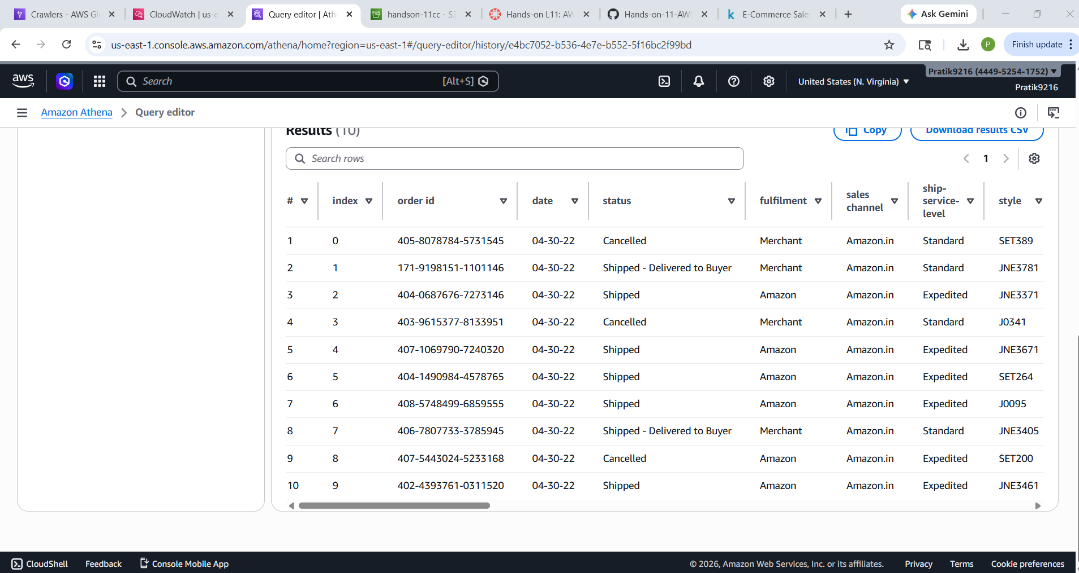

Step 6 — Run the SQL Queries
All queries are run in the Athena Query Editor. Data source: AwsDataCatalog | Database: output_db | Table: raw.
Copy each query into the Athena Query Editor and click Run. Download results as CSV from the Results panel.

Query 1 — Basic Table Exploration
Retrieves the first 10 records to verify the table is set up correctly.

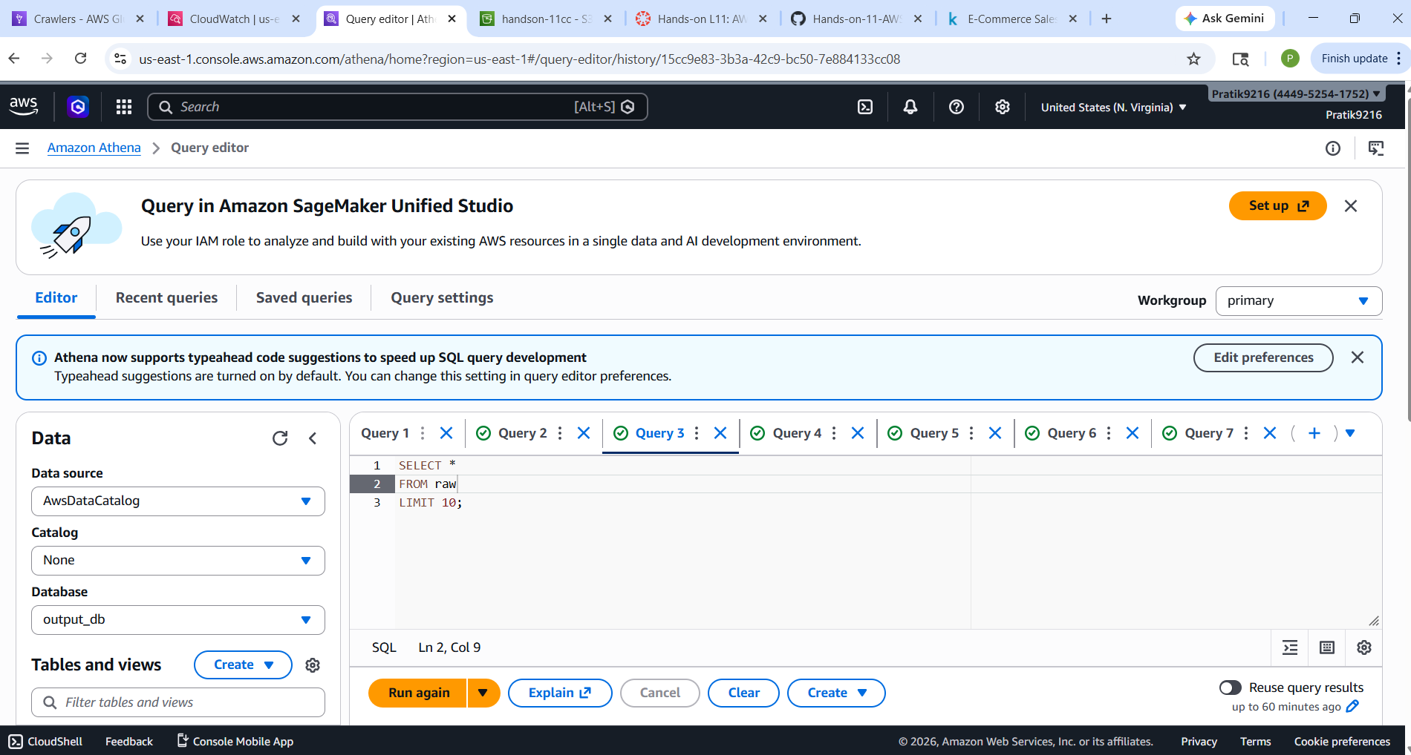
Output:
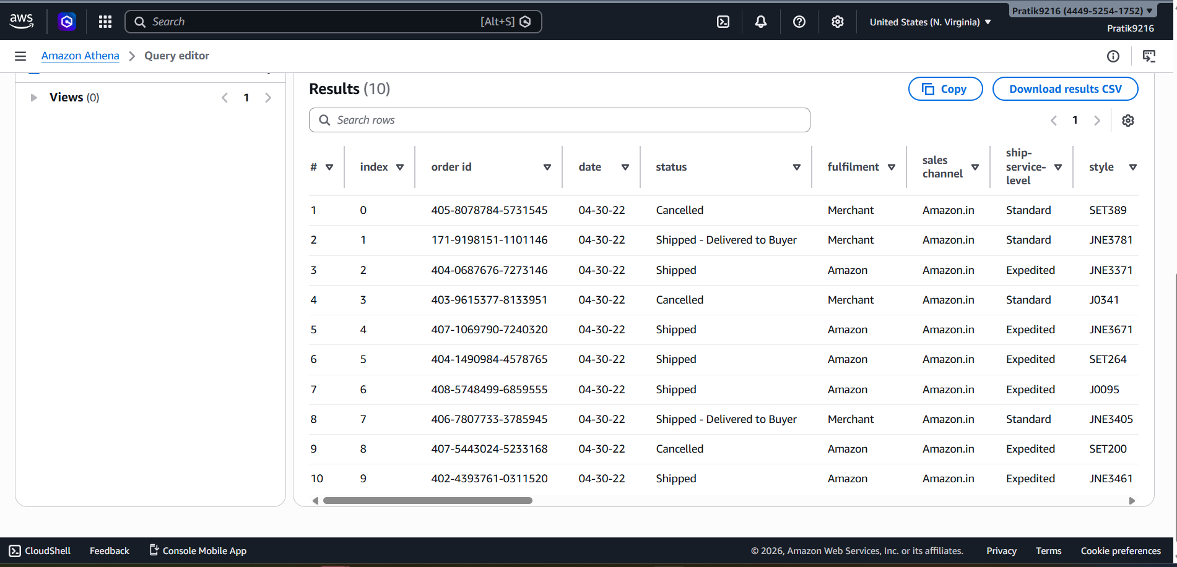

Query 2 — Orders by Product Category
Returns the count of orders in each product category, sorted by most popular.
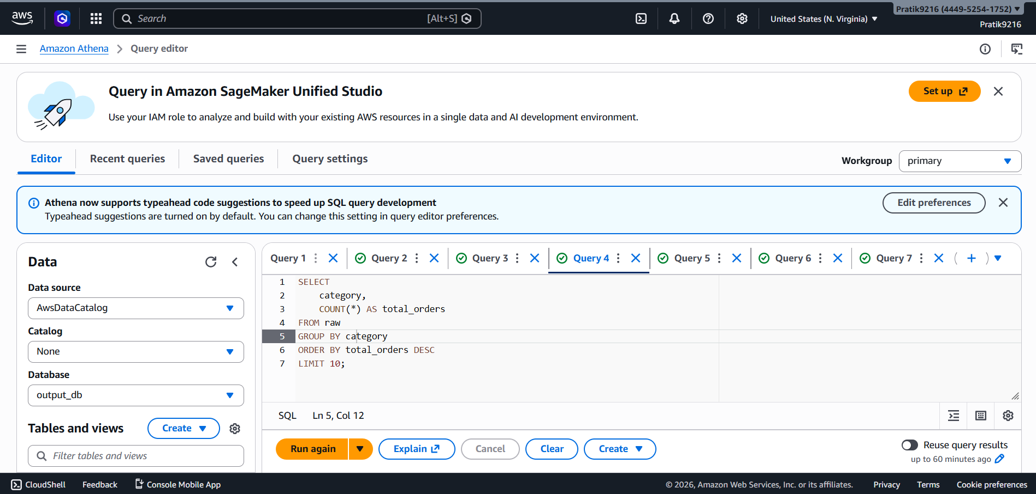
Output:
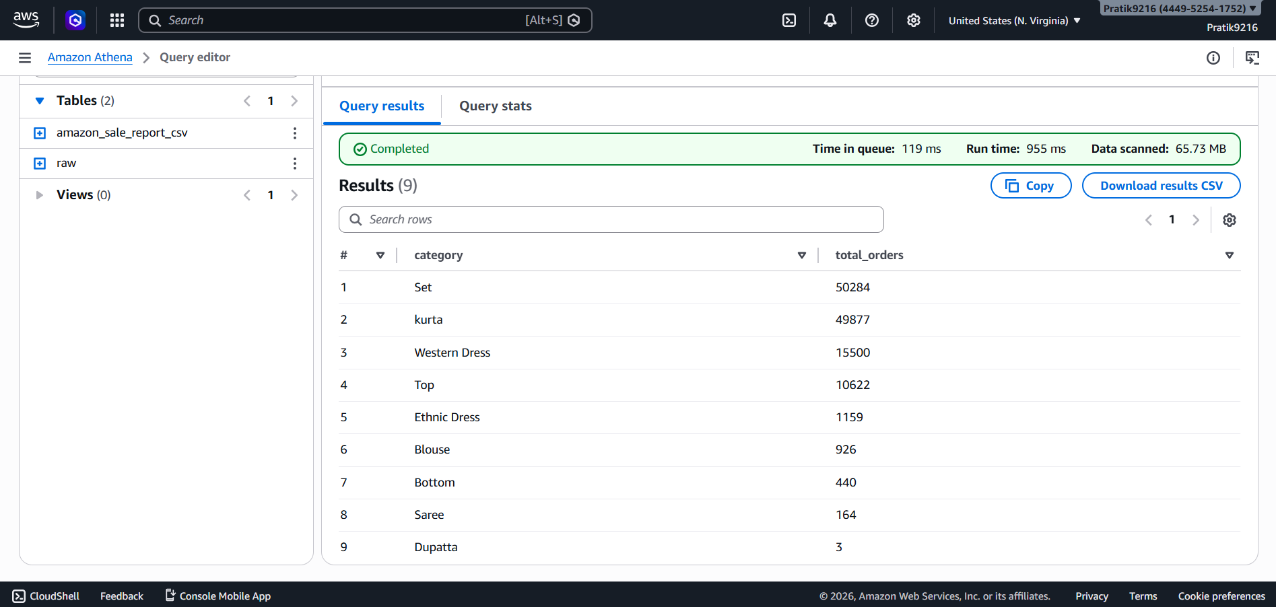

Query 3 — Revenue and Quantity by Fulfilment Method
Compares fulfilment methods (Amazon vs Merchant) by order volume, units sold, and revenue — excluding cancelled and pending orders.

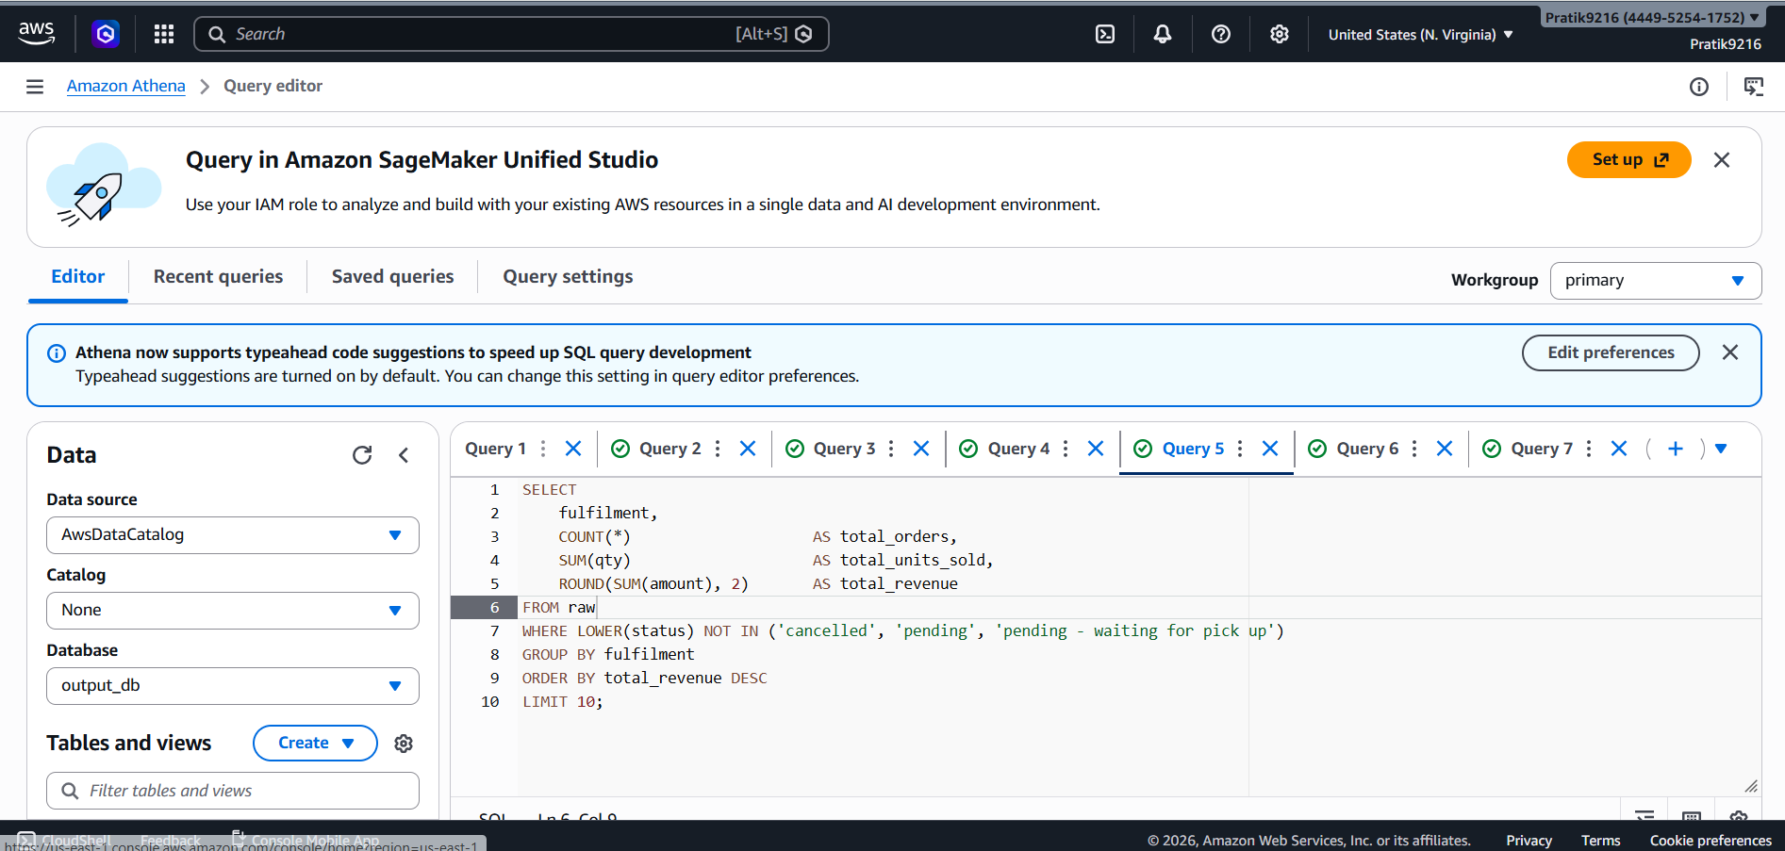
Output:
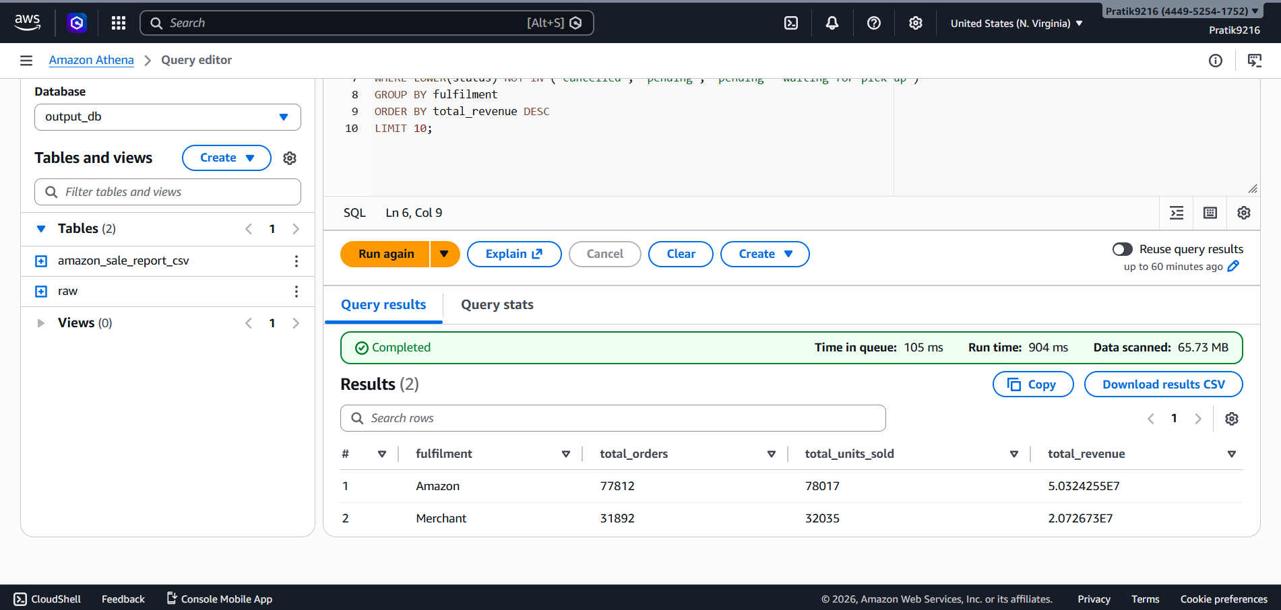

Query 4 — Monthly Sales Trend
Shows how orders and revenue changed month-over-month, sorted chronologically. Uses DATE_PARSE to parse the MM-DD-YY string date column.
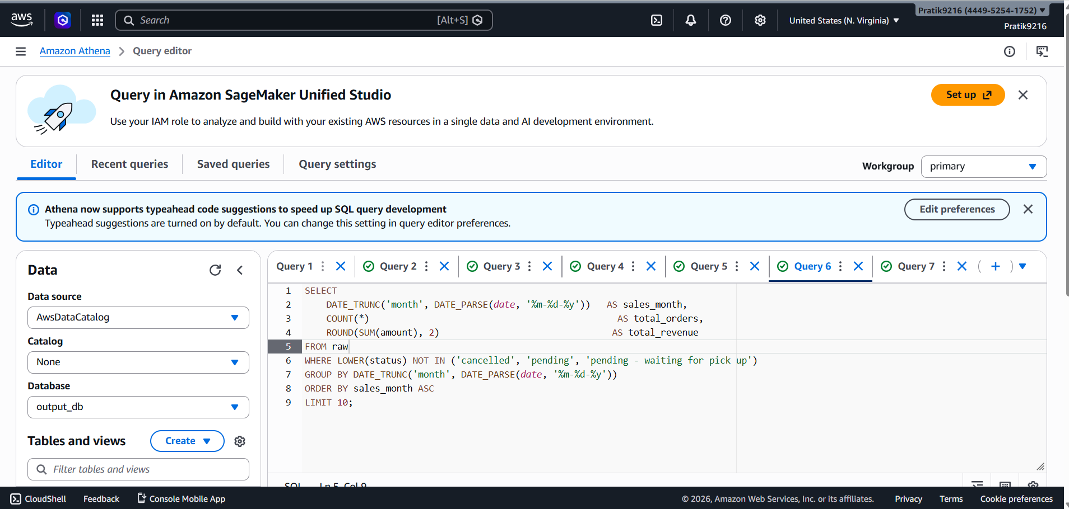
Output:
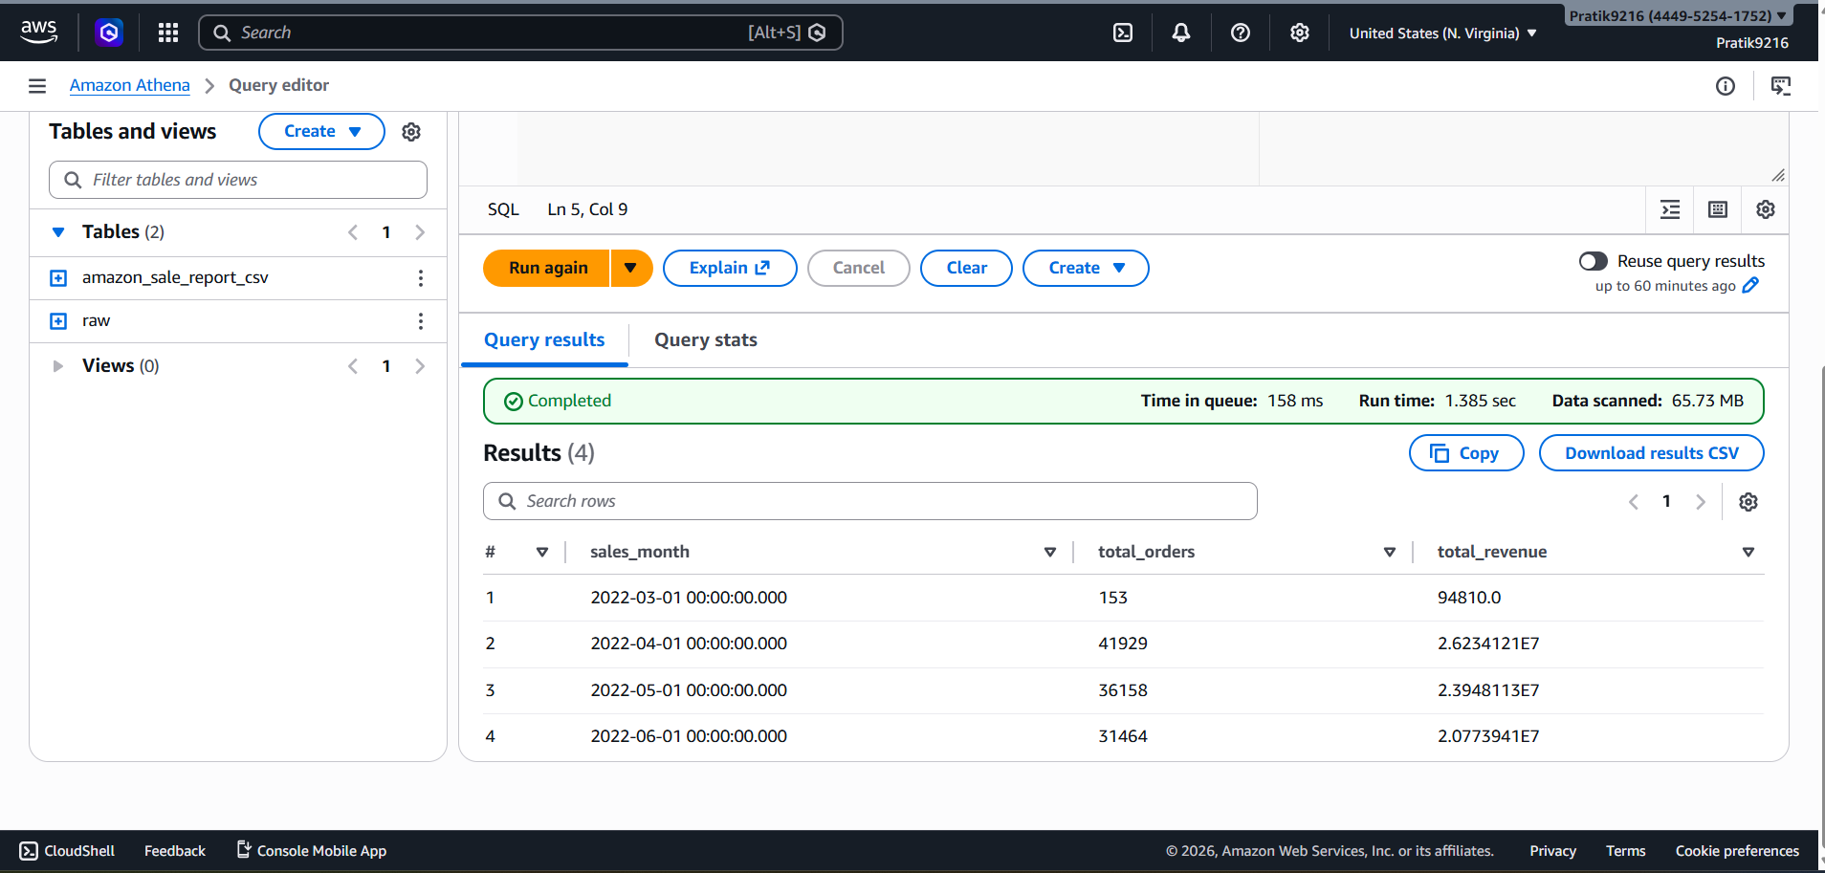

Query 5 — Top 5 Best-Selling SKUs per Category
Uses a CTE + ROW_NUMBER() window function to rank SKUs within each category by total revenue, returning only the top 5 per category.
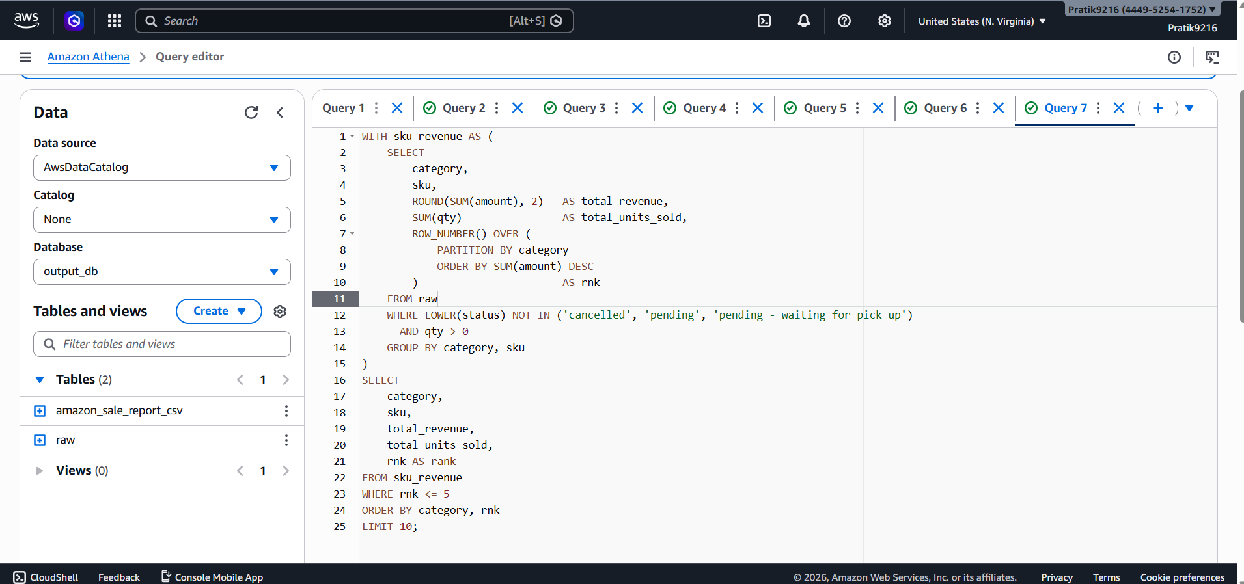

Output :
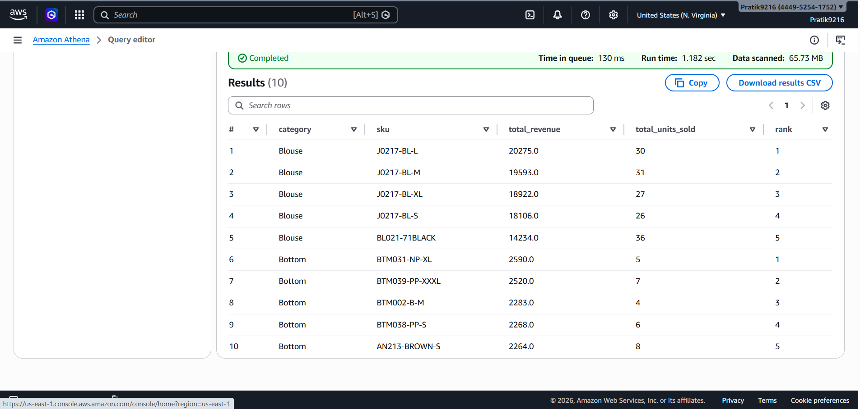

Repository Structure
Hands-on-11-AWS-Core-Services/
├── queries/
│ └── athena_queries.sql # All 5 Athena SQL queries
├── results/
│ ├── query1_basic_exploration.csv
│ ├── query2_orders_by_category.csv
│ ├── query3_revenue_by_fulfilment.csv
│ ├── query4_monthly_sales_trend.csv
│ └── query5_top5_skus_per_category.csv
├── screenshots/
│ ├── s3_buckets.png # handson-11cc bucket
│ ├── iam_role.png # chicken_roll role & policies
│ └── cloudwatch.png # handsoncrawler CloudWatch logs
└── README.md

Key Takeaways
- Glue Crawler eliminates manual schema definition — it auto-detects column names and types from the raw CSV and registers them in the Glue Data Catalog.
- Athena is serverless — no clusters to manage; you pay only per query (per TB scanned). All 5 queries in this lab scanned 65.73 MB each.
- Date parsing in Athena uses Presto's DATE_PARSE with explicit format strings (%m-%d-%y for MM-DD-YY dates).
- Window functions (ROW_NUMBER OVER PARTITION BY) allow per-group rankings without subquery hacks.
- Always filter cancelled/pending orders before computing business revenue metrics to avoid inflated numbers.
- A single S3 bucket (handson-11cc) can serve dual purpose — storing raw input in raw/ and Athena query output in processed/.

Summary of Corrections from Original README

Section | Original README | Actual (per screenshots)
S3 Bucket (raw) | itcs6190-l11-raw-data | handson-11cc
S3 Bucket (results) | itcs6190-l11-athena-results (separate) | handson-11cc/processed/ (same bucket)
IAM Role Name | AthenaGlueLabRole | chicken_roll
IAM Policy 3 | AmazonAthenaFullAccess | AWSGlueConsoleFullAccess
Glue Database | sales_db | output_db
Crawler Name | amazon-sales-crawler | handsoncrawler
Glue Table Name | amazon_sales | amazon_sale_report_csv (also: raw)
Athena Database | output_db | output_db ✅
Athena Table (queries) | amazon_sales | raw
Query 2 Result Rows | 10 (LIMIT 10) | 9 (only 9 categories exist)
Query 3 Fulfilment Values | Easy Ship vs Merchant | Amazon vs Merchant
Query 4 Result Rows | 10 (LIMIT 10) | 4 (only 4 months of data)

