A

PROJECT REPORT

ENTITLED

PlaceTrade

Submitted to

Dr. Babasaheb Ambedkar Marathwada University,

Chhatrapati Sambhajinagar

Developed By

Pratik Pramod Joshi

Under the Guidance of

Pro. Ekhande S.

In partial fulfillment of the degree of

M.Sc. (Computer Science)



THROUGH

Advanced Computer College, Dharashiv

Dr. Babasaheb Ambedkar Marathwada University,

Chhatrapati Sambhajinagar

2023-2024

**DECLARATION**

We, Students of M.Sc. (Computer Science) (4th SEM) of Advanced Computer College, Dharashiv hereby declare that the project entitle **“PlaceTrade (algo Trading Project using python)”** is the result of my own effort and is raised on information collected with my guide.

The project report is correct to the best of my knowledge & this report so far has not been published anywhere else.

**Place**

**Date / / Signature of Student & Name**

1. **Pratik Pramod Joshi _________________________**

**CERTIFICATE**

This is to certify that Pratik Pramod Joshi has successfully completed the project, as per the course of Master of Computer Science, Advanced Computer College, Dharashiv.

He has submitted the project report in partial fulfillment of course of M.Sc. (Computer Science) for the academic year 2023-2024.

DATE:-

**SUBMITED BY GUIDED BY**

**ACKNOWLEDGEMENT**

We indebted to many people for the completion of the present study and now We would like to take this opportunity and go on record to thank them for their help and support. This task would have been impossible without their support. Especially We would like to thank Advanced Computer College for giving me this great opportunity to increase my knowledge. Although We can’t mention the entire name that has helped me, We especially thank the following people; firstly We would like to thank my Faculty Guide Prof. Ekhande Sir for his support and information during my training without their support, it would not have been able to do justice to the project. We wish to express my gratitude to my friends and teachers for their helpful inputs, insightful comments, and steadfast support. Last but not the least We would like to give my great thanks to some employees in Elovision Technology Pvt. Ltd. Who always supported me for my project and gave me plentiful knowledge.

**Name Sign**

❖ Mr. Joshi Pratik Pramod

**INDEX**

|  |  |  |
| --- | --- | --- |
| Sr. No. | Title | Page No. |
| **1.** | **INTRODUCTION** | 6 |
| 1.1 | Company Profile | 6 |
| 1.2 | Existing System and need for existing System | 6 |
| 1.3 | Scope of the work | 8 |
| 1.4 | Operating Environment-H/W, S/W | 10 |
| 1.5 | Description of Technologies Used in Algorithmic Trading System | 11 |
| **2.** | **Chapter 2: PROPOSED SYSTEM** | 13 |
| 2.1 | Proposed System Overview | 13 |
| 2.2 | Objective of system | 14 |
| 2.3 | User Requirement | 15 |
| 2.4 | Fact Finding Techniques | 16 |
| 2.5 | Feasibility Study | 18 |
| **3.** | **Chapter 3: ANALYSIS AND DESIGN** | 20 |
| 3.1 | Module Hierarchy diagram | 20 |
| 3.2 | Use Case Diagram | 20 |
| 3.3 | Sequence Diagram | 21 |
| 3.4 | Class Diagram | 22 |
| 3.5 | Collaboration | 23 |
| 3.7 | Component Diagram | 24 |
| 3.8 | Table Design | 25 |
| 3.10 | Test procedure and implementation | 26 |
| **4.** | **Chapter 4: User Manual** | 29 |
| 4.2 | Operation Manual | 32 |
| **5.** | **Limitations of the project** | 36 |
| **6.** | **Future enhancements of the Project** | 37 |
| **7.** | **Conclusion** | 39 |
| **8.** | **Bibliography** | 40 |
| **9.** | **Annexure** | 42 |
|  | Annexure 1: Details of technology used in Project | 42 |
|  | Annexure 2: CLI with data | 44 |

**1:Introduction**

**1.1 Company Profile :**

**Introduction**:

TradZoo is a premier destination for individuals looking to embark on a journey into the world of trading. Established with a mission to educate, empower, and guide aspiring traders, TradZoo provides a comprehensive platform designed to enhance understanding, refine skills, and maximize returns in the dynamic realm of the stock market.

**Vision**:

At TradZoo, we envision a future where every individual is equipped with the knowledge, skills, and resources to navigate the complexities of the stock market with confidence and precision. Our vision is to foster a community of informed and disciplined traders who achieve financial success through strategic decision-making and prudent risk management.

**Mission**:

Our mission at TradZoo is clear and resolute: to educate, empower, and inspire individuals to become proficient traders. Through our expert guidance, comprehensive resources, and practical strategies, we aim to instill in our students the passion, patience, and discipline required to excel in the ever-evolving landscape of trading.

**Domain**: StockMarket,

**CEO:** Mr. Ganesh Shahuraj Garad

**Internship Completion Letter**



**1.2 Existing System:**

In the existing system of algorithmic trading, trades are executed automatically based on predefined sets of rules and criteria, primarily revolving around technical indicators. These technical indicators are mathematical calculations derived from historical price and volume data, aimed at identifying potential buy or sell signals in the market.

**Key Components of the Existing System:**

1. Technical Indicators: The existing system relies on a variety of technical indicators, such as moving averages, relative strength index (RSI), stochastic oscillator, and others, to analyze market data and generate trading signals. These indicators serve as quantitative measures of market trends, momentum, volatility, and other key factors influencing price movements.

2. Algorithmic Strategies: Algorithmic trading strategies are developed and implemented to interpret the signals generated by technical indicators and execute trades accordingly. These strategies often incorporate rules for entry and exit points, position sizing, risk management, and other parameters to optimize trading performance and profitability.

3. Automated Execution: Once trading signals are generated by the algorithmic strategies, trades are executed automatically without human intervention. This automated execution ensures timely and efficient implementation of trading decisions, eliminating emotional biases and reducing the potential for human error.

4. Fixed Profit Exit Strategy: As part of the existing system, trades are typically exited based on a fixed profit target. This means that once a trade reaches a predefined profit level, the position is automatically closed to lock in gains. This fixed profit exit strategy helps traders capitalize on favorable market movements while minimizing the risk of giving back profits during subsequent price reversals.

**Need for Existing System:**

The implementation of algorithmic trading with a focus on technical indicators and fixed profit exit strategies addresses several key needs and objectives in the financial markets:

1. Efficiency: Algorithmic trading streamlines the trading process by automating trade execution based on predefined rules and criteria. This enhances efficiency by reducing manual intervention and eliminating the need for continuous monitoring of market conditions.

2. Precision: Technical indicators provide quantitative insights into market trends and dynamics, allowing traders to make informed decisions with a high degree of precision. By leveraging these indicators, algorithmic trading systems can identify optimal entry and exit points with greater accuracy, enhancing trading outcomes.

3. Risk Management: The use of algorithmic strategies with fixed profit exit targets helps mitigate risk by enforcing disciplined profit-taking practices. By setting predefined profit targets, traders can limit potential losses and ensure that profits are secured before market conditions potentially change.

4. Scalability: Algorithmic trading systems are highly scalable, capable of processing large volumes of data and executing trades across multiple markets and asset classes simultaneously. This scalability enables traders to capitalize on a wide range of trading opportunities while maintaining consistency and efficiency in their operations.

5. Competitive Advantage: By embracing algorithmic trading techniques, traders gain a competitive advantage in the financial markets. The ability to leverage advanced technology, sophisticated algorithms, and data-driven strategies allows traders to stay ahead of the curve and capitalize on market inefficiencies more effectively.

Overall, the existing system of algorithmic trading with a focus on technical indicators and fixed profit exit strategies addresses the growing demand for automated, data-driven trading solutions that enhance efficiency, precision, and profitability in the dynamic world of finance.

**1.3 Scope of Work**

1. Introduction:

The scope of this project encompasses the development and implementation of an algorithmic trading system designed to execute trades based on technical indicators and predefined profit targets. The system aims to automate the trading process, enhance efficiency, and optimize profitability in the financial markets.

2. Objectives:

- Develop algorithmic trading strategies utilizing a variety of technical indicators, including but not limited to moving averages, relative strength index (RSI), stochastic oscillator, and others.

- Implement automated trade execution functionality to execute buy and sell orders based on signals generated by the algorithmic strategies.

- Incorporate a fixed profit exit strategy to close trades automatically once a predefined profit target is reached, thereby securing gains and mitigating risk.

- Integrate risk management protocols to enforce disciplined position sizing, stop-loss orders, and portfolio diversification strategies to minimize potential losses and preserve capital.

- Provide real-time monitoring and performance analysis tools to evaluate the effectiveness of the algorithmic trading strategies and optimize trading outcomes.

3. Key Deliverables:

- Algorithmic trading strategies: Develop and document a set of algorithmic trading strategies incorporating technical indicators and predefined profit targets.

- Automated trade execution system: Design and implement a software solution capable of executing trades automatically based on signals generated by the algorithmic strategies.

- Fixed profit exit functionality: Integrate a mechanism to close trades automatically once a predetermined profit target is achieved, ensuring timely profit-taking and risk management.

- Risk management protocols: Implement risk management features such as position sizing, stop-loss orders, and portfolio diversification to mitigate potential losses and preserve trading capital.

- Real-time monitoring and analysis tools: Develop tools to monitor the performance of the algorithmic trading system in real-time, analyze trading outcomes, and identify areas for optimization.

4. Methodology:

- Research: Conduct extensive research on algorithmic trading techniques, technical indicators, and risk management strategies to inform the development process.

- Design: Develop a comprehensive design specification outlining the architecture, components, and functionality of the algorithmic trading system.

- Implementation: Build and deploy the algorithmic trading system according to the design specifications, incorporating automated trade execution, fixed profit exit, and risk management features.

- Testing: Conduct rigorous testing and validation of the system to ensure accuracy, reliability, and compliance with predefined requirements.

- Deployment: Deploy the algorithmic trading system in a live trading environment, monitoring its performance and making adjustments as necessary based on real-world feedback.

5. Timeline:

- Phase 1: Research and Design (4 weeks)

- Phase 2: Implementation and Testing (8 weeks)

- Phase 3: Deployment and Optimization (4 weeks)

6. Team Roles:

- Software Developers: Tasked with implementing the algorithmic trading system according to the design specifications.

- Quantitative Analysts: Provide expertise in algorithmic trading strategies, technical analysis, and risk management.

7. Budget:

- Allocate resources for software development, research, testing, and deployment activities.

- Consider costs associated with data acquisition, software licenses, hardware infrastructure, and ongoing maintenance and support.

8. Risks and Mitigation:

- Market Risks: Monitor market conditions and adapt trading strategies to changing trends and volatility.

- Technology Risks: Implement robust error handling and fail-safe mechanisms to mitigate risks associated with software bugs or system failures.

- Regulatory Risks: Ensure compliance with relevant regulations and guidelines governing algorithmic trading activities.

**1.4 Operating Environment: Hardware and Software Requirements**

**Hardware Requirements:**

1. Computing Infrastructure:

- High-performance servers or cloud computing resources capable of handling large volumes of data processing and trade execution in real-time.

- Multi-core processors with sufficient processing power to support algorithmic calculations and data analysis.

- Ample RAM (Random Access Memory) to accommodate simultaneous data storage, processing, and analysis tasks.

- Reliable network connectivity to ensure seamless communication between trading systems, data feeds, and execution platforms.

2. Data Storage:

- Robust storage solutions such as solid-state drives (SSDs) or network-attached storage (NAS) devices to store historical market data, trading algorithms, and system logs.

- Scalable storage capacity to accommodate growing data volumes and maintain historical records for backtesting and analysis purposes.

Software Requirements:

1. Operating System:

- Linux-based distributions such as Ubuntu Server or CentOS preferred for their stability, security, and compatibility with trading software and development tools.

- Windows Server operating systems may also be used, particularly for environments requiring integration with Microsoft technologies or proprietary software.

2. Algorithmic Trading Software:

- Programming languages and libraries for algorithm development and quantitative analysis, such as Python with libraries like NumPy, pandas, yfinance ,and pandas_ta.

- Integration with third-party trading APIs (Application Programming Interfaces) for accessing market data feeds, executing trades, and managing brokerage accounts. IIFL APIS

3. Data Management and Analysis Tools:

- Database management systems (DBMS) for storing and querying historical market data, including relational databases like MySQL or PostgreSQL, and NoSQL databases like MongoDB.

**1.5 Description of Technologies Used in Algorithmic Trading System**

1. Python Core :- Development

2. yfinance Library: Data Collection

3. pandas_ta (Technical Analysis) Library: Data Processing

4. IIFL API: Trade Execution

5. AngelOne API (Scripts List): For Getting Scriptlist

6. Integrated Development Environment (IDE): VS code

7. Version Control System (VCS): github for backup of code

**Chapter 2: Proposed System**

**2.1 Proposed System Overview:**

The proposed system builds upon the foundation of the existing algorithmic trading infrastructure, enhancing its capabilities with advanced features and technologies to improve performance, efficiency, and user experience. The proposed system aims to address existing limitations, capitalize on emerging opportunities, and adapt to evolving market dynamics in the financial trading landscape.

**Key Components of the Proposed System:**

1. Enhanced Algorithmic Strategies:

- Develop and refine algorithmic trading strategies leveraging advanced machine learning techniques, sentiment analysis, and alternative data sources to enhance predictive capabilities and adaptability to changing market conditions.

- Integrate deep learning models for pattern recognition, anomaly detection, and market sentiment analysis to identify unique trading opportunities and gain a competitive edge in the market.

2. Real-Time Market Data Integration:

- Expand data feed capabilities to include multiple sources of real-time market data, news feeds, and social media sentiment analysis platforms to provide traders with comprehensive insights into market trends, sentiment, and macroeconomic factors influencing price movements.

- Implement data preprocessing techniques and streaming data processing frameworks to handle high volumes of real-time data efficiently and extract actionable insights in near real-time.

3. Advanced Risk Management Framework:

- Enhance risk management protocols with dynamic position sizing algorithms, adaptive stop-loss mechanisms, and portfolio optimization techniques to minimize downside risk and maximize risk-adjusted returns.

- Utilize machine learning algorithms to model and forecast market volatility, correlation, and other risk factors, enabling proactive risk mitigation strategies and adaptive portfolio management.

4. Brokerage Integration and Execution Efficiency:

- Strengthen integration with brokerage platforms and execution venues to optimize trade execution speed, reliability, and cost-effectiveness.

- Implement smart order routing algorithms to dynamically select optimal execution venues based on factors such as liquidity, price, and order size, ensuring best execution practices and minimizing market impact.

5. Comprehensive Performance Analytics:

- Develop a suite of performance analytics tools and dashboards to track and evaluate the effectiveness of trading strategies, measure key performance indicators (KPIs), and conduct post-trade analysis.

- Incorporate advanced visualization techniques and interactive dashboards to provide traders with actionable insights into trading performance, strategy outcomes, and portfolio risk metrics.

**2.2 Objectives of the System:**

1. Enhanced Trading Performance:

- The primary objective of the system is to improve trading performance by implementing advanced algorithmic strategies, leveraging real-time market data, and optimizing trade execution processes. The system aims to generate consistent profits and maximize returns for traders.

2. Efficiency and Automation:

- Increase efficiency and automation in trading operations by streamlining processes, reducing manual intervention, and leveraging technology to execute trades swiftly and accurately. The system aims to minimize latency, optimize order routing, and enhance overall operational efficiency.

3. Risk Mitigation and Management:

- Implement robust risk mitigation and management measures to protect trading capital, minimize downside risk, and ensure the long-term sustainability of trading activities. The system aims to employ dynamic position sizing, adaptive stop-loss mechanisms, and portfolio diversification strategies to manage risk effectively.

4. Adaptability to Market Conditions:

- Develop algorithmic trading strategies and systems that are adaptable to changing market conditions, volatility levels, and macroeconomic factors. The system aims to employ machine learning techniques and alternative data sources to identify evolving market trends and capitalize on emerging opportunities.

5. Real-Time Insights and Decision Support:

- Provide traders with real-time insights, analytics, and decision support tools to make informed trading decisions based on comprehensive market data, technical analysis, and risk assessments. The system aims to empower traders with actionable insights and timely information to execute trades with confidence.

6. Continuous Improvement and Innovation:

- Foster a culture of continuous improvement and innovation within the system, leveraging feedback from traders, performance analytics, and market insights to refine algorithms, optimize strategies, and enhance overall system effectiveness. The system aims to adapt to evolving market dynamics and technological advancements to maintain a competitive edge.

7. Compliance and Regulatory Alignment:

- Ensure compliance with regulatory requirements, industry standards, and best practices in algorithmic trading to maintain transparency, integrity, and trustworthiness in trading activities. The system aims to adhere to relevant regulations, risk limits, and ethical guidelines to uphold ethical standards and regulatory compliance.

8. User Satisfaction and Engagement:

- Prioritize user satisfaction and engagement by delivering a user-friendly, intuitive trading platform with comprehensive features, advanced analytics, and responsive customer support. The system aims to meet the needs and expectations of traders, enhance user experience, and foster long-term relationships with clients.

**2.3 User requirement:**

1. Data Feeds and Integration:

- Access to reliable and high-quality market data feeds from various sources, including historical data and real-time data streams, to support algorithmic trading strategies.

2. Technical Analysis Libraries:

- Integration with technical analysis libraries, such as pandas_ta, for advanced analysis of market data and generation of trading signals based on predefined technical indicators.

3. Brokerage Integration:

- Integration with brokerage APIs, such as IIFL, for real-time order execution, account management, and accessing trading platforms for placing trades and managing positions.

4. Algorithmic Strategy Development:

- Tools and frameworks for developing, testing, and optimizing algorithmic trading strategies based on technical indicators, machine learning models, and risk management principles.

5. Risk Management Features:

- Implementation of risk management protocols, including position sizing algorithms, stop-loss mechanisms, and portfolio diversification strategies, to mitigate risks and preserve trading capital.

6. Execution Efficiency and Latency Optimization:

- Optimization of trade execution processes, order routing algorithms, and network infrastructure to minimize latency and ensure timely execution of trades in fast-paced market conditions.

7. Scalability and Flexibility:

- Designing a scalable and flexible architecture capable of handling increasing data volumes, trade frequencies, and user demands, while also accommodating future enhancements and changes in system requirements.

**2.4 Fact Finding Techniques**

1. Interviews with Traders and Analysts:

- Conduct structured interviews with experienced traders, financial analysts, and quantitative researchers to understand their trading strategies, risk management practices, and requirements for algorithmic trading software.

2. Observation of Trading Practices:

- Observe traders and analysts as they analyze market data, develop trading strategies, and execute trades using existing tools and systems. This helps identify workflow inefficiencies, pain points, and areas for improvement.

3. Analysis of Historical Trading Data:

- Analyze historical trading data to identify patterns, trends, and correlations that can inform the development of algorithmic trading strategies. This involves backtesting strategies on historical data to assess their performance and validity.

4. Prototyping and Simulation:

- Develop prototypes or simulation environments to test and validate algorithmic trading strategies in a controlled setting. Prototyping allows traders to experiment with different parameters and scenarios before deploying strategies in live markets.

5. Market Research and Benchmarking:

- Conduct market research and benchmarking analysis to evaluate existing algorithmic trading software solutions, identify market trends, and understand competitors' offerings. This helps identify gaps in the market and opportunities for innovation.

6. Feedback from Beta Testers:

- Engage beta testers or pilot users to provide feedback on early versions of the algorithmic trading software. Beta testing allows for iterative refinement of features, usability, and performance based on real-world usage.

7. Collaborative Workshops and Brainstorming Sessions:

- Facilitate workshops and brainstorming sessions with traders, analysts, and software developers to generate ideas, define requirements, and prioritize features for the algorithmic trading software. Collaboration fosters creativity and consensus-building.

8. Regulatory Compliance Analysis:

- Conduct a thorough analysis of regulatory requirements and compliance standards relevant to algorithmic trading software, including market access rules, trade reporting obligations, and risk management guidelines.

9. Technology Assessment and Feasibility Study:

- Assess the technical feasibility of implementing algorithmic trading software, considering factors such as data infrastructure, latency requirements, scalability, and integration with brokerage APIs. Conduct a feasibility study to evaluate the economic viability and potential risks of the project.

A feasibility study for algorithmic trading software involves assessing various factors to determine the viability and potential risks of developing and implementing the software solution. Here's how you can conduct a feasibility study specifically for algo trading software:

**2.5 Feasibility Study**

1. Technical Feasibility:

- Assess the technical capabilities and expertise required to develop algorithmic trading software, including proficiency in programming languages (such as Python), familiarity with financial markets, and knowledge of quantitative analysis and trading strategies.

- Evaluate the availability of data sources, APIs, and libraries necessary for accessing market data, executing trades, and implementing algorithmic strategies.

- Determine if the required hardware, software, and infrastructure are available or can be acquired within budget and time constraints.

2. Market Feasibility:

- Conduct market research to assess the demand for algorithmic trading software among traders, institutional investors, hedge funds, and financial institutions.

- Analyze market trends, competitor offerings, and customer preferences to understand the competitive landscape and identify opportunities for differentiation.

- Evaluate the size and growth potential of the algorithmic trading software market to determine the revenue potential and long-term viability of the software solution.

3. Economic Feasibility:

- Estimate the costs associated with developing, implementing, and maintaining the algorithmic trading software, including software development, data feeds, infrastructure, and personnel expenses.

- Conduct a cost-benefit analysis to compare the projected benefits of the software solution, such as increased trading efficiency, reduced risk, and potential revenue generation, against the estimated costs.

- Assess the return on investment (ROI) and payback period to determine if the project is financially viable and aligns with the organization's strategic objectives.

4. Legal and Regulatory Feasibility:

- Evaluate the legal and regulatory requirements applicable to algorithmic trading software, including securities regulations, data privacy laws, and industry standards.

- Assess the compliance implications and potential legal risks associated with developing and deploying the software solution, such as data security, market manipulation, and trade reporting obligations.

- Ensure that the proposed software solution complies with relevant regulations and can be implemented without encountering significant legal barriers or liabilities.

5. Operational Feasibility:

- Assess the operational feasibility of implementing the algorithmic trading software within the organization, considering factors such as organizational readiness, stakeholder support, and change management.

- Evaluate the impact of the software solution on existing business processes, workflows, and personnel roles to ensure smooth integration and minimize disruption.

- Identify potential challenges, risks, and mitigation strategies related to training, user adoption, and ongoing support to ensure the successful implementation and operation of the software solution.

**3. Analysis and Design**

**3.1 Module Hierarchy Diagram**

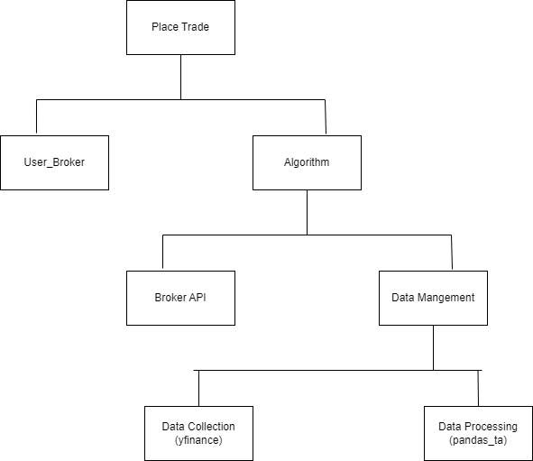

**3.2 Use case Diagram**

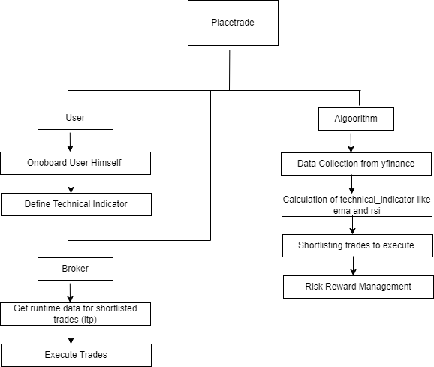

**3.3 Sequence Diagram**

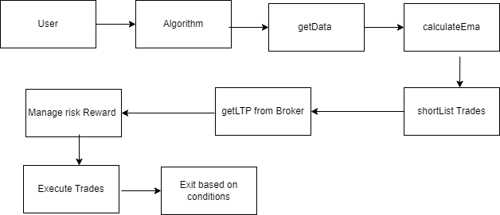

**3.4 Class Diagram**

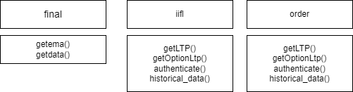

**3.5 Collaboration**

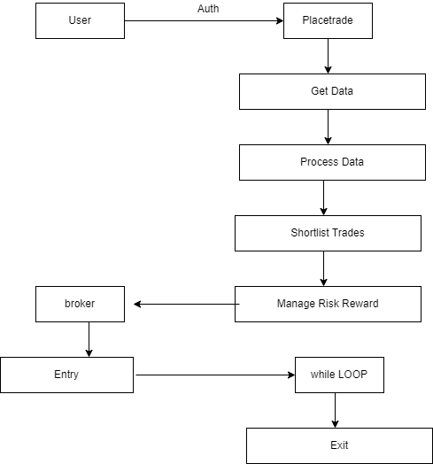

**3.6 Component diagram**

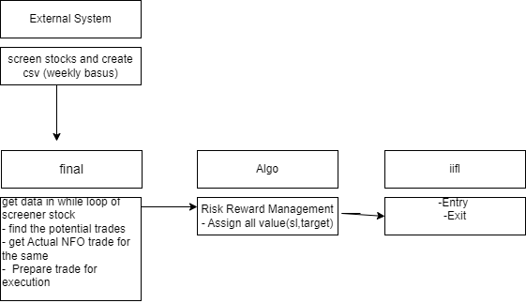

**3.7 Table Design**

Collections:

1. users Collection:

- This collection stores user information, including authentication credentials and application details.

| Field | Type | Description |

|------------|----------|----------------------------|

| userId | String | Unique identifier for the user. |

| password | String | Hashed password for the user. |

| clientId | String | Client identifier. |

| clientPass | String | Client password. |

| appName | String | Name of the associated application. |

2. rsi_ema Collection:

- This collection stores RSI and EMA data for different tickers.

| Field | Type | Description |

|------------|----------|---------------------------------|

| ema100 | Number | Exponential Moving Average (EMA) for a period of 100. |

| ema200 | Number | Exponential Moving Average (EMA) for a period of 200. |

| ticker | String | Ticker symbol. |

| close | Number | Closing price. |

| open | Number | Opening price. |

| high | Number | Highest price. |

| low | Number | Lowest price. |

3. scriptlist Collection:

- This collection stores details of scripts or stocks.

| Field | Type | Description |

|------------|----------|---------------------------------|

| name | String | Name of the script or stock. |

| expiry | Date | Expiry date (if applicable). |

| strike | Number | Strike price (if applicable). |

| lotsize | Number | Lot size. **|**

**3.8 Test Procedure and implementations**

Test Procedure:

1. User Collection Test:

- Insert a test user into the `users` collection.

- Retrieve the user from the collection and verify the correctness of the retrieved data.

- Update the user's information and verify the changes.

- Delete the user from the collection and ensure it is removed.

2. RSI_EMA Collection Test:

- Insert test RSI and EMA data for a specific ticker into the `rsi_ema` collection.

- Retrieve the RSI and EMA data for the ticker and verify the correctness of the retrieved data.

- Update the RSI and EMA data and verify the changes.

- Delete the RSI and EMA data from the collection and ensure it is removed.

3. Scriptlist Collection Test:

- Insert test script details into the `scriptlist` collection.

- Retrieve the script details and verify the correctness of the retrieved data.

- Update the script details and verify the changes.

- Delete the script details from the collection and ensure it is removed.

Test Implementations:

1. User Collection Test:

# Import necessary libraries

from pymongo import MongoClient

# Connect to MongoDB

client = MongoClient('localhost', 27017)

db = client['algorithmic_trading_db']

users_collection = db['users']

# Test Insert

test_user = {

"userId": "test_user",

"password": "test_password",

"clientId": "test_client_id",

"clientPass": "test_client_pass",

"appName": "test_app_name"

}

result = users_collection.insert_one(test_user)

print("Test User Inserted:", result.inserted_id)

# Test Retrieve

retrieved_user = users_collection.find_one({"userId": "test_user"})

print("Retrieved User:", retrieved_user)

# Test Update

update_query = {"userId": "test_user"}

new_values = {"$set": {"appName": "updated_test_app_name"}}

users_collection.update_one(update_query, new_values)

updated_user = users_collection.find_one({"userId": "test_user"})

print("Updated User:", updated_user)

# Test Delete

delete_result = users_collection.delete_one({"userId": "test_user"})

print("Test User Deleted:", delete_result.deleted_count)

2. RSI_EMA Collection Test:

(Similar structure to the User Collection Test, adapted for the `rsi_ema` collection)

3. Scriptlist Collection Test:

**4: User Manual** ­­

**4.1 User Manual**

Welcome to the Algorithmic Trading Software User Manual! This manual provides instructions on how to use the software effectively for trading and analysis.

Table of Contents:

1. Introduction

2. System Requirements

3. Getting Started

4. User Registration

5. User Login

6. Data Retrieval and Analysis

7. Trading Strategy Development

8. Trade Execution

9. Risk Management

10. Performance Monitoring

11. Troubleshooting

12. Support and Feedback

1. Introduction:

The Algorithmic Trading Software is a powerful tool designed to help traders analyze market data, develop trading strategies, execute trades, and manage risk efficiently. Although it does not have a graphical user interface (GUI), it provides a robust set of functionalities accessible through command-line or script-based interactions.

2. System Requirements:

- Compatible with Windows, macOS, and Linux operating systems.

- Requires MongoDB database for data storage.

- Internet connection for real-time market data updates.

3. Getting Started:

To begin using the Algorithmic Trading Software, follow these steps:

1. Install MongoDB on your system and ensure it is running.

2. Download and install the Algorithmic Trading Software package.

3. Launch the software and follow the instructions provided in the command-line interface.

4. User Registration:

If you are a new user, follow the registration prompts in the command-line interface to create your account. Once registered, you can log in using your credentials.

5. User Login:

Enter your username and password in the command-line interface to log in to the software. If you forget your password, follow the password recovery instructions provided.

6. Data Retrieval and Analysis:

Use commands or scripts to retrieve real-time and historical market data for analysis. Explore different technical indicators and perform technical analysis to identify trading opportunities.

7. Trading Strategy Development:

Develop trading strategies using scripting or programming languages supported by the software. Define entry and exit criteria based on technical indicators, risk tolerance, and investment goals.

8. Trade Execution:

Execute trades programmatically using the software's APIs or integration with brokerage platforms. Ensure that your brokerage account is configured for automated trade execution.

9. Risk Management:

Implement risk management techniques programmatically within your trading strategies. Set up stop-loss orders, position sizing rules, and other risk controls to protect your capital.

10. Performance Monitoring:

Monitor the performance of your trading strategies using performance metrics and analytics generated by the software. Evaluate the profitability and effectiveness of your trades over time.

11. Troubleshooting:

If you encounter any issues while using the software, refer to the troubleshooting section in the user manual or consult the software documentation. Additionally, you can seek assistance from the software's support channels.

Thank you for choosing the Algorithmic Trading Software. Happy trading!

**4.2 Operation Manual**

Table of Contents:

1. Introduction

2. System Requirements

3. Installation

4. Configuration

5. User Management

6. Data Retrieval and Analysis

7. Trading Strategy Development

8. Trade Execution

9. Risk Management

10. Performance Monitoring

11. Maintenance and Troubleshooting

12. Support and Resources

1. Introduction:

Welcome to the Algorithmic Trading Software Operation Manual! This manual provides detailed instructions on how to operate and maintain the algorithmic trading software effectively for trading and analysis.

2. System Requirements:

Ensure that your system meets the following requirements:

- Compatible with Windows, macOS, or Linux operating systems.

- MongoDB database installed and running.

- Internet connection for real-time market data updates.

3. Installation:

Follow these steps to install the algorithmic trading software:

1. Download the software package from the official website.

2. Extract the contents of the package to your desired directory.

3. Navigate to the installation directory in the command-line interface.

4. Run the installation script or executable to complete the installation process.

4. Configuration:

Before using the software, configure the following settings:

- MongoDB connection: Specify the MongoDB connection details in the configuration file.

- API keys: If integrating with external services, such as brokerage platforms, enter the API keys in the configuration file.

- Logging settings: Adjust the logging level and output location as needed.

5. User Management:

Manage users and access control using the command-line interface:

- Create new users: Use the appropriate command to add new users to the system.

- Update user credentials: Modify user passwords or other details as required.

- Delete users: Remove users from the system when necessary.

6. Data Retrieval and Analysis:

Retrieve and analyze market data using command-line tools or scripts:

- Fetch real-time data: Use commands to retrieve real-time market data for analysis.

- Analyze technical indicators: Perform technical analysis using built-in tools or custom scripts.

- Store data: Save analyzed data or results in the MongoDB database for future reference.

7. Trading Strategy Development:

Develop and test trading strategies using scripting or programming languages:

- Define entry and exit criteria: Write scripts to define trading rules based on technical indicators.

- Backtest strategies: Test strategies using historical data to evaluate performance.

- Optimize strategies: Fine-tune parameters and adjust trading rules for optimal results.

8. Trade Execution:

Execute trades programmatically using APIs or integration with brokerage platforms:

- Connect to brokerage APIs: Integrate the software with brokerage platforms for trade execution.

- Place orders: Use commands or scripts to place buy and sell orders based on trading strategies.

- Monitor orders: Track the status of orders and manage open positions as needed.

9. Risk Management:

Implement risk management techniques within trading strategies:

- Set stop-loss orders: Define stop-loss levels to limit potential losses on trades.

- Manage position sizes: Control the size of positions based on risk tolerance and account size.

- Monitor risk exposure: Regularly assess risk metrics and adjust strategies to mitigate risks.

10. Performance Monitoring:

Monitor the performance of trading strategies and overall system:

- Track key performance indicators: Monitor metrics such as profitability, win rate, and drawdown.

- Analyze results: Evaluate the effectiveness of trading strategies and identify areas for improvement.

- Generate reports: Create reports or visualizations to present performance data to stakeholders.

11. Maintenance and Troubleshooting:

Perform routine maintenance tasks and troubleshoot issues as needed:

- Backup data: Regularly backup MongoDB database to prevent data loss.

- Update software: Keep the software up-to-date with the latest releases and patches.

- Resolve issues: Troubleshoot errors or issues encountered during operation and implement solutions.

**5. Limitations of the Project**

1. Market Risk: The software operates based on historical and real-time market data, but it cannot predict unforeseen events or market volatility with absolute certainty. Users should exercise caution and implement robust risk management strategies to mitigate potential losses.

2. Technical Limitations: The performance of the software may be affected by technical constraints such as network latency, system downtime, or data inaccuracies. Users should be aware of these limitations and take them into account when making trading decisions.

3. Data Accuracy: While the software strives to provide accurate market data and analysis, there may be instances of data inaccuracies or delays, especially in real-time data feeds. Users should verify data from multiple sources and perform their due diligence before making trading decisions.

4. Strategy Effectiveness: The profitability and effectiveness of trading strategies developed using the software are not guaranteed. Market conditions, regulatory changes, and other external factors can impact the performance of trading strategies. Users should continuously evaluate and refine their strategies based on market dynamics.

5. Integration Dependencies: The software may rely on external services or APIs for data retrieval, trade execution, or other functionalities. Any disruptions or changes to these dependencies could affect the operation of the software. Users should stay informed about integration dependencies and have contingency plans in place.

6. Regulatory Compliance: Users are responsible for ensuring compliance with relevant financial regulations and legal requirements when using the software for trading activities. The software may provide tools and analytics, but users must adhere to regulatory guidelines and exercise due diligence in their trading activities.

7. User Skill and Knowledge: Effective utilization of the software requires a certain level of trading knowledge, technical skills, and understanding of financial markets. Novice traders may need time to familiarize themselves with the software's features and concepts before using it effectively.

8. Lack of Frontend Interface: The software operates primarily through command-line or script-based interactions, which may not be as user-friendly as a graphical user interface (GUI). Users should be comfortable with command-line tools and scripting languages to utilize the software effectively.

**6. Future Enhancements of the Project**

To continuously improve the algorithmic trading software and enhance its capabilities, here are some potential future enhancements:

1. Machine Learning Integration: Integrate machine learning algorithms to improve trading strategy development, pattern recognition, and predictive analytics. Machine learning models can analyze large datasets and identify complex patterns that may not be apparent through traditional analysis methods.

2. Natural Language Processing (NLP): Incorporate NLP techniques to analyze news sentiment, social media sentiment, and other textual data sources for market sentiment analysis. This can provide valuable insights into market trends and investor sentiment that can inform trading decisions.

3. Advanced Risk Management Tools: Develop advanced risk management tools that utilize sophisticated algorithms to dynamically adjust risk parameters based on market conditions, portfolio performance, and other factors. This can help traders adapt to changing market dynamics and reduce downside risk.

4. Multi-Asset Trading Support: Expand the software's capabilities to support trading across multiple asset classes, including stocks, options, futures, forex, and cryptocurrencies. This enables traders to diversify their portfolios and explore new trading opportunities across different markets.

5. Quantitative Analytics Toolkit: Develop a comprehensive quantitative analytics toolkit that provides a wide range of quantitative analysis tools, statistical models, and performance metrics for evaluating trading strategies and optimizing portfolio performance.

6. Cloud-Based Infrastructure: Transition to a cloud-based infrastructure to improve scalability, reliability, and accessibility. Cloud computing offers flexible computing resources, real-time data processing capabilities, and built-in security features that can enhance the software's performance and reliability.

7. User-Friendly Interface: Develop a user-friendly graphical user interface (GUI) that simplifies the user experience and makes it easier for traders to access and interact with the software's features. The GUI should provide intuitive navigation, customizable dashboards, and interactive visualizations for data analysis.

8. Social Trading Platform: Implement a social trading platform that allows users to share trading ideas, strategies, and insights with other traders in a collaborative environment. This fosters community engagement, knowledge sharing, and idea generation among traders.

9. Backtesting Enhancements: Enhance the backtesting functionality to support more sophisticated testing scenarios, including parameter optimization, walk-forward testing, and Monte Carlo simulation. This enables traders to rigorously test and validate their strategies before deploying them in live trading.

10. Compliance and Regulatory Tools: Integrate compliance and regulatory tools to help traders navigate regulatory requirements, monitor compliance with financial regulations, and ensure adherence to best practices in algorithmic trading.

**7. Conclusion**

In the rapidly evolving landscape of financial markets, PlaceTrade emerges as a sophisticated and dynamic platform, poised to empower traders with advanced tools and insights to navigate the complexities of trading effectively. As traders seek to capitalize on market opportunities and manage risks in real-time, PlaceTrade stands as a beacon of innovation, offering a comprehensive suite of features designed to meet the diverse needs of today's traders.

At the heart of PlaceTrade lies a commitment to excellence, reflected in its array of advanced tools and analytics meticulously crafted to provide traders with a competitive edge. From real-time market data feeds to robust technical analysis tools, PlaceTrade equips traders with the resources they need to make informed decisions and seize opportunities as they arise. Whether traders are seasoned professionals or newcomers to the world of finance, PlaceTrade offers a user-friendly interface and intuitive navigation, ensuring accessibility and ease of use for all.

Furthermore, PlaceTrade's commitment to continuous improvement is evident in its roadmap for future enhancements. By embracing cutting-edge technologies such as machine learning and natural language processing, PlaceTrade seeks to further enhance its analytical capabilities and provide traders with deeper insights into market trends and sentiment. Through these advancements, traders can refine their strategies, optimize their performance, and stay ahead of the curve in an ever-changing market environment.

The name "PlaceTrade" itself encapsulates the core purpose of the platform: to serve as the ultimate destination for traders to execute their trades with confidence and precision. Whether trading stocks, options, futures, or currencies, PlaceTrade offers a secure and reliable environment for traders to execute their strategies and pursue their investment goals. With a commitment to excellence, innovation, and user satisfaction, PlaceTrade sets the standard for modern trading platforms, empowering traders to navigate financial markets with clarity, precision, and success.

**8. Bibliography**

Here's a bibliography entry for each of the sources you've mentioned:

1. Screener.in

- Website: [Screener.in](https://screener.in/)

- Description: Screener.in is a comprehensive stock screening and analysis platform that provides users with financial data, company information, and screening tools to analyze stocks listed on Indian stock exchanges.

2. Yahoo Finance

- Website: [Yahoo Finance](https://finance.yahoo.com/)

- Description: Yahoo Finance is a leading financial news and data platform that offers a wide range of financial information, including stock quotes, historical data, market news, and analysis tools, to help investors make informed decisions.

3. Pandas Technical Analysis (pandas-ta)

- GitHub Repository: [Pandas Technical Analysis](https://github.com/twopirllc/pandas-ta)

- Description: Pandas Technical Analysis (pandas-ta) is a Python library that extends the functionality of the pandas library with technical analysis indicators commonly used in financial markets. It provides a convenient way to perform technical analysis on financial data using pandas DataFrame objects.

4. IIFL Securities APIs

- Website: [IIFL Securities APIs](https://api.iiflsecurities.com/)

- Description: IIFL Securities offers a set of APIs that allow developers to integrate their trading platform with IIFL Securities brokerage services. These APIs provide access to real-time market data, order execution, account information, and other trading-related functionalities.

5. Angel One APIs

- Description: Angel One (formerly known as Angel Broking) offers APIs that provide access to market data, trading functionalities, and account management features for traders and developers. These APIs enable integration with Angel One's trading platform to access real-time market data and execute trades programmatically.

Each of these sources has contributed to the development and functionality of the project, providing valuable data, tools, and services for stock screening, data retrieval, analysis, technical analysis, trade execution, and core data collection.

**9 Annexure**

**9.1 Details of technology used in Project**

Certainly! Here's a detailed description of each technology you've used in your project:

1. Python:

- Description: Python is a versatile and widely-used programming language known for its simplicity, readability, and extensive ecosystem of libraries and frameworks. In your project, Python serves as the primary programming language for developing the core functionalities, data processing, and integration with various APIs and databases. Its ease of use and rich library support make it an ideal choice for building algorithmic trading systems.

2. pandas_ta (Pandas Technical Analysis):

- Description: pandas_ta is a Python library that extends the functionality of the pandas library with technical analysis indicators commonly used in financial markets. It provides a convenient way to perform technical analysis on financial data using pandas DataFrame objects. With pandas_ta, you can easily calculate a wide range of technical indicators such as moving averages, relative strength index (RSI), exponential moving averages (EMA), Bollinger Bands, MACD, and more, facilitating comprehensive analysis of stock price movements.

3. yfinance (Yahoo Finance):

- Description: yfinance is a Python library that provides an interface to the Yahoo Finance API, allowing users to retrieve historical market data, real-time stock quotes, and other financial information. In your project, yfinance is used to fetch historical price data, company information, and other relevant data points necessary for conducting analysis and developing trading strategies. Its simplicity and ease of use make it a popular choice for accessing financial data from Yahoo Finance.

4. MongoDB:

- Description: MongoDB is a popular open-source NoSQL database known for its flexibility, scalability, and performance. In your project, MongoDB serves as the core database for storing and managing various types of data, including historical price data, technical analysis indicators, user information, and trading strategies. Its document-oriented data model and JSON-like documents make it well-suited for storing unstructured or semi-structured data commonly encountered in financial applications.

5. IIFL API (IIFL Securities API):

- Description: The IIFL API provides a set of web services and APIs that allow developers to integrate their trading applications with IIFL Securities brokerage services. In your project, the IIFL API is used to access real-time market data, execute trades, retrieve account information, and perform other trading-related tasks. By integrating with the IIFL API, you can build custom trading applications, algorithmic trading systems, and automated trading strategies that leverage the features and capabilities of IIFL Securities brokerage platform.

6. EMA (Exponential Moving Average):

- Description: Exponential Moving Average (EMA) is a popular technical indicator used in technical analysis to analyze trends and identify potential entry and exit points in financial markets. In your project, EMA is utilized as part of the technical analysis toolkit to calculate moving averages of stock prices over a specified period. EMA is preferred over simple moving averages (SMA) for its responsiveness to recent price changes, making it well-suited for short-term trend analysis and momentum trading strategies.

7. LTP (Last Traded Price):

- Description: Last Traded Price (LTP) refers to the most recent price at which a security was traded in the market. In your project, LTP serves as a key data point used in real-time market data feeds, trade execution, and monitoring of stock prices. By tracking the LTP of stocks in real-time, you can make informed trading decisions, monitor market trends, and execute trades at optimal prices.

**9.2 CLI with Data**

Login :-

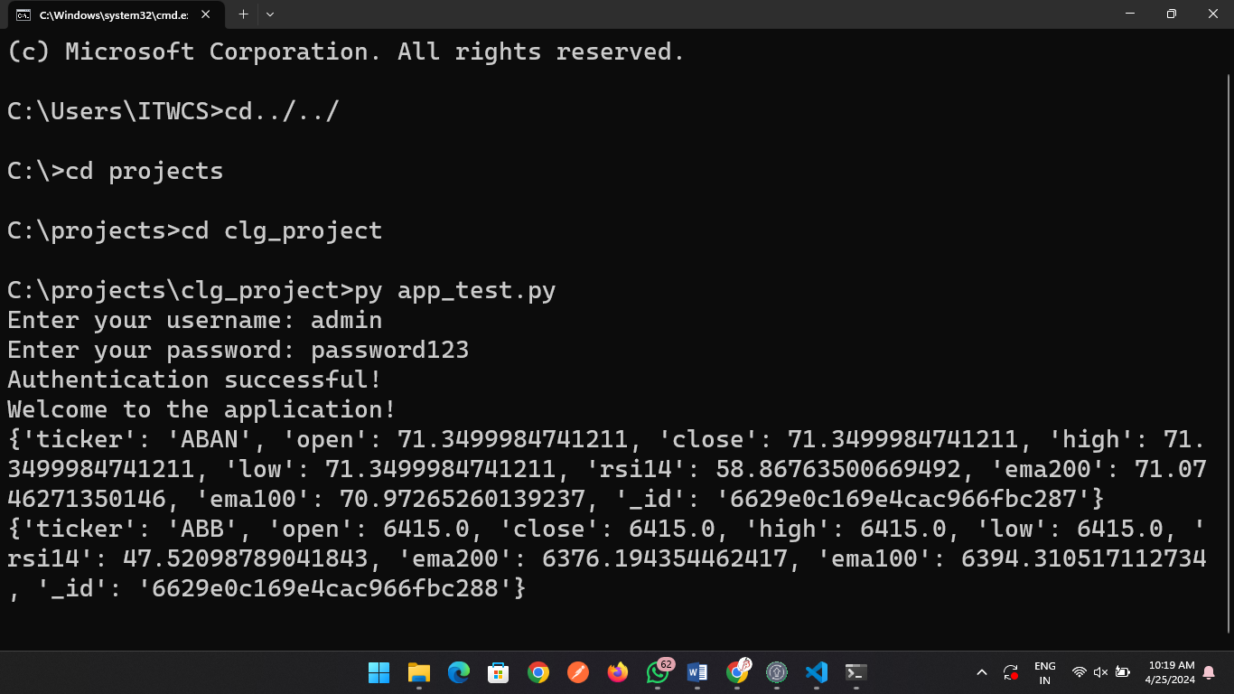

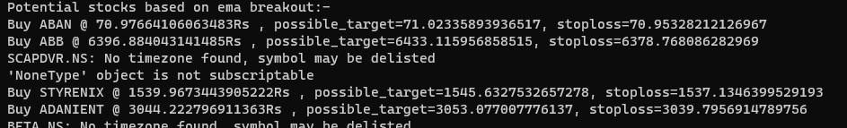 Possible Trades : -