Create AMI using packer and Install Docker using Ansible

Packer is used to create identical, reusable machine images so your infrastructure is fast, predictable, and immutable.

Packer important modules
1. Builders (most important)
What they do:
Create the machine image on a platform.
Examples:
- amazon-ebs → AWS AMIs
- azure-arm → Azure images
- googlecompute → GCP images
- docker → Docker images
- vmware-iso, virtualbox-iso

2. Provisioners
What they do:
Install and configure software inside the image.
Common ones:
- shell – run bash scripts (most common)
- ansible – use Ansible playbooks
- chef, puppet
- file – copy files into the image
- powershell – for Windows images

3. Post-Processors
What they do:
Run after the image is built.
Examples:
- manifest – record image metadata
- compress – package artifacts
- docker-tag
- checksum

4. Variables
What they do:
Make builds reusable and environment-agnostic.
Examples:
- Image name
- Region
- OS version
- App version
Used via:
- .pkr.hcl
- CLI flags
- Environment variables

5. Communicators
What they do:
Define how Packer connects to the build instance.
Types:
- ssh (Linux)
- winrm (Windows)
- none (Docker)
Usually auto-handled, but important for debugging.

6. Plugins (modern Packer)
What they do:
Extend Packer with builders/provisioners.
Examples:
- AWS plugin
- Azure plugin
- Ansible plugin
Declared explicitly in newer Packer versions.

Minimal mental model
Builder → creates the VM
Provisioner → installs software
Post-processor → exports metadata
Variables → make it reusable

- Create main.pkr.hcl and paste the content below.
- packer {
- required_plugins {
- amazon = {
- source = "github.com/hashicorp/amazon"
- version = "~> 1.2"
- }
- }
- }

- source "amazon-ebs" "base" {
- region = "us-east-1"
- instance_type = "t2.micro"
- source_ami = "ami-0b6c6ebed2801a5cb" # Ubuntu AMI ID from AWS I have picked up
- ssh_username = "ubuntu"
- ami_name = "ansible-image"
- }

- build {
- sources = ["source.amazon-ebs.base"]

- provisioner "shell" {
- inline = [
- "sudo apt update -y",
- "sudo apt install -y python3 git ansible"
- ]
- }
- }

2. Give the command to initialise.
packer init .
3. validate the packer file with using below command
packer validate .
4. Give the build command to build the ami.
Packer build .

It will show output like below
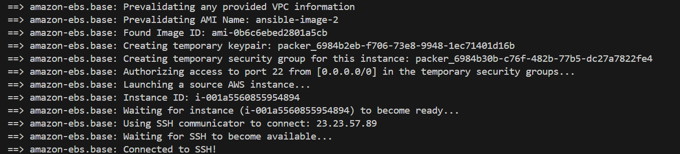
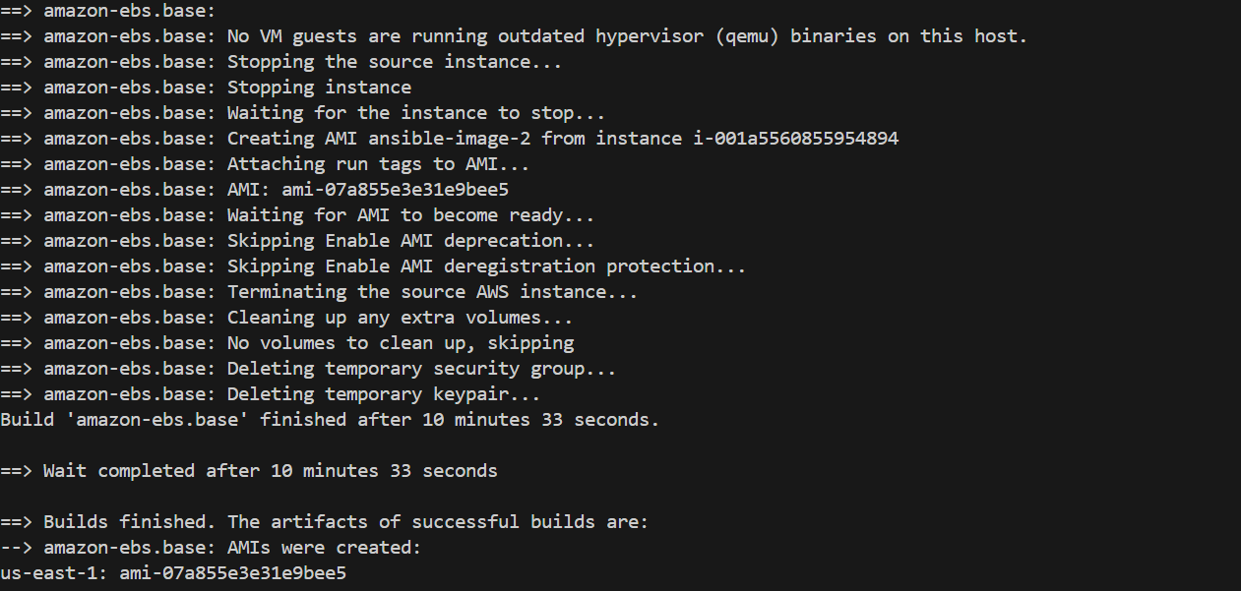
It will create the ami and shows the AMI ID.

Now the AMI is build I am using that AMI in terraform to create the instance.
1 mater and 2 slave instances.

Below are my files for terraform
Main.tf
- #Key_pair
- resource "aws_key_pair" "ec2_key" {
- key_name = "ec2_key"
- public_key = file("C:path_to/key.pub")

- }

- module "project_vpc" {
- source = "terraform-aws-modules/vpc/aws"
- version = "~> 5.0"

- name = "project_vpc"
- cidr = "10.0.0.0/16"

- azs = ["us-east-1a", "us-east-1b"]
- private_subnets = ["10.0.1.0/24", "10.0.2.0/24"]
- public_subnets = ["10.0.101.0/24", "10.0.102.0/24"]

- enable_nat_gateway = true
- enable_vpn_gateway = false
- }
- #Security Group
- resource "aws_security_group" "aws_security_group" {
- name = "aws_security_group"
- description = "trying the ec2 connect"
- vpc_id = module.project_vpc.vpc_id

- ingress {
- from_port = 0
- to_port = 65535
- protocol = "tcp"
- cidr_blocks = ["0.0.0.0/0"]
- description = "allowed all traffic"

- }

- egress {
- from_port = 0
- to_port = 0
- protocol = "-1"
- cidr_blocks = ["0.0.0.0/0"]
- ipv6_cidr_blocks = ["::/0"]
- }
- }
- resource "aws_instance" "master" {
- ami = var.ami_id
- instance_type = "t2.micro"
- root_block_device {
- volume_type = "gp3"
- volume_size = var.volume_size
- }
- key_name = aws_key_pair.ec2_key.key_name
- vpc_security_group_ids = [aws_security_group.aws_security_group.id]
- subnet_id = module.project_vpc.public_subnets[0]
- associate_public_ip_address = true
- tags = {
- Name = "ansible-master"
- Role = "master"
- }
- }

- resource "aws_instance" "slaves" {
- count = 2
- ami = var.ami_id
- instance_type = "t2.micro"
- root_block_device {
- volume_type = "gp3"
- volume_size = var.volume_size
- }
- key_name = aws_key_pair.ec2_key.key_name
- vpc_security_group_ids = [aws_security_group.aws_security_group.id]
- subnet_id = module.project_vpc.private_subnets[0]

- tags = {
- Name = "ansible-slave-${count.index}"
- Role = "slave"
- }
- }

Output.tf
- output "ec2_public_ip" {
- value = aws_instance.master.public_ip
- }

- output "ec2_private_ip" {
- value = aws_instance.slaves[*].private_ip
- }

Terraform.tf
- terraform {
- required_providers {
- aws = {
- source = "hashicorp/aws"
- version = "~> 6.0"
- }
- }
- }

Provider.tf
- provider "aws" {
- region = "us-east-1"
- }

Varialbes.tf
- variable "instance_type" {
- default = "t3.micro"
- type = string
- }

- variable "ami_id" {
- default = "ami-0325f3e5651e7d58f"
- type = string
- }

- variable "volume_size" {
- default = 15
- type = number
- }

- variable "env" {
- default = "dev"
- type = string

- }

Create key pair folder inside the same directory.
And give ssh-keygen to create key pair in that directory.

Login the instance with the key pair.
ssh -i "ec2_key" ubuntu@ec2-107-21-199-157.compute-1.amazonaws.com

and create ansible folder using mkdir ansible
Create inventory.ini
[masters]
master_node ansible_host=107.21.199.157 ansible_user=ubuntu ansible_ssh_private_key_file=~/.ssh/ec2_key

[slaves]
slave1 ansible_host=10.0.1.218 ansible_user=ubuntu ansible_ssh_private_key_file=~/.ssh/ec2_key ansible_ssh_common_args='-o ProxyCommand="ssh -i ~/.ssh/ec2_key -W %h:%p ubuntu@107.21.199.157"'

slave2 ansible_host=10.0.1.47 ansible_user=ubuntu ansible_ssh_private_key_file=~/.ssh/ec2_key ansible_ssh_common_args='-o ProxyCommand="ssh -i ~/.ssh/ec2_key -W %h:%p ubuntu@107.21.199.157"'

go to authorized_keys and paste your instance private key here.
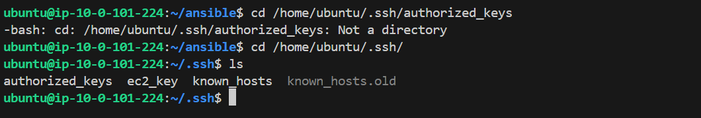

Give the below commands to check connections between the nodes.
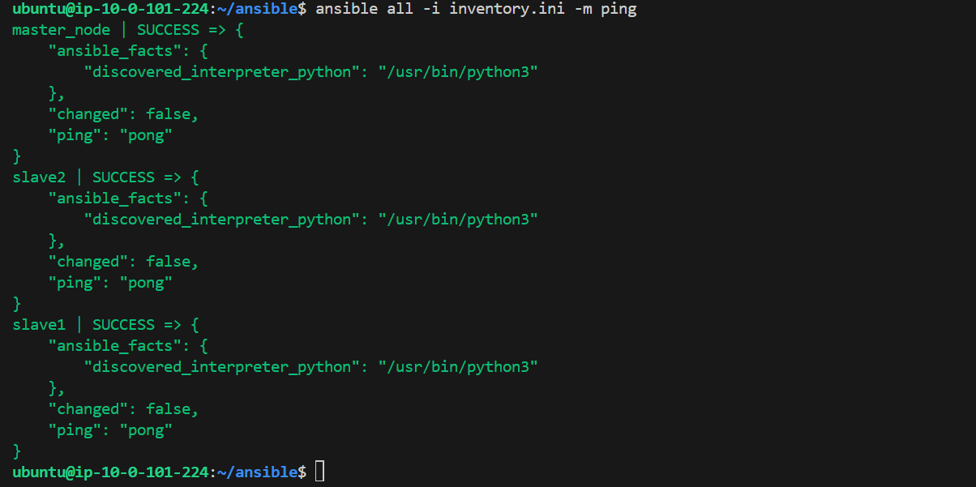

Create a file install_docker.yml
- - name: Install Docker using official script
- hosts: slaves
- become: yes

- tasks:
- - name: Ensure required packages are present
- apt:
- name:
- - curl
- - ca-certificates
- state: present
- update_cache: yes

- - name: Download Docker install script
- get_url:
- url: https://get.docker.com
- dest: /tmp/get-docker.sh
- mode: '0755'

- - name: Run Docker install script
- command: sh /tmp/get-docker.sh

- - name: Start and enable Docker
- service:
- name: docker
- state: started
- enabled: yes

- - name: Add ubuntu user to docker group
- user:
- name: ubuntu
- groups: docker
- append: yes

Give the command
ansible-playbook -i inventory.ini install_docker.yml
it will install the docker and show you the status.
