USE CASE DOCUMENT

Transport Management System (TMS)

GoodWill Company
Small Scale Transport Business Startup

Prepared By
Praitk Bhopi | Surayank Chavan
Mohit Nehte | Abhinav Badhe
Sachin Babhad | Karan Doifode

MIT Academy of Engineering, Alandi
Department of Computer Engineering | Academic Year: 2025 – 2026
Date: 16/02/2026 | Version: 1.0

Table of Contents
1. Introduction3
2. System Overview Diagram3
3. Customer Module4
3.1 Use Case Diagram — Customer Module4
3.2 UC-01: Register and Login4
3.3 UC-02: Place a Transport Order5
3.4 UC-03: View Order History and Status6
3.5 UC-09: Make Payment7
3.6 UC-10: Receive Delivery Notifications8
4. Staff / Admin Module9
4.1 Use Case Diagram — Staff / Admin Module9
4.2 UC-04: View and Manage Incoming Orders9
4.3 UC-05: Assign Driver and Vehicle10
4.4 UC-06: Set / Adjust Order Price11
4.5 UC-07: Manage Drivers12
4.6 UC-08: Manage Vehicles13
4.7 UC-11: View Payments and Transactions14
5. Driver Module15
5.1 Use Case Diagram — Driver Module15
5.2 UC-12: Driver Login15
5.3 UC-13: View Assigned Trips16
5.4 UC-14: Update Trip Status17
5.5 UC-15: Upload Proof of Delivery18
6. Payment Module19
6.1 Use Case Diagram — Payment Module19
6.2 UC-16: Pay Online19
6.3 UC-17: Cash on Delivery (COD)20
6.4 UC-18: Mark COD as Paid21
6.5 UC-19: View Transaction Log22
7. Business Dashboard Module23
7.1 Use Case Diagram — Dashboard Module23
7.2 UC-20: View Orders Summary23
7.3 UC-21: View Revenue24
7.4 UC-22: View Fleet Status25
7.5 UC-23: View Driver Activity26
8. Use Case Summary Table27

1. Introduction
This document describes all the use cases for the Transport Management System (TMS) developed for GoodWill Company. It follows the IEEE standard use case format and covers the complete interaction between each type of user (actor) and the system.
The system involves five primary modules: Customer Module, Staff / Admin Module, Driver Module, Payment Module, and Business Dashboard Module. Each module section in this document includes a Use Case Diagram followed by detailed use case tables for every use case in that module.

Field | Description
Document Title | Use Case Document — Transport Management System
Project Name | Transport Management System (TMS)
Client / Company | GoodWill Company (Small Scale Transport Startup)
Institution | MIT Academy of Engineering, Alandi
Department | Computer Engineering
Academic Year | 2025 – 2026
Version | 1.0
Date | 16/02/2026
Authors | Praitk Bhopi, Surayank Chavan, Mohit Nehte, Abhinav Badhe, Sachin Babhad, Karan Doifode
Total Use Cases | 23 Use Cases across 5 Modules

2. System Overview Use Case Diagram
The diagram below shows all actors and the five functional modules of the TMS at a high level, illustrating which actors interact with which modules.

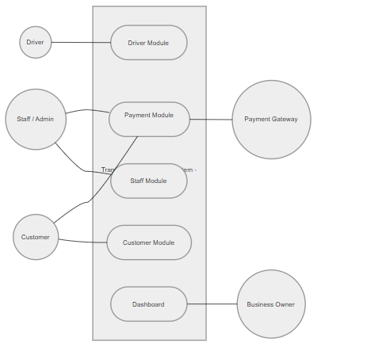
Figure 1 — System Overview Use Case Diagram — TMS (GoodWill Company)

3. Customer Module
The Customer module covers all interactions a registered customer has with the TMS web portal — from account creation and order placement to payment and delivery tracking.
Actors: Customer (Primary)

3.1 Use Case Diagram — Customer Module
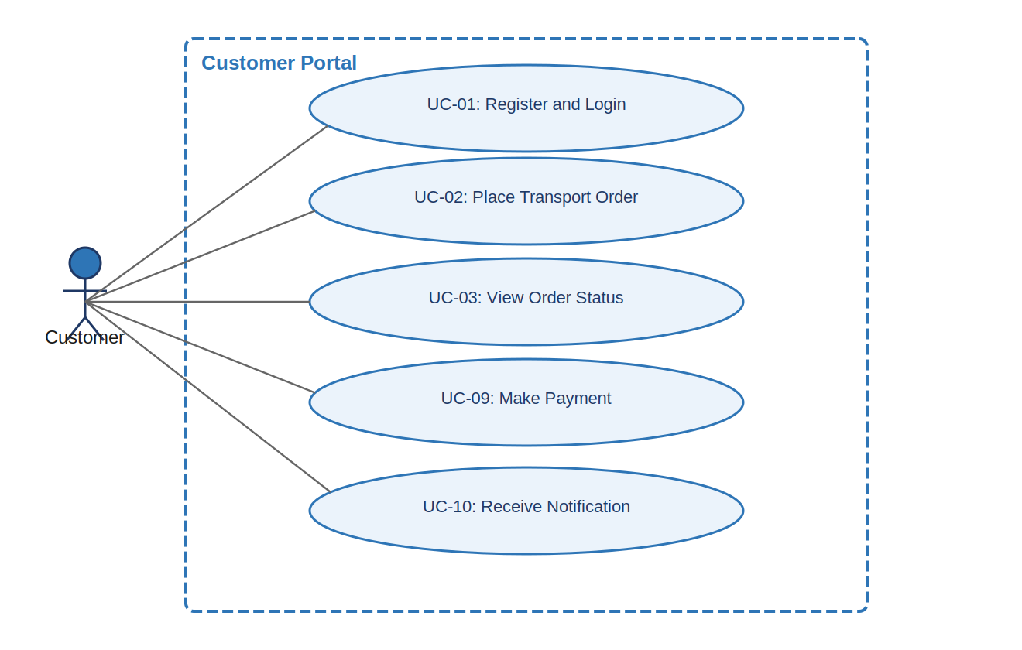
Figure 2 — Use Case Diagram: Customer Module

3.2 UC-01: Register and Login
UC-01 Register and Login [High]
Use Case ID | UC-01
Use Case Name | Register and Login
Module | Customer Module
Priority | High
Actor(s) | Primary: Customer
Goal | Allow a new customer to register an account and an existing customer to log in to the TMS portal.
Pre-conditions | Customer has a valid email address and internet access.
Post-conditions | Customer is authenticated and redirected to the customer dashboard.
Primary Scenario | 1. Customer visits the TMS web portal.  2. New customer clicks 'Register' and fills in: Full Name, Email Address, Phone Number, Password.  3. System validates all inputs and sends a verification email.  4. Customer clicks the verification link in the email.  5. Customer is redirected to the login page and enters email and password.  6. System authenticates credentials and displays the customer dashboard.
Alternative Scenarios | 2a. Returning customer clicks 'Login' directly and skips registration.  5a. Customer clicks 'Forgot Password' — system sends a reset link via email.
Exception Scenarios | 3a. If email is already registered, system shows: 'Email already in use. Please log in.'  5a. If credentials are wrong, system shows an error; account is locked after 5 failed attempts.
Frequency of Use | Every session — customers must log in before placing or tracking orders.
Business Rules | Each email address can be associated with only one customer account.
Special Requirements | Password must be at least 8 characters with one uppercase letter and one number.

3.3 UC-02: Place a Transport Order
UC-02 Place a Transport Order [High]
Use Case ID | UC-02
Use Case Name | Place a Transport Order
Module | Customer Module
Priority | High
Actor(s) | Primary: Customer
Goal | Allow an authenticated customer to submit a request to transport goods from one location to another.
Pre-conditions | Customer is logged in to the TMS portal.
Post-conditions | Order is created with status 'Pending' and staff is notified for assignment.
Primary Scenario | 1. Customer clicks 'New Order' from the dashboard.  2. Customer fills in the order form:  - Pickup Address  - Drop-off Address  - Type of Goods (e.g., furniture, electronics, parcels)  - Estimated Weight (kg)  - Preferred Pickup Date and Time  - Special Instructions (optional)  3. System calculates and displays an estimated price based on distance and goods type.  4. Customer reviews all details and clicks 'Confirm Order'.  5. System generates a unique Order ID, saves the order with status 'Pending', and notifies the staff.
Alternative Scenarios | 4a. Customer clicks 'Edit' to modify details before confirming.  4b. Customer clicks 'Cancel' — order is discarded and not saved.
Exception Scenarios | 3a. If the address is outside the service area, system shows: 'Location not serviceable.'  2a. If required fields are missing, system highlights them and prevents submission.
Frequency of Use | Every time a customer needs goods transported.
Business Rules | Customers can have a maximum of 5 active (non-delivered) orders at one time.
Special Requirements | Price estimation must respond within 5 seconds of address entry.

3.4 UC-03: View Order History and Status
UC-03 View Order History and Status [High]
Use Case ID | UC-03
Use Case Name | View Order History and Status
Module | Customer Module
Priority | High
Actor(s) | Primary: Customer
Goal | Allow the customer to view the current status of active orders and the history of past orders.
Pre-conditions | Customer is logged in and has placed at least one order.
Post-conditions | Customer can see full details of any order including current status, driver info, and vehicle assigned.
Primary Scenario | 1. Customer navigates to 'My Orders' from the dashboard.  2. System displays a list of all orders with:  - Order ID, Date Placed, Pickup & Drop-off, Status, Amount.  3. Customer clicks on an order to view full details:  - Assigned Driver Name and Contact  - Vehicle Number  - Current Status with timestamp history  - Proof of Delivery photo (if delivered)
Alternative Scenarios | 2a. Customer filters orders by status (Pending / In Transit / Delivered) or by date range.
Exception Scenarios | 2a. If no orders exist, system shows: 'No orders placed yet. Place your first order.'
Frequency of Use | Frequently — customers check order status after placing an order.
Business Rules | Order history is retained for 12 months from delivery date.
Special Requirements | Status updates must reflect within 10 seconds of a driver updating them.

3.5 UC-09: Make Payment
UC-09 Make Payment [High]
Use Case ID | UC-09
Use Case Name | Make Payment
Module | Customer Module / Payment Module
Priority | High
Actor(s) | Primary: Customer | Secondary: Payment Gateway
Goal | Allow the customer to pay for a confirmed transport order either online or via Cash on Delivery.
Pre-conditions | Order has been assigned by staff and a final price has been confirmed.
Post-conditions | Payment status is updated to 'Paid' (online) or 'COD Pending'. Order proceeds to pickup.
Primary Scenario | 1. Customer receives a notification that the order is assigned with a confirmed price.  2. Customer opens the order and clicks 'Pay Now'.  3. Customer selects 'Pay Online'.  4. System redirects to the payment gateway.  5. Customer completes payment using Card / UPI / Net Banking.  6. Payment gateway sends confirmation to the system.  7. System updates payment status to 'Paid' and sends a receipt to the customer.
Alternative Scenarios | 3a. Customer selects 'Cash on Delivery' — system marks payment status as 'COD Pending'. No redirect to gateway.
Exception Scenarios | 5a. If payment fails, system shows an error and allows retry or switch to COD.  6a. If gateway timeout occurs, system retries confirmation; if unresolved, order remains in 'Payment Pending' status.
Frequency of Use | Once per order.
Business Rules | Payment must be completed or COD selected before the driver is dispatched.
Special Requirements | No card or payment data is stored on TMS servers — all handled by the payment gateway (PCI-DSS compliant).

3.6 UC-10: Receive Delivery Notifications
UC-10 Receive Delivery Notifications [Medium]
Use Case ID | UC-10
Use Case Name | Receive Delivery Notifications
Module | Customer Module
Priority | Medium
Actor(s) | Primary: Customer | Secondary: System (automated)
Goal | Keep the customer informed of order progress through automated notifications at key status changes.
Pre-conditions | Customer has placed an order and has a verified email / phone number.
Post-conditions | Customer receives timely notifications at each stage of the order.
Primary Scenario | System automatically sends notifications at the following events:  1. Order Confirmed — 'Your order #XXXX has been placed successfully.'  2. Order Assigned — 'Your order #XXXX has been assigned to Driver [Name], Vehicle [No].'  3. Picked Up — 'Your goods have been picked up and are on the way.'  4. In Transit — 'Your delivery is in transit. ETA: [Time].'  5. Delivered — 'Your order #XXXX has been delivered. View POD in My Orders.'
Alternative Scenarios | Customer may opt out of SMS notifications but email notifications remain mandatory.
Exception Scenarios | If email delivery fails, system retries once after 2 minutes and logs the failure.
Frequency of Use | Automatically triggered — 4 to 5 times per order lifecycle.
Business Rules | Notifications are sent via email. SMS is optional and depends on SMS gateway availability.
Special Requirements | Notification delivery must occur within 30 seconds of the triggering event.

4. Staff / Admin Module
The Staff / Admin module covers all order management, assignment, driver management, and vehicle management tasks performed by business employees through the admin panel.
Actors: Staff / Admin (Primary)

4.1 Use Case Diagram — Staff / Admin Module
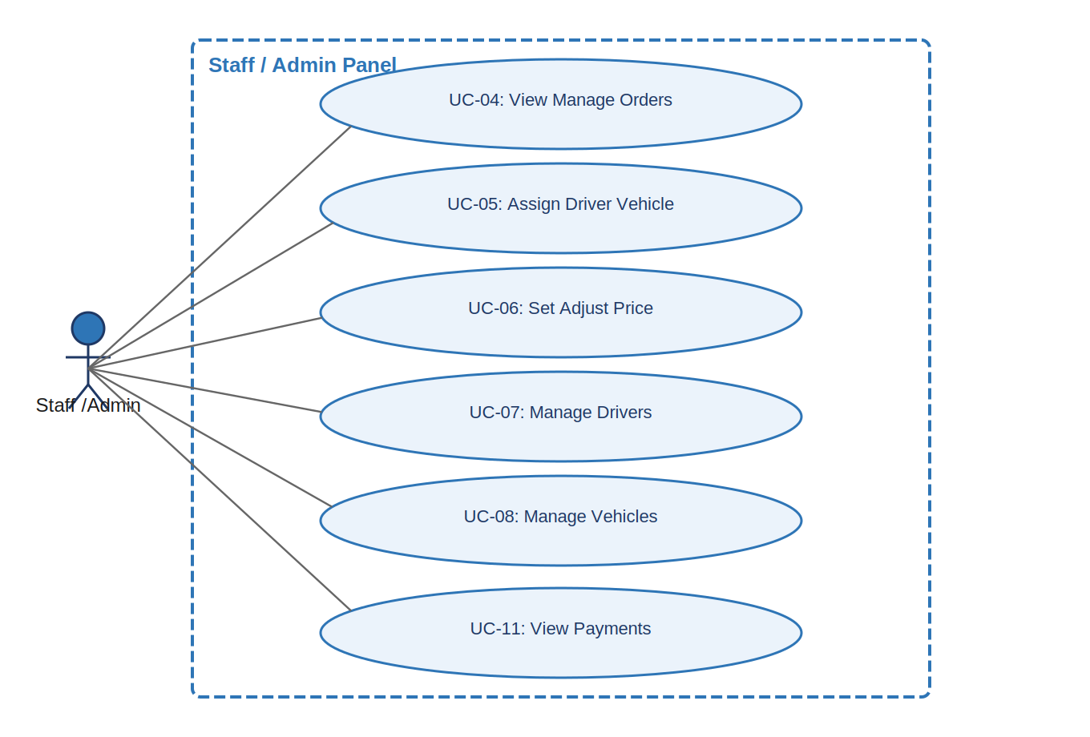
Figure 3 — Use Case Diagram: Staff / Admin Module

4.2 UC-04: View and Manage Incoming Orders
UC-04 View and Manage Incoming Orders [High]
Use Case ID | UC-04
Use Case Name | View and Manage Incoming Orders
Module | Staff / Admin Module
Priority | High
Actor(s) | Primary: Staff / Admin
Goal | Allow staff to monitor all customer orders filtered by status and take appropriate action.
Pre-conditions | Staff is logged in to the admin panel.
Post-conditions | Staff can view order details and navigate to assignment, price, or driver/vehicle management.
Primary Scenario | 1. Staff logs in and lands on the Orders dashboard.  2. System displays all orders grouped by status: Pending, Assigned, In Transit, Delivered.  3. Staff clicks on any order to view full details: customer info, addresses, goods, weight, preferred time.  4. Staff can filter orders by date, status, or driver.  5. Staff selects a Pending order and proceeds to assign it (see UC-05).
Alternative Scenarios | 4a. Staff can search for a specific order by Order ID or customer name.
Exception Scenarios | 2a. If no orders are present, system shows: 'No orders available at this time.'
Frequency of Use | Multiple times daily — staff monitor orders throughout the working day.
Business Rules | Only staff and admins can view the full order list. Customers can only see their own orders.
Special Requirements | The orders list must refresh automatically every 60 seconds to show new incoming orders.

4.3 UC-05: Assign Driver and Vehicle
UC-05 Assign Driver and Vehicle [High]
Use Case ID | UC-05
Use Case Name | Assign Driver and Vehicle
Module | Staff / Admin Module
Priority | High
Actor(s) | Primary: Staff / Admin
Goal | Allow staff to assign an available driver and vehicle to a Pending order.
Pre-conditions | Staff is logged in. A Pending order exists. At least one driver and one vehicle are available.
Post-conditions | Order status changes to 'Assigned'. Driver and customer are notified.
Primary Scenario | 1. Staff opens a Pending order.  2. Staff clicks 'Assign Driver and Vehicle'.  3. System displays a list of available drivers and available vehicles.  4. Staff selects a driver and a vehicle from the dropdowns.  5. Staff clicks 'Confirm Assignment'.  6. System updates order status to 'Assigned'.  7. System sends notifications to the assigned driver and to the customer.
Alternative Scenarios | 3a. If no drivers are available, system shows a warning but still allows manual entry of a driver name.
Exception Scenarios | 4a. If the selected driver is already assigned to another active trip, system shows a conflict warning and prevents double-booking.
Frequency of Use | Once per Pending order.
Business Rules | One driver can only be actively assigned to one trip at a time.
Special Requirements | Assignment must update driver and customer portals within 10 seconds.

4.4 UC-06: Set / Adjust Order Price
UC-06 Set / Adjust Order Price [High]
Use Case ID | UC-06
Use Case Name | Set / Adjust Order Price
Module | Staff / Admin Module
Priority | High
Actor(s) | Primary: Staff / Admin
Goal | Allow staff to confirm the system-estimated price or manually override it before or after assignment.
Pre-conditions | Staff is logged in and viewing an order.
Post-conditions | Final price is confirmed and visible to the customer for payment.
Primary Scenario | 1. Staff opens an order (Pending or Assigned).  2. System displays the auto-calculated estimated price.  3. Staff reviews the price.  4a. If acceptable: Staff clicks 'Confirm Price' — price is locked.  4b. If adjustment needed: Staff enters a new price, adds a reason note, clicks 'Update Price'.  5. System saves the final price and makes it visible to the customer.
Alternative Scenarios | N/A — all price changes are manually triggered by staff.
Exception Scenarios | 4b. If staff enters a price below the system minimum, a warning is shown. Staff must confirm the override explicitly.
Frequency of Use | Once per order, during or just after order assignment.
Business Rules | Price can only be adjusted before the customer completes payment.
Special Requirements | Any manual price override must include a reason note for audit purposes.

4.5 UC-07: Manage Drivers
UC-07 Manage Drivers [High]
Use Case ID | UC-07
Use Case Name | Manage Drivers
Module | Staff / Admin Module
Priority | High
Actor(s) | Primary: Staff / Admin
Goal | Allow staff to add new drivers, update driver details, and deactivate drivers who are no longer with the business.
Pre-conditions | Staff is logged in with management access.
Post-conditions | Driver records are updated. New drivers receive login credentials. Deactivated drivers cannot log in.
Primary Scenario | 1. Staff navigates to the Drivers section in the admin panel.  2. Staff clicks 'Add New Driver'.  3. Staff fills in: Full Name, Phone Number, License Number, License Expiry Date, Address.  4. System creates the driver profile and generates login credentials (username + temporary password).  5. System sends login credentials to the driver via SMS or email.
Alternative Scenarios | Edit Driver: Staff clicks 'Edit' on an existing driver — updates name, phone, or license details.  Deactivate Driver: Staff clicks 'Deactivate' — driver is removed from the available assignment pool.
Exception Scenarios | 3a. If the license number already exists in the system, an error is shown: 'Driver with this license already registered.'
Frequency of Use | When the team grows, or when driver details change.
Business Rules | A deactivated driver cannot be assigned to new orders but their trip history is retained.
Special Requirements | License expiry dates must trigger a warning to admin 30 days before expiry.

4.6 UC-08: Manage Vehicles
UC-08 Manage Vehicles [High]
Use Case ID | UC-08
Use Case Name | Manage Vehicles
Module | Staff / Admin Module
Priority | High
Actor(s) | Primary: Staff / Admin
Goal | Allow staff to add vehicles to the fleet, update vehicle details, and change vehicle availability status.
Pre-conditions | Staff is logged in.
Post-conditions | Vehicle record is saved and the vehicle is available for assignment.
Primary Scenario | 1. Staff navigates to the Vehicles section.  2. Staff clicks 'Add Vehicle'.  3. Staff fills in: Registration Number, Vehicle Type (truck/mini-truck/van), Capacity (tons), Owner Name.  4. System saves the vehicle and marks it as 'Available'.
Alternative Scenarios | Edit: Staff edits vehicle details (type, capacity).  Status Change: Staff changes status to 'In Use', 'Available', or 'Under Maintenance'.
Exception Scenarios | 3a. Duplicate registration number returns a validation error.
Frequency of Use | When a new vehicle joins or leaves the fleet, or when status changes.
Business Rules | A vehicle marked 'Under Maintenance' cannot be assigned to orders.
Special Requirements | Vehicle status must reflect in the assignment dropdown immediately after update.

4.7 UC-11: View Payments and Transactions
UC-11 View Payments and Transactions [Medium]
Use Case ID | UC-11
Use Case Name | View Payments and Transactions
Module | Staff / Admin Module
Priority | Medium
Actor(s) | Primary: Staff / Admin
Goal | Allow staff to view payment statuses for all orders and mark COD orders as paid upon cash collection.
Pre-conditions | Staff is logged in.
Post-conditions | Staff has visibility over all payment records and can update COD collection status.
Primary Scenario | 1. Staff navigates to the Payments section.  2. System displays all orders with payment status: Paid, COD Pending, Payment Failed.  3. For a COD order: Staff clicks 'Mark as Paid' after the driver confirms cash collection.  4. System updates the payment status to 'Paid (COD)' and logs the transaction.
Alternative Scenarios | Staff can filter payment records by date range or payment mode.
Exception Scenarios | 3a. Marking a COD order as paid requires confirmation prompt to prevent accidental updates.
Frequency of Use | Daily — staff review payments at end of working day.
Business Rules | Only staff can mark COD orders as paid. This action is logged with a timestamp and the staff member's name.
Special Requirements | All payment records are immutable — no deletions. Only status updates are allowed.

5. Driver Module
The Driver module provides a simple mobile-friendly interface for drivers to view assigned trips, update trip progress, and confirm delivery with proof of delivery.
Actors: Driver (Primary)

5.1 Use Case Diagram — Driver Module
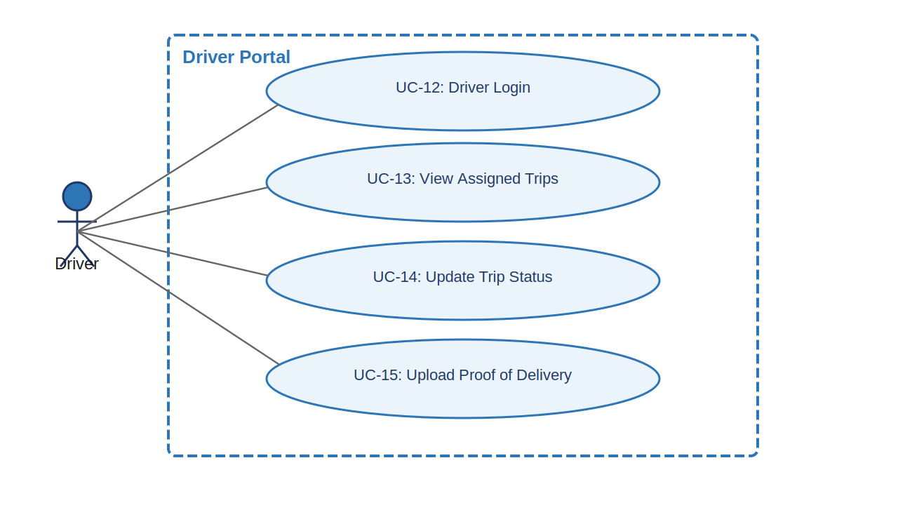
Figure 4 — Use Case Diagram: Driver Module

5.2 UC-12: Driver Login
UC-12 Driver Login [High]
Use Case ID | UC-12
Use Case Name | Driver Login
Module | Driver Module
Priority | High
Actor(s) | Primary: Driver
Goal | Allow a driver to securely log in to the driver portal using credentials provided by staff.
Pre-conditions | Driver has received login credentials (username and temporary password) from staff.
Post-conditions | Driver is authenticated and redirected to the driver dashboard showing assigned trips.
Primary Scenario | 1. Driver opens the TMS portal on their mobile browser.  2. Driver enters their username and password.  3. System validates credentials.  4. Driver is redirected to the driver dashboard.
Alternative Scenarios | 2a. Driver clicks 'Forgot Password' — system sends a reset link to the registered phone / email.
Exception Scenarios | 2a. If credentials are wrong, system shows an error. Account is locked after 5 consecutive failed attempts.
Frequency of Use | Every working day — drivers log in at the start of their shift.
Business Rules | Driver accounts can only access the driver portal. They have no access to admin, customer, or dashboard areas.
Special Requirements | The driver portal must be fully functional on mobile screens (minimum 360px width).

5.3 UC-13: View Assigned Trips
UC-13 View Assigned Trips [High]
Use Case ID | UC-13
Use Case Name | View Assigned Trips
Module | Driver Module
Priority | High
Actor(s) | Primary: Driver
Goal | Allow the driver to see all trips currently assigned to them with full order details.
Pre-conditions | Driver is logged in. At least one trip has been assigned.
Post-conditions | Driver has all information needed to execute the pickup and delivery.
Primary Scenario | 1. Driver opens the driver dashboard.  2. System displays a list of assigned trips showing for each:  - Order ID  - Customer Name and Contact Number  - Pickup Address with Map Link  - Drop-off Address with Map Link  - Goods Description and Weight  - Preferred Pickup Date and Time  - Current Trip Status  3. Driver taps on a trip to view full details.
Alternative Scenarios | 2a. If no trips are assigned, system shows: 'No trips assigned. Check back soon.'
Exception Scenarios | If the driver's account is deactivated between login and dashboard load, system redirects to login with an error message.
Frequency of Use | Every working day, before starting each trip.
Business Rules | A driver can only see trips assigned specifically to them — not other drivers' trips.
Special Requirements | Trip list must show the most urgent (earliest pickup time) trip at the top.

5.4 UC-14: Update Trip Status
UC-14 Update Trip Status [High]
Use Case ID | UC-14
Use Case Name | Update Trip Status
Module | Driver Module
Priority | High
Actor(s) | Primary: Driver
Goal | Allow the driver to update the progress of a trip through each stage of the delivery lifecycle.
Pre-conditions | Driver is logged in. A trip is in 'Assigned' status.
Post-conditions | Trip status is updated in the system and the customer is automatically notified.
Primary Scenario | 1. Driver opens the assigned trip.  2. Driver arrives at the pickup location and taps 'Picked Up'.  - System updates status to 'Picked Up' and timestamps the event.  - Customer is notified.  3. Driver departs toward drop-off location and taps 'In Transit'.  - System updates status to 'In Transit'.  - Customer is notified.  4. Driver arrives at drop-off — proceeds to UC-15 (Upload Proof of Delivery).
Alternative Scenarios | Driver can tap 'Report Issue' at any step to flag a problem (e.g., customer unavailable, address not found) and add a note.
Exception Scenarios | If network connectivity is unavailable, driver app queues the status update locally and syncs when reconnected.
Frequency of Use | 2 to 3 times per trip.
Business Rules | Status updates must follow the sequence: Assigned → Picked Up → In Transit → Delivered. No skipping steps.
Special Requirements | Each status update must be timestamped and logged immutably for audit.

5.5 UC-15: Upload Proof of Delivery
UC-15 Upload Proof of Delivery [High]
Use Case ID | UC-15
Use Case Name | Upload Proof of Delivery
Module | Driver Module
Priority | High
Actor(s) | Primary: Driver
Goal | Allow the driver to confirm delivery by uploading a photo as proof before marking the trip as delivered.
Pre-conditions | Driver is logged in. Trip is in 'In Transit' status. Driver has arrived at drop-off location.
Post-conditions | Trip status is updated to 'Delivered'. POD photo is stored. Customer is notified and can view POD in their order history.
Primary Scenario | 1. Driver arrives at the drop-off location.  2. Driver taps 'Deliver' on the trip.  3. System prompts the driver to upload a Proof of Delivery (POD) photo.  4. Driver takes a photo of the delivered goods / recipient or selects from gallery.  5. Driver taps 'Confirm Delivery'.  6. System saves the photo, updates trip status to 'Delivered', and notifies the customer.  7. Trip is marked as complete in the driver's dashboard.
Alternative Scenarios | 4a. Driver uploads a pre-taken photo from the device gallery.
Exception Scenarios | 4a. If the upload fails (poor connectivity), driver is prompted to retry. Delivery cannot be confirmed without a POD.  4b. If the file is not a valid image format (jpg, png) or exceeds 5MB, system rejects the upload and shows an error.
Frequency of Use | Once per delivery — mandatory before marking a trip as delivered.
Business Rules | POD photo is mandatory. A trip cannot be marked 'Delivered' without a valid POD upload.
Special Requirements | POD images must be stored securely and accessible to the customer and business owner for at least 6 months.

6. Payment Module
The Payment module manages all financial transactions for orders — online payment through a gateway, Cash on Delivery tracking, and transaction records accessible to staff and the business owner.
Actors: Customer (Primary), Staff / Admin, Payment Gateway (Secondary)

6.1 Use Case Diagram — Payment Module
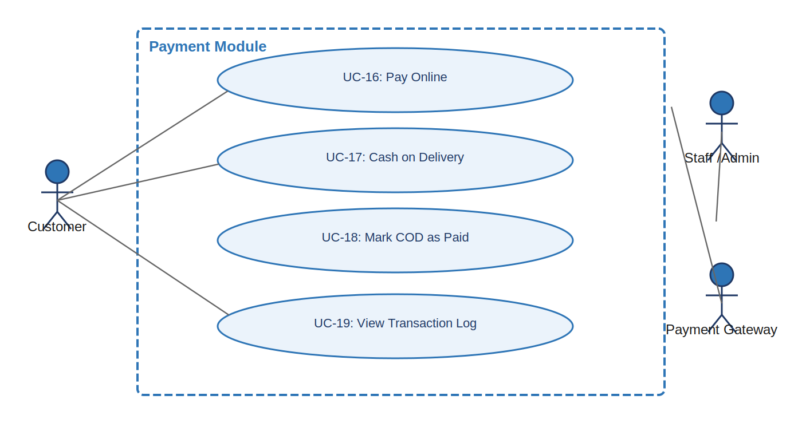
Figure 5 — Use Case Diagram: Payment Module

6.2 UC-16: Pay Online
UC-16 Pay Online [High]
Use Case ID | UC-16
Use Case Name | Pay Online
Module | Payment Module
Priority | High
Actor(s) | Primary: Customer | Secondary: Payment Gateway
Goal | Allow the customer to pay for a confirmed order using an online payment gateway.
Pre-conditions | Order is in 'Assigned' status with a confirmed final price. Customer is logged in.
Post-conditions | Payment is processed. Order payment status is updated to 'Paid'. Receipt sent to customer.
Primary Scenario | 1. Customer views the confirmed order and clicks 'Pay Now'.  2. Customer selects 'Pay Online'.  3. System redirects to payment gateway (Razorpay / Stripe / PayU).  4. Customer selects payment method: Credit/Debit Card, UPI, or Net Banking.  5. Customer completes authentication and confirms payment.  6. Payment gateway sends a success callback to the TMS.  7. System updates payment status to 'Paid' and sends a receipt via email.
Alternative Scenarios | Customer can switch to COD at any point before completing payment on the gateway.
Exception Scenarios | 5a. Payment is declined by bank — gateway returns failure; system shows error and allows retry.  6a. Gateway callback timeout — system sets status to 'Payment Verification Pending' and retries verification.
Frequency of Use | Once per order (for online payment orders).
Business Rules | Payment must be received before the driver begins pickup.
Special Requirements | No sensitive payment data is stored on TMS. All transactions comply with PCI-DSS standards.

6.3 UC-17: Cash on Delivery (COD)
UC-17 Cash on Delivery (COD) [High]
Use Case ID | UC-17
Use Case Name | Cash on Delivery (COD)
Module | Payment Module
Priority | High
Actor(s) | Primary: Customer | Secondary: Driver, Staff
Goal | Allow the customer to choose COD as a payment option, deferring payment to the time of delivery.
Pre-conditions | Order is in 'Assigned' status with a confirmed price. Customer is logged in.
Post-conditions | Order payment status is set to 'COD Pending'. Driver is informed of the COD amount to collect.
Primary Scenario | 1. Customer views the confirmed order and clicks 'Pay Now'.  2. Customer selects 'Cash on Delivery'.  3. System displays the COD amount and a confirmation prompt.  4. Customer confirms.  5. System updates payment status to 'COD Pending'.  6. Driver is notified of the COD amount to collect at delivery.
Alternative Scenarios | Customer can switch from COD to online payment before the driver is dispatched.
Exception Scenarios | If the customer is unavailable at delivery and payment cannot be collected, driver reports the issue and staff follows up.
Frequency of Use | For every COD order — common for first-time or less tech-savvy customers.
Business Rules | COD orders are allowed only for orders below a maximum value threshold set by the business.
Special Requirements | Staff must manually mark the COD as collected after driver confirmation — see UC-18.

6.4 UC-18: Mark COD as Paid
UC-18 Mark COD as Paid [High]
Use Case ID | UC-18
Use Case Name | Mark COD as Paid
Module | Payment Module
Priority | High
Actor(s) | Primary: Staff / Admin
Goal | Allow staff to update the payment status of a COD order to 'Paid' after the driver confirms cash collection.
Pre-conditions | Order has been delivered. Payment status is 'COD Pending'. Staff is logged in.
Post-conditions | Payment status is updated to 'Paid (COD)'. Transaction is logged with timestamp.
Primary Scenario | 1. Staff navigates to Payments and filters by 'COD Pending'.  2. Staff finds the delivered order.  3. Staff clicks 'Mark as Paid'.  4. System prompts a confirmation: 'Confirm cash of [amount] collected for Order #XXXX?'  5. Staff confirms.  6. System updates payment status to 'Paid (COD)' and logs the transaction.
Alternative Scenarios | If cash was not collected (customer absent), staff can mark the order as 'Payment Not Collected' and log a reason.
Exception Scenarios | System prevents double-marking — if payment is already marked as Paid, the action is disabled.
Frequency of Use | Once per COD order after delivery.
Business Rules | This action is logged with the staff member's name and timestamp for accountability.
Special Requirements | All COD payment records are retained and cannot be deleted.

6.5 UC-19: View Transaction Log
UC-19 View Transaction Log [Medium]
Use Case ID | UC-19
Use Case Name | View Transaction Log
Module | Payment Module
Priority | Medium
Actor(s) | Primary: Staff / Admin | Secondary: Business Owner
Goal | Allow staff and the business owner to view a full log of all payment transactions.
Pre-conditions | Staff or Business Owner is logged in.
Post-conditions | User can see all transaction records with details and filter/export them.
Primary Scenario | 1. Staff navigates to Payments > Transaction Log.  2. System displays all transactions with: Order ID, Amount, Payment Mode, Status, Date, Customer Name.  3. Staff can filter by date range, payment mode, or status.  4. Staff can export the report as PDF or Excel.
Alternative Scenarios | Business Owner can view the same log from the Dashboard module.
Exception Scenarios | If no transactions exist for the selected filter, system shows: 'No transactions found for this filter.'
Frequency of Use | Daily by staff for reconciliation; weekly by the owner for revenue review.
Business Rules | Transaction data is read-only. No editing or deletion is allowed.
Special Requirements | Export functionality must generate a properly formatted PDF or Excel file within 10 seconds.

7. Business Dashboard Module
The Business Dashboard provides the GoodWill Company owner with a real-time overview of all business operations — orders, revenue, fleet, and driver performance — in a single view.
Actors: Business Owner (Primary)

7.1 Use Case Diagram — Dashboard Module
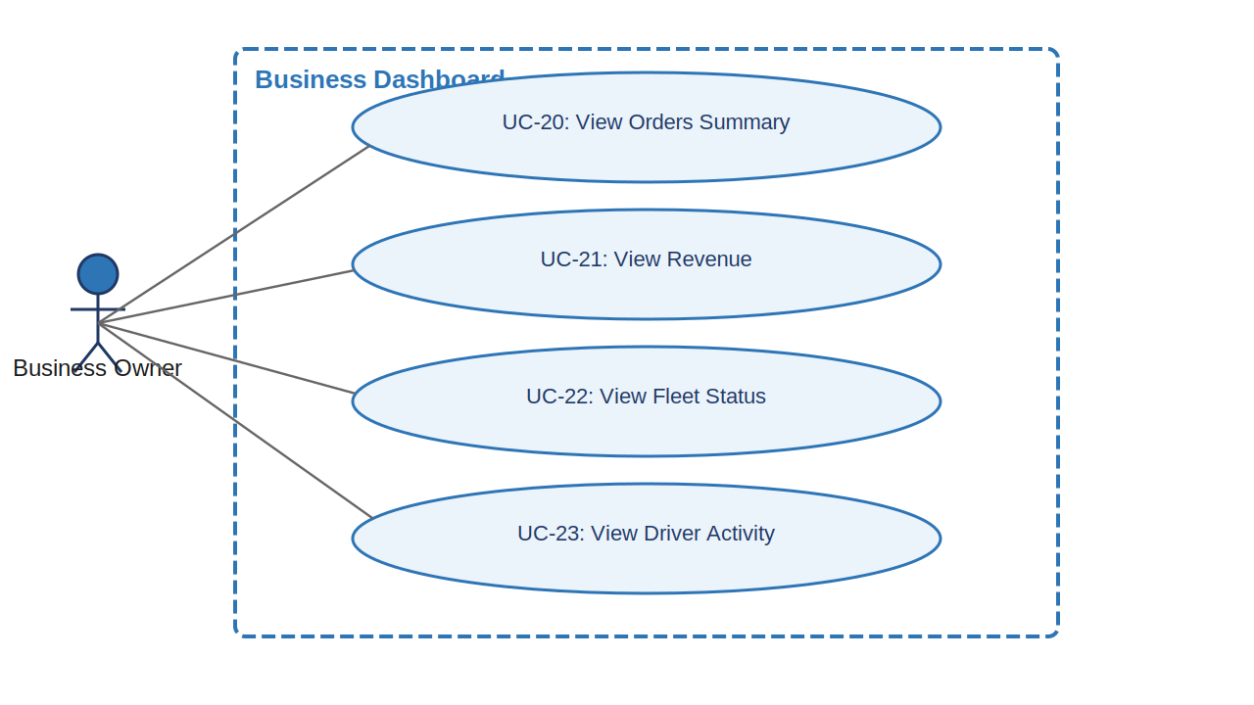
Figure 6 — Use Case Diagram: Business Dashboard Module

7.2 UC-20: View Orders Summary
UC-20 View Orders Summary [High]
Use Case ID | UC-20
Use Case Name | View Orders Summary
Module | Business Dashboard
Priority | High
Actor(s) | Primary: Business Owner
Goal | Allow the business owner to see a summary of all orders in a given time period.
Pre-conditions | Business Owner is logged in.
Post-conditions | Owner has a clear view of order volumes and statuses.
Primary Scenario | 1. Owner opens the dashboard.  2. System displays order summary cards:  - Total Orders Today  - Total Orders This Week  - Total Orders This Month  - Orders by Status (Pending / Assigned / In Transit / Delivered)  3. Owner can click on any status count to see the filtered order list.
Alternative Scenarios | Owner can change the date range using a date picker to view orders for custom periods.
Exception Scenarios | If no orders exist for the selected period, system shows: 'No orders for this period.'
Frequency of Use | Daily — first thing in the morning to assess the day's workload.
Business Rules | Business Owner has read-only access to the dashboard. No order modifications are allowed from here.
Special Requirements | Dashboard data must refresh every 5 minutes automatically.

7.3 UC-21: View Revenue
UC-21 View Revenue [High]
Use Case ID | UC-21
Use Case Name | View Revenue
Module | Business Dashboard
Priority | High
Actor(s) | Primary: Business Owner
Goal | Allow the business owner to view total revenue collected, broken down by payment mode and time period.
Pre-conditions | Business Owner is logged in. At least one payment has been processed.
Post-conditions | Owner sees revenue data and pending collections clearly.
Primary Scenario | 1. Owner navigates to the Revenue section of the dashboard.  2. System displays:  - Total Revenue Today / This Week / This Month  - Revenue split: Online Payments vs COD Collected  - Pending COD amount (not yet collected)  3. Owner can filter by date range and view a simple chart.
Alternative Scenarios | Owner can view revenue per driver (how much business each driver has generated).
Exception Scenarios | If no payments have been recorded, all values display as 0 with a note: 'No revenue data available yet.'
Frequency of Use | Daily or weekly, for financial review.
Business Rules | Revenue figures are calculated from confirmed 'Paid' and 'Paid (COD)' transactions only.
Special Requirements | Revenue chart must clearly distinguish between online and COD collections.

7.4 UC-22: View Fleet Status
UC-22 View Fleet Status [High]
Use Case ID | UC-22
Use Case Name | View Fleet Status
Module | Business Dashboard
Priority | High
Actor(s) | Primary: Business Owner
Goal | Allow the business owner to see the current status of all vehicles in the fleet at a glance.
Pre-conditions | Business Owner is logged in. Vehicles have been added by staff.
Post-conditions | Owner can see how many vehicles are available, in use, and under maintenance.
Primary Scenario | 1. Owner views the Fleet section of the dashboard.  2. System displays:  - Total Vehicles in Fleet  - Available (count)  - In Use / On Trip (count) — with trip and driver info  - Under Maintenance (count)  3. Owner can click on each vehicle to see its current assignment details.
Alternative Scenarios | N/A
Exception Scenarios | If no vehicles have been added yet, dashboard shows: 'No vehicles in fleet. Ask staff to add vehicles.'
Frequency of Use | Daily — to assess available capacity for incoming orders.
Business Rules | Vehicle status reflects live updates from staff assignments.
Special Requirements | Fleet status must update in real time when staff change vehicle assignments.

7.5 UC-23: View Driver Activity
UC-23 View Driver Activity [Medium]
Use Case ID | UC-23
Use Case Name | View Driver Activity
Module | Business Dashboard
Priority | Medium
Actor(s) | Primary: Business Owner
Goal | Allow the business owner to see driver-level activity including trips completed and current assignment.
Pre-conditions | Business Owner is logged in. Drivers have been added and trips have been assigned.
Post-conditions | Owner has a per-driver summary useful for performance review.
Primary Scenario | 1. Owner navigates to the Drivers section of the dashboard.  2. System displays a list of all active drivers with:  - Driver Name  - Current Status (On Trip / Available / Off Duty)  - Trips Completed Today  - Trips Completed This Month  3. Owner can click on a driver to see their full trip history.
Alternative Scenarios | Owner can sort drivers by trips completed (most to least) to identify top performers.
Exception Scenarios | If no driver activity exists, system shows: 'No driver activity recorded yet.'
Frequency of Use | Weekly — for performance review and trip load assessment.
Business Rules | Read-only view. Owner cannot modify driver data from here.
Special Requirements | Driver activity data must be accurate and consistent with the order records in the system.

8. Use Case Summary Table
The following table summarizes all 23 use cases across the 5 modules of the TMS for GoodWill Company.

UC ID | Module | Use Case Name | Actor(s) | Priority
UC-01 | Customer | Register and Login | Customer | High
UC-02 | Customer | Place a Transport Order | Customer | High
UC-03 | Customer | View Order History and Status | Customer | High
UC-09 | Customer | Make Payment | Customer, Payment Gateway | High
UC-10 | Customer | Receive Delivery Notifications | Customer, System | Medium
UC-04 | Staff | View and Manage Incoming Orders | Staff / Admin | High
UC-05 | Staff | Assign Driver and Vehicle | Staff / Admin | High
UC-06 | Staff | Set / Adjust Order Price | Staff / Admin | High
UC-07 | Staff | Manage Drivers | Staff / Admin | High
UC-08 | Staff | Manage Vehicles | Staff / Admin | High
UC-11 | Staff | View Payments and Transactions | Staff / Admin | Medium
UC-12 | Driver | Driver Login | Driver | High
UC-13 | Driver | View Assigned Trips | Driver | High
UC-14 | Driver | Update Trip Status | Driver | High
UC-15 | Driver | Upload Proof of Delivery | Driver | High
UC-16 | Payment | Pay Online | Customer, Payment Gateway | High
UC-17 | Payment | Cash on Delivery (COD) | Customer, Driver, Staff | High
UC-18 | Payment | Mark COD as Paid | Staff / Admin | High
UC-19 | Payment | View Transaction Log | Staff, Business Owner | Medium
UC-20 | Dashboard | View Orders Summary | Business Owner | High
UC-21 | Dashboard | View Revenue | Business Owner | High
UC-22 | Dashboard | View Fleet Status | Business Owner | High
UC-23 | Dashboard | View Driver Activity | Business Owner | Medium

