©VIT IPR&TTCELL
 Invention Disclosure Format (IDF)-A | Document No. | 02-IPR-R002
 | Issue No/Date | 2/01.02.2024
 | Amd. No/Date | 0/00.00.0000

1. Inventor(s) information

(i) | Full Name | Pratik A Shah
 | VIT Employee ID: | 22MID0281
 | Gender | Male
 | Nationality | Indian
 | Position | Student
 | Department | Department of Database Systems
 | School/Center | SCOPE
 | Phone & E-Mail (Office) | 7695988324, pratik.ashah2022@vitstudent.ac.in
 | Complete Address (Office) | T Block 1231,VIT Vellore Men’s Hostel,VIT University,Tiruvalam road,Vellore.  Pin code:632014
(ii) | Full Name | Anurag Paul
 | VIT Employee ID: | 22MID0080
 | Gender | Male
 | Nationality | Indian
 | Position | Student
 | Department | Department of Database Systems
 | School/Center | SCOPE
 | Phone & E-Mail (Office) | 9862558439, anurag.paul2022@vitstudent.ac.in
 | Complete Address (Office) | D Block402,VIT Vellore Men’s Hostel,VIT University,Tiruvalam road,Vellore.  Pin code:632014
(iii) | Full Name | Sai Yoshitha Natakala
 | VIT Employee ID: | 22MID0167
 | Gender | Female
 | Nationality | Indian
 | Position | Student
 | Department | Department of Database Systems
 | School/Center | SCOPE
 | Phone & E-Mail (Office) | 9182738764, saiyoshitha.n2022@vitstudent.ac.in
 | Complete Address (Office) | E Block 922,,VIT Vellore Girls Hostel,VIT University,Tiruvalam road,Vellore.  Pin code:632014
(iv) | Full Name | S. Jewel Reddy
 | VIT Employee ID: | 22MID0161
 | Gender | Female
 | Nationality | Indian
 | Position | Student
 | Department | Department of Database Systems
 | School/Center | SCOPE
 | Phone & E-Mail (Office) | 8008136729, jewelreddy.s2022@vitstudent.ac.in
 | Complete Address (Office) | F block, 901,VIT Vellore Girls Hostel,VIT University,Tiruvalam road,  Vellore. Pin code:632014
(v) | Full Name | Dr.ArulKumar V
 | VIT Employee ID:
 | Gender | Male
 | Nationality | Indian
 | Position
 | Department
 | School/Center
 | Phone & E-Mail (Office)
 | Complete Address (Office)

NOTE:
In case of co-inventors from external organization (Academic institution/ Industry / R&D lab/Funding agency with specific IP sharing agreement) contact IPR&TT Cell before submitting the IDF.

Declaration:

I declare that the information provided in this document is complete and true to the best of my knowledge and based on records.

Date: 03/05/2026

Inventor Name: Pratik A Shah
Signature:
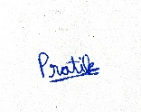

Inventor Name: Anurag Paul
Signature:
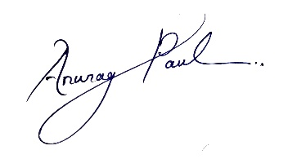
Inventor Name: Sai Yoshitha Natakala
Signature:
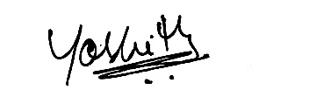

Inventor Name: S. Jewel Reddy
Signature:

Inventor Name: Dr.ArulKumar V
Signature:

---------------------END OF THE DOCUMENT-----------------------------

