 Invention Disclosure Format (IDF)-B | Document No. | 02-IPR-R003
 | Issue No/Date | 2/01.02.2024
 | Amd. No/Date | 0/00.00.0000

- Title of the invention:

Systems and Methods for Fingerprint-Guided Multi-Agent Automated Data Science with Cross-Phase Artifact Propagation, Fingerprint consistency gate, and Pre-Execution Code Safety Validation

- Field /Area of invention:

The invention pertains to computer-implemented automated data-processing systems for tabular datasets, particularly systems that use structured dataset fingerprinting, bounded execution planning, deterministic generated-code validation, data-integrity gating, phase-indexed artifact propagation, checkpointed execution, and reproducible machine-learning workflow orchestration.

- Prior Patents and Publications from literature (provide a table summarizing the prior art)

Prior Art Category | Prior Art Description | Limitations Addressed by This Invention
Traditional AutoML Systems | Systems such as TPOT, Auto-sklearn, and similar AutoML frameworks search through machine-learning pipelines using genetic programming, Bayesian optimization, or predefined model spaces. | Focus is limited to model search and performance optimization.  No use of a structured dataset fingerprint as a lifecycle control signal across ingestion, planning, modeling, integrity validation, and reporting.
Automated Tabular Modeling Frameworks | Frameworks such as AutoGluon automate model selection, ensembling, stacking, and tabular prediction workflows. | Lack of workflow centralization around phase-indexed artifact propagation, deterministic generated-code validation, fingerprint consistency gating, and market-basket-aware target suppression.
Notebook and LLM-Based Code Agents | LLM agents and notebook automation tools generate executable analysis code from prompts or contextual instructions. | Generated code may be unsafe, brittle, or non-reproducible due to absence of deterministic pre-execution AST validation, structured provenance tracking, and post-transformation data-integrity checks.
Data Quality and Validation Tools | Data profiling and validation tools detect missing values, schema issues, duplicate rows, data drift, or quality anomalies. | Operate as standalone validation components.  No integration of fingerprint-guided execution planning, automated modeling, artifact propagation, code validation, checkpointing, and report synthesis into a unified lifecycle.
Market-Basket Analysis Tools | Association-rule and item-frequency tools analyze sparse transaction data, item co-occurrence, and basket patterns. | No integration into a full automated data-science workflow.  Do not prevent unsafe supervised target inference or preserve duplicate transaction rows as frequency signal within a broader automated pipeline.

- Summary and background of the invention (Address the gap / Novelty)

The invention addresses the technical problem of unsafe, unbounded, and non-auditable automated data-science execution on tabular datasets. Existing automated machine-learning and code-generation systems often begin model search or code execution without first using a structured representation of the dataset as a lifecycle control signal. This can result in unsafe generated code, silent corruption of dataset structure during automated cleaning, unsupported target inference, loss of reproducible context between workflow phases, and unnecessary model-search overhead.

The invention addresses these gaps through four cooperating technical mechanisms:

1. Structured fingerprint-guided execution:
A structured data fingerprint is computed before execution planning.
The fingerprint includes dataset shape, feature-type distribution, missingness, duplicate ratio, sparsity, correlation density, target characteristics, class balance, outlier metrics, noise estimate, suggested task, suggested model families, and memory footprint.
The fingerprint is used as an execution-control signal for planning, branch routing, model-family selection, integrity validation, and report synthesis.

2. Phase-indexed artifact propagation:
A phase-indexed artifact registry stores typed outputs from each lifecycle phase and supplies bounded upstream context to downstream agents.
This improves reproducibility, auditability, and controlled execution.

3. Safety and integrity gating:
A fingerprint consistency gate compares pre-mutation and post-mutation fingerprints to detect row loss, target mutation, sparsity drift, statistical drift, and memory-footprint changes.
Generated Python code is also parsed into an abstract syntax tree before execution and rejected when it contains prohibited imports, dynamic execution, filesystem mutation, network access, or dunder traversal patterns.

4. Market-basket-aware routing:
For sparse item-slot transaction datasets, the invention detects market-basket structure, suppresses unsupported supervised target inference, preserves duplicate transaction rows as frequency signals, and routes execution toward basket profiling and reporting unless an explicit target is supplied.

Accordingly, the invention is directed to a technical control architecture for safer, bounded, and reproducible automated data processing, rather than merely to automated model selection or abstract data analysis.

- Objective(s) of Invention

1. To automate ingestion, profiling, exploratory analysis, modeling, evaluation, reporting, checkpointing, and event streaming for tabular datasets.

2. To compute a structured data fingerprint before model training or analysis execution.

3. To use the structured data fingerprint as a lifecycle control signal for execution planning, branch routing, model-family selection, integrity validation, and report synthesis.

4. To generate bounded execution plans based on dataset characteristics rather than relying on unbounded brute-force model search.

5. To preserve lifecycle outputs as typed artifacts in a phase-indexed artifact registry for downstream context, auditability, and reproducibility.

6. To detect harmful data changes introduced by automated cleaning or transformation by comparing pre-mutation and post-mutation structured fingerprints.

7. To generate anomaly artifacts when configured thresholds for row loss, sparsity drift, statistical drift, target mutation, or memory-footprint change are exceeded.

8. To validate generated executable code through deterministic abstract syntax tree inspection before execution.

9. To reject generated code containing prohibited imports, unsafe dynamic execution, filesystem mutation, network access, or dunder traversal patterns.

10. To identify sparse item-slot market-basket datasets and avoid unsupported supervised target inference.

11. To preserve duplicate transaction rows as frequency signals in market-basket datasets.

- Working principle of the invent (in brief)

The invention operates through a controlled automated data-science workflow for tabular datasets.

1. Dataset receipt and fingerprinting:
The system first receives a tabular dataset and an optional target column.
The dataset is parsed, schema characteristics are detected, and a structured data fingerprint is computed before model training or downstream analysis.
The fingerprint captures structural, statistical, sparsity, target-state, duplicate-row, and memory-footprint characteristics of the dataset.

2. Fingerprint-guided planning:
A planner uses the structured fingerprint and target-column state to generate a bounded lifecycle execution plan. The plan determines whether the workflow should proceed through exploratory analysis, supervised modeling, market-basket profiling, checkpointing, event streaming, report generation, or a combination of these phases.

3. Pre-execution code safety:
Before generated Python code is executed, the code is parsed into an abstract syntax tree.
The validator checks the parsed tree against prohibited imports, unsafe dynamic execution, filesystem mutation, network access, and dunder traversal patterns.
Code that violates the configured safety rules is rejected before runtime.

4. Data-integrity monitoring:
Data cleaning and transformation are monitored by comparing pre-mutation and post-mutation fingerprints.
If configured thresholds for row loss, sparsity drift, statistical drift, target mutation, or memory-footprint change are exceeded, the system emits anomaly artifacts and integrity events.

5. Artifact propagation and routing:
Lifecycle outputs are stored as typed artifacts in a phase-indexed artifact registry.
Downstream agents retrieve bounded context from the registry for exploratory analysis, modeling, market-basket profiling, checkpointing, event streaming, and report generation.
For sparse item-slot transaction datasets without an explicit target,
the system suppresses supervised modeling and routes execution to market-basket profiling while preserving repeated transaction rows as frequency signals.

- Description of the invention in detail (Include drawing and or photograph as needed)

The invention comprises five main functional blocks.

(A) Data Ingestion and Fingerprinting Block:
The system receives tabular files such as CSV, TSV, JSON, Excel, and Parquet.
The ingestion module parses the file, detects schema, identifies data types, calculates null counts, detects duplicate rows, assesses data quality, and performs conservative cleaning.
A structured data fingerprint is computed before downstream execution.
The fingerprint includes row count, column count, dimensionality ratio, feature-type counts, missingness, sparsity, duplicate-row ratio, correlation metrics, target type, class balance, outlier ratio, noise estimate, suggested task, suggested model families, and memory footprint.

(B) Lifecycle Planning and Artifact Registry Block:
A planner generates a bounded lifecycle execution plan based on the fingerprint and target-column state.
The plan may include profiling, exploratory analysis, supervised modeling, market-basket profiling, checkpointing, event streaming, and report generation.
A phase-indexed artifact registry stores typed outputs from each phase, including schema artifacts, fingerprints, cleaning logs, statistics, generated code, model metrics, integrity results, events, and reports.

(C) Safety and Integrity Block:
Generated Python code is parsed into an abstract syntax tree before execution.
The validator rejects prohibited imports, dynamic execution calls, filesystem mutation operations, network access operations, and dunder traversal patterns.
A fingerprint consistency gate compares pre-mutation and post-mutation fingerprints to detect row loss, sparsity drift, statistical drift, target-type mutation, and memory-footprint change.

(D) Modeling and Branch-Routing Block:
When supervised modeling is appropriate, the modeling agent trains bounded candidate model families selected from the fingerprint.
When sparse item-slot transaction structure is detected and no explicit target is supplied, supervised target inference is suppressed and execution is routed to market-basket profiling.

(E) Checkpointing, Event, and Reporting Block:
The checkpoint manager stores phase status, current phase, execution plan, target column, metadata, metrics, and serialized artifacts.
The event stream emits structured events for phase start, phase completion, integrity status, plan generation, pipeline completion, and failure.
The report module synthesizes stored artifacts into a final analysis report.

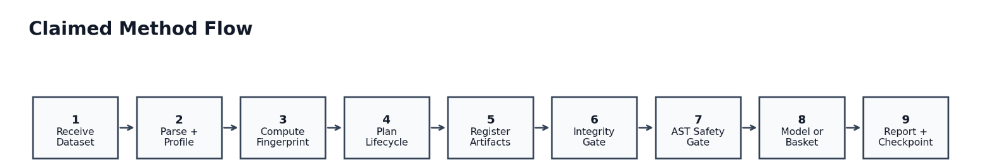

Figure 1: Method flow from dataset ingestion to schema detection, pre-mutation fingerprint computation, bounded execution-plan generation, AST-based generated-code validation, controlled execution, post-mutation fingerprint computation, fingerprint comparison, artifact storage, branch routing, checkpointing, and report synthesis.

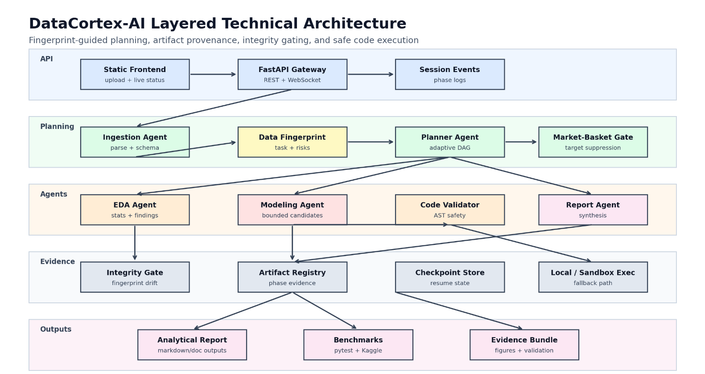

Figure 2: Overall system architecture showing the data ingestion module, structured fingerprinter, lifecycle planner, phase-indexed artifact registry, AST-based generated-code validator, fingerprint consistency gate, supervised modeling branch, market-basket profiling branch, checkpoint manager, event stream, and report generator.

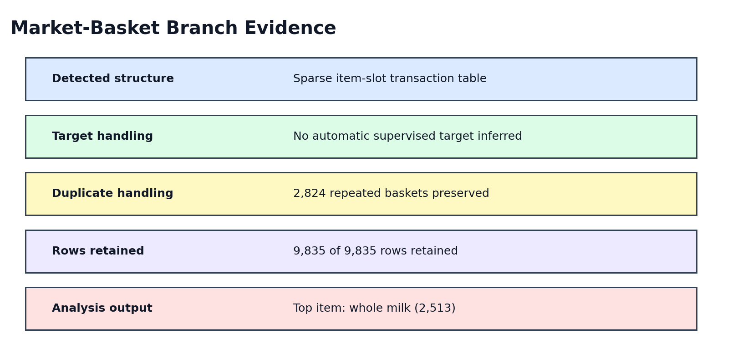

Figure 3: Safety and integrity flow showing generated-code parsing, prohibited-node detection, execution rejection or approval, pre-mutation fingerprint capture, post-mutation fingerprint capture, drift-threshold comparison, anomaly-artifact generation, and event emission.

- Experimental validation results:

The system was validated under laboratory conditions using automated regression tests, validation scripts, benchmark datasets, end-to-end public dataset runs, failure-mode checks, baseline comparisons, and generated evidence artifacts.

A) Automated regression validation:
The test suite covers artifact registry behavior, checkpointing, code validation, configuration, fingerprint computation, consistency checking, ingestion target detection, modeling regression behavior, comparative benchmarks, and planner demo flow.

B) Validation benchmark results:
The completed datasets include Iris, Churn, Credit Risk, Housing, Hard Benchmark, Titanic, and Airline Satisfaction.
Task detection accuracy on completed validation datasets was 7/7.
All completed benchmark datasets recorded integrity status as pass.
The average recorded benchmark score was 0.904, using dataset-specific metrics.

C) Static code-safety validation:
The scripted static attack set recorded a 100% block rate for covered unsafe code patterns.
The validator rejects prohibited imports, unsafe built-ins, dynamic execution, network access, filesystem mutation, and dunder traversal before execution.
This supports the claimed pre-execution safety gate, while not claiming a complete security sandbox.

D) End-to-end public dataset validation:
A Kaggle Titanic run completed ingestion, profiling, exploratory analysis, modeling, and reporting.
The RandomForest model achieved test accuracy of 0.8212 and cross-validation accuracy of 0.8216.
A Kaggle Groceries run detected market_basket structure, preserved 9,835 of 9,835 rows, retained 2,824 repeated basket rows as transaction-frequency signal, skipped unsupported supervised modeling, and identified whole milk as the top item with count 2,513.

E) Failure-mode validation:
Six identified risks were mapped to tests or end-to-end artifacts, and all six recorded pass status.
These risks include market-basket data being misread as supervised classification, duplicate basket rows being removed as ordinary duplicates, unsafe generated Python being accepted, long-running modeling appearing opaque, invalid target selection from structural item-slot columns, and validation reports overstating evidence quality.

F) Comparative benchmark validation:
The executable comparison harness compared dummy, linear, tree, boosting, fingerprint-selected DataCortex candidates, and a broad local model pool using the same folds, preprocessing, and metrics.
Across 6 datasets, the fingerprint-selected policy recorded a mean lift of 0.3857 over dummy baselines, a mean gap of 0.0042 to the broad local pool, and a mean search-budget ratio of 0.672 compared with the broad pool.

G) Evidence quality grading:
The current evidence supports TRL 4 laboratory validation.
Automated regression tests are the strongest evidence for core behavior stability.
Local fixture benchmarks and Kaggle end-to-end runs support prototype operation across representative datasets. Dummy-baseline comparisons provide sanity checks, while capability comparisons provide mechanism-level distinction only.
The current evidence does not claim production certification, external leaderboard superiority, or complete security assurance.

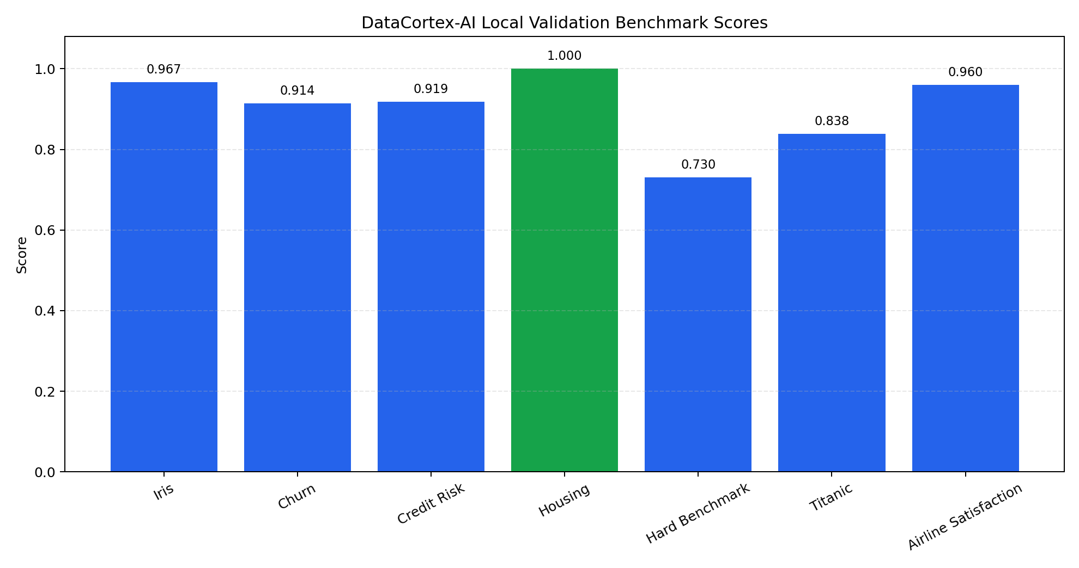
Figure 4: Market-basket execution branch showing sparse item-slot detection, target-column state checking, suppression of unsupported supervised target inference, preservation of duplicate transaction rows as frequency signals, item-frequency computation, and market-basket recommendation generation.

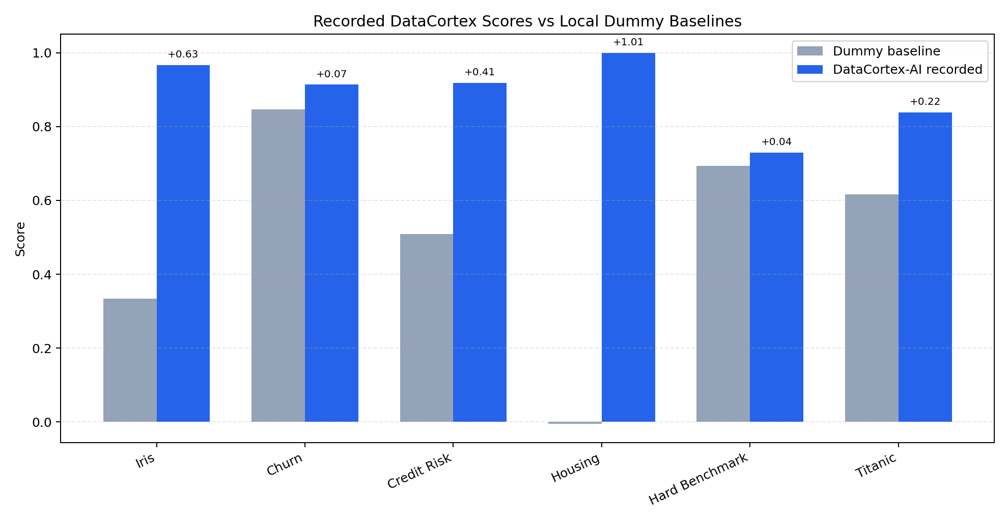
Figure 5: Validation evidence showing benchmark task-detection results, static code-safety attack blocking, supervised model performance, market-basket row preservation, and comparative candidate-model evaluation.

- What aspect(s) of the invention need(s) protection?

1. The complete fingerprint-guided multi-agent automated data-science workflow for tabular datasets.

2. The method of computing a structured data fingerprint before model training or analysis execution.

3. The use of the structured data fingerprint as a lifecycle control signal for execution planning, branch routing, model-family selection, data-integrity validation, and report synthesis.

4. The generation of bounded execution plans based on dataset characteristics rather than unbounded brute-force model search.

5. The phase-indexed artifact registry for storing typed lifecycle outputs and supplying bounded upstream context to downstream agents.

6. The fingerprint consistency gate for comparing pre-mutation and post-mutation fingerprints to detect row loss, sparsity drift, statistical drift, target-type mutation, and memory-footprint change.

7. The generation of structured anomaly artifacts when configured data-integrity thresholds are exceeded.

8. The deterministic AST-based generated-code validator that rejects prohibited imports, dynamic execution, filesystem mutation, network access, and dunder traversal before execution.

9. The market-basket-aware routing method that detects sparse item-slot transaction structure and suppresses unsupported supervised target inference.

10. The preservation of repeated transaction rows as frequency signals in market-basket datasets.

11. The combined architecture comprising fingerprint-guided planning, artifact propagation, data-integrity gating, generated-code validation, checkpointing, event streaming, branch routing, and report synthesis.
Invention Disclosure Format (IDF)-B | Document No. | 02-IPR-R003
 | Issue No/Date | 2/01.02.2024
 | Amd. No/Date | 0/00.00.0000

- What is Technology readiness level of your invention? (Tick the appropriate TRL)

Research |  |  | Development |  |  | Deployment
TRL 1 | TRL 2 | TRL 3 | TRL 4 | TRL 5 | TRL 6 | TRL 7 | TRL 8 | TRL 9
Basic | Technology | Experimental | Technology | Technology | Technology | System | System | Actual system
Principles | concept | proof of | validated in | validated in a | demonstrated | prototype | complete | proven in an
observed | formulated | concept | a lab | relevant | in a relevant | demonstration | and | operational
 |  |  |  | environment | environment | in an | qualified | environment
 |  |  |  | (industrially | (industrially | operational |  | (competitive
 |  |  |  | relevant in | relevant in | environment |  | manufacturing
 |  |  |  | case of key | case of key |  |  | in case of key
 |  |  |  | enabling | enabling |  |  | enabling
 |  |  |  | technologies) | technologies) |  |  | technologies,
 |  |  |  |  |  |  |  | or in space )
 |  |  | ✔️
Justification of TRL 4:
- Working laboratory prototype implemented in Python with the core modules operational
- Includes ingestion, data fingerprinting, planning, artifact propagation, data-integrity checking, generated-code validation, modeling, checkpointing, and reporting
- Automated unit and regression tests passed locally, with 74 recorded passing tests
- Validated on repository fixtures and benchmark datasets under controlled local conditions
- Demonstrated through end-to-end local workflows, including supervised classification and market-basket analysis
- Suitable for laboratory validation, but not yet independently validated, production deployed, or formally certified for operational use

----------------------END OF THE DOCUMENT-----------------------------

