Invention Disclosure Format (IDF)-B | Document No. | 02-IPR-R003
Invention Disclosure Format (IDF)-B | Issue No/Date | 2/01.02.2024
Invention Disclosure Format (IDF)-B | Amd. No/Date | 0/00.00.0000

1. Title of the invention:
Systems and Methods for Fingerprint-Guided Multi-Agent Automated Data Science with Cross-Phase Artifact Propagation, Data-Integrity Gating, and Pre-Execution Code Safety Validation
2. Field /Area of invention:
The invention relates to automated data science, automated machine learning, generated-code validation, multi-agent workflow orchestration, data-quality monitoring, checkpointed workflow execution, and reproducible machine-learning evaluation for tabular datasets.
3. Prior Patents and Publications from literature (provide a table summarizing the prior art)
Reference / Framework | Summary of Prior Art | Limitation Addressed by the Invention
TPOT | Uses genetic programming to search machine-learning pipelines. | Searches broad pipeline permutations and does not use a phase-propagated dataset fingerprint as a lifecycle control signal.
Auto-sklearn | Uses Bayesian optimization and meta-learning over predefined ML pipeline spaces. | Does not combine fingerprint-guided planning, phase-indexed artifact propagation, integrity gating, and generated-code AST screening in one workflow.
AutoGluon | Automates tabular modeling through ensembling, stacking, and model selection. | Strong model automation, but not centered on cross-phase artifact provenance, deterministic code validation, or market-basket routing.
LLM / notebook code agents | Generate executable analysis code from prompts or notebook context. | Generated code may be unsafe or non-reproducible without deterministic AST validation, artifact provenance, and data-integrity checks.
Market-basket analysis tools | Compute association rules, item frequencies, or co-occurrence patterns for transaction data. | Generally do not integrate sparse transaction detection into a full automated data-science lifecycle with checkpointing and report synthesis.

4. Summary and background of the invention (Address the gap / Novelty)
Existing automated data-science systems often treat profiling, planning, modeling, code execution, and reporting as loosely connected stages. As a result, downstream phases may operate without a structured record of upstream schema, quality, cleaning, fingerprint, and modeling artifacts. Generated analysis code may also be executed without deterministic pre-execution safety checks, and automated cleaning can silently alter the data through row loss, sparsity drift, target mutation, or inappropriate duplicate removal.
The invention addresses this gap by using a structured data fingerprint as an execution-control signal before model training. The fingerprint guides task detection, lifecycle planning, bounded model-family selection, market-basket routing, and downstream context. A phase-indexed artifact registry preserves provenance across agents, a fingerprint consistency gate detects harmful data mutations, and an AST-based validator rejects unsafe generated Python code before execution.
The novelty lies in the coordinated technical combination of fingerprint-guided execution planning, cross-phase artifact propagation, data-integrity gating, deterministic generated-code validation, market-basket-aware target suppression, checkpointed execution, and structured progress events in a single automated data-science workflow.
5. Objective(s) of Invention
- Automate ingestion, profiling, exploratory analysis, modeling, evaluation, reporting, checkpointing, and event streaming for tabular datasets.
- Use dataset characteristics to select execution plans and bounded model families before training.
- Preserve lifecycle outputs as structured artifacts for downstream context, auditability, and reproducibility.
- Detect harmful data changes introduced by automated cleaning or transformation.
- Validate generated executable code through deterministic AST inspection before execution.
- Detect sparse item-slot market-basket datasets and avoid unsafe supervised target inference.
- Provide reproducible validation evidence through tests, benchmark scripts, and end-to-end demo runs.
6. Working principle of the invent (in brief)
- The system receives a tabular dataset and an optional target column.
- An ingestion module parses the file, detects schema, assesses data quality, performs conservative cleaning, and stores ingestion artifacts.
- A data fingerprinter computes dataset shape, feature-type distribution, missingness, duplicate ratio, sparsity, correlation density, target characteristics, class balance, outlier metrics, noise estimate, suggested task, and suggested model families.
- A planner uses the fingerprint and target-column state to select lifecycle phases such as EDA, supervised modeling, market-basket profiling, and reporting.
- Lifecycle agents store outputs in a phase-indexed artifact registry, and downstream agents retrieve bounded context from upstream artifacts.
- A data-integrity gate compares pre-mutation and post-mutation fingerprints to detect row loss, sparsity drift, statistical drift, or target-type mutation.
- Generated Python code is parsed into an AST and rejected when prohibited imports, dynamic execution, filesystem mutation, network access, or dunder traversal patterns are found.
- The workflow persists checkpoints and emits structured progress events for inspection, resumability, and user-interface visibility.
7. Description of the invention in detail (Include drawing and or photograph as needed)
The implementation is organized as a multi-agent automated data-science system. The ingestion agent supports CSV, TSV, JSON, Excel, and Parquet inputs; records schema, null counts, data types, duplicate status, quality issues, and cleaned dataframe samples; and avoids target inference when dataset structure does not support it.
The data fingerprint includes row and column counts, dimensionality ratio, memory estimate, numeric, categorical, temporal, and text-like column counts, high-cardinality indicators, missingness, sparsity, duplicate-row ratio, correlation density, maximum correlation, skewness, outlier ratio, noise estimate, target type, class count, class balance, suggested task, and suggested model families.
The planner constructs a lifecycle plan from the fingerprint. It runs supervised modeling only when an explicit target exists or the fingerprint supports a supervised task. For sparse item-slot transaction tables, the system suppresses automatic target selection, preserves duplicate baskets as transaction frequency signal, treats blank item slots as absent items, and produces market-basket summaries instead of unsupported classification or regression reports.
The artifact registry stores typed artifacts by phase, including schema, data quality, cleaning logs, data fingerprints, statistics, correlations, generated code, findings, model comparisons, metrics, feature importance, execution logs, and reports. This registry gives later phases structured upstream context rather than fragile unstructured shared state.
The generated-code validator applies deterministic pre-execution screening using Python AST parsing. It rejects prohibited modules such as os, subprocess, socket, requests, urllib, pickle, marshal, shelve, and pathlib; prohibited builtins such as eval, exec, __import__, open, input, globals, and locals; filesystem mutation methods; and dunder attribute traversal.
Drawings/attachments: Figure 1 may show the overall architecture, Figure 2 the claimed method flow, and Figure 3 the market-basket branch. Existing project figures are available in the disclosure artifact folder for attachment to the filing package.
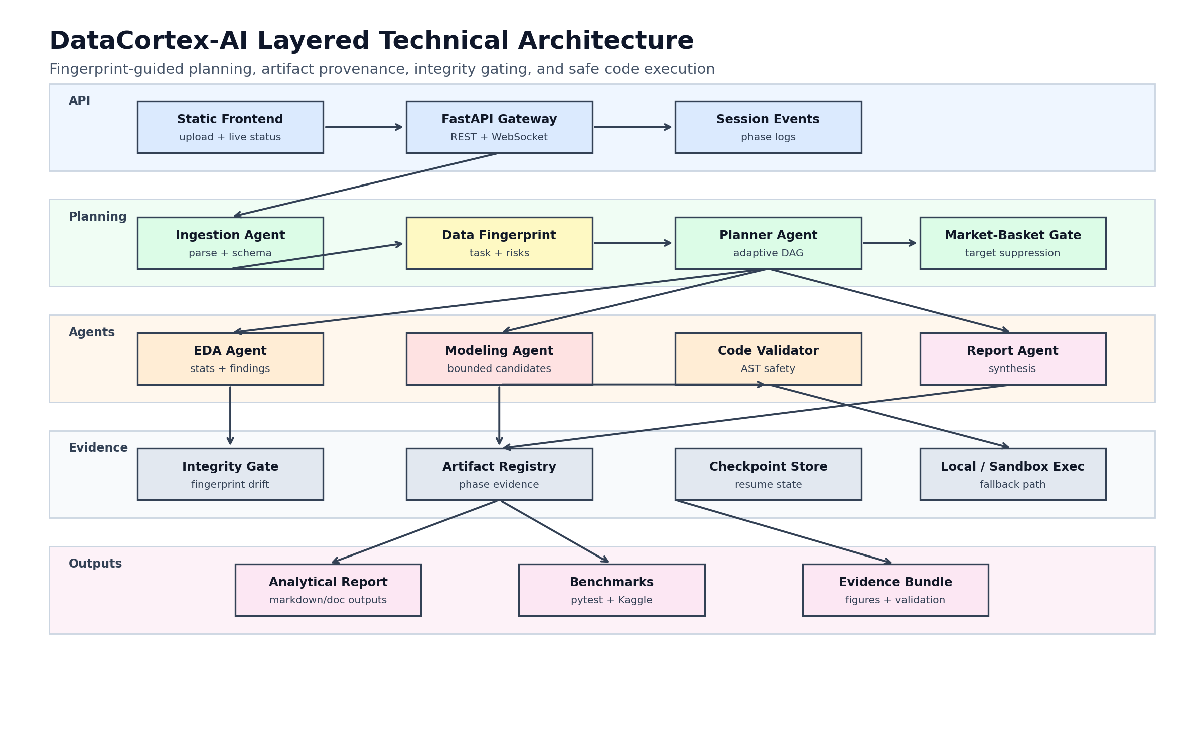
Figure 1: Overall architecture of the fingerprint-guided multi-agent automated data-science workflow.
8. Experimental validation results:
- Automated unit and regression tests recorded in the workspace: 74 passed.
- Completed validation benchmark datasets: 7; skipped validation datasets: 1.
- Task detection accuracy on completed validation datasets: 7/7.
- Static code-safety scripted attack block rate: 100%.
- Average best benchmark score across completed validation datasets: 0.904.
- Kaggle Titanic end-to-end run completed ingestion, profiling, EDA, modeling, and reporting with RandomForest test accuracy of 0.8212 and CV accuracy of 0.8216 +/- 0.0203.
- Kaggle Groceries end-to-end run detected market_basket structure, preserved 9,835 of 9,835 rows, and retained 2,824 repeated basket rows as frequency signal.
- The current evidence supports local laboratory validation and does not assert production security certification, external state-of-the-art superiority, or legal protectability.
9. What aspect(s) of the invention need(s) protection?
- Computing a structured data fingerprint and using it to select a bounded lifecycle execution plan before model training.
- Selecting candidate model families from fingerprint metrics rather than relying only on broad brute-force pipeline search.
- Propagating typed artifacts between lifecycle agents through a phase-indexed artifact registry.
- Comparing pre-mutation and post-mutation fingerprints to detect data-integrity anomalies.
- Validating generated executable code through deterministic AST inspection before execution.
- Detecting sparse market-basket item-slot structure and suppressing unsafe supervised target inference.
- Preserving duplicate transaction rows as frequency signal in market-basket datasets.
- Combining fingerprint-guided planning, artifact propagation, code validation, checkpointing, event streaming, and report synthesis in one automated data-science workflow.

Invention Disclosure Format (IDF)-B | Document No. | 02-IPR-R003
Invention Disclosure Format (IDF)-B | Issue No/Date | 2/01.02.2024
Invention Disclosure Format (IDF)-B | Amd. No/Date | 0/00.00.0000

10. What is Technology readiness level of your invention? (Tick the appropriate TRL)
Research | Research | Research | Development | Development | Development | Deployment | Deployment | Deployment
TRL 1 | TRL 2 | TRL 3 | TRL 4 | TRL 5 | TRL 6 | TRL 7 | TRL 8 | TRL 9
Basic  principles  observed | Technology  concept  formulated | Experimental  proof of  concept | Technology  validated in  a lab | Technology  validated in a  relevant  environment  (industrially  relevant in  case of key  enabling  technologies) | Technology  demonstrated  in a relevant  environment  (industrially  relevant in  case of key  enabling  technologies) | System  prototype  demonstration  in an  operational  environment | System  complete  and  qualified | Actual system  proven in an  operational  environment  (competitive  manufacturing  in case of key  enabling  technologies,  or in space)

Selected TRL: TRL 4 - Technology validated in a laboratory environment.
Justification: core Python modules are implemented, automated tests and local validation scripts pass, repository fixtures and benchmark CSVs have been evaluated, and end-to-end demos have been completed. Production deployment, formal security certification, and independent external benchmarking remain future work.
----------------------END OF THE DOCUMENT-----------------------------

