DataCortex-AI Technical Disclosure Package
Condensed Technical Claims, Architecture Figures, Validation Results, and Benchmark Attachments
Project | DataCortex-AI
Package Type | Technical disclosure support document
Claim Set | Condensed 6-claim set
Evidence Scope | Local laboratory validation, pytest, benchmark fixtures, Kaggle E2E demos

This document is technical drafting support and evidence packaging. It is not a legal opinion.

1. Executive Summary
DataCortex-AI is a Python prototype for automated tabular data science. The disclosure package focuses on a concrete technical combination: computing a data fingerprint before training, using it to control planning and bounded model selection, propagating structured artifacts across lifecycle phases, checking data-integrity drift, validating generated code by AST inspection, and handling market-basket item-slot data without unsafe target inference.
- Condensed claim set: 6 claims, including method, system, and computer-readable-medium coverage.
- Validation evidence is graded by strength: regression tests, fixture benchmarks, Kaggle E2E demos, sanity baselines, and qualitative capability comparisons are separated.
- Kaggle E2E evidence: Titanic supervised classification and Groceries market-basket analysis with duplicate transaction preservation.
- Evidence boundary: validated prototype behavior only; no production security, legal, or external state-of-the-art claim.

Suggested IPC/CPC Classification
Code | Relevance
G06N 20/00 | Machine learning systems and automated model selection
G06F 16/00 | Information retrieval and structured data management
G06F 11/36 | Program testing, validation, and execution safety checks
G06F 21/56 | Protection against unsafe or unauthorized code behavior
G06Q 10/06 | Workflow management and process monitoring
G06F 9/54 | Inter-module communication and event-driven workflow orchestration

2. Concrete Novelty Matrix
Novelty | Concrete Mechanism | Technical Effect | Evidence
Fingerprint-guided execution | Compute structured fingerprint before model training and use it for task, plan, and model-family selection. | Bounds model search and makes the selected path auditable. | data_fingerprint.py, planner.py, VALIDATION_RESULTS.md
Phase-indexed artifacts | Store lifecycle outputs by phase and artifact type; downstream agents retrieve bounded upstream context. | Creates explicit provenance across ingestion, EDA, modeling, and reporting. | artifact_registry.py, report_agent.py, demo checkpoint JSON
Fingerprint integrity gate | Compare fingerprints before and after data mutations. | Detects row loss, sparsity drift, statistical drift, and target mutation. | validate_consistency, planner integrity events
AST safety validation | Parse generated Python and reject prohibited imports, builtins, networking, file mutation, and dunder traversal. | Screens unsafe generated code before execution. | sandbox_executor.py, test_code_validator.py
Market-basket branch | Detect sparse item-slot transactions, suppress target inference, preserve repeated baskets, and skip supervised modeling absent a target. | Prevents bogus classification and preserves transaction frequency. | Groceries E2E, ingestion_agent.py, eda_agent.py
Observable checkpointed pipeline | Emit phase/integrity/plan events and persist checkpoints with artifacts. | Makes long-running analysis inspectable and resumable. | planner.py, checkpoint.py, demo_events.json

3. Architecture and Method Figures
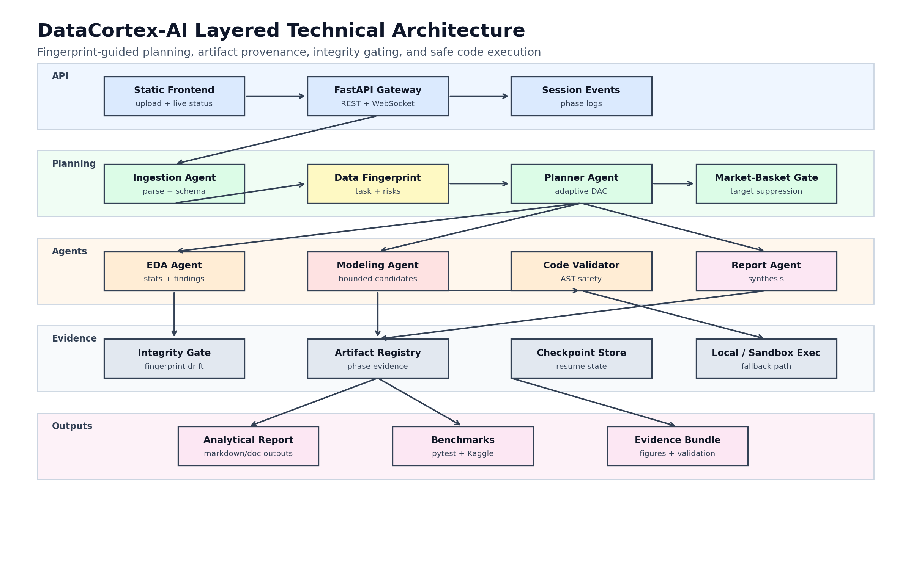
Figure 1. DataCortex-AI architecture: planner, agents, artifact registry, AST validator, checkpoints, and events.
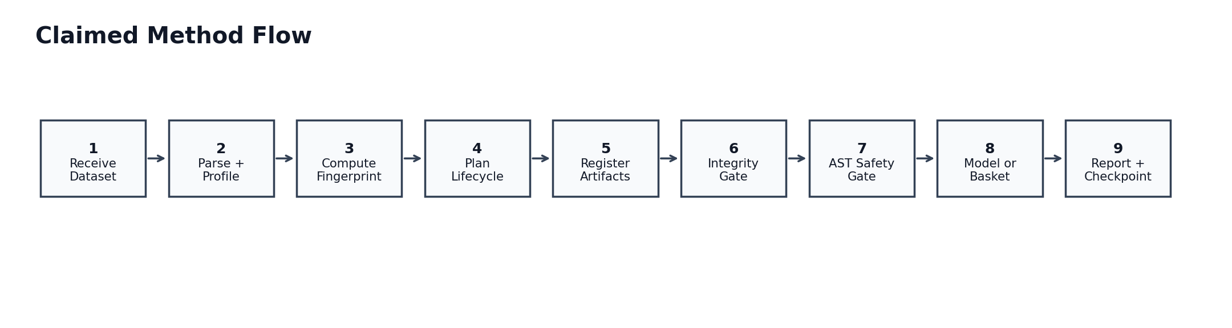
Figure 2. Condensed method claim flow from dataset receipt to report and checkpoint.
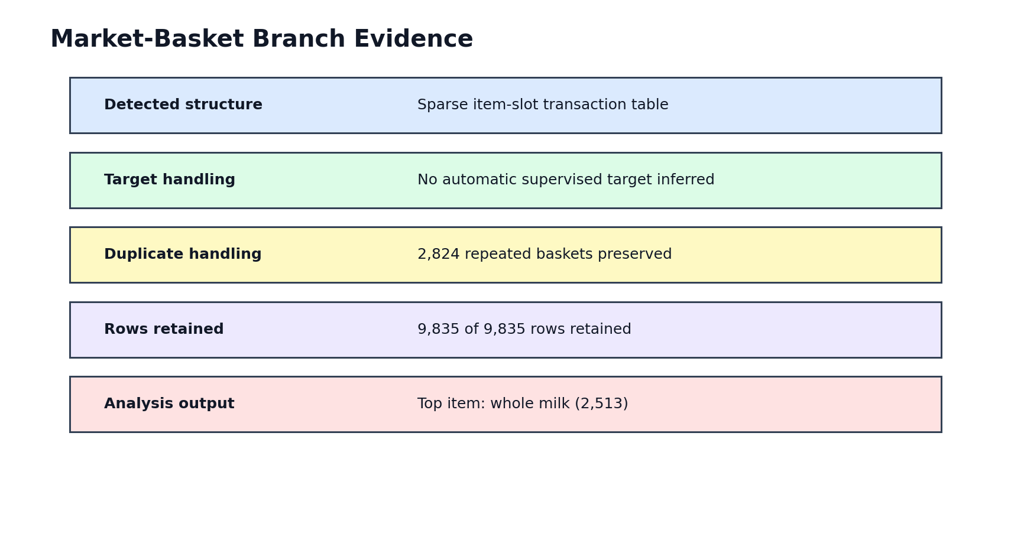
Figure 3. Market-basket branch evidence from the Kaggle Groceries E2E run.
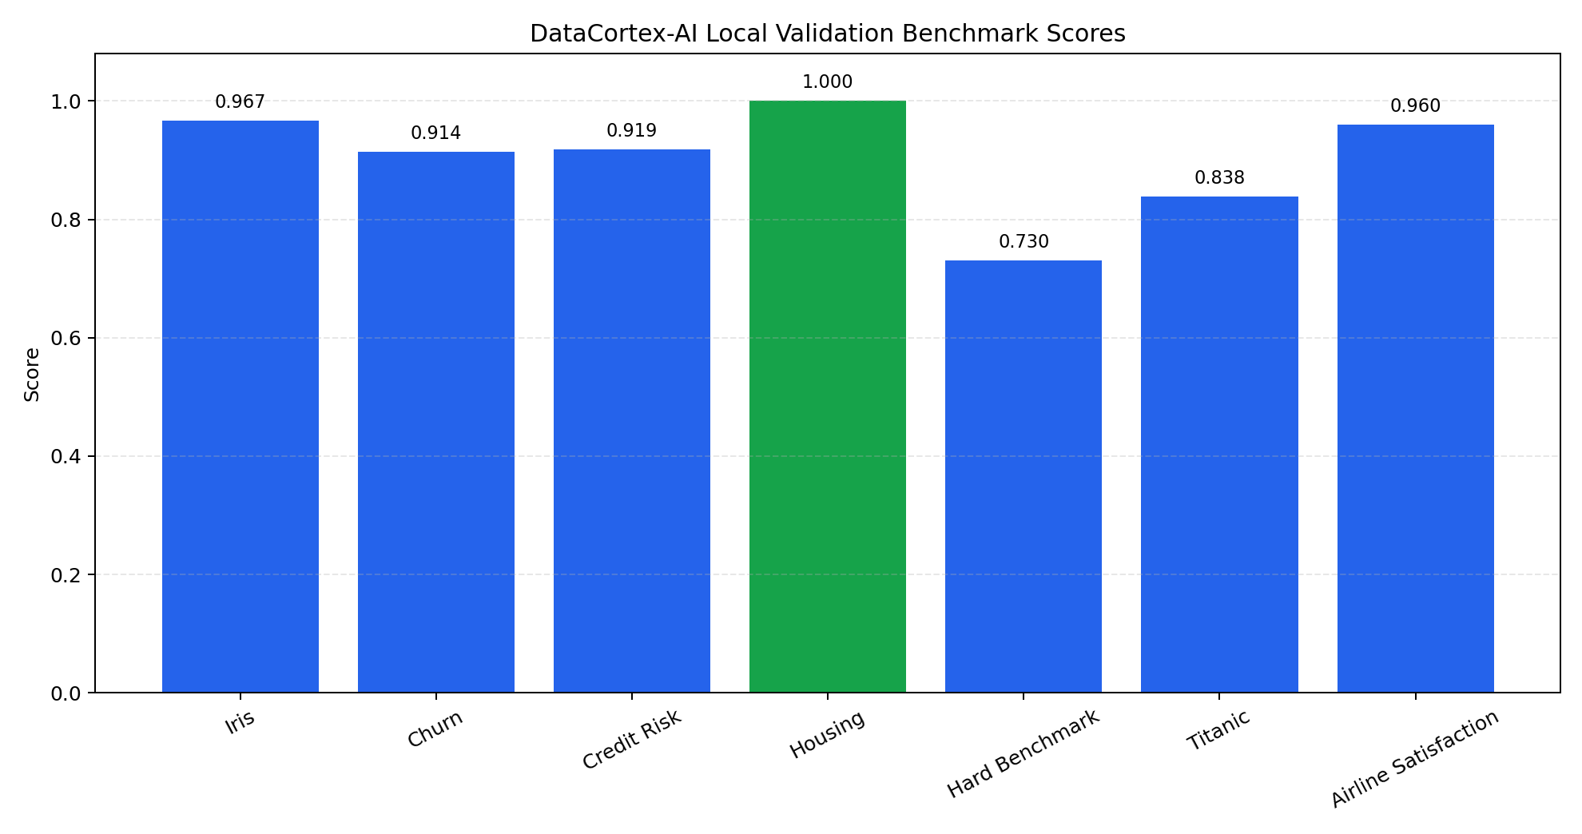
Figure 4. Local validation benchmark scores recorded in the evidence package.
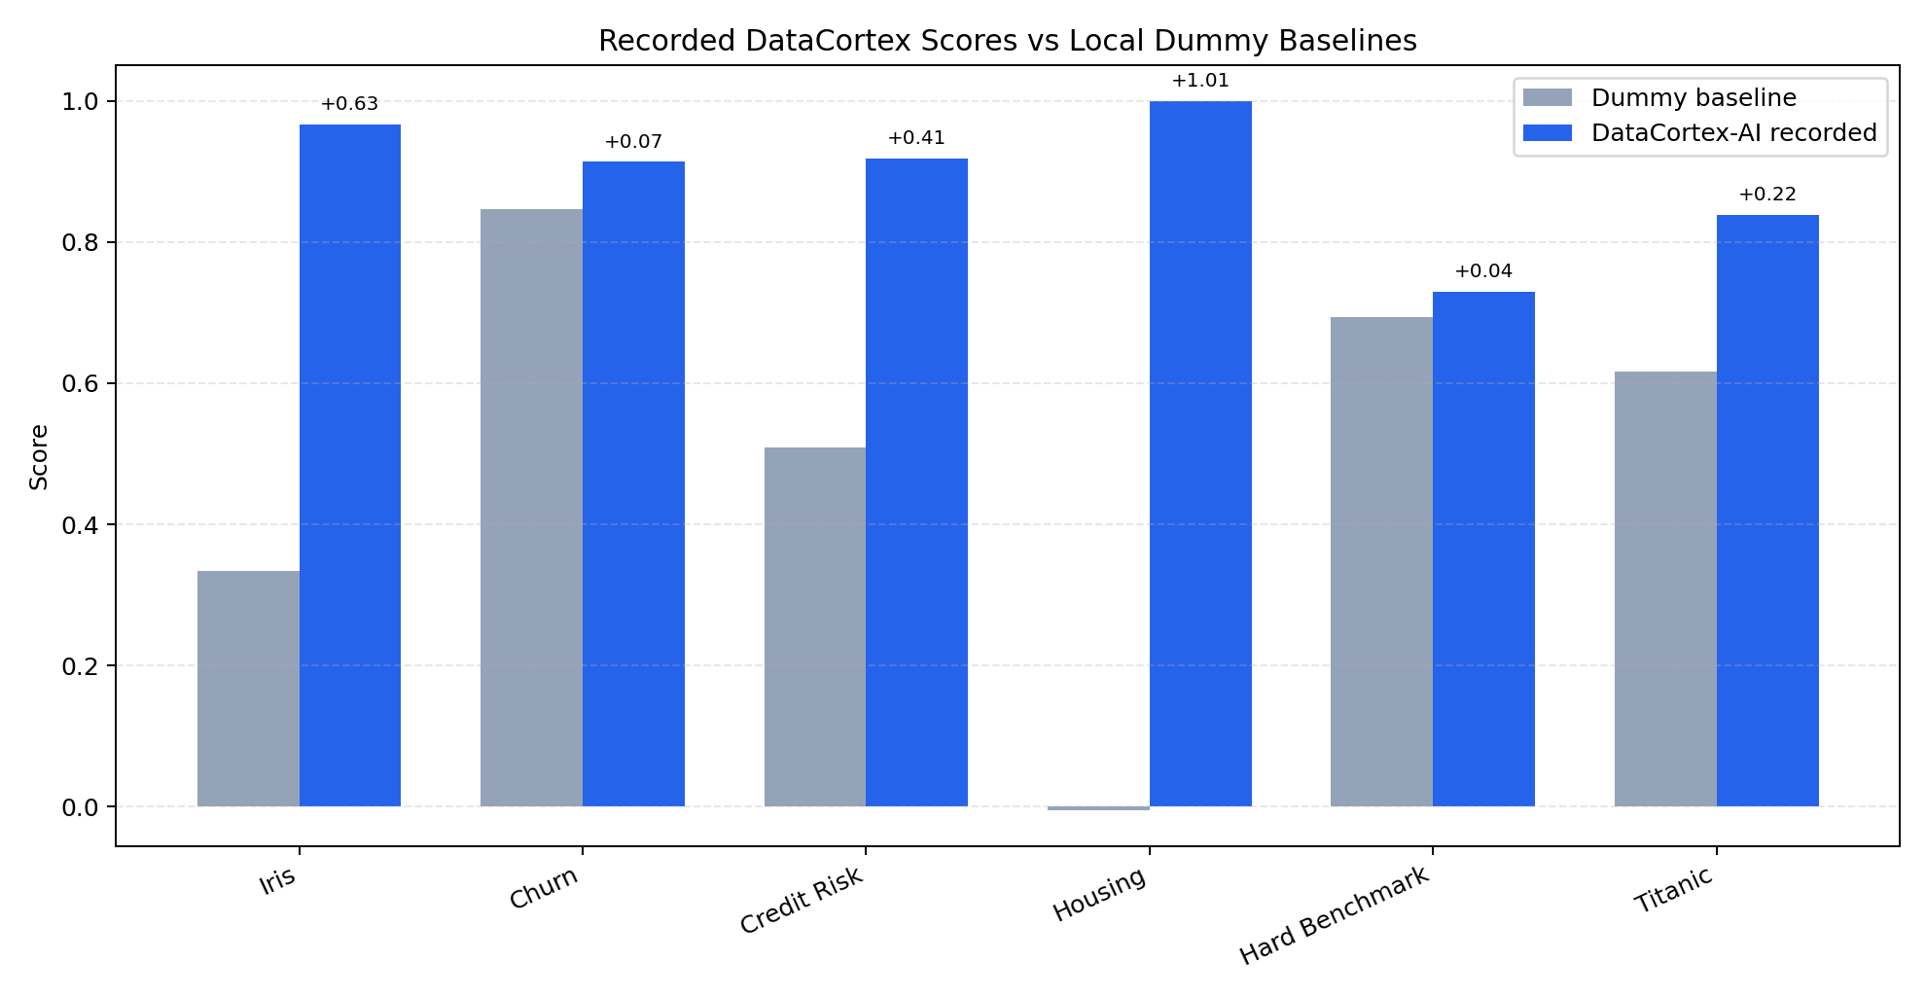
Figure 5. Recorded fixture scores compared with deterministic dummy sanity baselines.
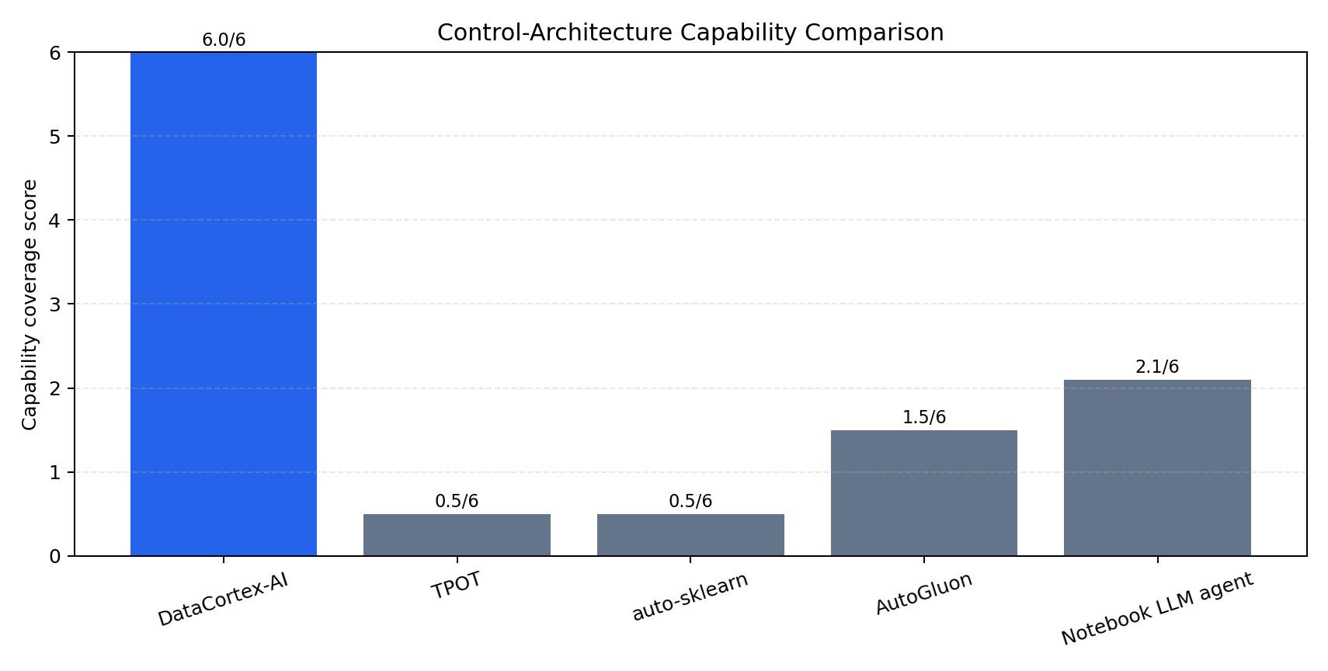
Figure 6. Control-architecture capability comparison; not a performance leaderboard.
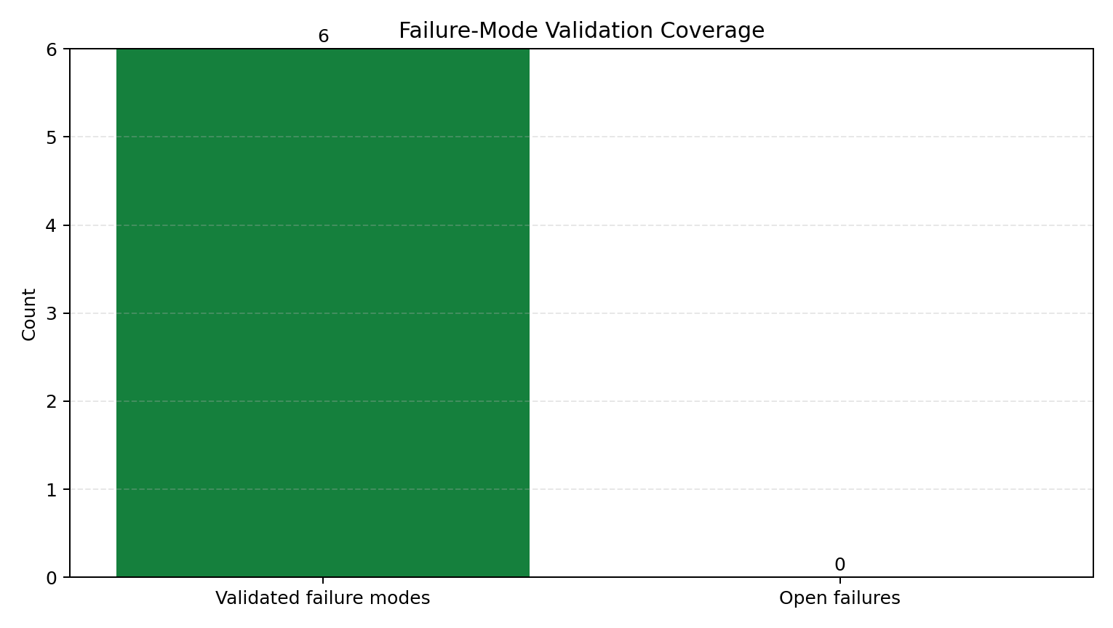
Figure 7. Failure-mode validation coverage for concrete regressions and unsafe behaviors.
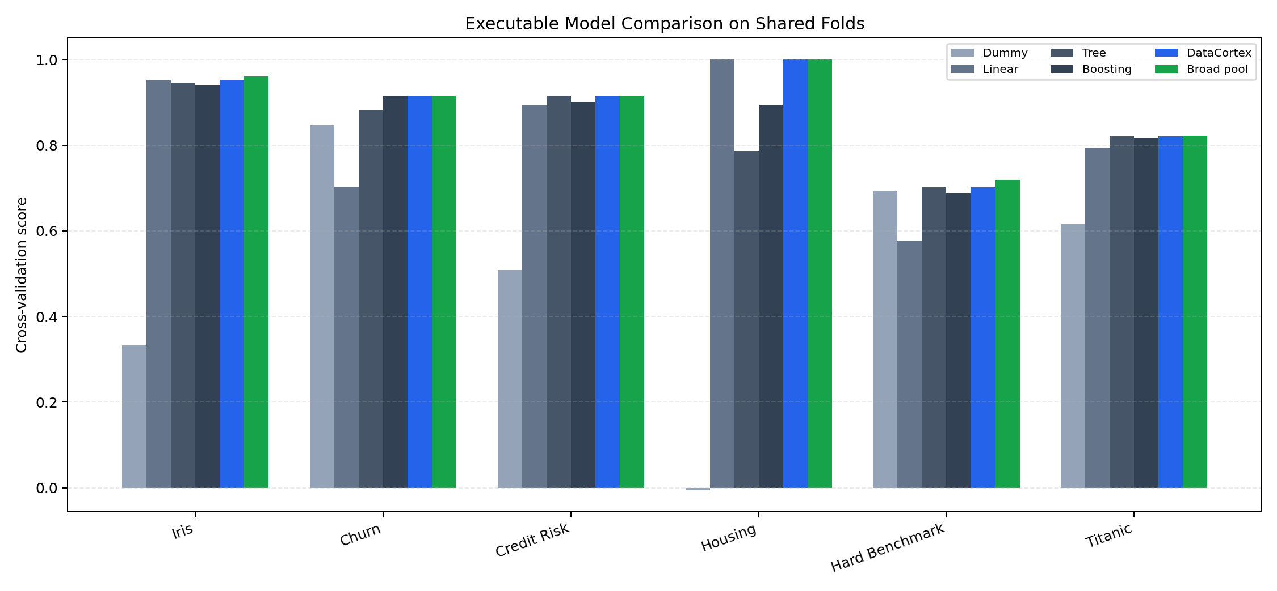
Figure 8. Executable model comparison across dummy, linear, tree, boosting, DataCortex, and broad-pool groups.

4. Condensed Proposed Claim Set
The condensed set keeps the filing focused on the strongest technical combination. It avoids excess narrow dependent claims while preserving coverage for the major implementation mechanisms.
Independent Claim 1 - Method: A computer-implemented method comprising receiving and parsing a tabular dataset; computing a data fingerprint; selecting an execution plan and bounded candidate model families from the fingerprint; storing phase outputs as artifacts; providing downstream context from upstream artifacts; comparing fingerprints across mutations to detect anomalies; validating generated code by AST inspection; and executing at least one lifecycle phase while storing the result as an artifact.
Claim 2 - Expanded Fingerprint and Model Selection: The fingerprint further includes skewness, outlier ratio, noise estimate, text/temporal/high-cardinality indicators, suggested model families, and memory-use estimate, and model-family selection is modified by target continuity, class cardinality, or class-balance threshold.
Claim 3 - AST Rejection Categories: Generated code validation rejects prohibited imports, dynamic execution, network-access modules, file-mutation methods, or dunder traversal.
Claim 4 - Market-Basket Routing and Frequency Preservation: The workflow skips supervised training when market-basket structure is detected without an explicit target; duplicate baskets are preserved as transaction-frequency signal and item-frequency summaries are computed.
Independent Claim 5 - System: A system comprising ingestion, fingerprinting, planning, artifact registry, data-integrity, code-validation, modeling, market-basket detection, and reporting modules.
Independent Claim 6 - Computer-Readable Medium: A non-transitory medium stores instructions for fingerprinting, planning, artifact storage, AST validation, integrity anomaly detection, market-basket detection, checkpointing, event emission, and report generation.

5. Validation and Benchmark Evidence
This section intentionally separates evidence strength. Regression tests and E2E artifacts are stronger evidence than qualitative comparisons, while dummy baselines only demonstrate that recorded supervised results exceed trivial predictors.

5.1 Evidence Quality Grading
Grade | Scope | Supports | Artifact | Limit
A | Automated regression tests | Core behavior remains stable across code changes | VALIDATION_RESULTS.md; tests/* | Not production reliability
B | Fixture benchmarks | Task detection, model execution, metric reporting | validation_benchmarks.csv/json | Not an external leaderboard
B | Kaggle E2E demos | Full demo pipeline on independently sourced CSVs | kaggle_e2e_results.json; demo_outputs/* | Two public datasets only
C | Dummy-baseline deltas | Recorded scores beat trivial class/mean predictors | baseline_comparison.csv/json | Not mature AutoML comparison
D | Capability comparison | Mechanism-level architecture comparison | capability_comparison.csv/json | Qualitative, not speed or accuracy

5.2 Concrete Regression and Failure-Mode Checks
Risk Tested | Expected Behavior | Evidence Artifact | Status
Market-basket data misread as classification | Detect market_basket and skip supervised training without explicit target | demo_outputs/kaggle_groceries_iter4/demo_summary.json | Pass
Duplicate baskets discarded | Retain 9,835/9,835 rows and preserve 2,824 repeated baskets | demo_outputs/kaggle_groceries_iter4/demo_report.md | Pass
Unsafe generated Python | Reject imports, eval/exec, networking, file mutation, dunder traversal | tests/test_code_validator.py | Pass
Long-running workflow invisible | Emit phase events and checkpoints for post-run inspection | demo_outputs/kaggle_titanic_iter3/demo_events.json | Pass

5.3 Executable Model Comparison
Dataset | Metric | DataCortex | Broad Pool | Budget Ratio | Gap
Iris | Accuracy | 0.9533 | 0.9600 | 0.600 | 0.0067
Churn | Accuracy | 0.9160 | 0.9160 | 0.800 | 0.0000
Credit Risk | Accuracy | 0.9163 | 0.9163 | 0.600 | 0.0000
Housing | R2 | 1.0000 | 1.0000 | 0.833 | 0.0000
Hard Benchmark | Accuracy | 0.7013 | 0.7187 | 0.600 | 0.0174
Titanic | Accuracy | 0.8204 | 0.8215 | 0.600 | 0.0011

5.4 Baseline and E2E Results
Scope | Comparator | Result | Metric | Interpretation
Fixture benchmarks | Dummy class/mean predictors | Mean absolute lift 0.396 across 6 local comparisons | Dataset-specific accuracy/R2 | Sanity baseline only
Kaggle Titanic | Held-out local evaluation | RandomForest test accuracy 0.8212; CV 0.8216 +/- 0.0203 | Accuracy | Supervised E2E executes
Kaggle Groceries | Input/output integrity | 9,835/9,835 rows retained; 2,824 repeated baskets preserved | Integrity | Market-basket branch fixed
Static safety | Scripted attack set | 100% block rate recorded | AST screening | Pre-execution guard works for covered attacks

6. Attachment Inventory
- TECHNICAL_DISCLOSURE_DRAFT.md - full condensed technical draft.
- Invention_Disclosure_Data.md - invention disclosure format.
- CLAIM_CHART.md - claim-to-code evidence mapping.
- VALIDATION_APPENDIX.md - technical validation appendix.
- disclosure_artifacts/evidence_manifest.json - generated evidence manifest.
- COMPREHENSIVE_RESULTS.md - graded validation, baseline, failure-mode, and capability comparison summary.
- COMPARATIVE_BENCHMARKS.md - executable model comparisons and concrete novelty measurements.
- disclosure_artifacts/figures/* - architecture, method, market-basket, baseline, capability, failure-mode, and model-comparison figures.
- disclosure_artifacts/benchmarks/* - benchmark, model-comparison, novelty, failure-mode, quality-grading, and Kaggle E2E CSV/JSON.

7. Evidence Limits
- Evidence supports a local laboratory prototype, not a production certification.
- Static AST validation is a deterministic safety gate, not a complete security sandbox.
- Benchmark results are repository evidence, not external leaderboard or mature AutoML superiority claims.
- Final filing language should be reviewed by qualified counsel.

