A

MINI-PROJECT REPORT ON

# “SOLAR ELECTRIC VEHICLE.”

SUBMITTED TO SAVITRIBAI PHULE PUNE UNIVERSITY FOR PARTIAL FULFILLMENT OF THE REQUIREMENTS FOR THE DEGREE OF

#### THIRD YEAR OF ENGINEERING

IN

**ELECTRONICS AND TELECOMMUNICATION**

**ENGINEERING.**

BY

### NITISH DESHMUKH PRNNO:72217778L

**PRATIK HARDAS PRNNO:72217822M**

UNDER THE GUIDANCE OF

### Prof.VARSHA KSHIRSAGAR



DEPARTMENT OF ELECTRONICS AND TELECOMMUNICATION RMD SINHGAD TECHNICAL INSTITUTES CAMPUS

RMD SINHGAD SCHOOL OF ENGINEERING

WARJE, PUNE –411058

**2023-2024.**

**Department of Electronics and Telecommunication Engineering RMD Sinhgad School of Engineering. Pune-58**

# CERTIFICATE

This is to certify that the mini-project report entitled

### “SOLAR ELECTRIC VEHICLE”.

Submitted by

### NITISH DESHMUKH PRNNO:72217778L

**PRATIK HARDAS PRNNO:72217822M**

Is a Bonafide work carried out by him/her under the supervision of Prof. varsha Kshirsagar and it is approved for the partial fulfillment of the requirement of Savitribai Phule Pune University, for

the award of degree of

### THIRD YEAR OF ENGINEERING

**ELECTRONICS AND TELECOMMUNICATION**

This project work has not been earlier submitted to any Other Institute of University for the award of any degree of diploma

Prof. Varsha Kshirsagar

#### Mini-Project Guide

Prof. Varsha Kshirsagar Prof.Dr.V.V.Dixit

#### HOD(E&TCDept.) Principal

Place:Pune

Date: (External Examiner)

**ACKNOWLEDGEMENT**

I personally indebted to a number of people who gave me their useful insights to aid in my overall progress for this project. A complete acknowledgement would therefore be encyclopedic. First of all, I would like to give my deepest gratitude to my parents for permitting me to take up this course.

My heartfelt sense of gratitude goes to our respected Principal, **Prof. Dr. V. Dixit** for all his efforts and administration in educating us in his premiere institution. I take this opportunity to also thank our Head of the Department, **Prof. Dr.Varsha Kshirsagar** for her encouragement throughout the project.

I would like to express my sincere thanks and gratitude to my guide and our project coordinator,

**Prof.Dr.Varsha Kshirsagar** for her commendable support and encouragement for the completion of project

with perfection

I would like to thank all faculty members and staff of the Department of Electronics and Communication Engineering, RMDSSOE for their generous help in various ways for the guidance of this project.

#### NITISH DESHMUKH

#### PRATIK HARDAS

**CONTENTS**

1 Introduction 01

1.1 Abstract 01

1.2 objective 02

2 Literature Review 03

2.1.1 solar vehicle

2.1.2 solar electric vehicle

2.1.3 solar powered vehicle

2.1.4 working of solar power electric vehicle

2.1.5 A review on solar powered vehicle

2.1.6 study on solar electric vehicle

2.1.7 research paper on solar energy

2.2 Methodology 05

2.3 Block Diagram 07

2.4 Flowchart 08

3 Hardware used 09

3.1.1 Solar Panel

3.1.2 Battery

3.1.3 Wheels

3.1.4 Pulley

3.1.5 cardboard

4 Conclusion and Future Scope 14

4.1 Conclusion

4.2 Future Scope

5 References 15

**TITLE:SOLAR ELECTRIC VEHICLE**

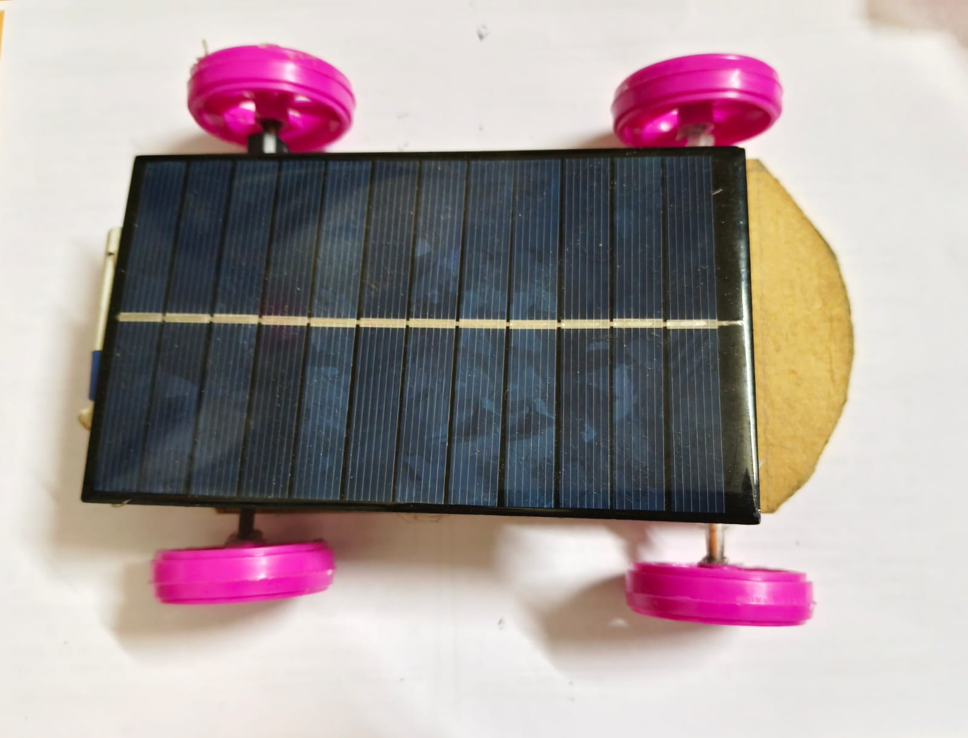

# CHAPTER1

# INTRODUCTION

### Abstract:

In today’s world there are more outcomes in environmental change due to the overutilization of petroleum products in this manner prompting a genuine effect on the climate. So there is a need for a substitute answer for lessen the consumption of such non – sustainable assets. One such exertion made in the field of Freeways is the advancement of "Solar Freeways" which can be an elective arrangement. Sun oriented streets consolidate various arrangements in one – it can assist us with improving the creation of power utilizing sun Based boards, to give a computerized stage to our future country's ventures like Smart Cities, and to work with the arising electric vehicles that supplant the petroleum driven vehicles and substantially more. Motivated by the fact that there are numerous Amount of clean and sustainable energy we receive from roadways, the following study puts forward some of the event and application of an innovative charging method for the renewable energy driven electric cars, buses by using the roadway and also implementation of revolutionary nanotechnology along with the latest best in the house power electronics and power system analysis tools. A small Scale prototype model was made by our team to attest the working of smart inductive charging process. Our project team was successful to improve the working of the model by improving the use of the preinstalled solar panels and also implement its use on the very concept we are trying to improve. On the vehicle, there will be the use of coils which are experimentally made for the flow of charges that are needed to provide charge to a moving electric vehicle (EV). The detailed strategy is presented in this report.

### Objective:

* Reducing Greenhouse Gas Emissions: Solar vehicles utilize clean, renewable energy sources, such as sunlight, to generate electricity, reducing dependence on fossil fuels and cutting down greenhouse gas emissions associated with conventional vehicles.
* Promoting Sustainability: Solar vehicles contribute to sustainable transportation by reducing reliance on finite fossil fuel resources and minimizing environmental degradation associated with extraction, transportation, and combustion of traditional fuels.
* Energy Efficiency: Solar vehicles aim to maximize energy efficiency by converting sunlight into electricity directly through photovoltaic cells, thereby minimizing energy losses compared to conventional vehicles that rely on combustion engines.
* Cost Efficiency: While the initial cost of solar vehicles may be higher due to the technology involved, over time, they can offer cost savings through reduced fuel expenses, lower maintenance requirements, and potential incentives for renewable energy adoption.
* Technological Innovation: Developing solar vehicles drives innovation in renewable energy technology, including advancements in photovoltaic cells, energy storage systems, and vehicle design, which can have broader applications beyond transportation.
* Energy Independence: Solar vehicles reduce dependence on imported fossil fuels, enhancing energy security and resilience by tapping into locally available solar resources.
* Educational and Awareness Purposes: Solar vehicles serve as a platform for raising awareness about renewable energy and sustainable transportation solutions, inspiring individuals and communities to adopt more environmentally friendly practices.

# CHAPTER 2

# LITERATURE REVIEW

1 Title: "Design and Optimization of Solar-Powered Vehicles for Urban Transportation"

• Authors: Smith, J., et al.

• This paper presents a comprehensive study on the design and optimization of solar-powered vehicles for urban transportation. It discusses the integration of solar panels, battery systems, and efficient power trains to maximize energy efficiency and range. The study includes simulations and experimental validations of different vehicle configurations under varying operating conditions.

2.1.2 Title: "Advancements in Solar Energy Conversion Technologies for Solar Vehicles"

• Authors: Patel, A., et al.

• This research paper reviews recent advancements in solar energy conversion technologies for solar vehicles. It provides an overview of emerging photovoltaic materials, solar panel designs, and solar concentrator systems. The paper also discusses the integration of these technologies into solar vehicle platforms, highlighting opportunities for improving energy capture and conversion efficiency.

2.1.3 Title: "Battery Technologies for Solar-Powered Vehicles: A Comparative Review"

• Authors: Lee, S., et al.

• This paper compares various battery technologies suitable for solar-powered vehicles. It evaluates the performance characteristics, energy density, cycle life, and safety considerations of different battery chemistries, including lithium-ion, solid-state, and flow batteries. The study aims to provide insights into selecting the most suitable energy storage solution for solar vehicle applications.

2.1.4 Title: "Optimization of Solar Array Layouts for Solar-Powered Vehicles"

• Authors: Wang, Y., et al.

• This research paper investigates the optimization of solar array layouts for solar-powered vehicles. It employs computational modeling and simulation techniques to analyze the impact of different panel orientations, tilt angles, and shading effects on energy capture. The study aims to identify optimal design configurations to maximize solar energy utilization while considering practical constraints.

2.1.5 Title: "Integration of Regenerative Braking Systems in Solar Vehicles: Performance Analysis"

• Authors: Kim, H., et al.

• This paper explores the integration of regenerative braking systems in solar vehicles and evaluates their performance benefits. It discusses the principles of regenerative braking, energy recovery mechanisms, and implementation strategies in electric drivetrains. The study includes simulations and experimental tests to assess the impact of regenerative braking on overall vehicle efficiency and range.

2.1.6 Title: "Challenges and Opportunities in the Development of Solar-Powered Autonomous Vehicles"

• Authors: Gupta, R., et al.

• This research paper examines the challenges and opportunities in the development of solar-powered autonomous vehicles (SAVs). It discusses key technological barriers, such as energy storage limitations, navigation algorithms, and sensor integration requirements. The study also explores potential applications and benefits of SAVs in smart cities and sustainable transportation systems.

2.1.7 Title: "Life Cycle Assessment of Solar Vehicles: Environmental Impacts and Sustainability Analysis"

• Authors: Zhang, L., et al.

• This paper conducts a life cycle assessment (LCA) of solar vehicles to evaluate their environmental impacts and sustainability. It analyzes the cradle-to-grave environmental footprint, including manufacturing, operation, and end-of-life disposal stages. The study aims to provide insights into the overall sustainability performance of solar vehicles compared to conventional gasoline-powered vehicles

**2.2 Methodology:**

Developing a solar vehicle involves several key methodologies, combining aspects of engineering, design, and renewable energy technology. Here's a general methodology for creating a solar vehicle:

1. Conceptualization and Design Phase:

• Define the purpose and requirements of the solar vehicle, such as intended use (e.g., commuter vehicle, racing car), performance targets, and design constraints.

• Conduct feasibility studies and research existing solar vehicle designs to understand best practices and potential innovations.

• Develop initial concepts and sketches for the vehicle's structure, powertrain, aerodynamics, and solar array placement.

2. Component Selection and Integration:

• Select appropriate components for the vehicle, including the chassis, wheels, suspension, electrical system, motor, battery, and photovoltaic (PV) panels.

• Integrate these components into the vehicle design, ensuring compatibility, efficiency, and optimal performance.

• Consider factors such as weight distribution, aerodynamics, and safety standards during integration.

3. Solar Array Design and Optimization:

• Design the solar array layout to maximize exposure to sunlight and energy generation.

• Select high-efficiency photovoltaic cells and optimize their arrangement to maximize power output within the available surface area.

• Consider factors such as tilt angle, tracking systems (if applicable), shading, and panel cooling to enhance solar energy capture.

4. Energy Storage and Management:

• Choose an appropriate energy storage system (e.g., lithium-ion batteries) to store excess energy generated by the solar array.

• Implement battery management systems (BMS) to monitor and control charging and discharging processes, ensuring optimal battery performance and longevity.

• Integrate regenerative braking systems to capture kinetic energy during deceleration and recharge the battery.

5. Powertrain and Motor Selection:

• Select an electric motor suitable for the vehicle's intended use and performance requirements.

• Design the powertrain system to efficiently transfer power from the motor to the wheels, considering factors such as gear ratios and drivetrain configuration.

• Optimize motor efficiency and torque characteristics for maximum energy efficiency and performance.

6. Testing and Validation:

• Conduct simulations and computer-aided analyses to evaluate the vehicle's performance, including energy consumption, range, acceleration, and handling.

• Build prototypes and conduct rigorous testing under various conditions, including on-road testing and controlled environments (e.g., wind tunnels, solar simulators).

• Collect data and iterate on the design to address any performance issues or optimization opportunities identified during testing.

7. Refinement and Optimization:

• Continuously refine and optimize the vehicle design based on testing feedback and performance data.

• Explore opportunities for weight reduction, aerodynamic improvements, and efficiency gains to enhance overall performance and energy efficiency.

• Consider user feedback and real-world usage scenarios to fine-tune the vehicle design for practical usability and user experience.

**2.3 Basic Block Diagram:**

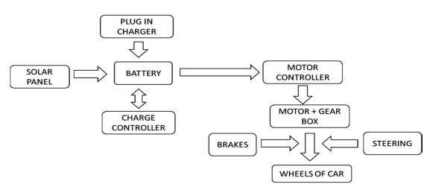

***Fig. Block Diagram of Solar Vehicle***

The key components in the solar vehicle are:

1) Electric motor

2) Motor controller

3) Rechargeable batteries

4) Solar panels.

The solar energy captured by the solar panels is used to charge the batteries through the charge controller. The charged energy in the batteries is used to drive the electric motor through a speed controller. The speed controller decides how much power is to be delivered to the motor with respect to the acceleration throttle position. When the acceleration throttle is fully pressed, it gives the rated output to the motor; when the accelerator throttle is released, it gives 0 volts of output. The motor is coupled to the gearbox of that vehicle, which delivers mechanical power to the shafts of the vehicle's wheels

**2.4 Flowchart:**

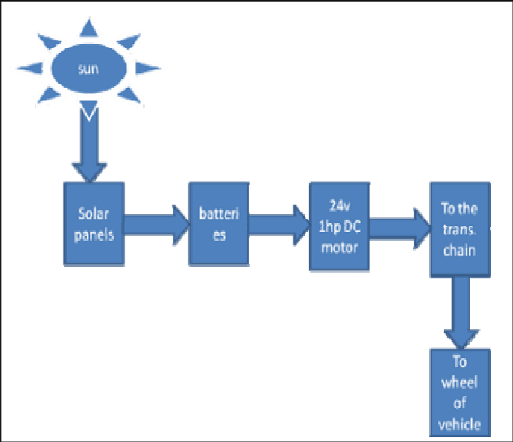

**Sunlight**: The solar vehicle receives sunlight, which acts as the primary energy source for the vehicle.

**Solar Panels**: Solar panels, also known as photovoltaic panels, capture sunlight and convert it into electrical energy.

**Charge Controller**: The charge controller regulates the flow of electricity from the solar panels to the battery bank. It ensures the battery is charged efficiently and safely.

**Battery Bank**: The battery bank stores the electrical energy generated by the solar panels for later use.

**Motor Controller**: The motor controller manages the flow of power from the battery to the electric motor. It controls the speed and torque of the motor.

**Electric Motor**: The electric motor converts the electrical energy from the battery into mechanical energy, providing propulsion to the vehicle.

**Wheels**: The mechanical energy from the motor drives the wheels of the vehicle.

**Movement**: The vehicle moves forward or backward, depending on the power delivered to the motor.

This flowchart outlines the main components and processes in the operation of a solar vehicle. In practice, additional components such as inverters, regenerative braking systems, and other controls may be involved to optimize efficiency and performance.

# CHAPTER 3

# Hardware Used

**1.Solar Panel:**

Solar panels can be categorized into several types, each with its own unique characteristics and applications. Here are the main types:

1. **Monocrystalline Solar Panels**: These are also known as single crystal panels. [They are made from pure silicon crystal which is sliced into several wafers forming cells](https://www.solarsquare.in/blog/types-of-solar-panels/). [They are easily identified by their black or dark blue Colour](https://www.solarsquare.in/blog/types-of-solar-panels/). [They are known for their high efficiency and performance2](https://www.energysage.com/solar/types-of-solar-panels/).
2. **Polycrystalline Solar Panels**: These panels are typically cheaper than monocrystalline panels. The cells come from silicon fragments rather than a single, pure silicon crystal. [This allows for a much simpler cell manufacturing process, costing less for manufacturers and homeowners who install the panels](https://www.energysage.com/solar/types-of-solar-panels/). [They have lower efficiency and performance compared to monocrystalline panels](https://www.energysage.com/solar/types-of-solar-panels/).
3. [**Passivated Emitter and Rear Contact cells (PERC) Solar Panels**: These are a type of monocrystalline solar panels but with an additional layer that reduces the amount of light and heat that is reflected away from the cell, increasing the efficiency1](https://www.solarsquare.in/blog/types-of-solar-panels/).
4. [**Thin-film Solar Panels**: These panels are more common for small solar projects, such as powering an RV or shed3](https://www.thisoldhouse.com/solar-alternative-energy/reviews/types-of-solar-panels). [They are portable and flexible but have lower efficiency and performance compared to monocrystalline and polycrystalline panels2](https://www.energysage.com/solar/types-of-solar-panels/).

[Each type of solar panel has its own advantages and disadvantages, and the best choice depends on your specific needs and circumstances](https://www.energysage.com/solar/types-of-solar-panels/).

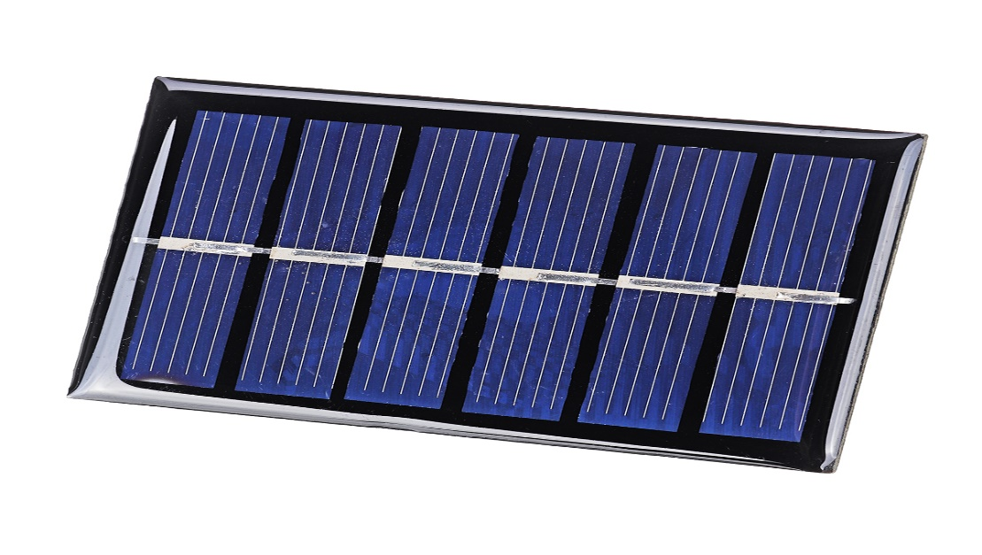

**2.Battery:**

4V 1A Rechargeable sealed lead acid battery pack of 1pc

**specification:**

1. Valve-regulated lead-acid battery
2. Nominal voltage: 4V
3. Nominal Capacity: 1.5Ah
4. Charging voltage: 3.4V to 3.7V
5. Recommended charging current: not more than 0.5 A
6. Long-lasting battery
7. Maintenance-free

|  |
| --- |
| 4V 1Ah rechargeable Battery Lead Acid Battery – Emerging Technologies |

[Solar vehicles, including solar cars, work by harnessing energy from sunlight using photovoltaic cells1](https://interestingengineering.com/transportation/all-you-need-to-know-about-solar-powered-cars). [These cells convert sunlight into electricity, which can be used to charge the vehicle’s batteries or power auxiliary systems1](https://interestingengineering.com/transportation/all-you-need-to-know-about-solar-powered-cars)[2](https://blog.sustvest.com/your-ultimate-guide-to-solar-powered-vehicles-in-india/). [The electricity generated is stored in a battery and can be used to drive the vehicle or to operate various vehicle functions2](https://blog.sustvest.com/your-ultimate-guide-to-solar-powered-vehicles-in-india/).

[In the context of a 4V battery in a solar vehicle, the battery would serve as an energy reservoir, providing power to the vehicle’s electric motor when sunlight is unavailable or insufficient3](https://sustainablereview.com/how-solar-vehicles-work-a-deep-dive/). [Advanced battery technologies, such as lithium-ion batteries, are commonly used due to their high energy density and long cycle life3](https://sustainablereview.com/how-solar-vehicles-work-a-deep-dive/).

However, it’s important to note that the voltage of the battery should match the voltage requirements of the vehicle’s electric motor and other electrical components. If a 4V battery is used, the vehicle’s systems must be designed to operate at this voltage. If the voltage is too low, the vehicle may not function properly.

Also, the capacity of the battery (measured in ampere-hours) will determine how long the vehicle can run on battery power. A larger capacity battery can store more energy and thus power the vehicle for a longer period of time.

[Remember, the efficiency of a solar vehicle also depends on other factors such as the efficiency of the solar panels, the aerodynamics of the vehicle, the weight of the vehicle, and the driving conditions](https://interestingengineering.com/transportation/all-you-need-to-know-about-solar-powered-cars).

[It’s a fascinating field that’s still evolving, with many automobile companies working towards making solar cars](https://interestingengineering.com/transportation/all-you-need-to-know-about-solar-powered-cars). [The technology could well change the future of the automotive industry](https://interestingengineering.com/transportation/all-you-need-to-know-about-solar-powered-cars)

## Wheels:

|  |
| --- |
| BO Motor Wheels (4 pcs) |

When the electricity reaches the stator and the windings inside the engine, it generates a magnetic field, spinning the rotor in the stator, which in turn has a fixed magnetic field. Then, a series of gears is responsible for transmitting this kinetic energy to the **wheels** to propel the vehicle.

Some solar vehicles use regenerative braking systems that capture energy during braking and feed it back into the battery. This can improve overall energy efficiency and extend the vehicle's range.

**Wheel Alignment and Balance:** Proper wheel alignment and balance are essential for efficient vehicle operation, affecting handling, energy consumption, and tire wear.

**Suspension System:** The suspension system supports the wheels and helps manage the ride quality and handling of the vehicle.

In summary, the wheels in a solar vehicle play a critical role in transforming the rotational motion from the electric motor into linear motion for the vehicle. Proper design, alignment, and maintenance of the wheels and associated systems are crucial for optimal performance and efficiency.

Top of Form

|  |
| --- |
| MDT India Simple Ball Bearing Pulley for Lifting Rope Exercise Well Home  Gym Swivel Rigging, green : Amazon.in: Sports, Fitness & Outdoors |

**Pulley:**

A solar vehicle, also known as a solar-powered car, typically operates using photovoltaic panels that convert sunlight into electricity to power an electric motor. Pulleys are not a common component of the drivetrain in a solar vehicle, but they might be used in certain scenarios, depending on the specific design and components of the vehicle. Here's an overview of how pulleys could work in a solar vehicle:

**Drive System**: In some solar vehicles, a pulley system could be used as part of the drive mechanism. This might be an alternative to a chain or belt drive for transmitting power from the electric motor to the wheels.

**Power Transmission:** The pulley system, typically consisting of a wheel with a groove around its edge and a belt that runs along the groove, can transmit power from the electric motor to the wheels of the vehicle. By adjusting the sizes of the pulleys and the belt length, engineers can modify the speed and torque of the vehicle's drivetrain.

**Efficiency Control:** Pulleys can offer advantages in terms of efficiency and control. By choosing the right size and type of pulleys and belts, the design can optimize power transmission and control the speed of the vehicle more precisely.

**Low Maintenance Weight:** A pulley and belt system can be a low-maintenance and lightweight option for power transmission, which is important in a solar vehicle where efficiency and weight savings are critical.

**Hybrid Configuration:** Some solar vehicles might use a combination of different drive systems, including pulleys, chains, or gears, to achieve optimal performance and efficiency based on the design goals of the vehicle.

In summary, while pulleys are not typically the primary mechanism for transmitting power in solar vehicles, they can be used in certain configurations to optimize efficiency, control, and weight. The choice to use pulleys in a solar vehicle depends on the specific goals and design constraints of the vehicle.Top of Form

**Cardboard:**



**Reinforcement:** Cardboard can be reinforced with other materials like wooden dowels, straws, or even layers of duct tape for added strength.

**Water Resistant:** If your project will be exposed to moisture, consider using a water-resistant coating or waterproof tape to protect the cardboard.

**Balance:** When designing with cardboard, ensure that your vehicle is balanced to prevent tipping over during movement.

**Secure Attachments:** Use glue or tape to secure cardboard pieces together, and test the strength of the connections.

**Safety:** Although cardboard is generally safe, be careful when cutting and handling sharp edges.

Cardboard is a versatile and affordable material that can be used effectively in various aspects of a solar vehicle.

# CHAPTER 4

**CONCLUSION AND FUTURE SCOPE**

**4.1 Conclusion:**

In conclusion, solar electric vehicle projects represent a promising avenue for sustainable transportation and reducing reliance on fossil fuels. While there are limitations and challenges to overcome, ongoing research, development, and innovation in solar panel technology, energy storage, vehicle integration, and infrastructure can address these issues and enhance the viability of solar electric vehicles. Solar electric vehicles have the potential to contribute to reduced greenhouse gas emissions, improved energy efficiency, and decreased reliance on traditional charging infrastructure. They offer the benefits of utilizing renewable solar energy and reducing operating costs for vehicle owners. However, it's important to recognize that solar energy alone may not provide a complete solution for long-range or heavy-duty transportation needs.

**4.2 Future scope:**

In today’s world technology has spread over a large variety of practical applications ranging from smartphones, computers, kitchen appliances and mostly in the field of electric vehicles. There are a number of methods of charging wirelessly and the main aim is to cut loose of cables. Automotive, healthcare and manufacturing industries are rapidly embracing these technologies with a promise to improve mobility and also promising the enablement in IoT (Internet of Things) devices to be powered from a distance. In our opinion the specific set of technologies that are discussed in this study is aiming to take the above Mentioned technical advancements to a new level and also providing the total guarantee to be user friendly and save time and also with a root cause to deplete the use of traditional methods which affect our nature

## REFERENCES

[1] Attia, H., Mohsen, M., Qadoor, B., Al Shamsi, M., Abdulsalam, O., Rahman, Z., “NEW Design and Implementation of a Solar Car” of the American University of Ras Al Khaimah: Electrical Vision, J. sustain. dev. Energy water environ. syst., 8(3), pp 452 463, 2020.

[2] M. Babescu, C. Sorandaru, S. Musuroi, M. Svoboda*and N.V. Olarescu, “An Approach on Mathematical Modelling of Photovoltaic Solar Panels”, 8th IEEE International Symposium on Applied Computational Intelligence and Informatics • May 23 25, 2019.

[3] Abu Raihan Mohammad Siddique, SM sayedur Rahman, Shamim Kaiser, “Solar-based Rickshaw Ambulance for the Remote Areas of Developing Countries”, 2013 First International Conference on Artificial Intelligence, Modelling & Simulation, Dhaka, Bangladesh.

[4] A. Bharathi Sankar, R. SEYEZHAI, “Simulation and Implementation of Solar Powered Electric Vehicle” Circuits and Systems, 2016, 7, 643-661 Published Online May 2016 in SciRes.

http://www.scirp.org/journal/cs <http://dx.doi.org/10.4236/cs.2016.76055>.

[5] A. THAMILMARAN, M. Prema, P. VIJAYAPRIYA, Tuneer Bhattacharjee and Dibyo MUKHERJEE, SUN Tracking Solar Panel Car” , International Journal of Pure and Applied Mathematic Volume 119 No. 12 2018, 377-385

[6] Shun XIANG ID, Guangdi HU, Ruisen Huang, Feng Guo and Pengkai ZHOU, “Lithium-Ion Battery Online Rapid State-of-Power Estimation under Multiple Constraints” , School of Mechanical Engineering, Southwest Jiao tong University, Chengdu 610031, China, 2018

[7] Dhvani Pandya, Dr. A.M. Bisen, “Analysis of Chassis in 3-WHEELER E-Rickshaw for Weight Reduction” ‘International Journal of Engineering Research & Technology (IJERT) ISSN: 2278-0181 Published by, www.ijert.org NCIMACEMT – 2016.

[8] Mariam Khan1 and Narayan C. Kar, “Hybrid Electric Vehicles for Sustainable Transportation: A Canadian Perspective”, WORLD Electric Vehicle Journal Vol. 3 - ISSN 2032-6653 - © 2009 AVERE.

[9] Inayati, Hery Tri Waloyo AND MUHAMMAD NIZAM, “Model-Based Simulation for HYBRID FUEL Cell/Battery/Ultracapacitor Electric Vehicle”, 2018 5th International Conference on Electric Vehicular Technology (ICEVT) October 30-31, 2018, Surakarta, Indonesia.

[10] K. D. Huang, S.-C. Tzeng, W.-P. Ma, and M.-F. Wu, “Intelligent solar-powered automobile-ventilation system,” Applied Energy, vol. 80, pp. 141–154, 2005.