DEPARTMENT OF


COMPUTER SCIENCE & ENGINEERING

EXPERIMENT- 7

Student Name: Pratik Kaushal UID: 22BCS10026

Branch: CSE Section/Group: 22BCS_DL-902-A

Semester: 6 Date of Performance: 10.03.25

Subject Name: Project Based Learning in Java Subject Code:22CSH-359

EASY LEVEL

- Aim: Create a Java program to connect to a MySQL database and fetch data from a single table.

- Objective: To retrieve and display all records from a table named Employee with columns EmpID, Name, and Salary.

- Implementation/Code:

package Project1; import java.sql.*; public

class Easy7JDBC { public static void

main(String[] args) {

// Database connection details

String url = "jdbc:mysql://localhost:3306/shivanidb";

String | username = |  | "root";
String | password = |  | "Shivani@1234";
// SQL | Query | "SELECT * FROM Employee"; |  | try (Connection
String | query = |  |  | try (Connection
conn = DriverManager.getConnection(url, username, password);
Statement |  | stmt = conn.createStatement();
ResultSet |  | rs | = stmt.executeQuery(query)) {
System.out.println("Connected to shivanidb successfully!\n");

System.out.println("EmpID | Name | Salary"); while (rs.next())

{

System.out.printf("%d | %s | %.2f\n",

rs.getInt("EmpID"), rs.getString("Name"),

rs.getDouble("Salary"));}

} catch (SQLException e) {

System.err.println("Connection failed: " + e.getMessage());

}

}}

4. Output:

DEPARTMENT OF

COMPUTER SCIENCE & ENGINEERING
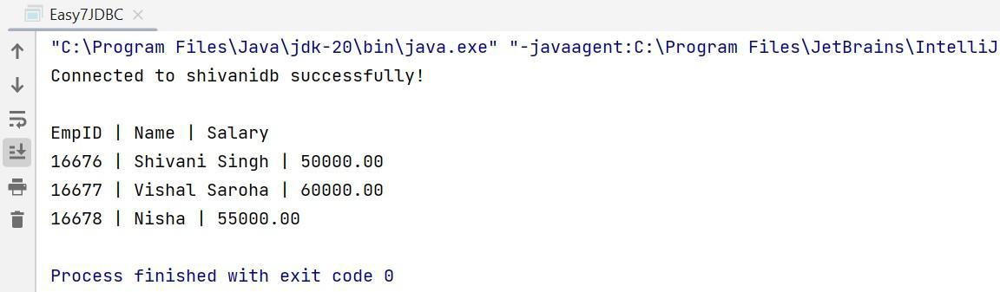

MEDIUM LEVEL

- Aim: Build a program to perform CRUD operations

- Objective: To perform Create, Read, Update, Delete on a database table

Product with columns: ProductID, ProductName, Price, and Quantity. The program should include menu-driven options for each operation.

- Implementation/Code:

package Project1; |  | import
java.sql.*; |  | import
java.util.Scanner; public class
Medium7JDBC {
public static void main(String[] args) {
String url = "jdbc:mysql://localhost:3306/shivanidb";
String user = "root"; |  |  |  |  |  | Scanner sc = new
String password = "Shivani@1234";
Scanner(System.in); |  |  | try (Connection conn = |  |  |  | while
DriverManager.getConnection(url, user, password)) {
(true) { |  |  |  |  |  |  | 2. View Products
 | System.out.println("\n1. Add Product
3. Update Price 4. Delete Product |  |  |  | 5. Exit");
int choice = sc.nextInt(); |  |  |  |  | if (choice == 1)
addProduct(conn, sc); |  |  |  |  | else if (choice == 2)
viewProducts(conn); |  |  |  |  | else if (choice == 3)
updateProduct(conn, sc); |  |  |  |  | else if (choice == 4)
deleteProduct(conn, sc); |  |  |  |  | else if (choice == 5)
break; | else System.out.println("Invalid choice.");
 | }
{ | } catch (SQLException e) |  |  |  | static void
{ | e.printStackTrace();}}
addProduct(Connection conn, Scanner sc) throws SQLException {

System.out.print("Enter Product Name: "); sc.nextLine();
DEPARTMENT OF

COMPUTER SCIENCE & ENGINEERING

String name = sc.nextLine(); |  | double
System.out.print("Enter | Price: "); | double
price = sc.nextDouble(); |  | int
System.out.print("Enter | Quantity: "); | int
quantity = sc.nextInt();
PreparedStatement stmt = conn.prepareStatement("INSERT INTO Product (ProductName, Price, Quantity) VALUES (?, ?, ?)");
stmt.setString(1, name); stmt.setDouble(2, price);

stmt.setInt(3, quantity); stmt.executeUpdate();

System.out.println("Product added.");

}

static void viewProducts(Connection conn) throws SQLException { ResultSet rs = conn.createStatement().executeQuery("SELECT * FROM
Product");

System.out.println("\nProductID | Product Name | Price | Quantity");

while (rs.next()) {

System.out.printf("%d | %s | %.2f | %d\n", rs.getInt(1), rs.getString(2), rs.getDouble(3), rs.getInt(4));

}

}

static void updateProduct(Connection conn, Scanner sc) throws SQLException {

System.out.print("Enter ProductID to update: "); int id = sc.nextInt();

System.out.print("Enter new Price: "); double price = sc.nextDouble();

PreparedStatement stmt = conn.prepareStatement("UPDATE Product

SET Price=? WHERE ProductID=?"); stmt.setDouble(1, price);

stmt.setInt(2, id); stmt.executeUpdate();

System.out.println("Product updated.");

}

static void deleteProduct(Connection conn, Scanner sc) throws SQLException {

System.out.print("Enter ProductID to delete: "); int id = sc.nextInt();

PreparedStatement stmt = conn.prepareStatement("DELETE FROM

Product WHERE ProductID=?"); stmt.setInt(1, id); stmt.executeUpdate();

System.out.println("Product deleted.");

}}

4. Output:

DEPARTMENT OF

COMPUTER SCIENCE & ENGINEERING
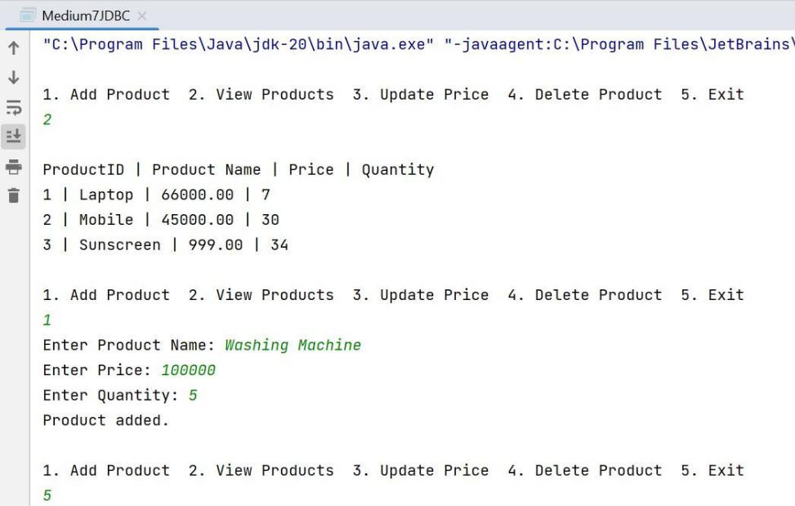

HARD LEVEL

- Aim: Develop a Java application using JDBC and MVC architecture to manage student data.

- Objective: To Use a Student class as the model with fields like StudentID, Name, Department, and Marks. Include a database table to store student data.

- Implementation/Code:

package Project1;

import java.sql.SQLException;

import java.util.List; import

java.util.Scanner;

public class StudentView { public static

void main(String[] args) { try {

StudentController controller = new StudentController();

Scanner sc = new Scanner(System.in);

while (true) {

- Update Marks 4. Delete Student 5. Exit"); int choice = sc.nextInt();

if (choice == 1) {
DEPARTMENT OF

COMPUTER SCIENCE & ENGINEERING

System.out.print("Enter Name: ");

sc.nextLine();

String name = sc.nextLine();

System.out.print("Enter Department: ");

String dept = sc.nextLine();

System.out.print("Enter Marks: "); double marks =

sc.nextDouble(); controller.addStudent(new

Studentss(0, name, dept, marks)); }

else if (choice == 2) {

List<Studentss> students = controller.getStudents(); System.out.println("\nStudentID | Name | Department |
Marks");

System.out.println("---------------------------------

-----");

for (Studentss s : students) {

System.out.printf("%d | %s | %s | %.2f\n",

s.getStudentID(), s.getName(), s.getDepartment(), s.getMarks());

}

}

else if (choice == 3) {

System.out.print("Enter StudentID to update: ");

int id = sc.nextInt();

System.out.print("Enter new Marks: ");

double marks = sc.nextDouble();

controller.updateStudentMarks(id, marks);

}

else if (choice == 4) {

System.out.print("Enter StudentID to delete: ");

int id = sc.nextInt(); controller.deleteStudent(id);

}

else if (choice == 5) {

break; | System.out.println("Exiting...");
break; | } | else {
System.out.println("Invalid choice.");

}

}

} catch (SQLException e) {

e.printStackTrace();

}

}

}

4. Output:

DEPARTMENT OF

COMPUTER SCIENCE & ENGINEERING
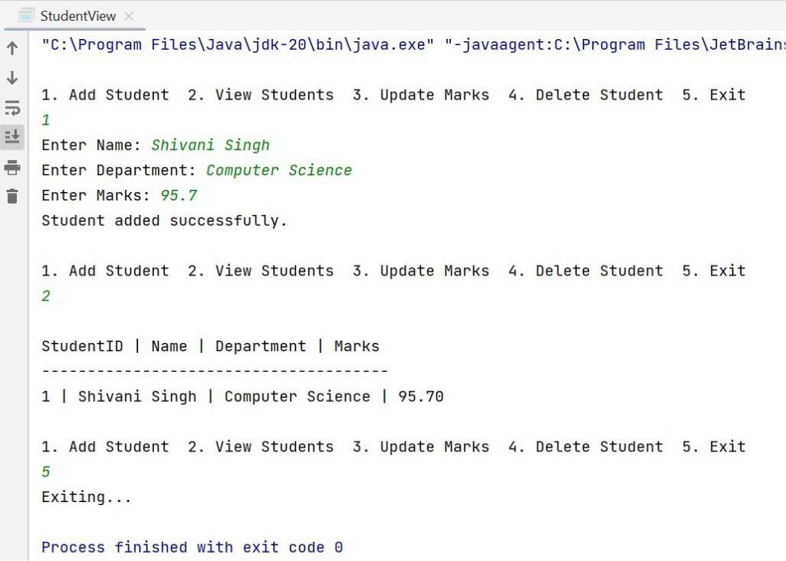

- Learning Outcomes:

  - Learn how to establish a connection between a Java application and a MySQL database using JDBC.

  - Understand the use of DriverManager and Connection objects to interact with the database.

  - Learn to use PreparedStatement to securely execute SQL queries.

