
DEPARTMENT OF

COMPUTER SCIENCE & ENGINEERING

Experiment 3

Student Name: Pratik Kaushal

Branch: CSE

Semester: 6th

UID: 22BCS10026

Section/Group: DL-902/A

DOP: 23/1/2025

Subject: Java Lab

Subject Code: 22CSH-359

Problem Statement: Write a Java program to calculate the square root of a number entered

by the user. Use try-catch to handle invalid inputs (e.g., negative numbers or non-numeric values).

CODE:

import java.util.Scanner;

public class SquareRootCalculator

{ public static void main(String[] args)

{

Scanner scanner = new Scanner(System.in); System.out.print("Enter a number: ");

try {

double number = scanner.nextDouble();

if (number < 0) {

throw new IllegalArgumentException("Error: Cannot calculate the square root of a negative number.");

}

double result = Math.sqrt(number);

System.out.println("Square root: " + result);

} catch (IllegalArgumentException e) { System.out.println(e.getMessage());
} catch (Exception e) {

} finally

{ scanner.close();

}

}

}
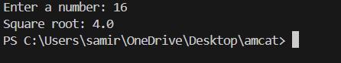


DEPARTMENT OF

COMPUTER SCIENCE & ENGINEERING

Problem Statement: Write a Java program to simulate an ATM withdrawal system. The program should:

Ask the user to enter their PIN.

Allow withdrawal if the PIN is correct and the balance is sufficient.

Throw exceptions for invalid PIN or insufficient balance.

Ensure the system always shows the remaining balance, even if an exception occurs.

CODE :

import java.util.Scanner;

class InvalidPINException extends Exception

{ public InvalidPINException(String message) {

super(message);

}

}

class InsufficientBalanceException extends Exception

{ public InsufficientBalanceException(String message) { super(message);

}

public class ATMWithdrawalSystem {

private static final int CORRECT_PIN = 1234;

private static double balance = 3000;

public static void main(String[] args)

{ Scanner scanner = new Scanner(System.in);

try {

System.out.print("Enter PIN: ");

int pin = scanner.nextInt();

if (pin != CORRECT_PIN) {

throw new InvalidPINException("Error: Invalid PIN.");

}

System.out.print("Withdraw Amount: ");

double amount = scanner.nextDouble();

if (amount > balance) {

throw new InsufficientBalanceException("Error: Insufficient balance.");

}

balance -= amount;

DEPARTMENT OF

COMPUTER SCIENCE & ENGINEERING

System.out.println("Withdrawal successful. Remaining Balance: " + balance);

} catch (InvalidPINException | InsufficientBalanceException e) { System.out.println(e.getMessage());
} catch (Exception e) {

System.out.println("Error: Invalid input. Please enter numeric values."); } finally {

System.out.println("Current Balance: " + balance);

scanner.close();

}

}

}
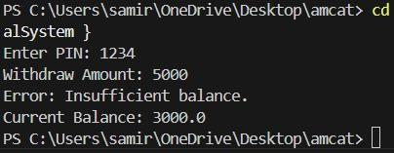

Problem Statement: Create a Java program for a university enrollment system with exception handling.

The program should:

Allow students to enroll in courses.

Throw a CourseFullException if the maximum enrollment limit is reached.

Throw a PrerequisiteNotMetException if the student hasn’t completed prerequisite courses.

CODE :

import java.util.Scanner;

import java.util.HashSet;

import java.util.Set;

class CourseFullException extends Exception

{ public CourseFullException(String message) {

super(message);

}

}

class PrerequisiteNotMetException extends Exception

{ public PrerequisiteNotMetException(String message) { super(message);

}

}

DEPARTMENT OF

COMPUTER SCIENCE & ENGINEERING

class UniversityEnrollmentSystem {

private static final int MAX_ENROLLMENT = 30;

private static int enrolledStudents = 0;

private static final Set<String> completedCourses = new HashSet<>();

public static void enroll(String course, String prerequisite) throws CourseFullException, PrerequisiteNotMetException {

if (enrolledStudents >= MAX_ENROLLMENT) {

throw new CourseFullException("Error: Course is full. Cannot enroll.");

}

if (!completedCourses.contains(prerequisite)) {

throw new PrerequisiteNotMetException("Error: PrerequisiteNotMetException - Complete " + prerequisite + " before enrolling in " + course + ".");

}

enrolledStudents++;

System.out.println("Enrollment successful in " + course + ".");

}

public static void main(String[] args)

{ Scanner scanner = new Scanner(System.in);

System.out.print("Enroll in Course: ");

String course = scanner.nextLine();

System.out.print("Prerequisite: ");

String prerequisite = scanner.nextLine();

try {

enroll(course, prerequisite);

} catch (CourseFullException | PrerequisiteNotMetException e) { System.out.println(e.getMessage());
} finally {

System.out.println("Total Enrolled Students: " + enrolledStudents); scanner.close();

}

}

}
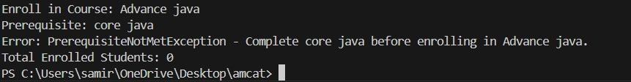

DEPARTMENT OF

COMPUTER SCIENCE & ENGINEERING

Learning Outcomes:

- Inheritance: Use of base and derived classes for shared attributes and methods.

- Method Overriding: Custom implementation of methods in subclasses.

- Constructor: Initializing object attributes using constructors.

- Encapsulation: Storing and manipulating data within objects.

- Polymorphism: Different behavior of calculateInterest() based on object type.

- Interest Calculation: Implementing FD and RD interest formulas.

- Class Interaction: Creating objects and calling methods to display details.


DEPARTMENT OF

COMPUTER SCIENCE & ENGINEERING

