DEPARTMENT OF


COMPUTER SCIENCE & ENGINEERING

Experiment-4



StudentName: Pratik Kaushal

Branch: BE-CSE

Semester: 6th

Subject Name: PBLJ Lab

UID:22BCS10026

Section/Group: DL-902-A

Date of Performance:07/02/25

Subject Code: 22CSH-359

- Aim:Write a Java program to implement an ArrayList that stores employee details (ID, Name, and Salary). Allow users to add, update, remove, and search employees.

- Algorithm:

  - Initialize an ArrayList to store employees.

  - Display a menu for adding, updating, removing, searching, and displaying employees.

  - Perform operations based on user input using loops and conditions.

  - Exit when the user chooses to quit.

- Implementation/Code:
import java.util.ArrayList;

import java.util.Scanner;

class Employee {

int id;

String name;

double salary;

Employee(int id, String name, double salary) { this.id = id;

this.name = name;

this.salary = salary;

}

@Override

public String toString() {

return "ID: " + id + ", Name: " + name + ", Salary: " + salary;

}

DEPARTMENT OF


COMPUTER SCIENCE & ENGINEERING

}

public class EmployeeManagement {

public static void main(String[] args) {

ArrayList<Employee> employees = new ArrayList<>(); Scanner scanner = new Scanner(System.in); int choice;

do {

System.out.println("\n1. Add Employee");

System.out.println("2. Update Employee");

System.out.println("3. Remove Employee"); System.out.println("4. Search Employee"); System.out.println("5. Display All Employees"); System.out.println("6. Exit"); System.out.print("Enter your choice: "); choice = scanner.nextInt(); switch (choice) {

case 1:

System.out.print("Enter ID: ");

int id = scanner.nextInt();

scanner.nextLine(); // consume newline

System.out.print("Enter Name: ");

String name = scanner.nextLine();

System.out.print("Enter Salary: ");

double salary = scanner.nextDouble();

employees.add(new Employee(id, name, salary));

System.out.println("Employee added successfully!");

break;

case 2:

System.out.print("Enter ID to update: ");

int updateId = scanner.nextInt();
DEPARTMENT OF


COMPUTER SCIENCE & ENGINEERING

for (Employee emp : employees) {

if (emp.id == updateId) {

scanner.nextLine(); // consume newline

System.out.print("Enter New Name: ");

emp.name = scanner.nextLine();

System.out.print("Enter New Salary: ");

emp.salary = scanner.nextDouble();

System.out.println("Employee updated successfully!");

break;

}

}

break;

case 3:

System.out.print("Enter ID to remove: "); int removeId = scanner.nextInt(); employees.removeIf(emp -> emp.id == removeId); System.out.println("Employee removed successfully!"); break;

case 4:

System.out.print("Enter ID to search: ");

int searchId = scanner.nextInt();

for (Employee emp : employees) {

if (emp.id == searchId) {

System.out.println(emp);

break;

}

}

break;

case 5:

System.out.println("All Employees:");
DEPARTMENT OF


COMPUTER SCIENCE & ENGINEERING

for (Employee emp : employees) {

System.out.println(emp);

}

break;

case 6:

System.out.println("Exiting program...");

break;

default:

System.out.println("Invalid choice! Please try again.");

}

} while (choice != 6); scanner.close();
}

}

- OUTPUT:
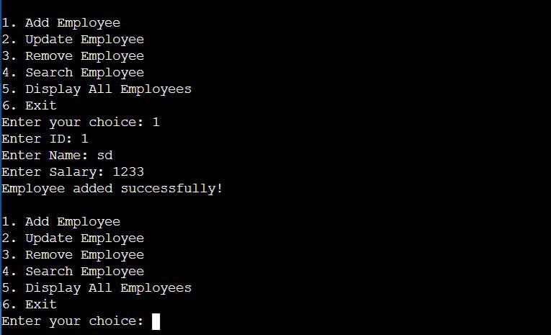

Question2:

- Aim: Create a program to collect and store all the cards to assist the users in finding all the cards in a given symbol using Collection interface.
DEPARTMENT OF


COMPUTER SCIENCE & ENGINEERING

  - Algorithm:

Create a List of cards with symbols and values. Accept user input for the symbol to search.

Loop through the list and display cards matching the symbol.

- Implementation/Code:

import java.util.ArrayList;

import java.util.Collections;

import java.util.List;

import java.util.Scanner;

class Card {

String symbol;

String value;

Card(String symbol, String value) {

this.symbol = symbol;

this.value = value;

}

public String toString() {

return symbol + "-" + value;

}

}public class CardCollection {

public static void main(String[] args) {

List<Card> cards = new ArrayList<>();
DEPARTMENT OF


COMPUTER SCIENCE & ENGINEERING

Scanner scanner = new Scanner(System.in);

cards.add(new Card("Hearts", "A"));

cards.add(new Card("Spades", "K"));

cards.add(new Card("Hearts", "10"));

cards.add(new Card("Diamonds", "Q"));

cards.add(new Card("Clubs", "J"));

System.out.println("Enter the symbol to search (e.g., Hearts): ");

String symbol = scanner.nextLine();

System.out.println("Cards with symbol \"" + symbol + "\":");

for (Card card : cards) {

if (card.symbol.equalsIgnoreCase(symbol)) { System.out.println(card);
}

}

scanner.close();

}

}
- Output:
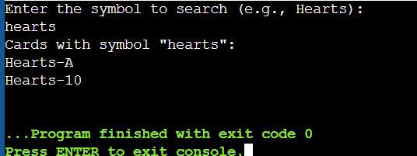
DEPARTMENT OF


COMPUTER SCIENCE & ENGINEERING

Question3:

- Aim:Develop a ticket booking system with synchronized threads to ensure no double booking of seats. Use thread priorities to simulate VIP bookings being processed first.

- Algorithm:

Initialize a boolean[] for seats and a ReentrantLock for synchronization. Create threads with priorities representing users booking seats.

Lock the seat array while booking to prevent double bookings. Run threads; higher priority threads book first.

- Implementation/Code:

import java.util.concurrent.locks.ReentrantLock; class TicketBookingSystem {
private final boolean[] seats;

private final ReentrantLock lock;

TicketBookingSystem(int totalSeats) {

this.seats = new boolean[totalSeats];

this.lock = new ReentrantLock();

}

public void bookSeat(String user, int seatNumber) { lock.lock();

try {

if (seatNumber < 0 || seatNumber >= seats.length) { System.out.println(user + ": Invalid seat number!"); return;

}

if (!seats[seatNumber]) {

seats[seatNumber] = true;

System.out.println(user + " successfully booked seat " + seatNumber); } else {

System.out.println(user + ": Seat " + seatNumber + " is already booked!");

}

} finally {

lock.unlock();

}
DEPARTMENT OF


COMPUTER SCIENCE & ENGINEERING

}

}

class User extends Thread {

private final TicketBookingSystem bookingSystem; private final int seatNumber;
User(String name, TicketBookingSystem bookingSystem, int seatNumber, int priority) {

super(name);

this.bookingSystem = bookingSystem;

this.seatNumber = seatNumber;

setPriority(priority);

}

@Override

public void run() {

bookingSystem.bookSeat(getName(), seatNumber);

}

}

public class TicketBookingDemo {

public static void main(String[] args) {

TicketBookingSystem bookingSystem = new TicketBookingSystem(10);

User user1 = new User("VIP_User1", bookingSystem, 3, Thread.MAX_PRIORITY);

User user2 = new User("Normal_User1", bookingSystem, 3, Thread.MIN_PRIORITY);

User user3 = new User("Normal_User2", bookingSystem, 5, Thread.NORM_PRIORITY);

User user4 = new User("VIP_User2", bookingSystem, 5, Thread.MAX_PRIORITY);

user1.start();

user2.start();

user3.start();

user4.start();

}

}
DEPARTMENT OF


COMPUTER SCIENCE & ENGINEERING

4. OUTPUT:
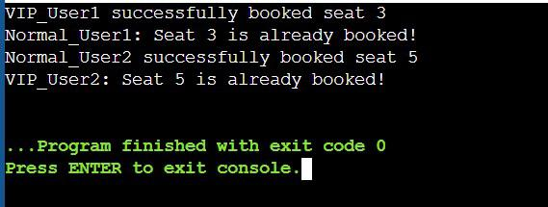

- Learning Outcome:

Object-Oriented Programming (OOP): Applied encapsulation, inheritance, and polymorphism to design modular and reusable code (e.g., Employee, Card, User classes).

Collections Framework: Utilized ArrayList and Collection for data storage, retrieval, and filtering operations, showcasing dynamic data management.

Multithreading and Synchronization: Designed a thread-safe system using ReentrantLock and thread priorities to handle concurrency and ensure data consistency (e.g., ticket booking).

User Interaction: Built interactive, menu-driven programs for CRUD operations, validating user inputs for robust functionality.

Real-world Problem Solving: Implemented practical systems like employee management, card searching, and seat booking, reflecting real-world scenarios and scalable design.

