DEPARTMENT OF


COMPUTER SCIENCE & ENGINEERING

Experiment 1

Name: Pratik Kaushal

Branch: BE-CSE

Semester:6th

Subject Name: Project Based Learning

in Java with Lab

UID: 22BCS10026

Section/Group: TPP-DL-902/A

Date of Performance: 8th Jan, 25

Subject Code: 22CSH-359

- Aim: Given the following table containing information about employees of an organization, develop a small java application, which accepts employee id from the command prompt and displays the following details as output: Emp No Emp Name Department Designation and Salary

You may assume that the array is initialized with the following details:
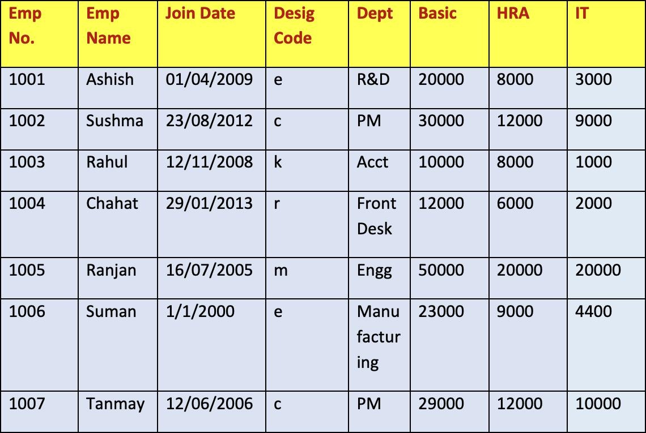

Salary is calculated as Basic+HRA+DA-IT. (DA details are given in the Designation table)

DEPARTMENT OF
COMPUTER SCIENCE & ENGINEERING

Designation details:
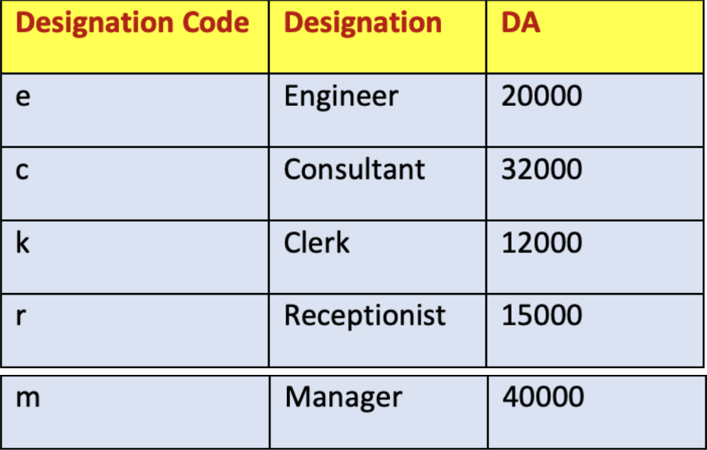

Use Switch-Case to print Designation in the output and to find the value of DA for a particular employee.

2. Objective:

- Assuming that your class name is Project1, and you execute your code as java Project1 1003, it should display the following output :

Emp No. Emp Name Department Designation Salary

1003 Rahul Acct Clerk 29000

- java Project1 123

There is no employee with empid : 123

- Implementation/Code: import java.util.*;

public class Emp{
public static void main(String[] args) {
Scanner sc = new Scanner(System.in);

String[] empNo = {"1001", "1002", "1003", "1004", "1005", "1006", "1007"}; String[] empName = {"Ashish", "Sushma", "Rahul", "Chahat", "Ranjan",
"Suman", "Tanmay"};

String[] joinDate = {"01/04/2009", "23/08/2012", "12/11/2008", "29/01/2013", "16/07/2005", "01/01/2000", "12/06/2006"};
DEPARTMENT OF
COMPUTER SCIENCE & ENGINEERING

String[] desigCode = {"e", "c", "k", "r", "m", "e", "c"};

String[] dept = {"R&D", "PM", "Acct", "Front Desk", "Engg", "Manufacturing", "PM"};

int[] basic = {20000, 30000, 10000, 12000, 50000, 23000, 29000}; int[] hra = {8000, 12000, 8000, 6000, 20000, 9000, 12000}; int[] it = {3000, 9000, 1000, 2000, 20000, 4400, 10000};

System.out.print("Enter the Employee ID: "); String id = sc.nextLine();

int index = -1;
for (int i = 0; i < empNo.length; i++) {
if (empNo[i].equals(id)) {
index = i;

break;
}
}

if (index == -1) {
System.out.println("There is no employee with empid: " + id);
}

else {
int da;
String designation;
switch (desigCode[index]) {
case "e":
designation = "Engineer";

da = 20000;
break;
case "c":
designation = "Consultant";
da = 32000;
break;
case "k":

designation = "Clerk";
da = 12000;
break;
case "r":
designation = "Receptionist";
da = 15000;

break;
case "m":
DEPARTMENT OF
COMPUTER SCIENCE & ENGINEERING

designation = "Manager";
da = 40000;

break;
default:
designation = "Unknown";
da = 0;
}

int salary = basic[index] + hra[index] + da - it[index]; System.out.println("Emp No\tEmp Name\tDepartment\tDesignation\tSalary"); System.out.println(empNo[index] + "\t" + empName[index] + "\t\t" +
dept[index] + "\t\t" + designation + "\t\t" + salary);
}

sc.close();
}
}

4. Output:
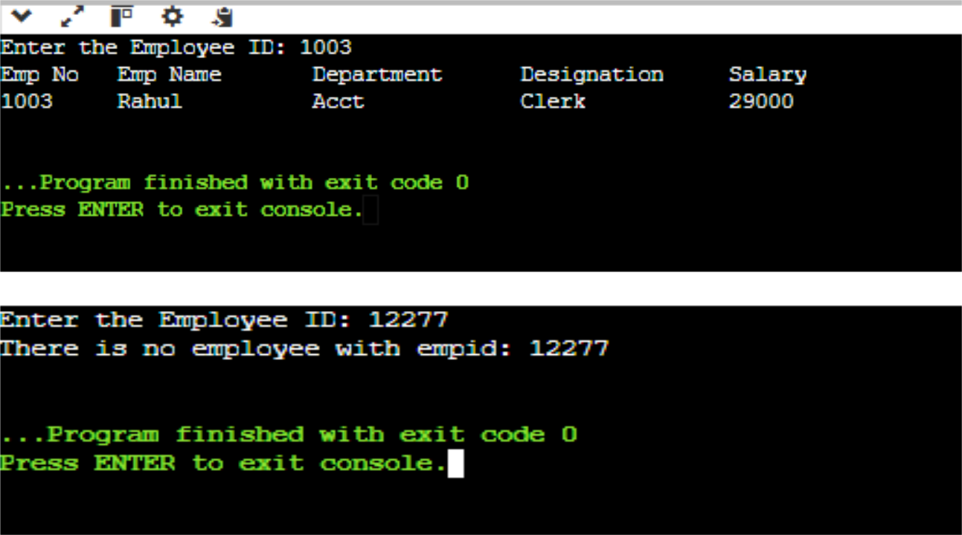

5. Learning Outcomes:

- Understand how to map employee details (like designation codes to roles) using efficient logic and structures.
DEPARTMENT OF
COMPUTER SCIENCE & ENGINEERING

- Learn to identify and address input mismatches or invalid entries through

- proper validation and error messages.

- Gain skills in presenting data in a well-structured and readable format for better user understanding.

