Experiment No.:1 Histogram of Gray scale Image
Aim: To obtain Histogram of Gray scale Image
Code:
import cv2
import numpy as np
from matplotlib import pyplot as plt
# image path
path = 'animal2.jpeg'
# using imread()
img = cv2.imread(path, cv2.IMREAD_GRAYSCALE)
cv2.imshow('Cat', img)
dst = cv2.calcHist(img, [0], None, [256], [0, 256])
plt.hist(img.ravel(), 256, [0, 256])
plt.title('Histogram for gray scale image')
plt.show()
OUTPUT:
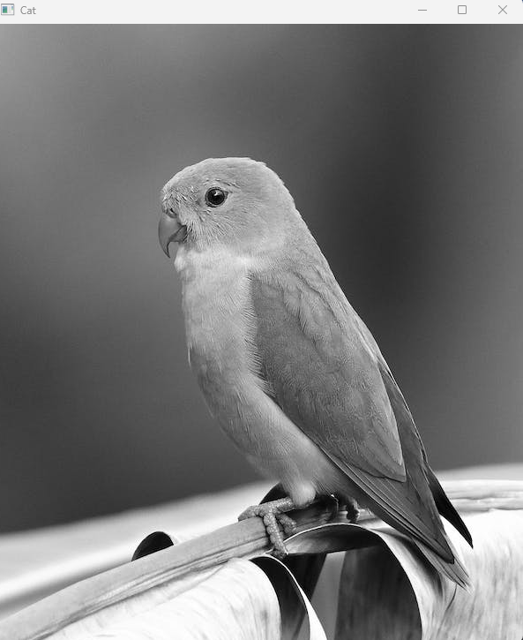
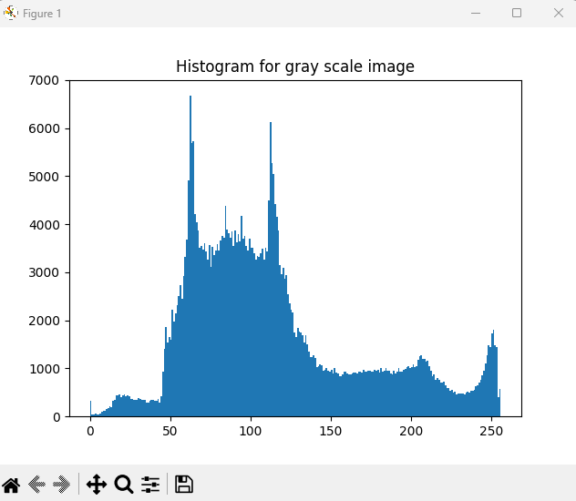

Experiment No.:2 Histogram of color Image
Aim: To obtain Histogram of color Image
Code:
import cv2
import numpy as np
from matplotlib import pyplot as plt
img = cv2.imread('animal.jpg')
# Calculate histogram without mask
hist1 = cv2.calcHist([img], [0], None, [256], [0, 256])
hist2 = cv2.calcHist([img], [1], None, [256], [0, 256])
hist3 = cv2.calcHist([img], [2], None, [256], [0, 256])
plt.subplot(221), plt.imshow(img)
plt.subplot(222), plt.plot(hist1), plt.plot(hist2), plt.plot(hist3)
plt.xlim([0, 256])
plt.show()
OUTPUT:
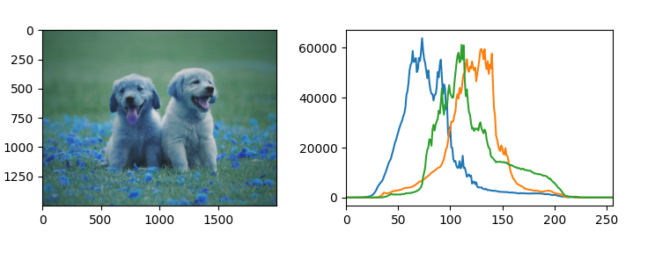

Experiment No.:3 Histogram Plotting and Stretching:
Aim: To obtain histogram stretching
import cv2
import numpy as np
import matplotlib.pyplot as pltt
# Load the input image with RGB channels
img_sam = cv2.imread('animal.jpg', cv2.IMREAD_COLOR)
# Split the channels into red, green, and blue
rd, gn, bl = cv2.split(img_sam)
# Plot the histograms for each channel
pltt.hist(rd.ravel(), bins=277, color='red', alpha=0.10)
pltt.hist(gn.ravel(), bins=277, color='green', alpha=0.10)
pltt.hist(bl.ravel(), bins=277, color='blue', alpha=0.10)
pltt.show()
# Stretch the contrast for each channel
red_c_stretch = cv2.equalizeHist(rd)
green_c_stretch = cv2.equalizeHist(gn)
blue_c_stretch = cv2.equalizeHist(bl)
# Merge the channels back together
img_stretch = cv2.merge((red_c_stretch, green_c_stretch, blue_c_stretch))
# Display the original and stretched images side by side
pltt.subplot(121)
pltt.imshow(cv2.cvtColor(img_sam, cv2.COLOR_BGR2RGB))
pltt.title('Original_Image')
pltt.subplot(122)
pltt.imshow(cv2.cvtColor(img_stretch, cv2.COLOR_BGR2RGB))
pltt.title('Stretched_Image')
pltt.show()
OUTPUT:
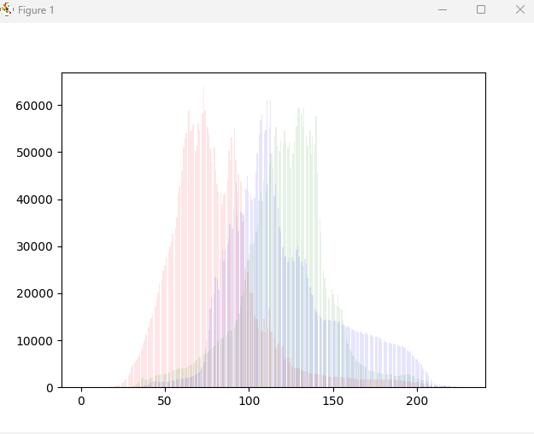
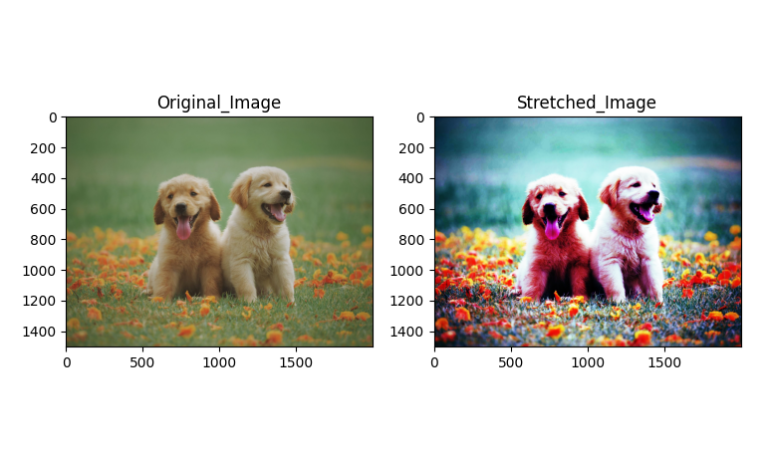

Experiment No.:4 Histogram Equalization
Aim: To obtain Histogram Equalized Image.
Code:
import cv2
import numpy as np
# load the source image
img = cv2.imread('rose.jpg')
# convert it to grayscale
img_yuv = cv2.cvtColor(img, cv2.COLOR_BGR2YUV)
# apply histogram equalization
img_yuv[:, :, 0] = cv2.equalizeHist(img_yuv[:, :, 0])
hist_eq = cv2.cvtColor(img_yuv, cv2.COLOR_YUV2BGR)
# display both images (original and equalized)
cv2.imshow("equalizeHist", np.hstack((img, hist_eq)))
cv2.waitKey(0)
OUTPUT:
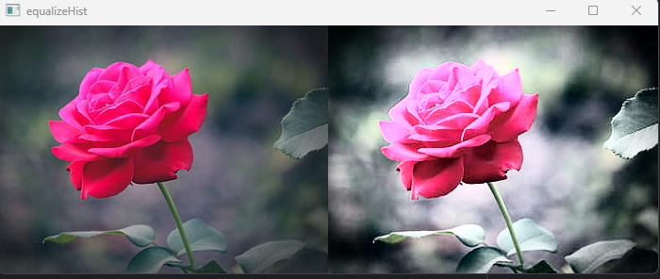

Experiment No.:5 Transforms-DCT
Aim: To apply Discrete Cosine Transform(DCT) on image
Code:
import cv2
import numpy as np
# read input image as grayscale
img = cv2.imread('rose.jpg', 0)
# convert the grayscale to float32
imf = np.float32(img) # float conversion
# find discrete cosine transform
dst = cv2.dct(imf, cv2.DCT_INVERSE)
# apply inverse discrete cosine transform
img1 = cv2.idct(dst)
img1 = np.uint8(img)
cv2.imshow("DCT", dst)
cv2.waitKey(0)
cv2.imshow("IDCT back image", img1)
cv2.waitKey(0)
cv2.destroyAllWindows()
OUTPUT:
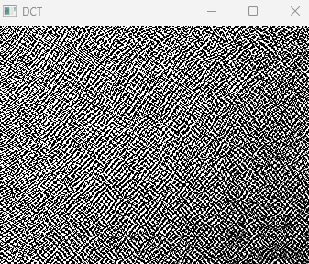
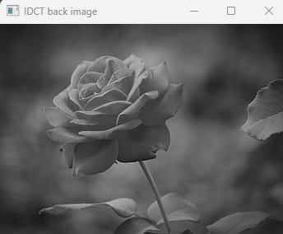

Experiment No.:6 Image Enhancement
Aim: To obtain Image enhancement
Code:
# Importing Image and ImageOps module from PIL package
from PIL import Image, ImageOps
# creating a image1 object
im1 = Image.open(r"rose.JPg")
im1.show()
# applying equalize method
im2 = ImageOps.equalize(im1, mask=None)
im2.show()
OUTPUT:
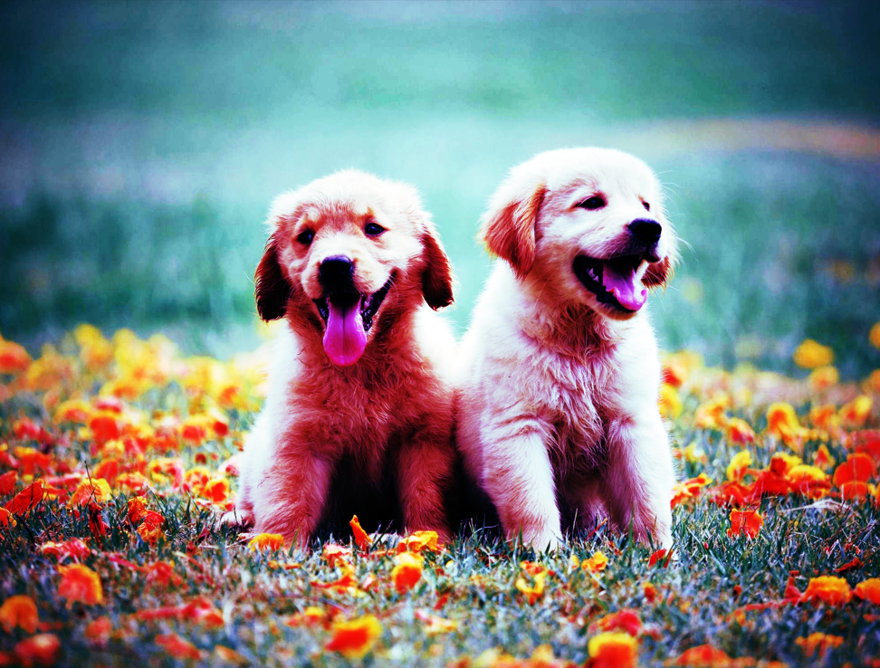

Experiment No.:7 Image Edge Detection
Aim: To implement image edge detection algorithm.
Code:
# Import the necessary Libraries
import cv2
import numpy as np
import matplotlib.pyplot as plt
# Read image from disk.
img = cv2.imread('rose.jpg')
# Convert BGR image to RGB
image_rgb = cv2.cvtColor(img, cv2.COLOR_BGR2RGB)
# Apply Canny edge detection
edges = cv2.Canny(image= image_rgb, threshold1=100, threshold2=700)
# Create subplots
fig, axs = plt.subplots(1, 2, figsize=(7, 4))
# Plot the original image
axs[0].imshow(image_rgb)
axs[0].set_title('Original Image')
# Plot the blurred image
axs[1].imshow(edges)
axs[1].set_title('Image edges')
# Remove ticks from the subplots
for ax in axs:
​
ax.set_xticks([])
​
ax.set_yticks([])
# Display the subplots
plt.tight_layout()
plt.show()
OUTPUT:
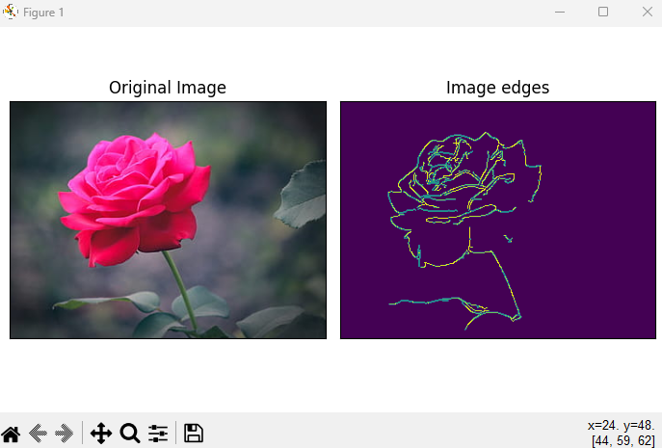

Experiment No.:8 Image Blurring
Aim: To obtain blurred image.
Code:
import cv2
import numpy
# image path
path = 'rose.jpg'
# using imread()
img = cv2.imread(path)
dst = cv2.GaussianBlur(img, (5, 5), cv2.BORDER_DEFAULT)
cv2.imshow('image', numpy.hstack((img, dst)))
cv2.waitKey(0);
cv2.destroyAllWindows();
cv2.waitKey(1)
OUTPUT:
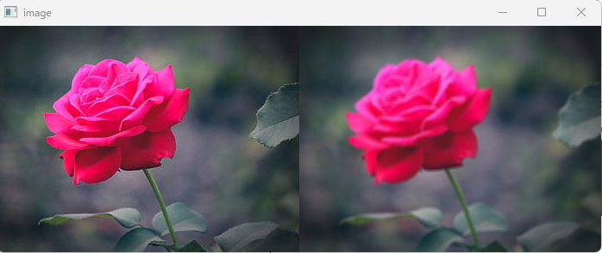

Experiment No.:9 Morphological operations
Aim: To perform morphological operations on image: dilation and erosion
Code:
import cv2
import numpy as np
# Reading the input image
img = cv2.imread('animal2.jpeg', 0)
kernel = np.ones((5, 5), np.uint8)
img_erosion = cv2.erode(img, kernel, iterations=1)
img_dilation = cv2.dilate(img, kernel, iterations=1)
cv2.imshow('Input', img)
cv2.imshow('Erosion', img_erosion)
cv2.imshow('Dilation', img_dilation)
cv2.waitKey(0)
OUTPUT:
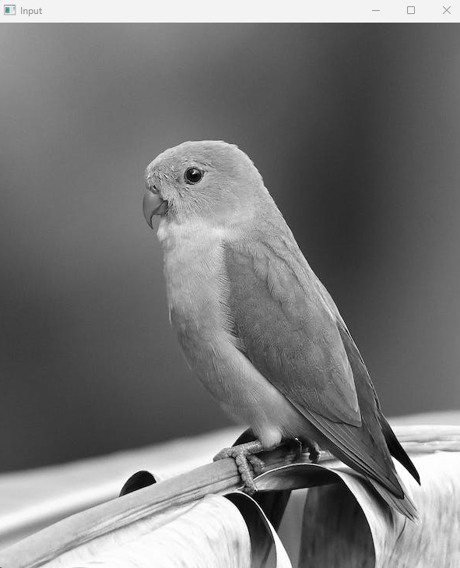
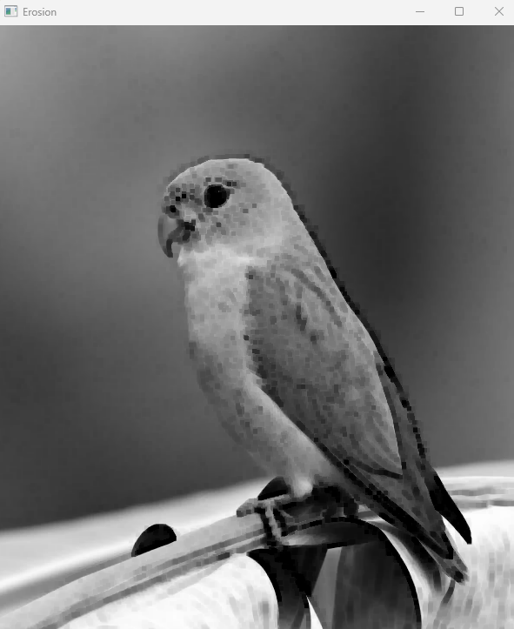
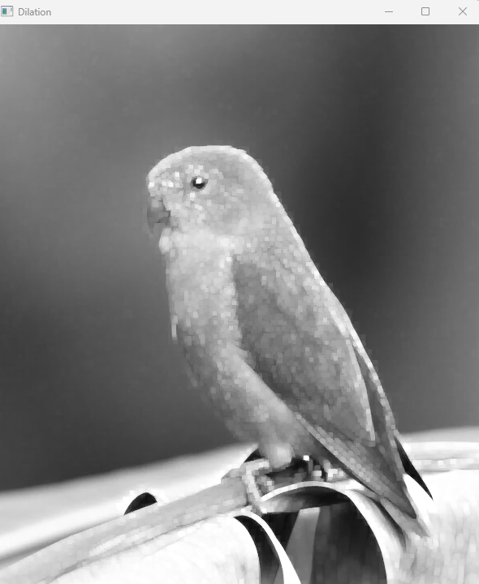

Experiment No.:10 Segmentation-Gradient Operators
Aim: To use Gradient operators in Image Processing
Code:
import numpy as np
import cv2 as cv
from matplotlib import pyplot as plt
img = cv.imread('rose.jpg', cv.IMREAD_GRAYSCALE)
assert img is not None, "file could not be read, check with os.path.exists()"
laplacian = cv.Laplacian(img,cv.CV_64F)
sobelx = cv.Sobel(img,cv.CV_64F,1,0,ksize=5)
sobely = cv.Sobel(img,cv.CV_64F,0,1,ksize=5)
plt.subplot(2,2,1),plt.imshow(img,cmap = 'gray')
plt.title('Original'), plt.xticks([]), plt.yticks([])
plt.subplot(2,2,2),plt.imshow(laplacian,cmap = 'gray')
plt.title('Laplacian'), plt.xticks([]), plt.yticks([])
plt.subplot(2,2,3),plt.imshow(sobelx,cmap = 'gray')
plt.title('Sobel X'), plt.xticks([]), plt.yticks([])
plt.subplot(2,2,4),plt.imshow(sobely,cmap = 'gray')
plt.title('Sobel Y'), plt.xticks([]), plt.yticks([])
plt.show()
OUTPUT:
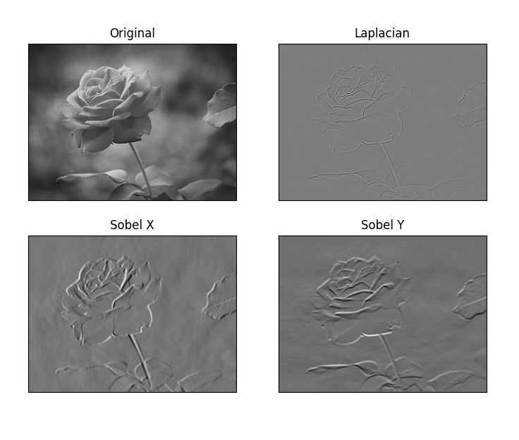

Experiment No.:11 Frequency Domain Filtering
Aim: To obtain Frequency Domain Filtering on an Image
Code:
import numpy as np
import pandas as pd
import cv2
#img_root=”Images/”
img_name='animal2.jpeg'
# Reading the Image
img = cv2.imread(img_name,cv2.IMREAD_UNCHANGED)
#domain filter
domainFilter = cv2.edgePreservingFilter(img, flags=1, sigma_s=60, sigma_r=0.6)
cv2.imshow('Domain Filter',np.hstack((img,domainFilter)))
#cv2.imshow('Domain Filter',domainFilter)
cv2.waitKey(0)
cv2.destroyAllWindows()
#gauss filter
gaussBlur = cv2.GaussianBlur(img,(5,5),cv2.BORDER_DEFAULT)
cv2.imshow("Gaussian Smoothing",np.hstack((img,gaussBlur)))
cv2.waitKey(0)
cv2.destroyAllWindows()
#highpass filter
highPass = img - gaussBlur
# or We can use this statement to filter the high pass image
#highPass = highPass + 127*np.ones(img.shape, np.uint8)
cv2.imshow("High Pass",np.hstack((img, highPass)))
cv2.waitKey(0)
cv2.destroyAllWindows()
#lowpass filter
lowPass = cv2.filter2D(img,-1,kernel=0)
lowPass = img - lowPass
cv2.imshow("Low Pass",np.hstack((img, lowPass)))
cv2.waitKey(0)
cv2.destroyAllWindows()
OUTPUT:
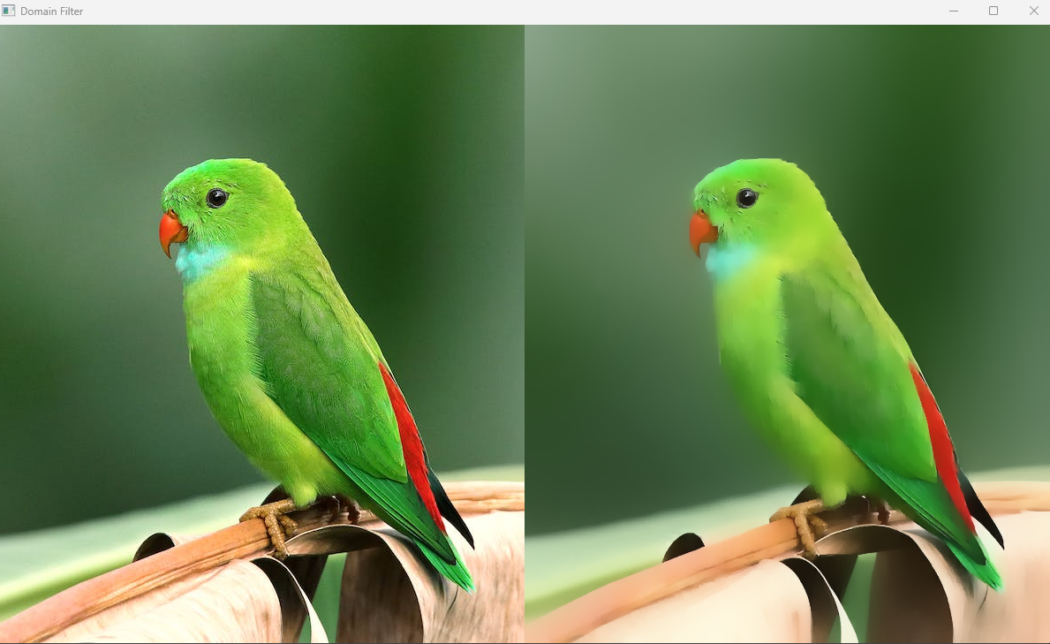
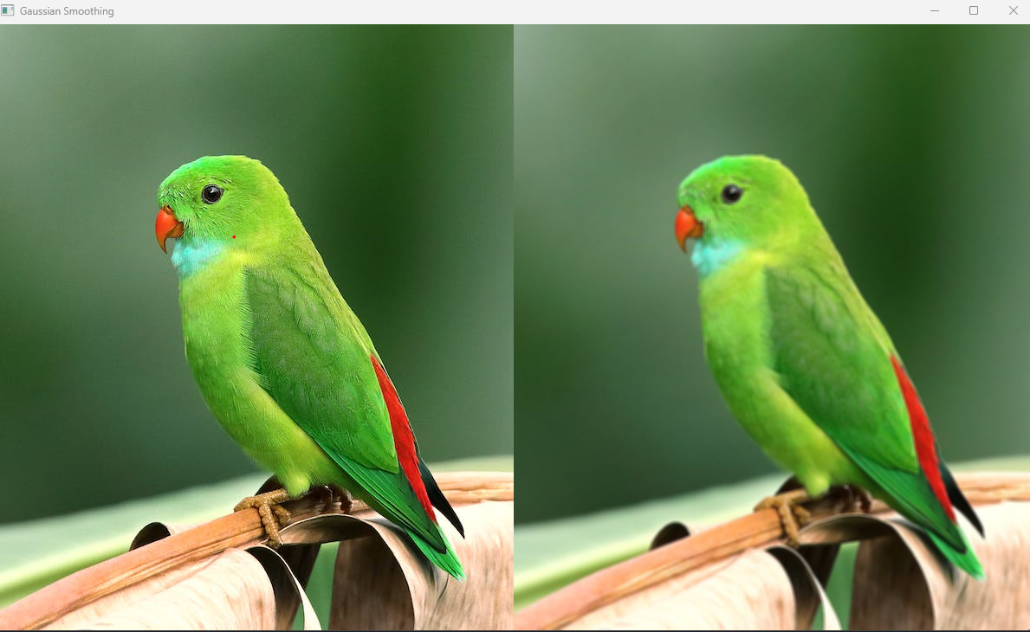
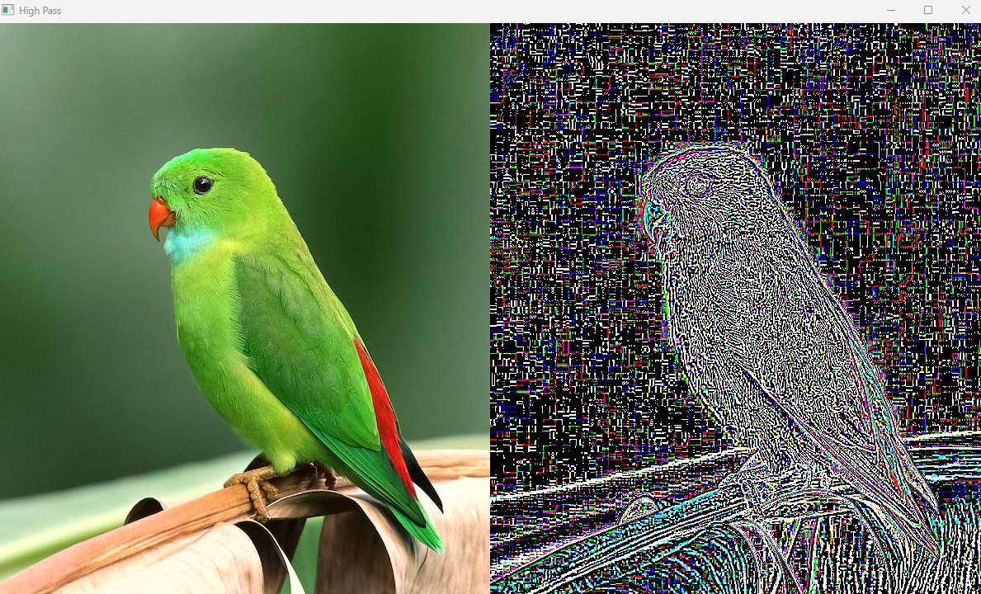

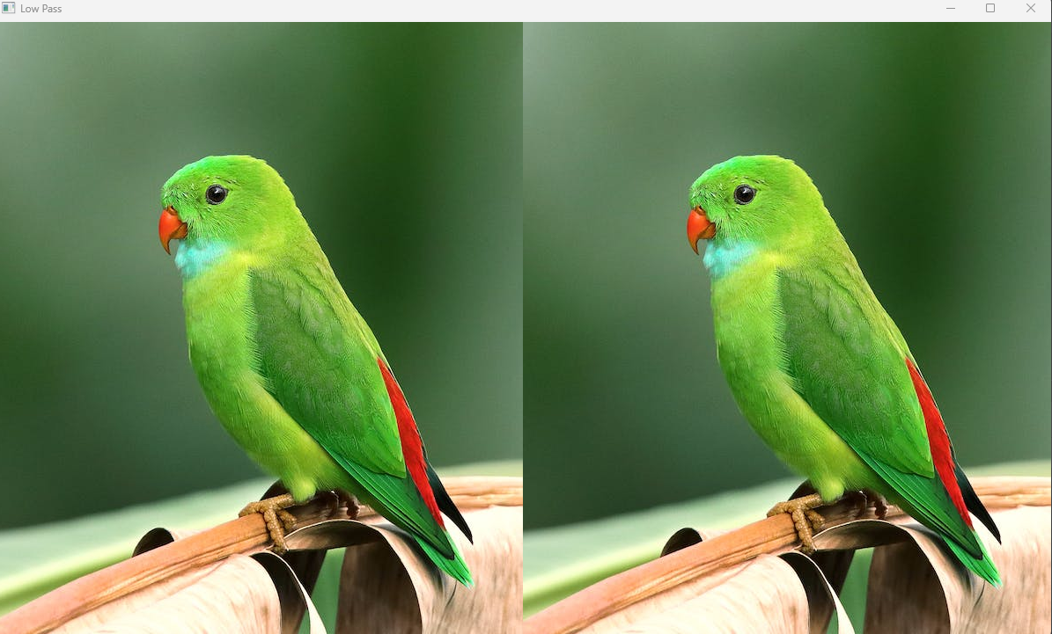

Ai
Name: Undestand agent
Practical 2: Study Simple Reflex Agent and Model Based Agent
Aim
To understand Simple Reflex Agent and Model Based Agent.
Theory
•
Simple Reflex Agent: Acts only on current percept using condition-action rules.
•
Model Based Agent: Maintains internal state to track aspects of the environment.
Example Program
def simple_reflex_agent(percept):
if percept == "Dirty":
return "Clean"
else:
return "Move"
print(simple_reflex_agent("Dirty"))
Result
Clean

Practical 3: Graph for Profit or Loss in Banking Application
Aim
To represent profit or loss using graphs in Python.
Simple Reflex Agent: Acts only on the current percept without considering past
states.
Example rule:
IF temperature > 30
THEN turn fan ON
Model Based Agent: Maintains an internal state of the environment and uses it for
decision making.
Agent Architecture Diagram
Environment
|
v
Sensors
|
v
Agent
(Decision Process)
|
v
Actuators
|
v
Environment
Flowchart
Start
|
Read Environment Input
|
Check Condition
|
Is Temperature > 30 ?
/ \
Yes No
| |
Fan ON Fan OFF
|
Stop Program
import matplotlib.pyplot as plt
months = ["Jan", "Feb", "Mar", "Apr"]
profit_loss = [5000, -2000, 3000, -1000]
plt.plot(months, profit_loss, marker='o')
plt.title("Bank Profit/Loss Graph")
plt.xlabel("Month")
plt.ylabel("Profit/Loss")
plt.show()
Result

Practical 4: PEAS Description
Aim
To describe a problem using PEAS.
Example: Self Driving Car
Result
Problem environment was successfully described using PEAS.
Component
Description
Performance
Safety, speed, comfort
Environment
Roads, traffic, pedestrians
Actuators
Steering, brakes, accelerator
Sensors
Camera, GPS, radar

Practical 5: Basic Searching Algorithm
Aim
To implement searching algorithm.
BFS Search Tree Diagram
A
/ \
B C
/ \ \
D E F
Traversal Order
A → B → C → D → E → F
Flowchart
Start
|
Insert Root Node into Queue
|
Remove Node from Queue
|
Visit Node
|
Add Unvisited Neighbours
|
Queue Empty ?
/ \
No Yes
| |
Repeat Stop
Python Program
from collections import deque
graph = {
'A':['B','C'],
'B':['D','E'],
'C':['F'],
'D':[],
'E':[],
'F':[]
} visited=set()
queue=deque(['A'])
while queue:
node=queue.popleft()
if node not in visited:
print(node,end=" ")
visited.add(node)
queue.extend(graph[node])
Program (Linear Search)
def linear_search(arr, key):
for i in range(len(arr)):
if arr[i] == key:
return i
return -1
arr = [10, 20, 30, 40]
key = 30
print("Element found at index:", linear_search(arr, key))
Result
Element found at index: 2

Practical 6: 8 Queens Problem
Aim
Place 8 queens on chessboard such that no queen attacks another.
Diagram
Q . . . . . . .
. . Q . . . . .
. . . . Q . . .
. Q . . . . . .
. . . . . Q . .
. . . Q . . . .
. . . . . . Q .
. . . . . . . Q
Flowchart
Start
|
Place Queen in Row
|
Check Column & Diagonal Safety
|
Safe ?
/ \
Yes No
| |
Next Row Try Next Column
|
All Queens Placed ?
/ \
Yes No
| |
Solution Backtrack
|
Stop
Program
N = 8
def solve(board, col):
if col >= N:
return True for i in range(N):
if is_safe(board, i, col):
board[i][col] = 1
if solve(board, col + 1):
return True
board[i][col] = 0
return False
def is_safe(board, row, col):
for i in range(col):
if board[row][i] == 1:
return False
return True
board = [[0]*N for i in range(N)]
solve(board, 0)
for row in board:
print(row)
Result
[1, 0, 0, 0, 0, 0, 0, 0]
[0, 1, 0, 0, 0, 0, 0, 0]
[0, 0, 1, 0, 0, 0, 0, 0]
[0, 0, 0, 1, 0, 0, 0, 0]
[0, 0, 0, 0, 1, 0, 0, 0]
[0, 0, 0, 0, 0, 1, 0, 0]
[0, 0, 0, 0, 0, 0, 1, 0]
[0, 0, 0, 0, 0, 0, 0, 1]

Practical 7: A* Algorithm
Aim
To implement A* search algorithm.
A* Evaluation Function
f(n) = g(n) + h(n)
Where
g(n) = cost from start
h(n) = heuristic estimate
A* Search Diagram
Start A
/ \
B C
\ /
D (Goal)
Program
import heapq
graph = {
'A': [('B',1), ('C',3)],
'B': [('D',3)],
'C': [('D',1)],
'D': []
}
def astar(start, goal):
queue = [(0,start)]
visited = set()
while queue:
cost,node = heapq.heappop(queue)
if node == goal:
print("Goal reached")
return
if node not in visited:
visited.add(node) for neighbour, weight in graph[node]:
heapq.heappush(queue,(cost+weight,neighbour))
astar('A','D')
Result
Goal reached

Practical 8: Alpha Beta Tree Search
Aim
To implement Alpha Beta pruning.
Game Tree Diagram
MAX
/ \
MIN MIN
/ \ / \
3 5 6 9
Alpha-Beta prunes unnecessary nodes.
Flowchart
Start
|
Generate Game Tree
|
Apply Minimax
|
Apply Alpha-Beta Pruning
|
Select Best Move
|
Stop
Program
import math
def alphabeta(depth, nodeIndex, maximizingPlayer, values, alpha, beta):
if depth == 3:
return values[nodeIndex]
if maximizingPlayer:
best = -math.inf
for i in range(2):
val = alphabeta(depth+1, nodeIndex*2+i, False, values, alpha, beta)
best = max(best,val)
alpha = max(alpha,best)
if beta <= alpha:
break return best
else:
best = math.inf
for i in range(2):
val = alphabeta(depth+1, nodeIndex*2+i, True, values, alpha, beta)
best = min(best,val)
beta = min(beta,best)
if beta <= alpha:
break
return best
values = [3,5,6,9,1,2,0,-1]
print("Optimal Value:", alphabeta(0,0,True,values,-math.inf,math.inf))
Result
Optimal Value: 5

Practical 9: Classical Planning Algorithm
Aim
To implement classical planning.
Example
Goal: Move from Room A → Room B.
Program
state = "A"
if state == "A":
action = "Move to B"
state = "B"
print("Current State:", state)
Result
Current State: B

Practical 10: Robot Obstacle Traversal Problem
Aim
Move robot from start to goal while avoiding obstacles.
Grid Diagram
S → Start
G → Goal
X → Obstacle
S 0 0
X X 0
0 0 G
Flowchart
Start
|
Current Position
|
Compare with Goal
|
Obstacle Present ?
/ \
Yes No
| |
Change Path Move Forward
|
Goal Reached ?
/ \
No Yes
| |
Repeat Stop
Program
grid = [
[0,0,0],
[0,1,0],
[0,0,0]
]
def is_safe(x,y):
return x>=0 and y>=0 and x<3 and y<3 and grid[x][y]==0 print("Robot can traverse avoiding
obstacle.")
Result
Robot can traverse avoiding obstacle.

Write a program to implement A* Algorithm
from queue import PriorityQueue
# Define the grid (0 = free space, 1 = obstacle)
grid = [
[0, 1, 0, 0, 0],
[0, 1, 0, 1, 0],
[0, 0, 0, 1, 0],
[1, 1, 0, 1, 0],
[0, 0, 0, 0, 0]
]
# Define possible movements (up, down, left, right)
moves = [(0, 1), (1, 0), (0, -1), (-1, 0)]
# Heuristic function (Manhattan Distance)
def heuristic(a, b):
return abs(a[0] - b[0]) + abs(a[1] - b[1])
# A* Algorithm
def astar(start, goal):
open_set = PriorityQueue()
open_set.put((0, start)) # (priority, node)
came_from = {} # Store the path
g_score = {start: 0} # Cost from start
f_score = {start: heuristic(start, goal)} # Estimated total cost
while not open_set.empty():
_, current = open_set.get()
if current == goal:
# Reconstruct path
path = []
while current in came_from:
path.append(current)
current = came_from[current]
path.append(start)
return path[::-1] # Return reversed path
# Explore neighbors
for move in moves:
neighbor = (current[0] + move[0], current[1] + move[1])

# Check if neighbor is within bounds and not an obstacle
if 0 <= neighbor[0] < len(grid) and 0 <= neighbor[1] < len(grid[0]) and
grid[neighbor[0]][neighbor[1]] == 0:
temp_g_score = g_score[current] + 1
if neighbor not in g_score or temp_g_score < g_score[neighbor]:
g_score[neighbor] = temp_g_score
f_score[neighbor] = temp_g_score + heuristic(neighbor, goal)
open_set.put((f_score[neighbor], neighbor))
came_from[neighbor] = current
return None # No path found
# Define start and goal positions
start = (0, 0)
goal = (4, 4)
# Run A* Algorithm
path = astar(start, goal)
# Print result
if path:
print("Path found:", path)
else:
print("No path found.")
Output:
Path found: [(0, 0), (1, 0), (2, 0), (2, 1), (2, 2), (3, 2), (4, 2), (4, 3), (4, 4)]

1. Write a program to implement the following
a) DFS.
b) BFS.
a) A Program to implement DFS
graph={
'A':['B', 'C'],
'B':['D','E'],
'C':['F'],
'D':[],
'E':['F'],
'F':[]
}
visited = set()
def dfs(visited, graph, node):
if node not in visited:
print(node,end="")
visited.add(node)
for neighbour in graph[node]:
dfs(visited, graph, neighbour)
dfs(visited, graph, 'A')
output: ABDEFCb)

A program to implement BFS Algorithm
graph={
'A':['B', 'C'],
'B':['D','E'],
'C':['F'],
'D':[],
'E':['F'],
'F':[]
}
visited = []
queue = []
def bfs(visited, graph, node):
visited.append(node)
queue.append(node)
while queue:
s=queue.pop(0)
print(s, end=" ")
for neighbour in graph[s]:
if neighbour not in visited:
visited.append(neighbour)
queue.append(neighbour)
bfs(visited, graph, 'A')
Output: ABCDEF

Write a program to implement Travelling Salesman Problem.
from itertools import permutations
# Distance matrix representing the cost between cities
distance_matrix = [
[0, 10, 15, 20], # Distances from city 0
[10, 0, 35, 25], # Distances from city 1
[15, 35, 0, 30], # Distances from city 2
[20, 25, 30, 0] # Distances from city 3
]
num_cities = len(distance_matrix)
cities = list(range(num_cities)) # List of city indices
def calculate_route_distance(route):
"""Calculate the total distance of a given route."""
total_distance = 0
for i in range(len(route) - 1):
total_distance += distance_matrix[route[i]][route[i + 1]]
total_distance += distance_matrix[route[-1]][route[0]] # Returning to start
return total_distance
# Brute-force approach: Try all possible city orderings
min_distance = float('inf')
best_route = Nonefor perm in permutations(cities[1:]): # Fix city 0 as the start point
route = (0,) + perm # Start from city 0
dist = calculate_route_distance(route)
if dist < min_distance:
min_distance = dist
best_route = route
# Output the best route and distance
print("Best Route:", " -> ".join(map(str, best_route)), "-> 0")
print("Minimum Distance:", min_distance)
Output:
Best Route: 0 -> 1 -> 3 -> 2 -> 0
Minimum Distance: 806.

Write a program to implement Towers of Hanoi
class Tower:
def __init__(self):
self.terminate = 1
def printMove(self, source, destination):
print("{} -> {}".format(source, destination))
def move(self, disc, source, destination, auxiliary):
if disc == self.terminate:
self.printMove(source, destination)
else:
self.move(disc - 1, source, auxiliary, destination)
self.move(1, source, destination, auxiliary)
self.move(disc - 1, auxiliary, destination, source)
t = Tower();
t.move(3, 'A', 'B', 'C')
Output:
A -> B
A -> C
B -> C
A -> B
C -> A
C -> B
A -> B

