**Car Crash Detection Using Deep Learning**

# A Thesis submitted to

**Chhattisgarh Swami Vivekanand Technical University Bhilai (C.G.), India**

*In fulfillment*

***For the award of the Degree***

***of***

**Bachelor of Technology**

# in

**Computer Science and Engineering**

**by**

1. **Abhishek Baghel**

# Enrolment No: BH3565

# Roll Number: 301602219002

# Anchal Nagwanshi

# Enrolment No: BH3570

# Roll Number: 301602219007

# Pratik Kujur

# Enrolment No: BH3597

# Roll Number: 301602219034

**Under the Guidance of**

**Asst. Prof. Mrs. Arzoo Pandey**

**Department of Computer Science & Engineering**

## GOVERNMENT ENGINEERING COLLEGE

## SEJBAHAR, RAIPUR (C.G.)

**Session: 2022 – 2023**

**DECLARATION BY THE CANDIDATES**

We the undersigned solemnly declare that the report of the Project Work entitled “***Car Crash Detection Using Deep Learning”***, is based on our own work carried out during the course of our study under the supervision of ***Assistant Professor Mrs. Arzoo Pandey*.**

We assert that the statements made and conclusions drawn are an outcome of the project work. We further declare that to the best of our knowledge and believe that the report does not contain any part of any work which has been submitted for the award of any other degree/diploma/certificate in this University/deemed the University of India or any other country. All help received and citations used for the preparation of the Project Work have been duly acknowledged.



(Signature of the candidate) Name: Abhishek Baghel Roll No: 301602219002 Enrolment No: BH3565



(Signature of the candidate) Name: Anchal Nagwanshi Roll No: 301602219007 Enrolment No: BH3570



(Signature of the candidate) Name: Pratik Kujur

Roll No: 301602219034 Enrolment No: BH3597



**(Signature of the Supervisor)**

**Asst. Prof. Mrs. Arzoo Pandey**

Dept. Of Computer Science & Engineering,

Government Engineering College

Sejbahar, Raipur

**CERTIFICATE OF THE SUPERVISOR**

This is to certify that the report of the thesis entitled “***Car Crash Detection Using Deep Learning***” is a record of bonafide research work carried out by ***Abhishek Baghel*** bearing Roll No: ***301602219002*** & Enrolment No.: ***BH3565, Anchal Nagwanshi*** bearing Roll No:***301602219007*** & Enrolment No.:***BH3570*** and ***Pratik Kujur*** bearing Roll No: ***301602219034*** & Enrolment No.: ***BH3597*** under my guidance and supervision for the award of Degree of Bachelor of Technology in the field of ***Computer Science and Engineering***, of Chhattisgarh Swami Vivekanand Technical University, Bhilai (C.G.), India.

To the best of my knowledge and belief the Project Work

* Embodies the work of the candidate him/herself,
* Has duly been completed,
* Fulfils the requirement of the ordinance relating to the BTech degree of the University
* Is up to the desired standard both in respect of contents and language for being referred to the examiners.

|  |
| --- |
| **______________________________**  **Prof. (Dr.) R.H. Talwekar**  (Head of Department) |
| Dept. Of Computer Science & Engineering |
| Government Engineering College, |
| Sejbahar, Raipur (C.G.) |

|  |
| --- |
| **______________________________**  **Asst. Prof. Mrs. Arzoo Pandey**  (Project Guide) |
| Dept. Of Computer Science & Engineering |
| Government Engineering College, |
| Sejbahar, Raipur (C.G.) |

Forwarded to Chhattisgarh Swami Vivekanand Technical University

Bhilai

_____________________

(Signature of Principal)

Government Engineering College, Sejbahar, Raipur

**CERTIFICATE BY THE EXAMINERS**

The Thesis entitled***Car Crash Detection Using Deep Learning***submitted ***Abhishek Baghel*** (Roll No: ***301602219002*** & Enrolment No.: ***BH3565), Anchal Nagwanshi*** (Roll No: ***301602219007*** & Enrolment No.: ***BH3570)*** and ***Pratik Kujur*** (Roll No: ***301602219034*** & Enrolment No.: ***BH3597)*** has been examined by the undersigned as a part of the examination and is hereby recommended for the award of the degree of Bachelor of Technology in the field of Computer Science and Engineering of Chhattisgarh Swami Vivekanand Technical University, Bhilai.

_________________ ___________________

Internal Examiner External Examiner

Date: Date:

**ACKNOWLEDGEMENT**

We would like to thank our guide as well as the Head of Department, **Prof. Dr. R.H. Talwekar**,, Department of Computer Science and Engineering for his immense support and enlightened guidance for our project which we have developed as B. Tech. students.

We are also very thankful to **Mr. Pushpendra Dhar Dwivedi,** Assistant Professor and Project In charge for his continuous support and guidance. We are very grateful for the inspiring discussions with all our faculties, their valuable support and path-guiding suggestions have helped us to develop this project. Alongside, we would like to take this opportunity to express our thanks to everyone in the Computer Laboratory of Government Engineering College, Sejbahar, and Raipur (C.G.).

We especially thank our colleagues, batch mates, and friends for their support and help that they offered us during the course of development of this project.



(Signature of the candidate) Name: Abhishek Baghel

Government Engineering College,

Sejbahar, Raipur



(Signature of the candidate) Name: Anchal Nagwanshi

Government Engineering College,

Sejbahar, Raipur



(Signature of the candidate) Name: Pratik Kujur

Government Engineering College,

Sejbahar, Raipur

**ABSTRACT**

Car crashes are a major cause of injuries and fatalities around the world. Rapid detection of car crashes and timely alerts to emergency services can significantly improve the chances of survival and reduce the severity of injuries. In recent years, deep learning techniques have shown tremendous promise in various computer vision tasks, including object detection and recognition. This has led to the exploration of deep learning for car crash detection systems. In this proposed system, a deep learning model is used to detect car crashes in real-time by analyzing video feeds from surveillance/CCTV cameras. It uses a convolutional neural network (CNN) to identify specific patterns associated with car crashes. Once a car crash is detected, the CNN model can identify it and an alert can be generated to emergency services.

# Table of Contents

Declaration by the Candidates .............i

Certificate of the Supervisor .ii

Certificate by the Examiners iii

Acknowledgement iv

Abstract………………………………………………………………………………………...v

List of figures...……………………………………………………...…………………….…viii

**Chapter - 1 Introduction 1**

1.1 Introduction ...…………………………………………….................................2

* 1. Major process to be followed in Car Crash Detection ....……….......................2

1.3 Issues and challenges ............………………………………….........................3

**Chapter - 2 Literature Review.................................................................................................4**

2.1 Introduction ......……………...…………………...........................................5-8

2.2 Observation Table ..........………………………………………………......9-10

**Chapter – 3 Problem Identification…………………………………………………...........11**

3.1 Introduction........………………………………………………………….......12

3.2 Major causes of road accident……………………….................................12-14

**Chapter - 4 Methodology .......................................................................................................15**

* 1. Software and Libraries requirements ...………………………………........16-17
  2. Hardware requirements……………………………………………………......17
  3. System Design…………………………………………………………...........18
  4. Data Flow Diagram ……………………………………………………..........18
  5. Methodology………………………………………………………………19-23
  6. CNN Model..................................................................................................23-26

**Chapter - 5 Results 27**

5.1 Model accuracy graphs.………………………...…………………………..28-29

5.2 Output screenshots......…………………………………………………………30

**Chapter - 6 Conclusion and Future scope 31**

6.1 Conclusion…………………………………………………………………….32

6.2 Future Scope………………………………………………………………….33

**Chapter -7 References.………………………………………………………………….34-35**

**List Of Figures**

Figure 3.1: Major causes of road accident deaths in 2021........................................................14

Figure 4.1: System Design……………………………………………………………………18

Figure 4.2: Data Flow Diagram…………................................................................................18

Figure 4.3: Methodology……………………………………………………………………...19

Figure 4.4: Crash……………………………………...............................................................21

Figure 4.5:Not Crash……………………………………………………................................21

Figure 4.6: Synthetic Crash……………………………………………………………….......21

Figure 4.7: Synthetic Not Crash ………………………………………………………….......21

Figure 4.8: Model Summary………………………………………………………………….26

Figure 4.9: CNN Architecture…………………………………………………………….......26

Figure 5.1: Car Crash Detected………………………………………………………............30

Figure 5.2: Not Car Crash Detected............................................................………………….30

3.

***Chapter-1***

# *INTRODUCTION*

* 1. **Introduction**

IP cameras and sensors are used in traditional traffic systems. These systems are already installed in most parts of the city. Their purpose is to monitor and control traffic. These systems are able to generate traffic tickets automatically, but it does not provide any solution to decrease the fatal accidental human damages rate which occur due to lack of medical aid in real time.

In this project we are proposing a system which can identify and detect moving cars in live camera feeds and detect car crashes and immediately send emergency alerts to the nearby authority for them to take necessary actions. The car crash detection using deep learning is an innovative solution to improve road safety and reduce the number of fatalities and injuries caused by car crashes. The system uses cameras and deep learning algorithms to detect car crashes in real-time and alert emergency services, providing a faster response to the scene of the accident. Due to which only the selected part of clips will be feeded to the deep learning model and from that clips model predicts the output i.e., - ‘Crash’ or ‘Not Crash’. If the outcome is found to be ‘Crash’ then further steps could be taken to notify the nearby emergency services.

* 1. **Major process to be followed in Car Crash Detection**

Deep learning can be used in various ways for car crash detection, depending on the specific approach and application. Here are two major techniques that can be used as a base for car crash detection using deep learning.

Convolutional Neural Networks (CNNs) for Video Analysis: CNNs are a type of deep learning algorithm commonly used for image and video analysis. For car crash detection, CNNs can be trained on large datasets of car crash videos and non-crash videos to learn the features that distinguish between them. These features can then be used to detect car crashes in real-time by analyzing the video frames captured by cameras mounted on vehicles or roadside cameras.

Object detection algorithms are used to identify and locate objects within images or videos. These algorithms can be used for a variety of purposes, such as online photo shopping and video surveillance. For car crash detection, object detection algorithms can be trained to recognize specific objects such as vehicles, pedestrians, and road signs. By analyzing the movement patterns of these objects and their interactions, these algorithms can detect car crashes and provide real-time alerts to emergency responders.

* 1. **Issues and Challenges**

There could be several challenges with a project which can be overcome by deep learning to detect car crashes. Some of these challenges include:

Data Collection and Labeling: Deep learning algorithms require large amounts of labeled data to be trained effectively. In the case of car crash detection, collecting and labeling a sufficient amount of data can be challenging, as car crashes are rare events and difficult to capture on camera. Additionally, labeling the data accurately can be time-consuming and requires expertise.

Real-time Processing: Car crash detection systems need to operate in real-time to provide timely alerts to emergency responders. This requires the deep learning algorithms to process video data at high speeds, which can be computationally intensive and challenging to implement on resource-constrained devices.

Variability in Car Crash Scenarios: Car crashes can occur in various scenarios, such as head-on collisions, rear-end collisions, and side-impact collisions. These scenarios can have different features and patterns that need to be learned by the deep learning algorithms, which can make the models complex and difficult to generalize across different crash types.

Lack of Diversity in Training Data: The accuracy and reliability of deep learning models depend on the quality and diversity of the training data. If the training data is biased or lacks diversity, the model may not perform well on new, unseen data. It's essential to ensure that the training data covers a wide range of scenarios and environmental conditions to build robust models that can generalize well.

Adapting to Changing Conditions: Car crash detection systems need to be adaptable to changing environmental conditions such as weather, lighting, and traffic density. This requires the deep learning algorithms to be able to learn and adapt to new conditions quickly. Additionally, the system needs to be designed to handle different scenarios such as urban and rural areas, highways, and parking lots.

***Chapter-2***

# *LITERATURE REVIEW*

* 1. **Introduction**

There are many related works which are done in the field of deep learning and artificial intelligence in car crash detection. Some of them are as follow:

1. **Fast car crash detection in video-**

This paper proposes a method for fast car crash detection in video using an SVM classifier and motion and HOG features. The authors use a sliding window approach to process the video frames in real-time. The proposed method was evaluated on a dataset of 114 videos, consisting of 57 videos with car crashes and 57 videos without car crashes. The authors report an accuracy of 89% in detecting car crashes in the video frames using their proposed method. One limitation of the proposed method is that it may not be able to detect car crashes that occur outside the field of view of the camera or in low-light conditions. Overall, the paper presents a promising approach to fast car crash detection in video with an accuracy of 89%.

1. **Detection of Road Traffic Crashes Based on Collision Estimation**-

The paper “Detection of Road Traffic Crashes Based on Collision Estimation” proposes a method for detecting road traffic crashes based on the estimation of collision probability using data from vehicle sensors and a camera feed. The authors use YOLO object detection system to detect vehicles and other objects in the camera feed. The method then estimates collision probability between the vehicle and detected objects using a machine learning algorithm. The proposed method achieves an accuracy of 93% in detecting crashes with a lower false positive rate of 2.5% compared to a similar method based on vehicle dynamics. One limitation of the method is that it requires specialized sensors and a camera, which may not be available in all vehicles. The proposed method can also be limited in detecting crashes outside the sensor and camera range or in noisy or incomplete data. Overall, the paper presents a promising approach to detecting road traffic crashes based on collision estimation using vehicle sensor data and visual information with high accuracy.

1. **A New Video-Based Crash Detection Method: Balancing Speed and Accuracy Using a Feature Fusion Deep Learning Framework-**

The paper “A New Video-Based Crash Detection Method: Balancing Speed and Accuracy Using a Feature Fusion Deep Learning Framework” proposes a video-based crash detection method using a feature fusion deep learning framework. The authors use a combination of two deep learning models, a Convolutional Neural Network (CNN) and a Long Short-Term Memory (LSTM) network, to extract spatiotemporal features from video footage of driving scenes. These features are then fused and used to classify crash and non-crash events. The proposed method achieves a high accuracy of 97.2% in detecting crashes with a low false positive rate of 1.5%.

The method is also able to process video footage in real-time, with a frame rate of 30 frames per second. The authors demonstrate the effectiveness of the proposed method on a dataset of real-world driving scenario.

One limitation of the proposed method is that it may not be able to detect certain types of crashes, such as low-speed collisions or collisions that occur outside the field of view of the camera. Additionally, the method requires significant computational resources due to the use of two deep learning models and feature fusion.

1. **Automated AI Based Road Traffic Accident Alert System: YOLO Algorithm-**

The paper proposes an automated AI-based road traffic accident alert system using the YOLOv3 algorithm for object detection in real-time video streams from cameras mounted on the roads. The system analyzes the relative positions and movements of objects on the road to determine if an accident has occurred. If an accident is detected, the system alerts emergency services and nearby vehicles with the accident’s location. The proposed system has the potential to reduce response times and save lives by providing real-time accident detection and alerting. The high accuracy rate of the system is due to the use of the YOLOv3 algorithm, which can process images at a very high speed. However, the system is dependent on a stable and reliable internet connection for sending alerts to emergency services and nearby vehicles. The system may not work optimally in situations with poor lighting or adverse weather conditions, which may affect the accuracy of the object detection algorithm. Further research is needed to evaluate the system’s effectiveness in real-world settings and under different environmental conditions.

1. **Real-Time Accident Detection in Traffic Surveillance Using Deep Learning-**

The paper proposes a system for real-time accident detection in traffic using deep learning, consisting of pre-processing, feature extraction, and classification stages. The deep learning model extracts features from each frame using a CNN to detect accidents in real-time. The system achieved an accuracy of 93% in detecting accidents, a significant improvement over existing method. However, the system requires a large amount of training data and may not detect accidents outside the camera’s field of view. The paper provides information about the collision estimation method used. The proposed system shows promise in accurately detecting accidents in real-time, but further research is needed to address limitations and improve performance. The system’s real-time capabilities make it useful for traffic surveillance applications. The study contributes to the growing body of literature on the application of deep learning in traffic safety.

1. **Deep Learning applied to Road Accident Detection with Transfer Learning and Synthetic Images-**

The development of deep learning techniques, such as transfer learning, data augmentation, and synthetic data, has significantly reduced the number of images required to train a neural network with satisfactory results. Transfer learning involves reusing pre-trained neural networks and customizing them for specific tasks, while data augmentation creates random variations of the input data. Synthetic data can also be used to emulate real data and increase the diversity of the training dataset.

In the case of road accident detection, these techniques have enabled the development of deep learning models that can be trained with a smaller number of images per class (between 150 and 500) compared to the thousands of images previously required. Transfer learning is often used with pre-trained neural networks trained on ImageNet, while data augmentation is used to create variations of images, and synthetic data is used to simulate positive events, such as road accidents. These techniques have enabled the development of more efficient and effective road accident detection models.

1. **Vehicle Accident Detection-**

The paper proposes a learning model that utilizes Machine Learning to predict and detect real-time collisions and accidents on highways through security cameras. The model learns over an image dataset and aims to classify accidents based on the level of damage they cause. The authors use an Artificial Neural Network to train the model to learn the similarities among images and accident data. The paper suggests that the use of Machine Learning in accident detection can be promising in reducing the overall damage rate that ensues these accidents, and could be used as a tool to improve road safety.

The paper utilizes one of the largest accident detection datasets available, the Accident Detection and Prediction (CADP) dataset, consisting of 1,416 video segments collected from YouTube with spatiotemporal annotations. The authors also reference the DETRAC dataset and several other related datasets commonly used for traffic analysis and accident detection. The model proposed in the paper achieves an accuracy of 97%, which is a promising result in the field of accident detection and prediction. The paper suggests that the use of Machine Learning with large datasets can significantly improve road safety and reduce the overall damage rate that occurs from accidents

.

1. **Vehicle Accident and Traffic Classification Using Deep Convolutional Neural Networks** –

The paper addresses the pressing issue of road traffic accidents by investigating the classification of traffic and accident images using deep learning techniques. The authors use a deep Convolutional Neural Network (CNN) model to categorize images into four predefined classes: Accident, Dense Traffic, Fire, and Sparse Traffic. The CNN model effectively maps input images to their labeled classes and shows good generalization to the test dataset, achieving an accuracy of 94.4% on four target traffic and accident classes.

The paper suggests that the use of deep learning techniques can significantly improve the performance of feature extraction and pattern recognition for accident and traffic classification. Keywords used in the paper include Convolutional neural network, Image classification, Traffic accident, Deep learning, Neural network, and Pattern recognition.

**2.2 Observation Table-**

|  |  |  |  |  |  |  |
| --- | --- | --- | --- | --- | --- | --- |
| **S.No** | **Author** | **Year** | **Method** | **Dataset** | **Result** | **Limitations** |
| **1.** | V. Machaca Arceda,E. Laura Riveros | 2018 | SVM  Classifier | 120 normal video traffic and 57 car-crash videos. | Achieves an accuracy of 89% | If the video feed is of poor quality or low resolution, the accuracy of the algorithm may suffer. |
| **2.** | Mohamed Essam, Nagia M. Ghanem and Mohamed A. Ismail | AIRCC,pp. 169-179, 2022. CS & IT - CSCP 2022 DOI: 10.5121/csit.2022.121213 | C Crash prediction using speed estimation | Data is gathered by downloading them from different YouTube sources, cutting and editing them, and getting 75 videos to test the system. | It achieved the accuracy 93% | Dataset can be improved. |
| **3.** | M. Zhenbo Lu,1 Wei Zhou,Shixiang Zhang,Chen Wang. | Journal of Advanced Transportation 2020 | SVM Classifier | 120 normal video traffic and 57 car-crash videos | It achieved the accuracy 89% | . This project does not give us crash estimation. |
| **4.** | DeDeeksha Gour; Amit Kanskar | Journal of Advanced Transportation 2020 | Deep learning CNN | Traffic Image Dataset | The proposed  Model achieved an accuracy of 78% | Th This project does not give us crash estimation. |
| **5.** | Hadi Ghahremannezhad,Hang Shi,Chengjun Liu | arXiv:2208.06461v1 [cs.CV] 12 Aug 2022 | YOLO algorithm | COCO dataset | It achieves an average precision of 37.2% | It It is difficult to detect small objects that appear in groups. |
| **6.** | Ol Tiago Tamaguskoa, Matheus Gomes Correiaa, Minh Anh Huynhb, Adelino Ferreiraa | . International Scientific Conference “The Science and Development of Transport | M MobileNet | Images were collected from a Finnish open data system through its API provided by Digitraffic. | The proposed model achieved an accuracy of 94% | No Actual images of crash images is taken (only synthetic). |
| **7.** | Alok Kumar, Indreesh Pandey, Arun Prakash, Akash Srivastava | IJARSCT, 5 May 2022 | Car crash classification using CNN | It uses 28000 accident images from CADP and 23000 non-accident images from  DETRAC dataset. |  |  |
| **8** | BU Bulbula kumeda,Zhang Fengli,Ariyo ,Oluwasanmi | 20  2019 | Convolutional Neural Network (CNN) | Traffic-Net dataset which contains 4,400 images where 1,100 images for each category, with 900 images for training and 200 images for testing. | It can perform the task with an accuracy of 94.4% on four target traffic and accident classes. | II This model will not give good result if take input from surveillance camera. |

***Chapter-3***

# *PROBLEM IDENTIFICATION*

* 1. **Introduction**

Car accidents are a major cause of death and injury worldwide, with millions of people affected every year. Traditional methods of car crash detection, such as human observation or accident reporting, can be slow and unreliable. Car accidents have been a major cause of concern for many decades, leading to numerous fatalities and injuries across the globe. According to the World Health Organization (WHO), road traffic injuries are the leading cause of death among people aged between 5-29 years. In addition to the loss of life, car accidents result in a significant economic impact on society, including healthcare costs, property damage, and lost productivity.

car crash detection system using deep learning can be particularly useful in detecting accidents that occur during early morning or late-night hours when there are fewer eyewitnesses and less visibility on the road.

During these times, it can be difficult for emergency responders to reach the scene of the accident in a timely manner. However, the deep learning model can detect the accident and notify the emergency services automatically, providing them with critical information about the location and severity of the crash. Furthermore, the system can also be useful in scenarios where the driver may be incapacitated or unable to call for help, such as in the case of a medical emergency. The deep learning model can automatically detect the accident and alert emergency services, potentially saving precious time in getting medical assistance to the affected individual.

To address this issue, researchers have been exploring various methods to detect car crashes and provide immediate assistance. One such approach is to use deep learning, a subset of artificial intelligence, to detect car crashes in real-time.

Deep learning-based car crash detection systems have the potential to overcome these limitations and provide a timely response to accidents. However, developing such a system poses several challenges, such as collecting and labeling large amounts of data, optimizing the algorithm for real-time processing, handling false positives, and ensuring the model's transparency and interpretability. This thesis aims to develop and evaluate a deep learning-based car crash detection system that addresses these challenges and provides accurate and reliable detection of car accidents.

* 1. **Major causes of road accident**

Road accidents are a major problem with a high number of fatalities and injuries reported each year. Some of the major causes of road accidents in worldwide include:

Human error: Human error is one of the leading causes of road accidents in India. Factors such as reckless driving, speeding, overtaking, driving under the influence of alcohol or drugs, and driver fatigue can lead to accidents on the road.

Poor road conditions: Poor Road conditions, including potholes, uneven surfaces, and inadequate signage, can increase the risk of accidents on the road. This is particularly true in rural areas, where roads may be poorly maintained or nonexistent.

Vehicle defects: Defective vehicles, including faulty brakes, steering systems, and tires, can also contribute to road accidents in India. Many vehicles on Indian roads are poorly maintained, leading to mechanical failures that can cause accidents.

Pedestrian safety: Pedestrian safety is another major concern on Indian roads, with many accidents caused by pedestrians crossing roads in unsafe areas or walking on the road instead of the sidewalk.

Overloading: Overloading of vehicles, particularly trucks and buses, can also increase the risk of accidents on Indian roads. Overloaded vehicles are more difficult to maneuver and are more likely to suffer from mechanical failures.

Weather conditions: Poor weather conditions, including heavy rain and fog, can also increase the risk of accidents on Indian roads. These conditions can make it difficult for drivers to see the road and other vehicles, and can also lead to skidding and loss of control.

Lack of road safety awareness: Finally, a lack of awareness about road safety and traffic rules is also a major contributor to road accidents in India. Many drivers and pedestrians are unaware of the risks involved in unsafe behavior on the road, and may not take the necessary precautions to avoid accidents.

Speeding: Speeding increases the risk of accidents by reducing the driver's ability to react to unexpected situations and stopping distance, making it difficult to avoid collisions. It is also a major contributor to fatal accidents, as high speeds can cause severe injuries in the event of a crash.

Driving under the influence of alcohol: Driving under the influence of alcohol or drugs can impair a driver's judgment, coordination, and reaction time, increasing the risk of accidents on the road. In India, drunk driving is a serious problem, with many accidents caused by drivers who are under the influence of alcohol.

In India, Major causes of road accident deaths in 2021

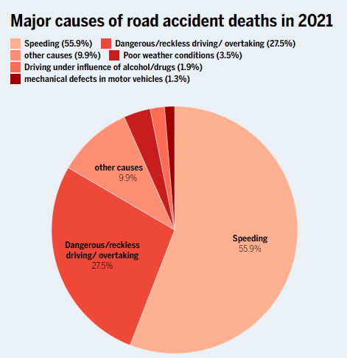

Fig 3.1: Major causes of road accident deaths in 2021

***Chapter-4***

# *METHODOLOGY*

**4.1 Software and libraries requirements-**

**4.1.1 Python-**

Python is a high-level, interpreted programming language that is widely used for web development, scientific computing, data analysis, artificial intelligence, and other applications. Python was first released in 1991 by Guido van Rossum. Since then, it has become one of the most popular programming languages in the world. One of the main advantages of Python is its simplicity and readability, making it easy for new programmers to learn and for existing code to be maintained. It also has a large and active community which has developed a wide range of libraries and frameworks for specific tasks such as NumPy for numerical computations, pandas for data manipulation, and TensorFlow for machine learning.

Python also supports multiple programming paradigms inclusive of object-oriented, practical, and procedural programming. It runs on various platforms such as Windows, Mac, Linux, and Unix.

It’s widely used in various fields such as Data Science, Web development, Machine Learning, Automation, and many more.

**4.1.2 OpenCV-**

OpenCV (Open-Source Computer Vision) is a library of programming functions mainly aimed at real-time computer vision. It was developed by Intel and is now maintained by a non-profit organization. OpenCV is written in C++ and has interfaces for C++, Python, and Java.

OpenCV provides a wide range of functionality for image and video processing, including:

* Image processing and manipulation, such as filtering, thresholding, and colour space conversions.
* Object detection and recognition, such as Haar cascades, HOG, and deep learning-based object detection.
* Camera calibration and 3D reconstruction.

OpenCV also provides a number of pre-trained deep learning models, including MobileNet, ResNet, which can be used for various computer vision tasks such as object detection and semantic segmentation.

**4.1.3 TensorFlow and Keras-**

TensorFlow is an open-supply software program library for dataflow and differentiable programming throughout a variety of tasks. It is a powerful library for numerical computation, particularly well suited and fine-tuned for large-scale Machine Learning and Deep Learning. TensorFlow allows developers to create data flow graphs—structures that describe how data moves through a model, and how the model should change to improve its performance. It also provides tools for deploying machine learning models on a variety of platforms, including web and mobile.

It provides a user-friendly API which makes it easy to build and train models, while still allowing for customization through the use of TensorFlow. Keras abstracts the complexities of building a deep neural network and allows users to focus on developing and evaluating their models. It is widely used for quickly prototyping, building, and training deep learning models, and it’s a popular choice for researchers and practitioners in the field of deep learning.

**4.2 Hardware requirements**

**4.2.1 Camera-**

Surveillance CCTV cameras can be used to monitor car crash accidents. These cameras can be installed in strategic locations such as intersections, highways to capture footage of accidents and help with accident investigations.

**4.3 System Design**

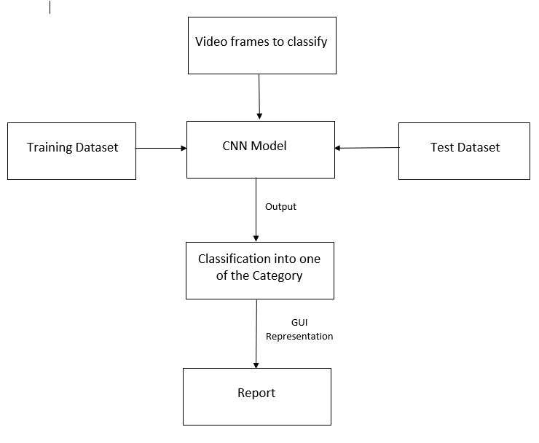

Fig 4.1 :System Design

**4.4 Data Flow Diagram-**

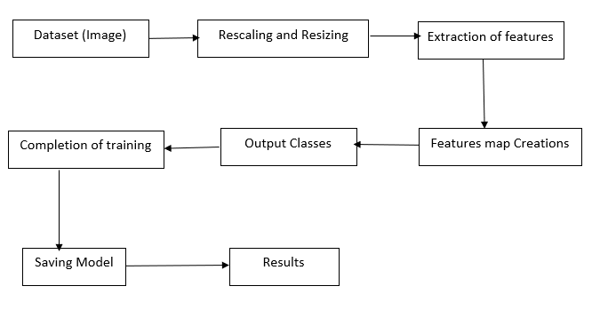

Fig 4.2 Data Flow Diagram

**4.5 Methodology**

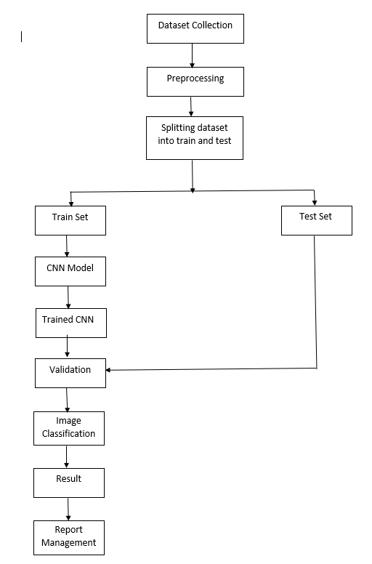

Fig 4.3 Methodology

This section presents the proposed deep learning model in detail. This model is motivated to classify images of different classes and together with deep convolutional networks for accurate identification performance and powerful deep feature extraction. It is conceivable to employ a convolutional neural network (CNNs) for classification on video frames to detect whether it’s a car crash or not.

The proposed model uses CNN model, in which convolution layer is use to extract features from input images. The network in this model learns to automatically extract relevant features from input images or videos that are useful for detecting cars accidents. And it uses fully connected layers for classification.

The dataset plays an important role to train any machine learning and deep learning model. The dataset must have both quality and quantity (quantity of a dataset depends upon scope or type of a problem). Since the input video frames are processed from CCTV camera, so the dataset must contain images of car accidents that are taken from CCTV camera’s point of view.

The step-by-step methodology for car crash detection using deep learning are as follows:

* + 1. **Dataset Collection**

The dataset is combination of real car crash images and synthetic car crash images which are collected from YouTube. And overall, it comprises 5,000 photos sorted into two categories: training (4,000 images), and testing (1000 images).

**Real car crash images Dataset:** This dataset includes real car crash which are caught on CCTV camera. It comprises 1,000 photos sorted into two categories: training (800 images), and testing (200 images).

**Synthetic car crash images Dataset:** This dataset includes synthetic car crash images (4,000 images). Synthetic images are digital images that are generated by a computer rather than captured by a camera or other imaging device. These images are typically created using software that simulates the appearance of real-world objects, surfaces, and lighting conditions. It comprises 4,000 photos sorted into two categories: training (3200 images), and testing (800 images).

**Training set:** This subset contains 4,000 car crash images that can be used for training purposes.

**Test set:** This subset comprises 1,000 car crash images that can be utilized for final model validation.

|  |  |  |  |  |  |  |
| --- | --- | --- | --- | --- | --- | --- |
| **S.no** | **Dataset** | **Label** | **Size** | **Training data** | **Testing data** | **Features** |
| 1. | **Real car crash images Dataset** | 0-NOT CRASH.  1-CAR CRASH. | It consists of 1000 images. | Training (800 images) | Testing (200 images) data | * Edges, lines and corners. * Car features like car’s body shape, wheels, headlights, windows etc. |
| 2. | **Synthetic car crash images Dataset** | 0-NOT CRASH.  1-CAR CRASH. | The dataset includes 4000 images | Training (3,200 images) | Testing (800 images) data | * Edges, lines and corners. * Car features like car’s body shape, wheels, headlights, windows etc. |

**Table-: Dataset Collection**

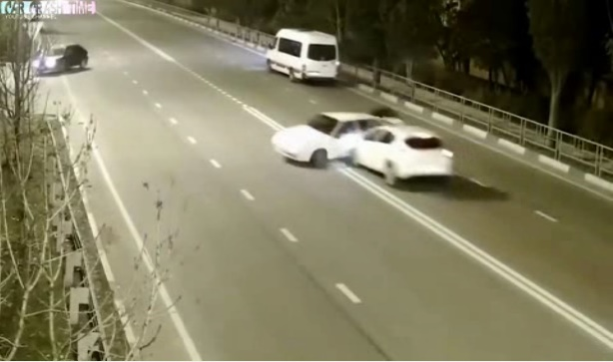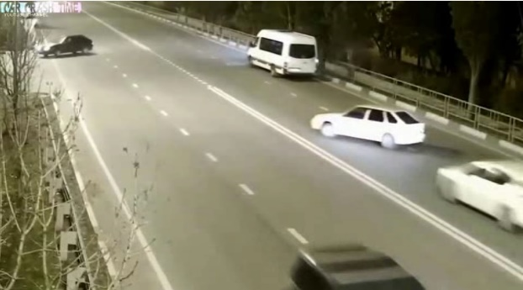

Fig 4.5 Not Crash image

Fig 4.4 Crash image

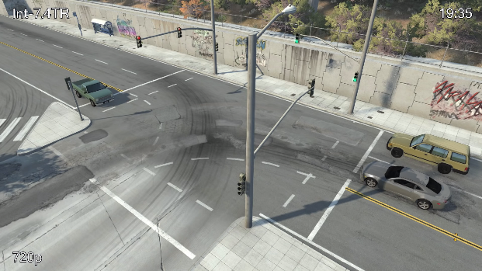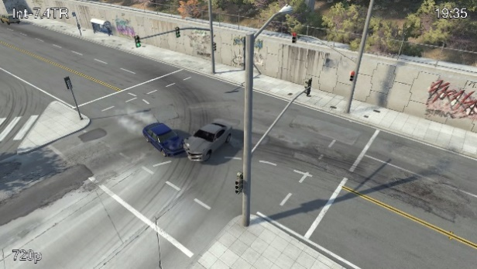

Fig 4.7 Synthetic Not Crash image

Fig 4.6 Synthetic Crash image

* + 1. **Data Preprocessing –**

The dataset is Preprocessed before training the model as it helps to improve the quality of the data, reduce noise, and extract useful features that can aid in modelling and analysis.

The data is pre-processed using following techniques-

1. **Data augmentation-**

Data augmentation is a machine learning approach that generates new training examples from existing ones to enhance the size of the training dataset. Data augmentation in image processing involves the process of generating new images by performing alterations to existing images, such as rotating, flipping, scaling, cropping, or adding noise.

The primary purpose of data augmentation is to improve the scalability and stability of machine learning models by increasing the variety and unpredictability of the training data. Data augmentation can assist to reduce overfitting and increase the model's capacity to handle diverse lighting situations, viewpoints, or orientations by introducing new variations and distortions in the training data.

|  |  |  |
| --- | --- | --- |
| **S.No.** | **Data Augmentation** | **Description** |
| 1. | Rotation | Rotation of the image by a random angle between -10 and 10 degrees along x-axis. |
| 2. | Flip | The image horizontally flipped with a probability of 0.5. |
| 3. | Zoom-in | Zoom-out is applied to the image with a random sigma value between 0.8x to 1.2x. |
| 4. | Zoom-out | Zoom-out is applied to the image with a random sigma value between 0.8x to 1.2x. |
| 5. | Distortion | The scaling factor is between 0% - 5% of original image.  . |

1. **Resizing -**

Resizing is often necessary because images in a dataset may have different sizes or resolutions, which can make it difficult to train the model.

The dimensions of images were of 1920 X 1080 (1920 pixels width and 1080 pixels height) before resizing. And after resizing images are of size 224 X 224 (224 pixels width and 224 pixels height).

1. **Normalization-**

Normalizing the input data helps to ensure that the model trains faster and converges to a better solution by improving the numerical stability of the optimization algorithm.

In CNNs, normalization is typically applied to the pixel values of the input images. The pixel values are first converted to floating point numbers and then normalized to have zero mean and unit variance. This can be achieved by subtracting the mean pixel value of the training dataset from each pixel and dividing by the standard deviation of the pixel values in the training dataset.

* 1. **CNN Model: -**

CNNs, or Convolutional Neural Networks, are a type of deep learning algorithm used for image classification, object detection, etc. In our project we are using CNN model to classify images from the video footages. These are designed to automatically learn and extract meaningful features from images, which can then be used to classify images into different categories. In addition to convolutional layers, CNNs also include pooling layers, which reduce the spatial size of the feature maps by down sampling. This helps to reduce the computational complexity of the network and makes it more robust to variations in the input images.

Various layer that our network architecture contains are:

* + 1. **Convolutional Layer:**

The basic idea behind a convolutional layer is to apply a set of learnable filters (also known as kernels or weights) to a smaller region of the input image. The basic operation of a convolutional layer in deep learning involves a convolution operation, where a small matrix called a kernel or filter is applied to a portion of the input image to produce a feature map. The filter slides over the image, pixel by pixel, and performs a dot product between its values and the corresponding pixels in the input image.

By stacking multiple convolutional layers on top of each other, a neural network can learn increasingly complex features that are able to capture high-level concepts such as edges, textures, and shapes.

In our proposed model we have a total of 3 convolutional layer with followed by ReLu as an activation function.

* + 1. **Pooling Layer:**

A pooling layer is a type of layer commonly used in convolutional neural networks (CNNs) to reduce the spatial dimensions of the input feature maps while retaining the most important information of an image. The purpose of a pooling layer is to down sample the feature maps in order to reduce the complexity and number of parameters in the model and to control overfitting.

The basic operation of a pooling layer involves dividing the input feature map into non-overlapping regions, called pooling regions, and then applying a pooling operation to each region. There are several types of pooling operations, but the most common ones are max pooling and average pooling.

In our CNN architecture we are using the max pooling where the maximum value in each pooling region is selected and passed on to the next layer. We have used two pooling layer of filter size 2x2 each after convolution layer.

**4.6.3 Flatten Layer:**

A flatten layer is a type of layer that is used to convert the output of the convolutional and pooling layers into a 1-dimensional vector, which can then be fed into a fully connected layer for classification or regression tasks.

As per our network architecture the output of the convolutional and pooling layers is a 3-dimensional tensor with shape (height, width, depth), where height and width represent the spatial dimensions of the feature maps, and depth represents the number of filters learned by the convolutional layer.

To pass this output to a fully connected layer, which requires a 1-dimensional input, a flatten layer is added to the network architecture. The flatten layer simply takes the 3-dimensional tensor output from the preceding layer and flattens it into a 1-dimensional vector, by stacking the values from each channel in sequence.

**4.6.4 Dense Layer:**

A dense layer is a type of layer where each neuron is connected to every neuron in the preceding layer, forming a fully connected network. Dense layers are also commonly known as fully connected layers or feedforward layers.

The basic operation of a dense layer involves computing a weighted sum of the inputs from the preceding layer, adding a bias term, and then applying an activation function to the result.

The number of neurons in the dense layer is typically chosen based on the complexity of the task and the size of the input data. More neurons allow the network to capture more complex relationships between inputs and outputs, but can also lead to overfitting if not properly regularized.

Dense layers are commonly used in the output layers of neural networks, where the final layer maps the features learned by the preceding layers to the desired output format (e.g., classification labels or regression values).

In our architecture 128 neurons of dense layer is present next to the 2nd pooling layer of CNN followed by a single neuron next to it.

**4.6.5 Loss Function:**

A loss function (also called a cost function or objective function) is a measure of how well a machine learning model can predict the target values for a set of input data. The objective of training a model is to maximize the accuracy of the model’s prediction by minimizing the value of loss function. There is various loss function to measure the model’s accuracy. Our model is binary classification model therefore we have used binary cross- entropy loss function. This loss function is used for binary classification tasks, where the goal is to predict a binary label (e.g., true or false). It measures the distance between the predicted probability distribution and the true distribution.

**4.6.6 Optimizer:**

Optimizer is a critical component that determines how the model's weights are updated during training in order to minimize the loss function.

During training we have used Adam optimizer which is a popular optimizer that uses a combination of adaptive learning rates and momentum to accelerate convergence. Adam adapts the learning rate for each parameter based on the historical gradients, and also incorporates a momentum term to help the optimizer escape from local minima.

|  |  |  |  |  |  |
| --- | --- | --- | --- | --- | --- |
| Layer | Operation Layer | Output Shape | Filter size | Stride | Weight |
| 0 | Input | 224,224,3 | - | - | - |
| 1 | Convolution 2D | 222,222,32 | 3,3 | - | 896 |
| 2 | Activation | 222,222,32 | - | - | 0 |
| 3 | Max Pooling | 111,111,32 | 2,2 | - | 0 |
| 4 | Convolution 2D | 109,109,64 | 3,3 | - | 18496 |
| 5 | Activation | 109,109,64 | - | - | 0 |
| 6 | Max Pooling | 54,54,64 | 2,2 | - | 0 |
| 7 | Flatten | 186624 | - | - | 0 |
| 8 | Dense | 128 | - | - | 0 |
| 9 | Dropout | 128 | - | - | 0 |
| 10 | Dense | 1 | - | - | 129 |

Total Parameters: 23,907,521

Fig 4.8 Model summary

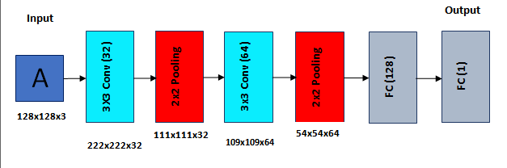

Fig 4.9 CNN architecture

***Chapter-5***

***RESULT***

**5.1 Model accuracy graphs -**

**Model accuracy graph trained on real crash images (25 epochs)**

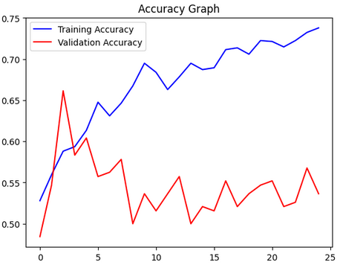

**Model accuracy graph trained on synthetic crash images (25 epochs)**

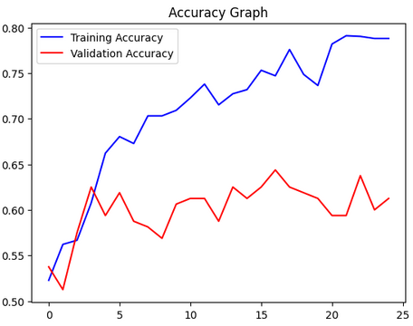

**Model accuracy graph trained on combination of real and synthetic crash images (25 epochs)**

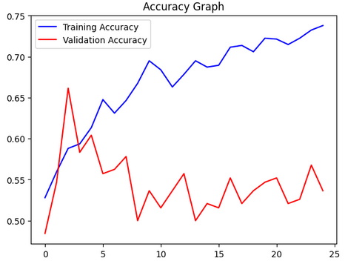

**Model accuracy graph trained on combination of real and synthetic crash images (100 epochs)**

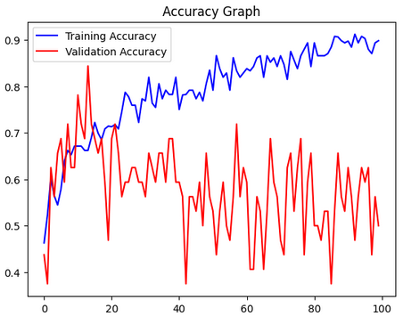

***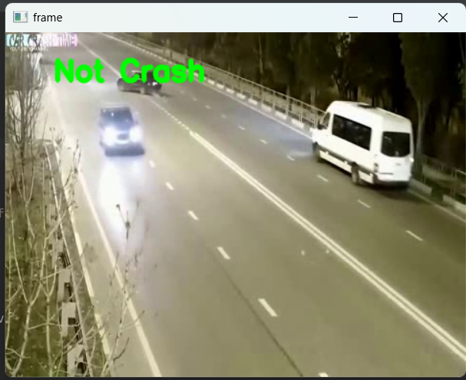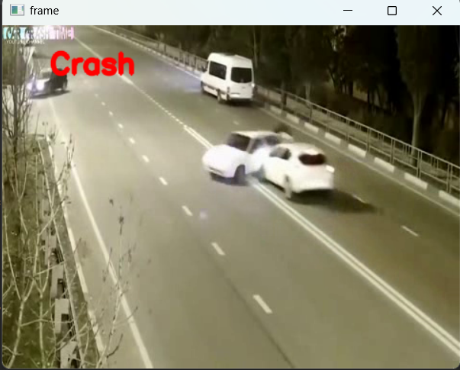*5.2 Output screenshots -**

Fig 5.2 Not Car crash Detected

Fig 5.1 Car Crash Detected

***Chapter-6***

# *CONCLUSION AND FUTURE SCOPE*

**6.1 Conclusion-**

We presented a system that can identify crash detection using surveillance camera installed in the road intersection or highway by taking continuous live video stream and feeding it into the binary classification model. We created our own dataset due to the lack of public crash dataset available. We also added synthetic images to the data to increase the amount and variety in our dataset. The CNN model was trained in this dataset.

Car crash detection using deep learning is a promising approach to improve road safety and reduce the number of car accidents. With the help of convolutional neural networks (CNNs), it's now possible to automatically detect car crashes in real-time by analyzing visual features in images or video streams. CNN models can be trained on large datasets of car crashes and non-crash scenes to learn to distinguish between the two with high accuracy. Once trained, these models can be deployed to a variety of applications, such as dashboard cameras, or autonomous vehicles, to provide early warning of potential car crashes.

**6.2 Future Scope -**

The future scope of car crash detection using deep learning is very promising. Deep learning is a type of machine learning that uses artificial neural networks to learn from data. This makes it well-suited for tasks such as car crash detection, which require the ability to identify patterns in complex data. Another solution could be to use sensors in the car to detect changes in the environment. For example, a sensor could be used to detect when the car is braking suddenly, which could indicate that a crash is about to happen. This current system can be integrated with emergency response systems, allowing for immediate notification of authorities in the event of a crash.

Deep learning models can be further developed to not only detect car crashes but also identify and track human occupants within the vehicle. This information can be used to trigger appropriate safety measures, such as deploying airbags, tightening seat belts, or sending distress signals to emergency services.

In conclusion, the future of car crash detection using deep learning has huge potential for improving road safety, enhancing autonomous vehicle technology, and minimizing the impact of collisions.

***Chapter-7***

# *REFERENCES*

1. V. Machaca Arceda,E. Laura Riveros: “**Fast car crash detection in video**”, 978-1-7281-0437-9/18/$31.00 ©2018 IEEE DOI 10.1109/CLEI.2018.00081
2. Mohamed Essam, Nagia M. Ghanem and Mohamed A. Ismail: “**DETECTION OF ROAD TRAFFIC CRASHES BASED ON COLLISION ESTIMATION**”, AIRCC,pp. 169-179, 2022. CS & IT - CSCP 2022 DOI: 10.5121/csit.2022.121213
3. Zhenbo Lu,1 Wei Zhou,Shixiang Zhang,Chen Wang: “**A NewVideo-Based Crash Detection Method: Balancing Speed and Accuracy Using a Feature Fusion Deep Learning Framework”** , Journal of Advanced Transportation Volume 2020, Article ID 8848874, 12 pages
4. Deeksha Gour; Amit Kanskar: “**Automated AI Based Road Traffic Accident Alert System: YOLO Algorithm**”, INTERNATIONAL JOURNAL OF SCIENTIFIC & TECHNOLOGY RESEARCH VOLUME 8, ISSUE 08, AUGUST 2019
5. Hadi Ghahremannezhad, Hang Shi,Chengjun Liu: “**Real-Time Accident Detection in Traffic Surveillance Using Deep Learning**”, arXiv:2208.06461v1 [cs.CV] 12 Aug 2022
6. Tiago Tamaguskoa, Matheus Gomes Correiaa, Minh Anh Huynhb, Adelino Ferreiraa: “**Deep Learning applied to Road Accident Detection with Transfer Learning and Synthetic Images**”, International Scientific Conference “The Science and Development of Transport - Znanost i razvitak prometa
7. Alok Kumar, Indreesh Pandey, Arun Prakash, Akash Srivastava: “**Vehicle Accident Detection**”, International Journal of Advanced Research in Science, Communication and Technology (IJARSCT)
8. BULBULA KUMEDA1, ZHANG FENGLI1, ARIYO OLUWASANMI1, FORSTER OWUSU1, MAREGU ASSEFA1, TEMESGEN AMENU2: “**VEHICLE ACCIDENT AND TRAFFIC CLASSIFICATION USING DEEP CONVOLUTIONAL NEURAL NETWORKS**”, 978-1-7281-4242-5/19/$31.00 ©2019 IEEE