**Sealed**

C# sealed keyword applies restrictions on the class and method.

If you create a sealed class, it **cannot be derived**.

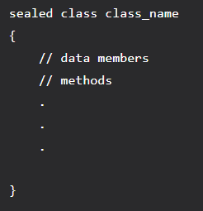

If you create a sealed method, it **cannot be overridden**.

If you want to declare a method as sealed, then it has to be declared as virtual in its base class.

**Structs** are implicitly sealed therefore they **can't be inherited**.

Local variables can't be sealed.