**Specialization in C#**

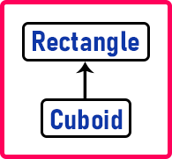

Rectangle class is already existing and from the Rectangle class, we have defined a new class with some extra features i.e. we have a specialized class that is Cuboid. This is a specialization in C#.

**class** Rectangle

**{**

**public** **int** Length;

**public** **int** Breadth;

**public** **int** Area**()**

**{**

**return** Length * Breadth;

**}**

**public** **int** Perimeter**()**

**{**

**return** 2 * **(**Length + Breadth**)**;

**}**

**}**

**class** Cuboid : Rectangle

**{**

**public** **int** Height;

**public** Cuboid**(int** l, **int** b, **int** h**)**

**{**

Length = l;

Breadth = b;

Height = h;

**}**

**public** **int** Volume**()**

**{**

**return** Length * Breadth * Height;

**}**

**}**

##### ****Generalization in C#****

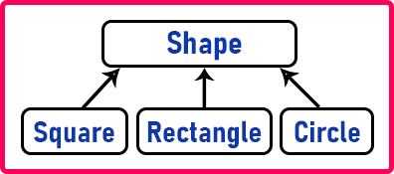

Can you find the area or perimeter of a rectangle? Yes.

Can you find the area or perimeter of the square? Yes.

Can you find the area or perimeter of the circle? Yes.

Does every shape have an area and perimeter? Yes.

This is a common feature, so we have brought it into shape.