**An Internship Report**

**“Real-Time Tell-Tale detection using Machine Learning”**

Submitted by

## PRATIK MORE

**(2021016402211563)**

In the partial Fulfilment of the degree of “Bachelor of Engineering”

(Electronics and Telecommunication Engineering) Of

## Dr. D. Y. Patil Institute of Technology, Pimpri, Pune

Under the Mentor of

## MRS. ATMAJA BHALSING (GM, ERC)

Name of the organization

**TATA MOTORS LTD, PIMPRI**

# DECLARATION

I declare that this written submission represents my ideas in my own words and where others' ideas or words have been included, I have adequately cited and referenced the original sources. I also declare that I have adhered to all principles of academic honesty and integrity and have not misrepresented or fabricated or falsified any idea/data/fact/source in my submission. I understand that any violation of the above will be a cause for disciplinary action by the Institute and can also evoke penal action from the sources which have thus not been properly cited or from whom proper permission has not been taken when needed.

**Pratik More**

(2021016402211563)

Date: 22/11/2024

# CERTIFICATE

This is to certify that the report entitled **“Internship Report”** being submitted by **Pratik More (2021016402211563)** to **Dr. D. Y. Patil Institute of Technology, Pune** as partial fulfillment for the award of the degree of **Bachelor of Engineering** in **Electronics and Telecommunication Engineering**, is a record of bonafide work carried out by him under our supervision and guidance. The matter contained in this report has not been submitted to any other university for the award of any degree or diploma.

## MRS. ATMAJA BHALSING

(GM, ERC)

Supervisor TATA.cv

## MR. BHARAT ZANWAR

(DGM, ERC)

Mentor

TATA.cv

# ACKNOWLEDGEMENT

I express my sincere gratitude towards ‘Tata Motors’ overall lead **Mr. Bharat Zanwar** and the entire team for their guidance and continuous encouragement and supervision throughout the course of our internship work. They were always available for any guidance.

I would like to place on record my deep sense of gratitude to the Head of Electronics and Telecommunication Department - **Dr. D. G. Bhalke** and the staff at **Dr. D. Y. Patil Institute of Technology’s Electronics and Telecommunication Department.**

Thank You!

# ABSTRACT

The manual inspection of tell-tale indicators in automotive instrument clusters is a time- consuming and error-prone process, with each cluster containing over 40 indicators that need verification. The work carried out aims to address these inefficiencies by developing an automated image processing solution. The proposed system involves capturing high-quality template images of tell-tale indicators under standardized conditions to create accurate reference patterns. These templates will be used for detecting and classifying indicators in real- time test images. The solution includes using digital imaging devices to capture clear and consistent images of the test clusters, ensuring reliable input for analysis. Advanced computer vision techniques, such as feature extraction and pattern matching algorithms including Scale- Invariant Feature Transform (SIFT) and Homography, will be employed to automatically identify and classify each tell-tale indicator. This automation will streamline the testing process, providing real-time feedback on the presence or absence of indicators and reducing the need for manual inspection. The implementation of this system is expected to improve testing efficiency, minimize human error, and ensure consistent evaluation of automotive displays, thereby enhancing overall product quality and reliability.

# INDEX

|  |  |  |
| --- | --- | --- |
| 1. | CHAPTER 1: COMPANY OVERVIEW | 7 |
| 2. | CHAPTER 2: TYPES OF COMMERCIAL VEHICLES | 8 |
| 3. | CHAPTER 3: SYSTEM DESIGN AND METHODOLOGY   * 1. PROBLEM STATEMENT   2. FLOWCHART   3. WORKFLOW   4. HOMOGRAPHY   5. FLANN ALGORITHM   6. OBJECT DETECTION USING SIFT   7. RESULTS | 9-16 |
| 4. | CHAPTER 4: ELECTRONIC CONTROL UNIT(ECU’S)   * 1. VEHICLE ELECTRONIC CONTROLLER UNIT(VECU)   2. DOMAIN CONTROLLER UNIT(DCU)   3. BATTERY COOLING SYSTEM(BCS) | 17-22 |
| 5. | CHAPTER 5: COMMUNICATION PROTOCOL USED IN VEHICLES(CAN) | 23-26 |
| 6. | CHAPTER 6: HARDWARE-IN-THE-LOOP (HIL) SECTION   * 1. MANUFACTURE OF HIL | 27-28 |
| 7. | CHAPTER 7: CONNECTIVITY AND TELEMATICS   * 1. FOTA   2. TATA MOTORS FLEET EDGE   3. ADAS IN AUTOMOTIVE   4. INFOTAINMENT   5. CLUSTER   6. ELCB **(**EARTH-LEAKAGE CIRCUIT BREAKERS) | 29-35 |
| 8. | CHAPTER 8: CONCLUSION | 36 |

1. COMPANY OVERVIEW

Tata Motors is one of India’s largest and most prominent automobile manufacturers, part of the Tata Group, a multinational conglomerate. Founded in 1945, Tata Motors initially focused on manufacturing locomotives but soon expanded into the automotive sector. The company has a diverse product portfolio, including passenger cars, trucks, buses, utility vehicles, and defence vehicles. Tata Motors is renowned for its commitment to innovation, quality, and sustainability. Over the years, it has established itself as a leader in the Indian market and has expanded its presence globally through strategic acquisitions, such as Jaguar Land Rover (JLR) in 2008. This acquisition allowed Tata Motors to enter the luxury car market and gain a foothold in Europe and other international markets.

The company is also focused on the future of mobility, with significant investments in electric vehicles (EVs), connected car technologies, and autonomous driving. Tata Motors’ EV range, including models like the Nexon EV, is a key part of its strategy to drive sustainable mobility in India and beyond. With a strong emphasis on research and development, Tata Motors continues to push the boundaries of automotive technology, aiming to meet the evolving needs of consumers while contributing to a greener future. In addition to its commercial success, Tata Motors is known for its corporate social responsibility initiatives, focusing on areas such as education, healthcare, and environmental sustainability.

The company is listed on the Bombay Stock Exchange (BSE) and the National Stock Exchange (NSE) in India, and its shares are also traded on the New York Stock Exchange (NYSE). Tata Motors is headquartered in Mumbai, Maharashtra, India. It has a significant presence in locations such as Pimpri (Pune), Jamshedpur (Jharkhand), Lucknow (Uttar Pradesh), Sanand (Gujarat), and Dharwad (Karnataka), where it operates major manufacturing facilities. The Pimpri plant, situated in the Pune metropolitan area, is one of Tata Motors' key manufacturing units. It plays a pivotal role in the production of various vehicles, including commercial vehicles, passenger cars, and electric vehicles. The facility is equipped with state-of-the-art technologies and adheres to stringent quality standards to ensure the production of high-quality automobiles.

Tata Motors produces a wide range of vehicles, including passenger cars, commercial vehicles, trucks, buses, and military vehicles. Some of its popular car models include the Tata Tiago, Tata Nexon, Tata Harrier, and Tata Safari. In the commercial vehicle segment, Tata Motors manufactures trucks, buses, and vans, catering to various industries and transportation needs. While Tata Motors primarily operates in India, it has a significant global presence, with manufacturing facilities in several countries, including the United Kingdom, South Africa, Thailand, and Argentina.

# TYPES OF COMMERCIAL VEHICLES

There are three types of variants of EV commercial busses

1. 4/12 Range
   1. It is a 12m long bus
   2. It has 400mm ground clearance.
   3. Also called as Low Floor Bus.
   4. Two number of Junction Boxes are used in the vehicle.
2. 9/12 Range
   1. It is a 12m long bus
   2. It has 900mm ground clearance.
   3. Three number of Junction Boxes are used in the vehicle.
3. 9/9 Range
   1. It is a 9m long bus.
   2. It has 900mm ground clearance.
   3. Three number of Junction Boxes are used in the vehicle.

Tata motors is in process of new development of commercial bus which is based on tender’s requirement.

Tata Motors offers a diverse range of commercial buses tailored to various transportation needs.

Each of these types of commercial buses caters to specific transportation requirements, ranging from urban commuting to long- distance travel, school transportation, corporate shuttles, tourism, and environmentally friendly transit options.

# SYSTEM DESIGN AND METHODOLOGY

* 1. PROBLEM STATEMENT

Automotive engineers have to inspect each tell-tale indicator during the testing phase manually. Each cluster comprises over 40 tell-tales, making it time-consuming and error-prone to confirm their presence or absence in a test image. The manual process impairs efficiency and introduces variability in testing results.

The main goal is to create an automated image processing solution capable of accurately detecting and classifying each tell-tale indicator in a captured test cluster image.

This solution must:

1. **Develop a method to capture high-quality template images of all tell-tales in automotive clusters under standardized conditions for cataloging.** These templates will serve as reference patterns for subsequent detection.

## Implement a mechanism for capturing test cluster images with digital imaging devices in real time, ensuring clear and consistent image quality for accurate analysis.

1. **Employ advanced computer vision techniques like feature extraction and pattern matching algorithms (e.g., SIFT, Homography) to automatically detect and classify each tell-tale indicator in the test cluster image.** The system should offer real-time feedback on the presence or absence of each tell-tale, streamlining the testing process and reducing the need for manual inspection.

The proposed solution aims to improve testing efficiency, minimize human error, and maintain consistency in evaluating automotive cluster displays. Automating the detection and classification of tell-tales allows automotive engineers to dedicate more time to critical analysis and decision- making, enhancing product quality and reliability.

* 1. 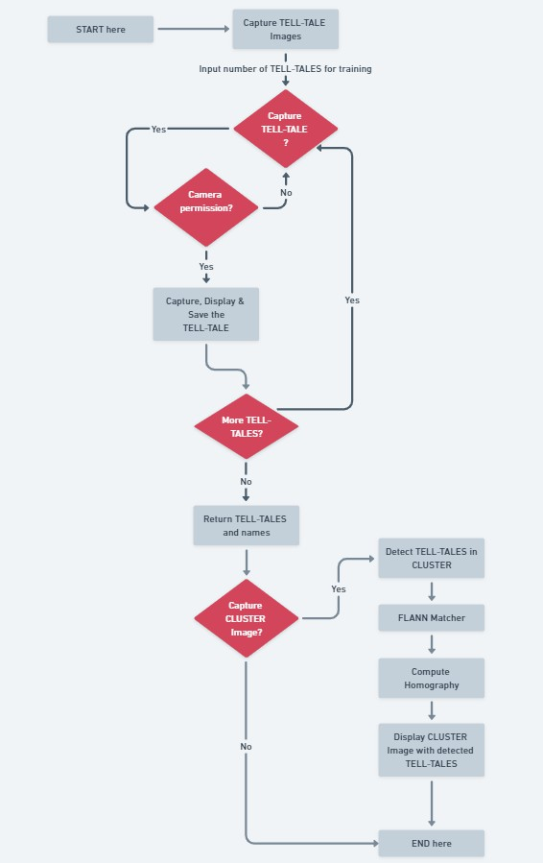FLOWCHART
  2. WORKFLOW

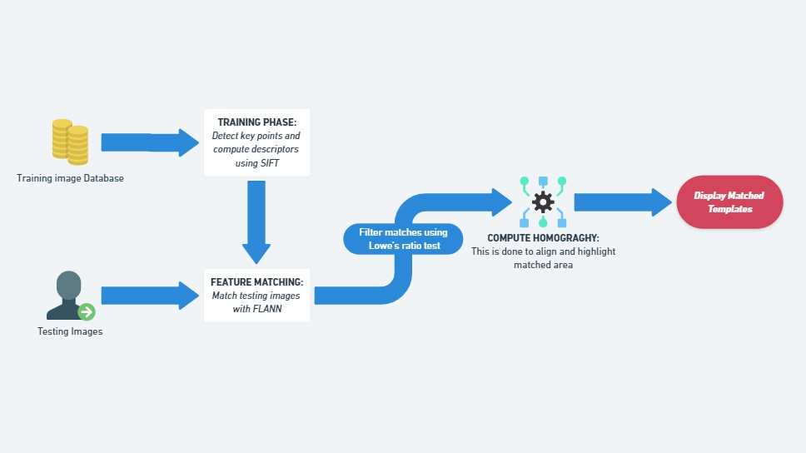

## Initialization and Library Import

* + **Purpose**: Import necessary libraries and initialize components for image processing and visualization.

## Libraries Used:

* + - **OpenCV (cv2)**: Handles image capture, feature extraction (SIFT), feature matching (FLANN), and visualization.
    - **NumPy**: Supports numerical operations on image data.
    - **Matplotlib**: Visualizes images and detection results.
    - **OS**: Manages directories for storing captured images and handling file operations.

1. **Capture Template Images (capture_template_images function)**
   * **Purpose**: Capture multiple Tell-Tale images interactively using the camera.

## Steps:

* + - **User Interaction**: Prompt user to enter names for each Tell-Tale template.
    - **Image Capture**: Utilize the capture_camera_image function to capture images.
    - **Display and Save**: Display each captured image for user verification using Matplotlib (plt.imshow) and save them in a specified directory (templates folder) using OS operations (os.makedirs, os.path.join).

1. **Capture Image from Camera (capture_camera_image function)**
   * **Purpose**: Capture a single image using the camera.

## Steps:

* + - Use OpenCV (cv.VideoCapture) to interact with the camera and capture an image.
    - Convert and return the captured image in a format usable by OpenCV (cv.cvtColor).

1. **Train Templates and Save (capture_template_images function)**
   * **Purpose**: Capture and save Tell-Tale templates for subsequent detection.

## Steps:

* + - Call capture_template_images function to capture specified number of templates.
    - Utilize the capture_camera_image function internally for image capture.
    - Display captured images using Matplotlib and save them in the templates

directory.

1. **Detect Templates in Main Image (detect_templates_in_main_image function)**
   * **Purpose**: Detect Tell-Tales (template images) within a larger image (Cluster image).

## Steps:

* + - **Image Capture**: Capture the main image (Cluster image) using the camera.
    - **Feature Extraction**: Extract keypoints and descriptors from both the template images (Tell-Tales) and the main image using SIFT (cv.SIFT).
    - **Feature Matching**: Use FLANN (Fast Library for Approximate Nearest Neighbors) (cv.FlannBasedMatcher) to match features between the templates and the main image.
    - **Homography Calculation**: Compute a homography matrix (cv.findHomography) to determine the transformation between matched keypoints.
    - **Visualization**: Draw bounding boxes around matched Tell-Tales on the main image using OpenCV functions (cv.rectangle).
    - **Display**: Display the processed main image with detected Tell-Tales overlaid using Matplotlib (plt.imshow).

## Main Program Execution

* + **Purpose**: Execute the main program flow to capture a main image (Cluster image) and detect Tell-Tales.

## Steps:

* + - **Capture Main Image**: Use capture_camera_image function to capture the main image.
    - **Call Detection Function**: Call detect_templates_in_main_image with the captured main image to detect Tell-Tales using previously trained templates.
    - **Output**: Display the main image with detected Tell-Tales overlaid for user verification and interaction.
  1. HOMOGRAPHY

**Homography** refers to a transformation matrix that maps points from one plane to another. It is particularly useful in computer vision for tasks such as:

* + - **Image Stitching**: Aligning and combining multiple images to create a panoramic view.
    - **Object Recognition and Augmentation**: Aligning an object in one image with its position in another image for augmented reality applications.
    - **Perspective Correction**: Adjusting the perspective distortion in images.

Key Concepts:

* + - **Transformation Matrix**: A 3x3 matrix that represents the transformation between two planes.
    - **Projective Geometry**: Homography is based on projective geometry principles, which describe how objects appear under different perspectives.

Usage in Computer Vision:

* + - **Feature Matching**: Homography is computed using matched feature points between two images.
    - **Algorithm**: Commonly computed using algorithms like **Direct Linear Transformation (DLT)** or **RANSAC (Random Sample Consensus)** for robustness against outliers.

Example Application:

In your project, homography would be used in the detect_templates_in_main_image function to find the transformation that aligns the key points of the Tell-Tale templates with their corresponding key points in the main image (Cluster image). This transformation allows accurate overlaying of bounding boxes around detected Tell-Tales.

* 1. FLANN ALGORITHM

**FLANN** (Fast Library for Approximate Nearest Neighbours) is an efficient algorithm for finding approximate nearest neighbours in high-dimensional spaces. It is particularly useful for accelerating feature matching in large datasets.

Key Concepts:

* + - **Nearest Neighbour Search**: Finding the closest points (or features) in feature space to a given point.
    - **Approximate Matching**: Provides results that are close to the exact nearest neighbours, often with significant speed improvements.
    - **Indexing Structures**: Uses indexing structures like KD-Trees, Hierarchical k-Means Trees, or Locality Sensitive Hashing (LSH) to optimize search times.

Usage in Computer Vision:

* + - **Feature Matching**: FLANN is employed to match feature descriptors extracted from images efficiently.
    - **Robustness**: Handles large datasets and high-dimensional feature spaces effectively.
    - **Integration with OpenCV**: OpenCV provides a wrapper (cv.FlannBasedMatcher) around FLANN to perform feature matching tasks.

Example Application:

In your project, FLANN would be used to match the feature descriptors (extracted using SIFT) between the Tell-Tale templates and the main image. This matching process helps identify candidate key points that likely correspond to the same physical point or object across different images.

* 1. OBJECT DETECTION USING SIFT

**SIFT** (Scale-Invariant Feature Transform) is a feature extraction algorithm widely used in computer vision for detecting and describing local features in images. It is robust to changes in scale, rotation, and illumination.

Key Concepts:

* + - **Feature Extraction**: Identifies distinctive key points in an image, along with their descriptors that encode information about the local image patch surrounding each key point.
    - **Scale Space**: SIFT constructs a scale space to detect key points across different scales.
    - **Orientation Assignment**: Assigns an orientation to each key point based on the local image gradient directions.
    - **Descriptor Generation**: Computes a feature vector (descriptor) for each key point based on gradient magnitudes and orientations in its vicinity.

Usage in Computer Vision:

* + - **Object Recognition**: SIFT features are used for recognizing objects or patterns in images.
    - **Object Localization**: Helps localize objects by matching SIFT features between template images (Tell-Tales) and the main image.
    - **Robustness**: SIFT is robust against changes in viewpoint and lighting conditions.

Example Application:

In your project, SIFT would be used in conjunction with FLANN for detecting Tell-Tales within the main image. The steps involve:

* + - Extracting SIFT key points and descriptors from both the Tell-Tale templates and the main image.
    - Using FLANN to match these descriptors between templates and the main image.
    - Computing a homography matrix to align matched key points, which allows for accurate detection and localization of Tell-Tales in the main image.
  1. RESULTS

**Training Phase:**

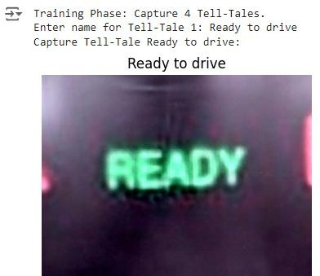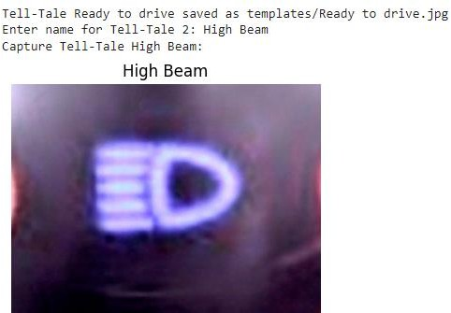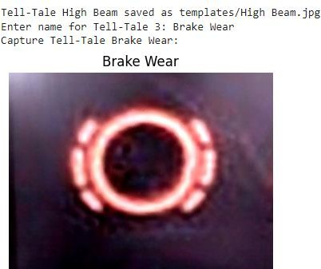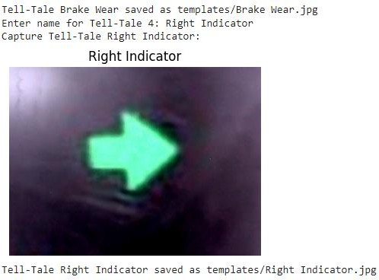

**Testing Phase:**

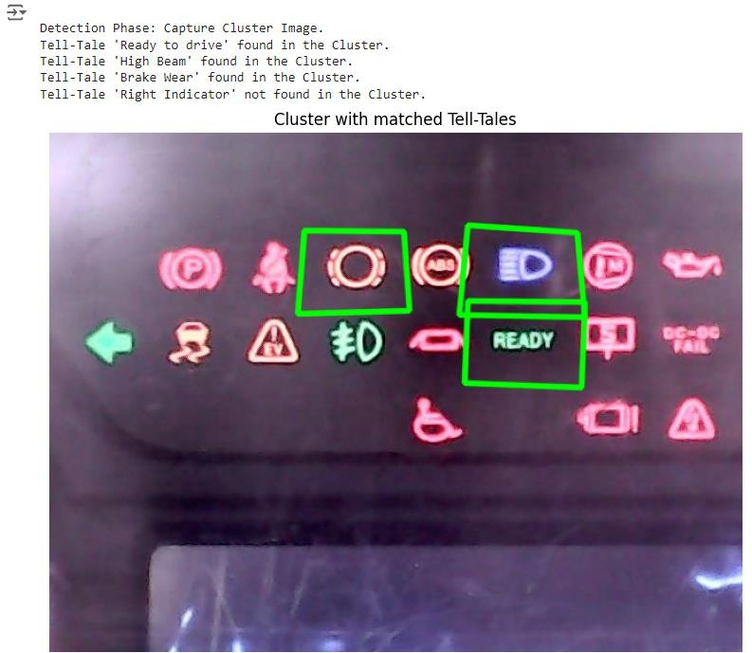

# ELECTRONIC CONTROL UNIT (ECU’s)

An Electronic Control Unit (ECU) is a critical component in modern vehicles and various other electronic systems. It's essentially a specialized computer that controls various functions within a vehicle or another electronic system. ECUs are commonly found in automobiles but are also used in applications such as industrial machinery, aerospace systems, and more.

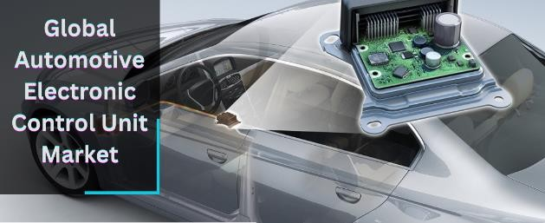

**Functionality**: ECUs are responsible for controlling and managing a wide range of systems within a vehicle, including engine management, transmission control, airbag systems, traction control, stability control, anti-lock braking systems (ABS), and more.

Types of ECUs**:**

1. **Engine Control Unit (ECU):** Manages the engine's performance by controlling fuel injection, ignition timing, idle speed, and other engine functions.
2. **Transmission Control Unit (TCU):** Controls the operation of automatic transmissions, optimizing gear shifts for performance, fuel efficiency, and smoothness.
3. **Body Control Module (BCM):** Oversees functions related to lighting, door locks, windows, and other body-related systems.
4. **Airbag Control Module (ACM):** Controls the deployment of airbags and other safety systems in the event of a collision.
5. **ABS Control Module:** Manages the anti-lock braking system, preventing wheels from locking up during hard braking.
6. **Traction Control Module (TCM):** Helps prevent wheel spin during acceleration by adjusting engine power and/or applying brakes to individual wheels.
7. **A Vehicle Electronic Controller Unit (ECU):** It is a crucial component in modern vehicles, responsible for controlling various electrical and electronic systems within the vehicle
8. **Components**: ECUs typically consist of a microcontroller or microprocessor, input/output circuits, memory (both volatile and non- volatile), and communication

interfaces. They receive input from various sensors, process that information according to predefined algorithms, and then output commands to actuators to control the vehicle's functions.

* 1. VEHCILE ELECTRONIC CONTROLLING UNIT

VECU is called the Vehicle Electronic Controller Unit. It is a central part or the brain of the vehicle; when we give input, the instruction is sent to the VECU, and then we get the output. A Vehicle Electronic Controller Unit (ECU) is a crucial component in modern vehicles, responsible for controlling various electrical and electronic systems within the vehicle. These systems can include engine management, transmission control, brake systems, steering assistance, airbag deployment, traction control, stability control, and more. The ECU gathers data from various sensors placed throughout the vehicle and processes this information to make real-time decisions and adjustments to optimize performance, efficiency, and safety. It utilizes embedded software known as firmware to execute these tasks. The features included in the VECU unit are left indicator, right indicator, wiper, low beam, high beam, RPass, FE switch, etc. The CAN protocol is used in the Vehicle Electronic Controller Unit. The 12V and 24V VECU units are used, where 12V is used for winger vehicles and 24V is used for commercial vehicles.

1. **Functionality:** ECUs process data from sensors in real time to control vehicle functions like engine performance, transmission, braking, and safety systems. They ensure the vehicle operates smoothly and efficiently.
2. **Types:** Common types of ECUs include the Engine Control Unit (manages engine operations), Transmission Control Unit (controls gear shifts), Brake Control Module (manages braking systems), and Body Control Module (controls non-engine functions like lighting and climate control).
3. **Communication:** ECUs communicate with each other and other vehicle systems through networks like the Controller Area Network (CAN) bus, coordinating operations to ensure the vehicle functions as intended.
4. **Safety:** Many ECUs are dedicated to safety-critical functions, such as anti-lock braking systems (ABS) and electronic stability control (ESC), which help prevent accidents and enhance vehicle safety.
5. **Diagnostics:** ECUs continuously monitor system performance, detecting and logging faults for later diagnosis and maintenance, thereby reducing downtime and repair costs.
6. **Challenges:** Designing ECUs involves addressing complexity, ensuring reliability under various conditions, securing against cyber threats, and complying with regulatory standards.
7. **Future Trends:** The future of ECUs includes greater integration, support for autonomous driving, electrification, over-the-air updates, and the use of artificial intelligence to further optimize vehicle performance.
   1. DOMAIN CONTROL UNIT (DCU)
8. DCU is a domain control unit.
9. A gateway is a network node that connects two or more networks using different protocols. It serves as an entry and exit point for data between different networks, translating data formats or protocols as needed to facilitate communication. They can perform various functions, including protocol conversion, data translation, security enforcement, and network management.
10. It was introduced in 2021.
11. This is the type of ECU in which CAN protocol is used.
12. The main function of DCU is in communication.
13. When the instruction is given, it is given to the DCU. The DCU communicates with VECU & then we get the output.
14. The FOTA system is also used in DCU in which instead of changing the whole function, we can change a particular part only.
15. On-board diagnostics (OBD) is a system used in vehicles to self- diagnose and report on the status of various systems, including the engine, transmission, emissions, and more.
16. It monitors sensors and actuators, detects faults or malfunctions, and generates diagnostic trouble codes (DTCs) to help technicians identify issues during maintenance or repairs.
17. OBD systems have evolved over time, with OBD-II being the standardized version used in most vehicles today.
18. It provides a standardized connector and a set of diagnostic trouble codes, facilitating easier diagnosis and repair across different vehicle makes and models.

DCU REQUIRES TOTAL 6 CAN:

1. P CAN: Power Train CAN
2. I CAN: Instrument Cluster CAN
3. D CAN: Diagnostic CAN
4. C CAN: Chassis CAN
5. T CAN: Telematics CAN
6. A CAN: ADAS CAN
   1. BATTERY COOLING SYSTEM (BCS)

The battery cooling system in vehicles, particularly electric vehicles (EVs) and hybrid vehicles, is crucial for maintaining battery performance, safety, and longevity. Effective cooling ensures that the battery operates within its optimal temperature range, which is essential for maximizing energy efficiency, extending battery life, and preventing overheating. Here’s a detailed explanation of the battery cooling system:

1. Purpose of Battery Cooling System
   1. **Temperature Regulation**: Batteries, especially lithium-ion types used in EVs and hybrids, generate heat during operation (charging and discharging) and can be sensitive to extreme temperatures. Cooling systems regulate battery temperatures to keep the batteries within a safe operating range.
   2. **Performance Optimization**: Maintaining the battery at the optimal temperature ensures it performs efficiently, providing consistent power output and charge acceptance.
   3. **Safety**: Overheating can cause thermal runaway, a dangerous condition where the battery temperature rapidly increases, potentially leading to fires or explosions. Effective cooling helps prevent such risks.
2. Components of a Battery Cooling System
   1. **Cooling Plates or Channels**: These are often integrated into the battery pack design and are responsible for transferring heat away from the battery cells. They can be made of metals with high thermal conductivity, like aluminum.
   2. **Coolant**: A cooling fluid (usually a mixture of water and glycol) circulates through the system to absorb heat from the battery and carry it away.
   3. **Pumps**: These circulate the coolant through the cooling plates or channels in the battery pack.
   4. **Radiators**: The coolant, after absorbing heat from the battery, is transferred to a radiator where it releases the heat to the air.
   5. **Fans**: Fans help dissipate heat from the radiator to the outside environment, enhancing the cooling efficiency.
   6. **Thermal Sensors**: These sensors monitor the temperature of the battery and coolant, providing feedback to the cooling system to adjust operations as needed.
   7. **Heat Exchangers**: In some systems, heat exchangers are used to transfer heat from the coolant to the outside air or another medium for further cooling.
3. Types of Battery Cooling Systems
   1. **Air Cooling**: Uses fans to blow air over the battery pack or through cooling channels. It is simpler and lighter but may be less effective in very high- performance applications.
   2. **Advantages**: Simpler design, lower cost, and lighter weight.
   3. **Disadvantages**: Less efficient in extreme temperatures and high-performance scenarios.
   4. **Liquid Cooling**: Uses a liquid coolant that circulates through channels or plates in the battery pack to absorb and transfer heat. It is more effective at managing heat in high-performance and high-capacity battery systems.
   5. **Advantages**: More effective at heat management, better for high-capacity and high-performance batteries.
   6. **Disadvantages**: More complex, heavier, and costlier.
4. Design Considerations
   1. **Efficiency**: The cooling system must efficiently transfer and dissipate heat to prevent overheating and ensure optimal battery performance.
   2. **Weight and Space**: The design should minimize weight and space usage to avoid impacting vehicle performance and cargo capacity.
   3. **Reliability**: Components like pumps, fans, and sensors must be reliable and durable, as failures can lead to overheating and potential safety risks.
   4. **Maintenance**: The system should be designed for easy maintenance, with accessible components and replaceable parts.

# COMMUNICATION PROTOCOLS USED IN VEHICLE PROTOCOL (CAN)

The Controller Area Network (CAN) protocol is a robust and widely used communication protocol designed for reliable, real-time data exchange between electronic control units (ECUs) in vehicles and industrial applications. The CAN protocol facilitates communication between microcontrollers and devices in a network without the need for a host computer. It is designed for real-time, robust communication in environments with electrical noise and potential data corruption. CAN is standardized under ISO 11898, with various versions and extensions developed over time, including CAN 2.0A, CAN 2.0B, and CAN FD (Flexible Data-rate). In CAN bus, messages consist of an identifier, data length code, data bytes, and a cyclic redundancy check (CRC) for error detection. The identifier distinguishes between different message types and their priority, while the data length code specifies the number of data bytes in the message. The data bytes contain the actual information being transmitted, and the CRC ensures data integrity. CAN bus supports both high-speed and low-speed communication by allowing different bit rates to be configured for different segments of the bus. Critical real-time applications such as engine control typically use high-speed CAN (up to 1 Mbps), while less time-sensitive tasks like body control modules use low-speed CAN (up to 125 Kbps). This flexibility allows for efficient utilization of the bus bandwidth while ensuring optimal performance for various system components. CAN protocol is a message-based protocol, not an address based protocol. This means that messages are not transmitted from one node to another node based on addresses. Embedded in the CAN message itself are the priority and the contents of the data being transmitted. All nodes in the system receive each message transmitted on the bus (and will acknowledge if the message was properly received). It is up to each node in the system to decide whether the message received should be immediately discarded or kept to be processed. A single message can be destined for one particular node to receive or many nodes based on the way the network and system are designed. For example, an automotive airbag sensor can be connected via CAN to a safety system router node only. This router node takes in other safety system information and routes it to all other nodes on the safety system network. Then all the other nodes on the safety system network can receive the latest airbag sensor information from the router at the same time, acknowledge if the message was received properly, and decide whether to utilize this information or discard it. CSMA stands for Carrier Sense Multiple Access. This concept is used in transmission media access. If multiple ECUs are connected and share the same transmission medium to transfer data, there is a possibility of collision and data corruption if these nodes start transmitting simultaneously. CSMA introduces two concepts, CSMA/CA and CSMA/CD, to avoid collisions and data corruption. The maximum speed of the CAN protocol depends on the specific variant. For standard CAN (ISO 11898-1), the maximum speed is 1 Mbps. However, high-speed variants like CAN FD (Flexible Data-rate) support higher speeds, reaching up to 5 Mbps. The CAN bus supports messages with a maximum length of 8 bytes in standard CAN.

CSMA/CA:

CSMA/CA is a carrier sense multiple access /collision avoidance. It first checks the state of the medium before sending. It is applicable before starting the transmission. The node having CSMA/CA enabled features first check the transmission medium status before starting transmission. If the BUS is idle (free) then it will start transmission otherwise it will wait for the bus to be idle. In CAN this feature is introduced by the Arbitration concept.

CSMA/CD:

CSMA/CD is a Carrier Sense Multiple Access/Collision Detection. It is applicable when data transmission starts. A Node with CSMA/CD enabled feature detects the collision and stop the further data transmission. It will initiate data re-transmission. In CAN this feature is successfully implemented through Bit Monitoring feature of Transmitter node.

CAN has four frame types:

1. Data frame: A frame containing node data for transmission.
2. Remote frame: A frame requesting the transmission of a specific identifier.
3. Error frame: A frame transmitted by any node detecting an error.
4. Overload frame: A frame to inject a delay between data or remote frame.

CAN standard supports several topologies. Commonly used topologies are:

1. Star Topology.
2. Loop Topology.
3. Bus Topology.
4. Combination.

Application of CAN protocol:

1. Passenger vehicles, trucks, buses (gasoline vehicles and electric vehicles).
2. Electronic equipment for aviation and navigation.
3. Industrial automation and mechanical control.
4. Elevators, escalators.
5. Building automation.
6. Medical instruments and equipment.

CAN Protocol Versions

1. **CAN 2.0A**: This version supports standard frame format with an 11-bit identifier. It provides basic functionalities for communication.
2. **CAN 2.0B**: Introduced an extended frame format with a 29-bit identifier, allowing for more identifiers and flexibility in network design.
3. **CAN FD (Flexible Data-rate)**: Enhances the original CAN protocol by allowing larger data payloads (up to 64 bytes) and faster data rates, improving efficiency and performance.

Advantages of CAN Protocol

* 1. Simple and low cost: ECUs communicate via a single CAN system instead of via direct complex analog signal lines - reducing errors, weight, wiring, and costs. CAN chipsets are readily available and affordable.
  2. Fully centralized: the CAN bus provides one point of entry to communicate with all network ECUs - enabling central diagnostics, data logging, and configuration.
  3. Extremely robust: the system is robust towards electric disturbances and electromagnetic interference ideal for safety-critical applications (e.g. vehicles).
  4. Efficient: CAN frames are prioritized by ID numbers. The top priority data gets immediate bus access, without causing interruption of other frames.
  5. Reduced vehicle weight: by the elimination of kilometers of heavily insulated electrical wires and their weight from the vehicle.
  6. Easy deployment: a proven standard with a rich support ecosystem.
  7. Resistant to EMI: this makes CAN ideal for critical applications in vehicles.

Types of CAN Protocol

1. Standard CAN (CAN 2.0A).
2. Extended CAN (CAN 2.0B).
3. CAN FD (Flexible Data-rate).

Applications of CAN

1. Automotive: ECU communication, safety systems, infotainment.
2. Industrial automation: Factory and building automation.
3. Aerospace, medical devices, marine electronics, etc.

# HARDWARE-IN-THE-LOOP (HIL) SECTION

* The process of testing a vehicle's hardware by integrating it into a software environment which forms a loop between hardware & software.
* Hardware-in-the-loop (HIL) is a testing methodology used in various industries, including automotive, aerospace, and power systems. In HIL testing, real hardware components (such as electronic control units, sensors, actuators, etc.) are connected to a simulation environment. This simulation environment mimics the behavior of the rest of the system or environment in which the hardware will operate.
* HIL testing allows engineers to evaluate the performance and functionality of hardware components in a controlled and repeatable environment before they are deployed in the actual system. It enables comprehensive testing of complex systems without the need for expensive prototypes or risking damage to physical equipments.
* In essence, HIL testing bridges the gap between purely simulated environments and real- world testing by providing a means to test real hardware in simulated conditions. This approach improves the efficiency, safety, and reliability of the development and validation process for complex systems.
  1. MANUFACTURE OF HIL

There are several manufacturers of Hardware-in-the-Loop (HIL) systems, each offering their own solutions tailored to specific industries and applications. Some prominent manufacturers include:

* **National Instruments (NI):** NI offers a range of HIL simulation platforms, such as the NI VeriStand software and PXI-based HIL systems, designed for testing and validation of embedded control systems in industries like automotive, aerospace, and power electronics.
* **dSPACE:** dSPACE provides comprehensive HIL simulation solutions, including real- time hardware and software tools like the SCALEXIO and MicroAutoBox platforms, used in automotive, aerospace, and industrial automation applications.
* **Vector Informatik:** Vector offers HIL simulation solutions like the VT System platform, specializing in automotive electronics testing and validation, including ECUs, sensors, and networks.
* **Typhoon HIL:** Typhoon HIL develops HIL simulation platforms focused on power electronics and renewable energy systems, offering real-time simulation hardware and software for rapid prototyping and testing.
* **Opal-RT:** Opal-RT provides real-time simulation solutions, including HIL systems like the eMEGAsim platform, used in power systems, power electronics, and aerospace applications.

These manufacturers offer a variety of HIL systems catering to different needs, ranging from small-scale desktop setups to large-scale enterprise-level solutions, with varying levels of integration, scalability, and customization options.

# CONNECTIVITY AND TELEMATICS

* 1. FOTA

FOTA stands for Firmware Over-The-Air. It refers to the process of remotely updating or upgrading the firmware of electronic devices, such as smartphones, IoT devices, automotive ECUs, and other connected devices, via wireless communication networks (such as cellular networks or Wi-Fi).

## Key aspects of FOTA include:

* + Remote Updates: FOTA enables manufacturers to remotely distribute firmware updates or patches to devices in the field without requiring physical access to the devices. This allows for efficient maintenance, bug fixes, security enhancements, and feature upgrades throughout the device's lifecycle .
  + Wireless Delivery: Firmware updates are delivered over-the-air, typically using wireless communication protocols such as cellular networks (3G, 4G, 5G), Wi-Fi, Bluetooth, or LoRaWAN. This eliminates the need for manual intervention or physical connections to update the devices.
  + Efficiency and Scalability: FOTA enables mass deployment of firmware updates to a large number of devices simultaneously, making it a scalable and cost- effective solution for managing firmware across distributed networks of connected devices.
  + Security Considerations: Security is a critical aspect of FOTA to prevent unauthorized access, tampering, or exploitation of vulnerabilities during the update process. Measures such as encryption, authentication, and secure boot mechanisms are typically employed to ensure the integrity and authenticity of firmware updates.
  + User Experience: FOTA improves the user experience by providing seamless and hassle-free updates without disrupting device operation or requiring user intervention. This helps ensure that devices are always up-to-date with the latest features, performance enhancements, and security patches.
  + Firmware Over-The-Air (FOTA) capabilities have become increasingly important in the IoT ecosystem, where the number of connected devices continues to grow rapidly. FOTA enables device manufacturers and service providers to efficiently manage and maintain firmware across diverse fleets of devices deployed in various locations, improving overall device reliability, security, and functionality.
  1. TATA MOTORS FLEET EDGE

Tata Motors Fleet Edge is a comprehensive fleet management solution designed to help commercial vehicle operators manage their fleets more efficiently. It leverages advanced telematics technology to provide real-time insights into vehicle performance, driver behavior, fuel efficiency, maintenance schedules, and more.

* Key features of Tata Motors Fleet Edge may include:
  + **Vehicle Tracking:** Real-time tracking of vehicles to monitor their location, route, and status.
  + **Driver Behavior Monitoring:** Monitoring driver behavior, such as speeding, harsh acceleration, harsh braking, and idling, to promote safer driving practices and reduce fuel consumption.
  + **Fuel Management:** Tracking fuel consumption and optimizing fuel efficiency by identifying inefficient driving behaviors and route planning.
  + **Maintenance Scheduling:** Predictive maintenance alerts based on vehicle diagnostics and usage data to minimize downtime and optimize fleet performance.
  + **Remote Diagnostics:** Remote monitoring of vehicle health and diagnostics to identify and address issues before they escalate.
  + **Compliance and Reporting:** Generating reports and analytics on various fleet performance metrics, compliance with regulations, and operational efficiency.

Tata Motors Fleet Edge aims to empower fleet operators with actionable insights and tools to improve productivity, reduce operating costs, enhance safety, and streamline fleet management processes.

* 1. ADAS IN AUTOMOTIVE

Advanced Driver Assistance Systems (ADAS) in automotive refers to a range of technologies designed to assist drivers in the driving process and improve overall safety. These systems use sensors, cameras, radar, and other technologies to monitor the vehicle's surroundings and provide warnings or take correct actions when necessary.

## ADAS features include:

* **Adaptive Cruise Control (ACC):** Automatically adjusts the vehicle's speed to maintain a safe following distance from the vehicle ahead.
* **Lane Departure Warning (LDW) and Lane Keeping Assist (LKA):** Alerts the driver if the vehicle begins to drift out of its lane and may even provide steering assistance to keep the vehicle in its lane.
* **Forward Collision Warning (FCW) and Autonomous Emergency Braking (AEB):** Warns the driver of an impending collision with a vehicle or obstacle ahead and can automatically apply the brakes if necessary to avoid or mitigate a collision.
* **Blind Spot Monitoring (BSM):** Alerts the driver if there is a vehicle in the vehicle's blind spot, usually with a visual or auditory warning.
* **Cross-Traffic Alert (CTA):** Warns the driver of approaching vehicles when backing out of parking spaces, driveways, or intersections with limited visibility.
* **Parking Assistance:** Assists the driver in parallel parking or perpendicular parking maneuvers by providing guidance or even automatically steering the vehicle into a parking space.
* **Traffic Sign Recognition (TSR):** Detects and interprets traffic signs such as speed limits, stop signs, and yield signs, and displays them to the driver on the dashboard or head-up display.
* **Driver Monitoring Systems (DMS):** Monitors the driver's attentiveness and can provide alerts if it detects signs of drowsiness or distraction.

ADAS technologies are continuously evolving, with advancements in artificial intelligence and sensor technology leading to more sophisticated systems capable of providing greater levels of automation and safety. These systems aim to reduce the likelihood of accidents, improve overall road safety, and enhance the driving experience. However, it is important to note that ADAS features are meant to assist the driver and not replace human judgment and responsibility behind the wheel.

* 1. INFOTAINMENT

Infotainment in the automotive industry refers to the integration of information and entertainment systems within vehicles. This typically includes features such as GPS navigation, multimedia playback (like music and videos), hands-free calling, internet connectivity, and various apps. Infotainment systems aim to enhance the driving experience by providing access to useful information and entertainment options while keeping the driver's attention on the road.

## Features and functionalities:

* **Touchscreen Displays:** Many modern vehicles are equipped with touchscreen displays that serve as the central interface for accessing infotainment features. These displays vary in size and resolution, offering intuitive control over various functions.
* **Connectivity:** Infotainment systems often offer connectivity options such as Bluetooth, USB, and Wi-Fi, allowing users to connect their smartphones or other devices to access music, make hands-free calls, and utilize internet-based services.
* **Navigation:** GPS navigation is a key feature of infotainment systems, providing real-time traffic updates, turn-by-turn directions, points of interest, and even 3D mapping in some cases.
* **Voice Recognition:** Many infotainment systems incorporate voice recognition technology, enabling drivers to control various functions using voice commands. This feature enhances safety by minimizing distractions.
* **Smartphone Integration:** Infotainment systems often support integration with smartphones through platforms like Apple CarPlay and Android Auto, allowing users to access their phone's apps, messages, and other features directly from the vehicle's display.
* **Entertainment Options:** In addition to music playback, infotainment systems may offer access to streaming services, satellite radio, and even video playback for passengers (with safety restrictions for the driver).
* **Driver Assistance:** Some infotainment systems integrate with advanced driver assistance systems (ADAS), providing alerts and notifications for features like lane departure warning, collision avoidance, and adaptive cruise control.
* **Customization:** Users can often customize their infotainment experience by adjusting settings for display preferences, audio settings, and personalized profiles.

Infotainment systems play a crucial role in modern vehicles, offering a blend of convenience, entertainment, and safety features to enhance the driving.

* 1. CLUSTER

In the automotive industry, "cluster" typically refers to the instrument cluster, which is the collection of gauges and displays located behind the steering wheel that provide important information to the driver, such as speed, fuel level, engine temperature, and more. These clusters have evolved over time from traditional analog gauges to digital displays with advanced features like navigation, entertainment, and vehicle status monitoring.

## Some key points about automotive clusters:

* + - **Components:** A typical instrument cluster includes various components such as speedometer, tachometer (engine RPM), fuel gauge, temperature gauge, odometer, and warning lights for critical functions like check engine, oil pressure, and battery.
    - **Evolution:** Instrument clusters have evolved significantly over the years. Early clusters consisted of analog gauges with mechanical components, while modern clusters feature digital displays with high-resolution screens capable of displaying a wide range of information.
    - **Display Types:** Modern instrument clusters may utilize different display technologies, including LCD (Liquid Crystal Display), TFT (Thin Film Transistor), OLED (Organic Light-Emitting Diode), and LED (Light-Emitting Diode). These displays offer flexibility in presenting information and can accommodate various designs and configurations.
    - **Customization:** Many newer vehicles allow drivers to customize the information displayed on the instrument cluster. This can include changing the layout, selecting different themes or color schemes, and prioritizing specific data based on individual preferences.
    - **Integration:** Instrument clusters are increasingly integrated with other vehicle systems, such as infotainment systems and driver assistance features. This integration allows for seamless communication between different components and enhances the overall user experience.
    - **Advanced Features:** Some advanced instrument clusters incorporate features like navigation prompts, multimedia controls, vehicle performance data, and smartphone connectivity. These features enhance convenience and safety while driving.

## RDE ( Real driving emissions):

RDE norms require vehicles to achieve emission targets in the real world not in just lobs. ARDE measures pollutants such as NOx emitted from a car. RDE ensures that cars deliver low emissions over on-road conditions.

## NON RDE ( NON Real driving emissions):

* + - Refers to the emissions produced by a vehicle under laboratory testing conditions rather than real-world driving conditions.
    - Non-RDE testing is conducted in controlled laboratory environments.
  1. ELCB **(**EARTH-LEAKAGE CIRCUIT BREAKERS)

Safety device used in electrical installations with high earth impedance to prevent shock.

It detects small stray voltages on metal enclosures of electrical equipments that interrupts the circuit if voltage level exceeds danger threshold.

* + - Purpose :- To prevent electrical shock & electrical fines that are caused by short circuit or overload in control panel with an automatic shut off when leakage is detected.
    - Principle of operation :- Detects Fault currents from phase to earth (ground) wire around an installation it protects. If sufficient volts appears across sense coil of ELCB, power will get turned off and remain in same state till circuit breaker is manually reset.

It detects and stops an electrical current that leaks to earth i.e. current is diverted from the intended path & Flows into the ground.

* + - Reasons :-

1. Installation failure due to age, temperature, physical damage.
2. Imperfect electrical connections.
3. Poor earthing system.
4. Use of faculty equipment.
5. Human error.
   * Working Principle :-

An ELCB continuously measures the voltage difference between power coming from source through the hot wire and power returning to source through the neutral wire.

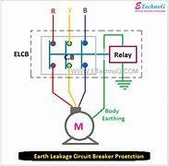

Hot wire (A) :- Current Flows from sources through hot wire, to the load. Neural wire (B) :- Carries current from load back to the source.

Phase wire (C) :- Carries current from lood back to the source.

Load(D) :- Metal component of device that ELCB connects to, eg. circuit panel door.

Relay Coil (E) :- One relay coil terminal connects to the load and the other terminal connects to the earth.

If the current difference between the hot wire and the neutral wire reaches a predetermined value (commonly 50 mA), the current in the relay creates an electromagnetic field strong enough to trigger the relay.

Earth (F) → Connecting the terminal of the relay coil to earth ensures safety by providing a low- impedance path for stray electrical currents.

After a breaker trips, it may not reset due to current still leaking to earth.

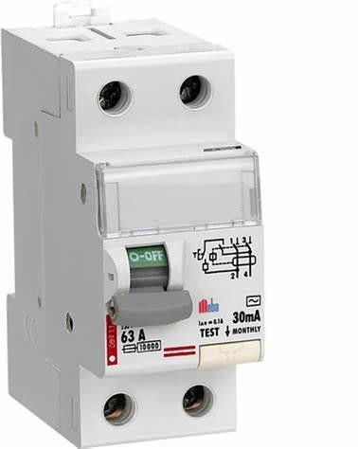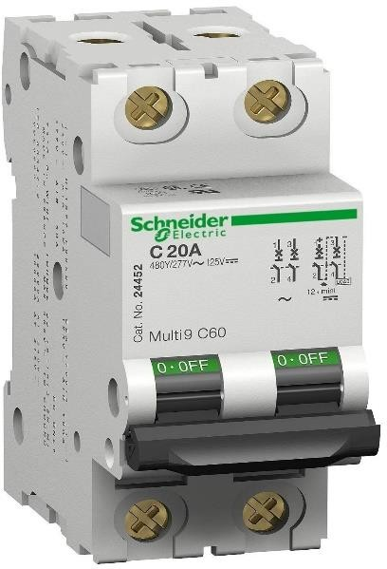

# CONCLUSION

The internship at Tata Motors Limited focused on the development and integration of a real-time tell-tale detection system utilizing advanced machine vision techniques. This system aimed to enhance the testing and validation processes for automotive instrument clusters by providing accurate detection and classification of tell-tale indicators.

A significant aspect of this project involved integrating machine vision with the Controller Area Network (CAN) protocol. This integration facilitated effective communication between the visual detection system and the vehicle’s electronic systems, allowing for real-time monitoring and verification of tell-tale indicators. The use of the CAN protocol enabled instantaneous feedback on the status of each indicator, thereby improving testing efficiency and accuracy.

Additionally, Hardware-in-the-Loop (HIL) simulations were employed to validate the performance of the tell-tale detection system under realistic conditions. This method provided a comprehensive platform for testing and fine-tuning the system, ensuring it met the stringent requirements of automotive applications.

The development of this automated detection system represents a significant advancement in real- time monitoring technology, contributing to enhanced product quality and reliability. The integration of machine vision with CAN protocol and HIL testing has refined the capabilities of tell - tale detection, benefiting the overall testing and validation processes at Tata Motors.