**Abstract**

**Project Title**–

Examination hall centralized mobile detection system using IOT

**Type** - Sponsored

**Name & Address of industry**–

Softtech Solutions (Nobel Manchester Building SR No 54/13, Near Thorat Barbeque Misal , Mumbai Pune Bypass Rd, in-front of Navale hospital , Narhe, Pune, Maharashtra 411041)

**Introduction –**

* The use of mobile phones is prohibited on college campuses and within the examination hall. Sometimes it's impossible to locate mobile phones with students. Detecting a mobile from this project will fix that problem automatically and therefore the alarm will ring automatically. The buzzer sound was detected within the project employing a graphical LCD to detect centralized mobile identification and therefore the use of mobile phones within the examination hall and this information is shown on LCD.
* This project proposes a technology to detect a cellphone that is being used by a restricted user in a restricted area, and also show the location of the user, to prevent the user from continuous use of the cellphone. the right number is checked. However, it is often busy and take time for an outsized number of scholars.
* Therefore, to avoid this problem, automated detection and identification of phones has been integrated. Currently there are mobile jammer to jam the whole network, but only to seek out cell phones of scholars who have been present within the exam hall there. It automatically detects the activity telephone within the e-hall and displays this information with the mobile detector on the remote computer (administrator) within the GUI until it detects the message, room number, location, etc.

**Block diagram –**

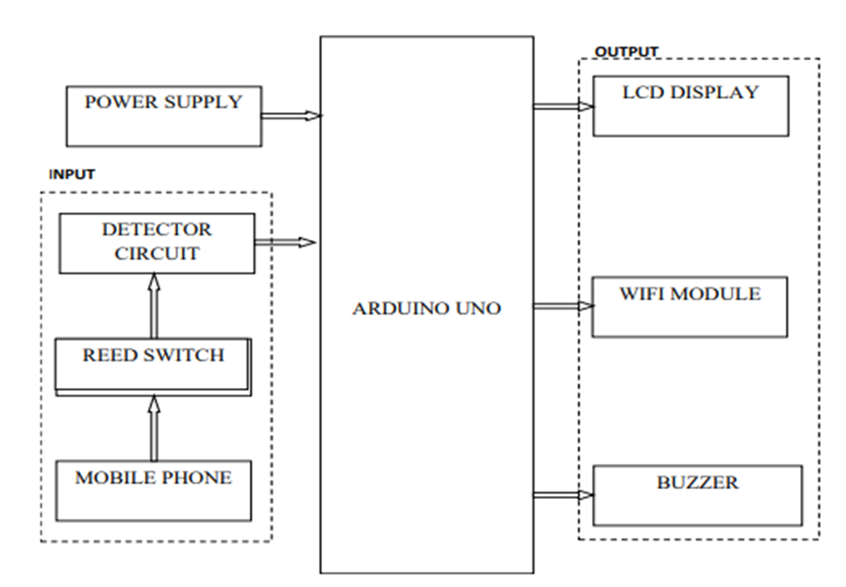

**Specifications –**

**System Specifications:**

1. **Detection Accuracy:**
   * **Range: The system should detect mobile devices within a radius of 5-10 meters, with high accuracy, to cover the entire examination hall.**
   * **Sensitivity: Capable of detecting both active (calling, texting) and passive (idle, airplane mode) mobile devices.**
2. **Connectivity:**
   * **Network Protocols: Support for Wi-Fi 802.11b/g/n, LoRaWAN, or other low-power wide-area network (LPWAN) protocols.**
   * **Data Transmission: Secure and encrypted data transmission between IoT nodes and the central server to prevent tampering or unauthorized access.**
3. **Power Management:**
   * **Battery Life: Designed for long-duration examinations, with a battery life of at least 8-12 hours per detection node.**
   * **Low Power Mode: Nodes should have the ability to enter a low-power mode when not actively detecting or transmitting data to conserve battery.**

**Hardware & Software requirements –**

* **ARDUNO UNO**
* **voltage sensor**
* **Lcd 16x2 display**
* **I2c module**
* **Battery, Resistors, Capacitors, Transistors, Cables and Connectors**
* **Diodes, PCB and Breadboards, LED, Transformer/Adapter, Push Buttons, Switch**
* **IC, IC Sockets**

**Advantages –**

* **When mobile phone is in active mode, it means that radiation signal is transmitted out in the form of sine wave which passes through the space. The receiver in the base station captures the encoded audio/video signal contains electromagnetic radiation. The modern 2G antenna in the base station has the transmitter power of 20-100 watts. The short signals that are transmitted by the mobile phones at regular intervals is used to register its availability to the nearest base station. The most important environmental factor is the distance to cellular base station. Generally, the nearer a cellular phone is to a base station or transmitting tower, the signal will be weaker that needs to come from the phone. The frequency range of the detector is usually identified by using a comparator. Here we use LM358 comparator. The huge amount of electromagnetic energy is carried by the high frequency RF wave in the micro wave region that is generated by the mobile phone.**

**Applications –**

* **The Mobile Phones which are around certain zone can be detected, with the goal that it can anticipate utilization of cell phones in examination lobbies, classified rooms. To identify the nearness of phone so as to abstain from spying in secret condition. Following applications will be detected: · Activated Mobile Phones and use of Mobile Phones in unauthorized places. · Mobile Phones used for Spying · Unauthorized transmission of signals.**

**References-**

* [1] Tunga M, A college attendance management system with mobile phone detector proposed framework. International Journal of Instrumentation Science and Engineering. 2022; 8(1):9-20.
* [2] Ataro E, Madara SD, Sitati S. Design and testing of mobile-phone-detectors. 2023.
* [3] Verma H, Tiwari RD, Mishra S, Srivastava S, Singh A, Tripathi H. Intelligent cell phone detector system at 4g bands of frequencies. IOSR Journal of Electronics and Communication Engineering. 2023; 12(2):55-9.
* [4] https://www.elektormagazine.com/magazine/elektor200205/17237. Accessed 14 January 2023.
* [5] Dar JA. Centralized mobile detection in examination hall using Arduino duemilanove (ATmega328). International Journal of Scientific & Engineering Research. India. 2022; 5(8):191-204.

|  |  |  |  |  |  |  |
| --- | --- | --- | --- | --- | --- | --- |
| **Group Details** | | | | | | |
| **Sr.**  **No** | **Roll No** | **Student Name** | **Mobile No** | **Signature** | **Guide** | **Name with Mob. No** |
| 1 |  |  |  |  | Internal |  |
| 2 |  |  |  |  | External |  |
| 3 |  |  |  |  |  |  |