
Tribhuvan University
Institute of Engineering
Thapathali Campus
Subject: Computer Networks
LAB Sheet #6
LAB REPORT ON “DYNAMIC ROUTING PROTOCOL”



Submitted by:
Name: Srijal Basnet
Roll No.: THA080BCT044

Submitted to:
Department of Electronics and Computer Engineering

Lab Date: 2082/10/27
Submission Date: 2082/11/05

TITLE: DYNAMIC ROUTING PROTOCOL (RIP AND OSPF)
OBJECTIVES:
- To understand the fundamental concepts and working principles of dynamic routing protocols such as RIP and OSPF.
- To configure, implement, and verify RIP and OSPF routing on a multi-router network topology using Cisco Packet Tracer.

THEORY:
RIP (Routing Information Protocol):
RIP is a distance-vector routing protocol commonly applied in small to medium networks. It determines routes using hop count as the metric, with a maximum of 15 hops, which limits its ability to scale for larger networks. Routers periodically exchange complete routing tables (usually every 30 seconds), making RIP easy to configure but slower in convergence and less suitable for complex network environments.
OSPF (Open Shortest Path First):
OSPF is a link-state routing protocol developed for larger and more advanced network structures. It uses Dijkstra’s Shortest Path First algorithm to find the optimal route based on cost, often determined by bandwidth. Compared to RIP, OSPF provides faster convergence, supports hierarchical network organization through areas, and improves efficiency by sending only incremental updates rather than full routing tables.
Commands for Router Configuration (RIP):
- Router1 Configuration:
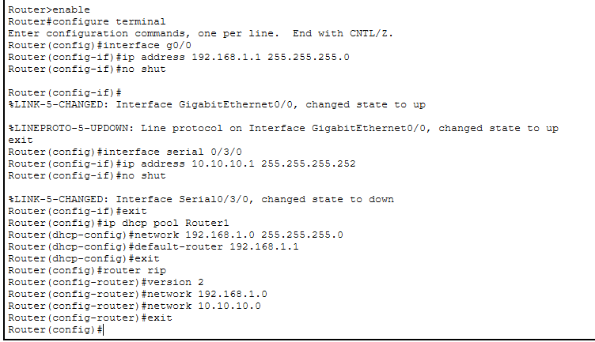

- Router2 Configuration:
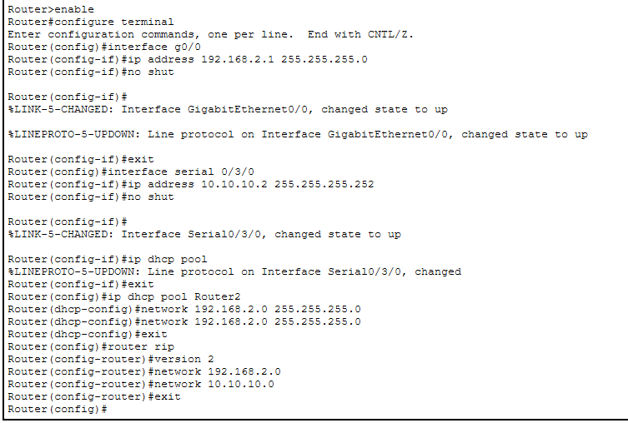
OUTPUT:
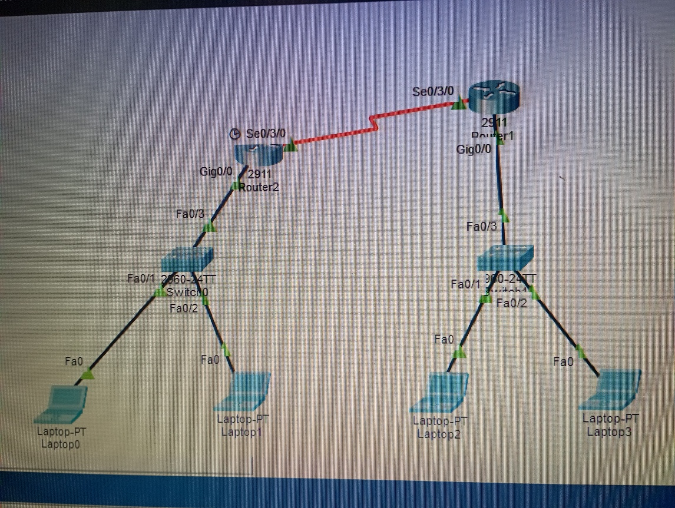
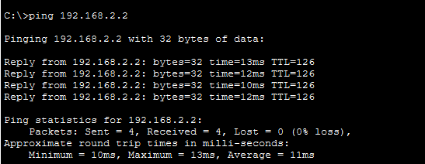

Commands for Router Configuration (OSPF):
- Router3 Configuration:
Router>enable
Router#configure terminal
Router(config)#interface g0/0
Router(config-if)#ip address 192.168.1.1 255.255.255.0
Router(config-if)#no shut
Router(config-if)#exit
Router(config)#interface s0/3/0
Router(config-if)#ip address 10.10.10.1 255.255.255.252
Router(config-if)#no shut
Router(config-if)#exit
Router(config)#ip dhcp pool Router3
Router(dhcp-config)#network 192.168.1.0 255.255.255.0
Router(dhcp-config)#default-router 192.168.1.1
Router(dhcp-config)#exit
Router(config)#router ospf 1
Router(config-router)#network 10.10.10.0 0.0.0.3 area 0
Router(config-router)#network 192.168.1.0 0.0.0.255 area 0
- Router4 Configuration:
Router>enable
Router#configure terminal
Router(config)#interface g0/0
Router(config-if)#ip address 192.168.2.1 255.255.255.0
Router(config-if)#no shut
Router(config-if)#exit
Router(config)#interface s0/3/0
Router(config-if)#ip address 10.10.10.2 255.255.255.252
Router(config-if)#no shut
Router(config-if)#exit
Router(config)#interface s0/3/1
Router(config-if)#ip address 20.20.20.1 255.255.255.252
Router(config-if)#no shut
Router(config-if)#exit
Router(config)#ip dhcp pool Router4
Router(dhcp-config)#network 192.168.2.0 255.255.255.0
Router(dhcp-config)#default-router 192.168.2.1
Router(dhcp-config)#exit
Router(config)#router ospf 1
Router(config-router)#network 10.10.10.0 0.0.0.3 area 0
Router(config-router)#network 192.168.2.0 0.0.0.255 area 0
Router(config-router)#network 20.20.20.0 0.0.0.3 area 0
- Router5 Configuration:
Router>enable
Router#configure terminal
Router(config)#interface g0/0
Router(config-if)#ip address 192.168.3.1 255.255.255.0
Router(config-if)#no shut
Router(config-if)#exit
Router(config)#interface s0/3/0
Router(config-if)#ip address 20.20.20.2 255.255.255.252
Router(config-if)#no shut
Router(config-if)#exit
Router(config)#ip dhcp pool Router5
Router(dhcp-config)#network 192.168.3.0 255.255.255.0
Router(dhcp-config)#default-router 192.168.3.1
Router(dhcp-config)#exit
Router(config)#router ospf 1
Router(config-router)#network 20.20.20.0 0.0.0.3 area 0
Router(config-router)#network 192.168.3.0 0.0.0.255 area 0
Router(config-router)#end
OUTPUT:
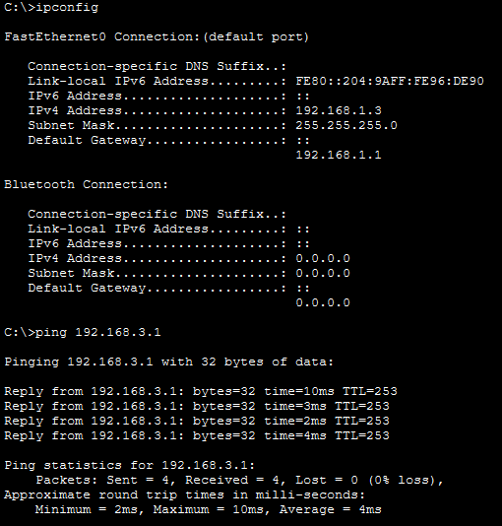
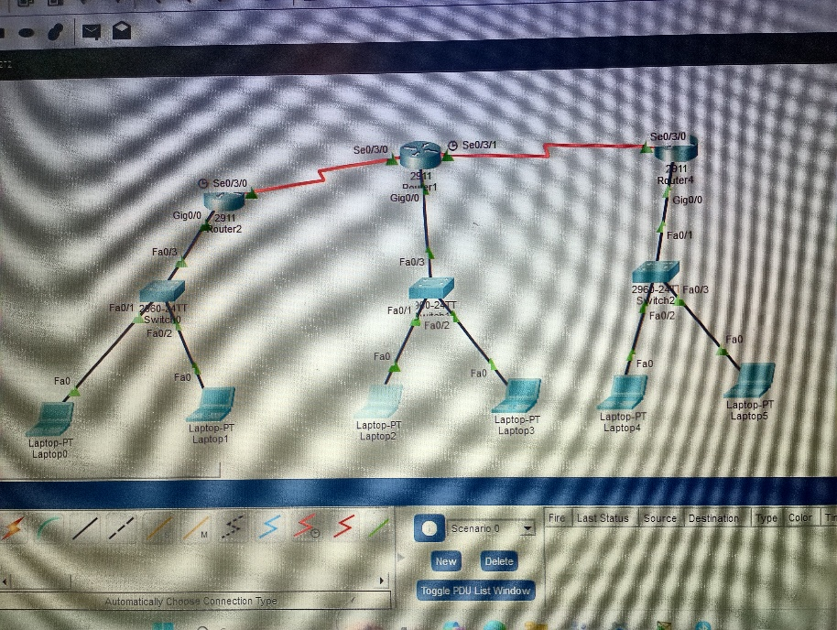
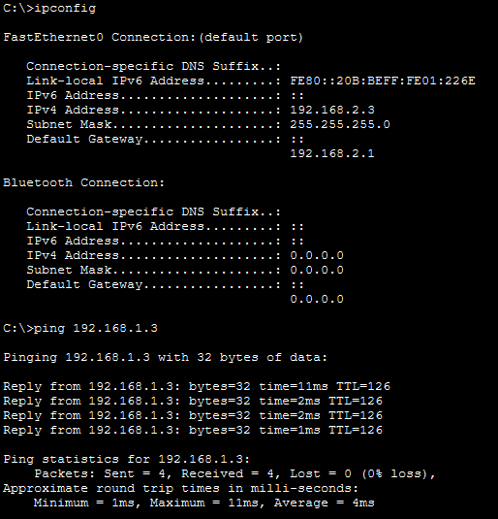

DISCUSSION AND CONCLUSION:
In this lab session, dynamic routing was configured using RIP and OSPF within a multi-router network topology. The setup process included assigning IP addresses, activating routing protocols, and checking routing tables to ensure proper functionality. It was observed that RIP relies on hop count as its routing metric and is relatively easy to configure, whereas OSPF uses a cost metric based on bandwidth and achieves faster convergence in larger network environments. Accurate network statements and proper interface configuration were necessary for successful route sharing.
Overall, this practical exercise provided a clear understanding of how dynamic routing protocols automatically exchange routing information among routers. OSPF demonstrated better efficiency and scalability compared to RIP, particularly in more complex network setups. The lab enhanced knowledge of routing principles, protocol operations, and network verification using Cisco Packet Tracer commands.

