**Hi Sir,**

Sir, I tried my best to solve the challenge given by you, but I couldn’t solve it.

The login/Session Page was missing because of this I was not able to solve the logic based on who logins the website and when the fields should be displayed or hidden.

The output was not having the dropdowns and was not originally what was told to me.

The database tables were empty and also I was not able to find how the different tables are linked together and with the code.

**So** **I tried to develop another website from scratch which is almost similar to the task assigned to me.**

* It has the dropdowns and is in perfect format.
* On Sundays it displays Sunday, and on other days you can select the project from dropdowns.
* The UI is linked with the database tables.
* The timesheets table contains all the project IDs that is being saved by the user from the frontend.

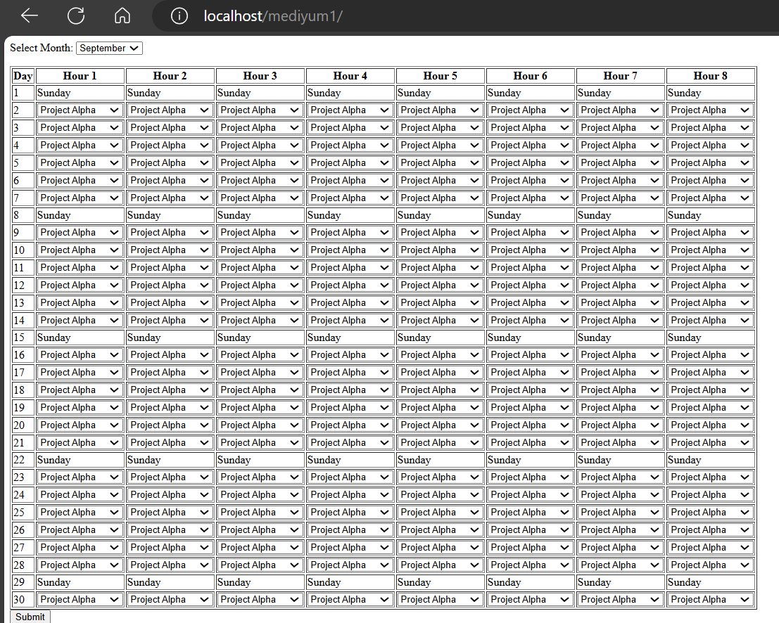

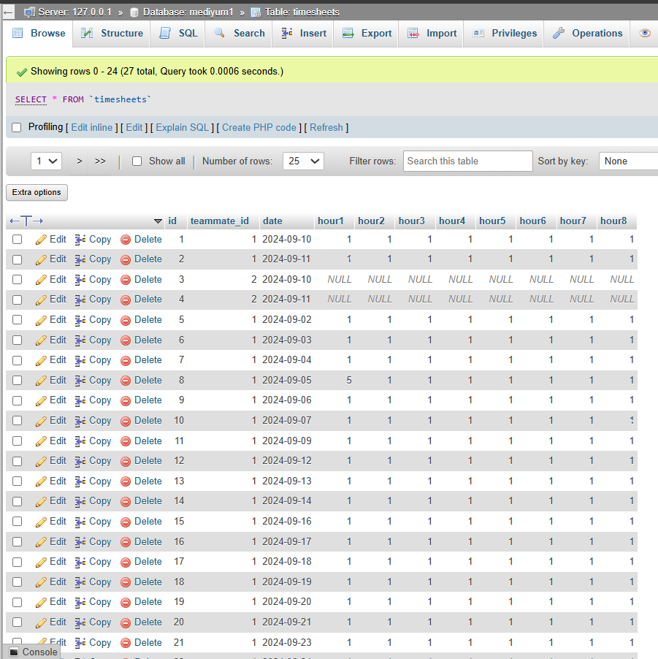

The code and the database are exported and provided in the zip folder given by mail.

If you have time to look at this work, please have a look. It is similar to the provided task.

If you think the work by me is satisfactory for you then I am ready to join your company.

Otherwise, it's fine. I will try another company.

Thank You For giving this project to me so that I was able to work on my pros and cons.

Thank you.