

**Platform Used**: phpmyadmin and MySql – for importing the dataset and performing sql queries.

Q) Obtain Sales Analysis of the following dataset and perform the Following 5 operations.

Operations -

1.Top Sales per Customer

2.Average Discount by Product Category

3.Top 5 Cities by Total Sales

4.Product with sales greater than $5000

5.Number of Orders per Shipping Mode

Project Details :

**Analysis of Superstore Dataset**

**Solution:->**

Steps for the working of the project:

1. Open your browser and access phpMyAdmin via <http://localhost/phpmyadmin>
2. Create a new database to store your dataset: CREATE DATABASE dataset;
3. Import the Dataset into the Database

By default, MySQL sets a limit on how large a file (or query) can be. (The dataset was not getting imported into my phpMyAdmin.) So I temporarily increased the size by the following query: SET GLOBAL max_allowed_packet = 64 * 1024 * 1024;

This increases the limit to 64MB for your current MySQL session.

After which I was able to import my .csv dataset into my phpMyAdmin.

1. After importing the dataset, I performed the 5 operations using SQL queries.

Outputs (with query):

* After importing the dataset: ( select * from superstore; )

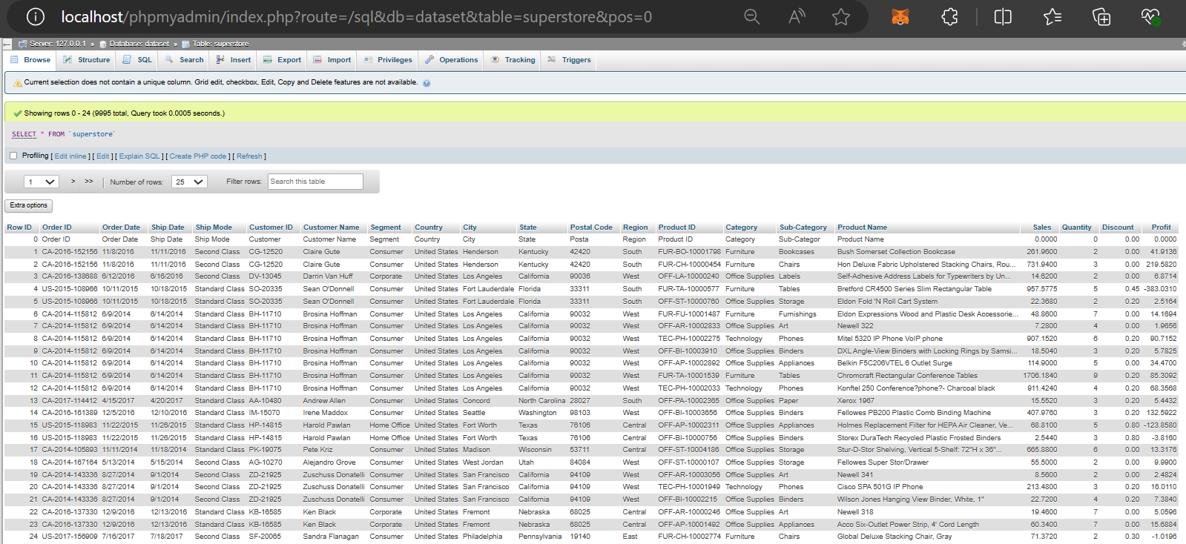

1. Top Sales per Customer :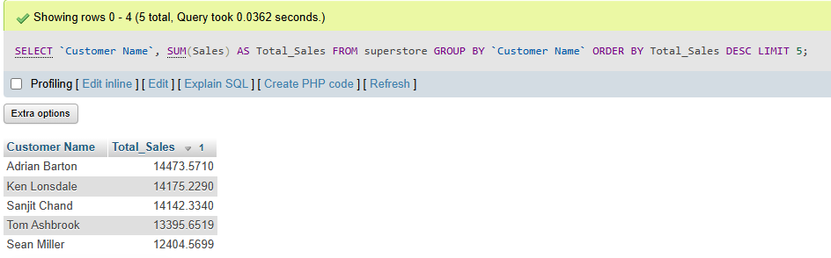

2. Average Discount by Product Category

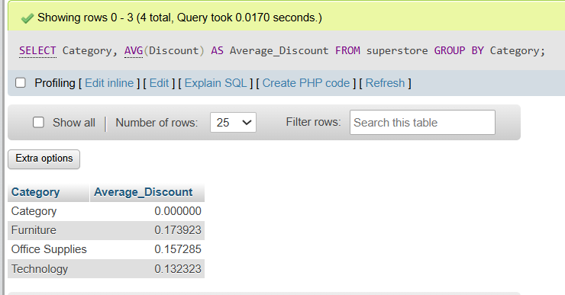

3. Top 5 Cities by Total Sales 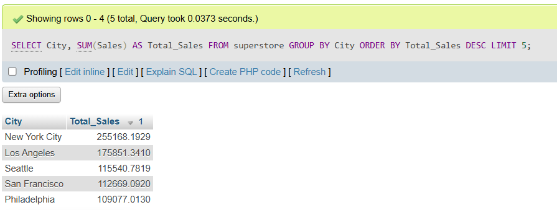

4. Product with sales greater than $5000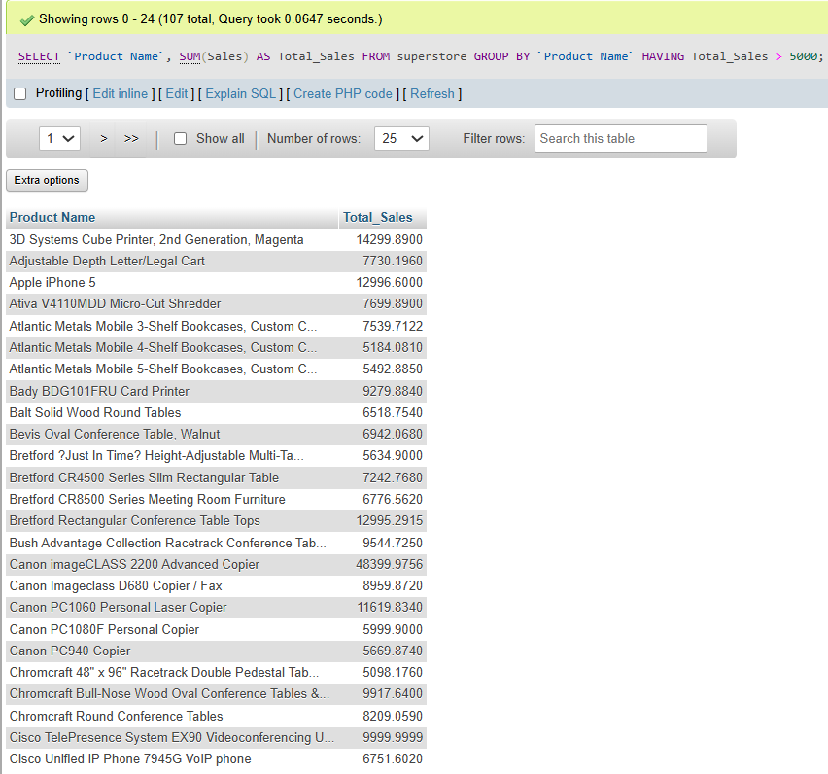

5. Number of Orders per Shipping Mode

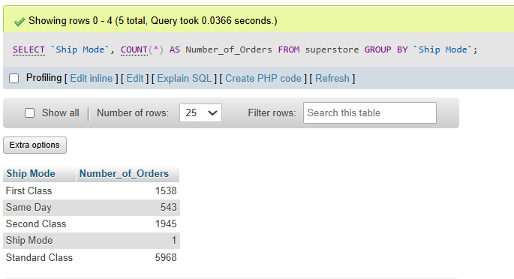

My Name: Pratik Pranav Post: IT Engineer (Fresher) Contact: 9096587712

Email: [pratikpranav786@gmail.com](mailto:pratikpranav786@gmail.com)

THANK YOU