B

Q1.

1. Suppose Node 1 starts the request and Node 2 gives the reply.

* ARP_REQUEST (Request message is broadcasted by Node 1.)
* ARP_REPLY (Reply message by Node 2.)
* TCP_SYN (Node 1 sends connection request.)
* TCP_SYNACK (Node 2 acknowledges the request.)
* TCP_ACK (Last step of 3 way handshaking by Node 1.)
* APP1_CBR (Data Packets.)
  + Then they continuously exchange TCP_ACK messages and data packets(APP1_CBR).

b)

* CONFIG_BPDU (Data messages exchanged between switches.) - Bridge Protocol Data Unit.
* ARP_REQUEST (Request message is broadcasted by some node to a switch and then from that switch to other nodes connected in the network.)
* ARP_REPLY (Reply message sent by that node(s) in the network for whom the ARP_REQUEST message was intended.)
* TCP_SYN (1st step in 3 way handshaking by the node(s) which receives ARP_REPLY.)
* TCP_SYNACK (2nd step of 3 way handshaking to acknowledge TCP_SYN.)
* TCP_ACK (Last step of 3 way handshaking by node(s) which receives TCP_SYNACK.)
* APP1_CBR (Data Packets.)
  + Then they continuously exchange TCP_ACK messages and data packets(APP1_CBR).
* APP2_CBR (Data Packets.)
  + Then they continuously exchange TCP_ACK messages and data packets(APP2_CBR).

Q2.

* For any packet , Transmitter ID denotes some node or switch in the network from where the packet( or it’s segment ) was sent and Receiver ID denotes the one which receives the packet.
* However, Source ID and Destination ID represents the source node from where the packet was generated and destination node where the packet is supposed to reach at the end respectively and they are independent of Transmitter and Receiver IDs.
* E.g. - Suppose a packet goes from Source – Node 1 to Switch 1 to Switch 2 to Node 2.
* Source ID – Node 1
* Destination ID – Node 2
* However for 3 different stages of transmission , Transmitter and Receiver IDs will be
  + Node 1 , Switch 1
  + Switch 1 , Switch 2
  + Switch 2 , Node 2

Q3.

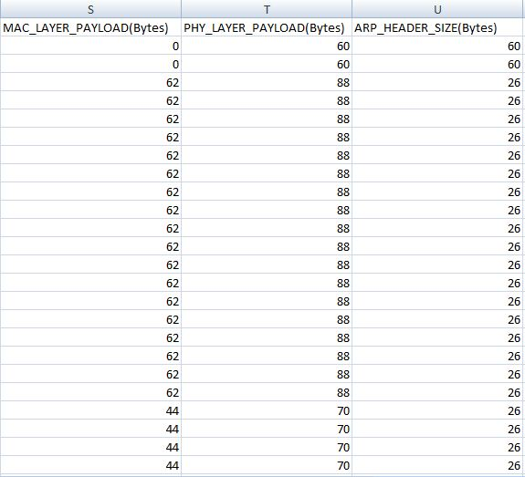

Q4.

* A switch MAC Address Table keeps record of the MAC Addresses of 1) Nodes directly connected to switch 2) Other Nodes which are connected to these nodes by APP_CBR and 3) Other Switches connected to it.

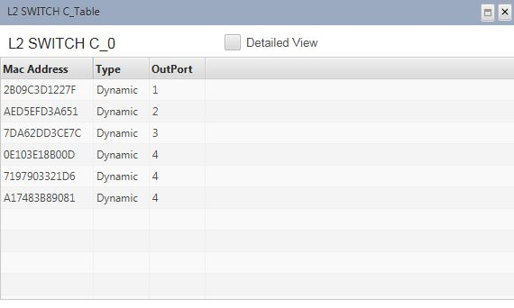

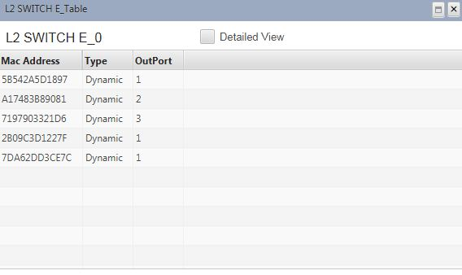

C

Q5.

* Flow of packets will be the same as in Q1 b) above . The only difference will be that all the packets from either of switches will first go to router and then the router will route the packets forward to other switch into the network.

Q6.

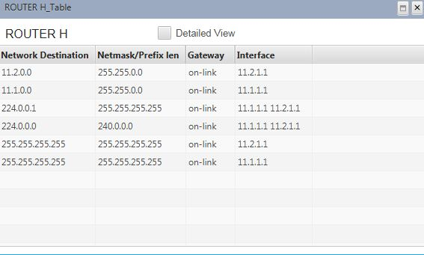

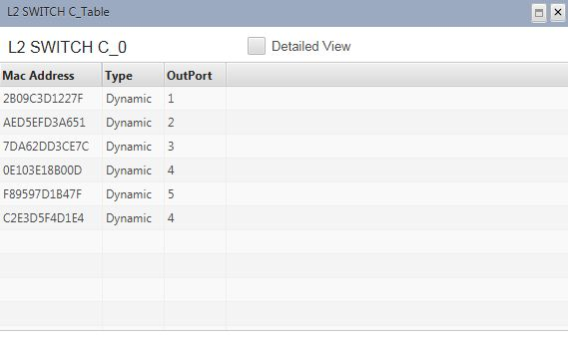

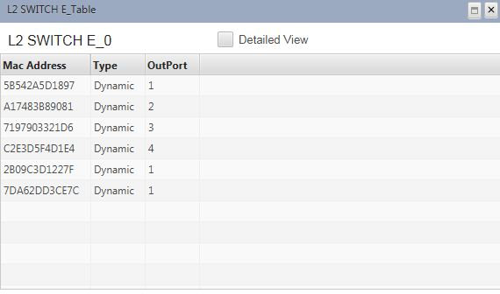

Nodes MAC Address IP Address

* 4 – 7D……………. 11.1.1.12
* 2 – AE……………. 11.1.1.11
* 1 – 2B……………. 11.1.1.10
* Router –
  + F8…………… 11.1.1.1
  + C2……………. 11.2.1.1
* 6 – A1………….. 11.2.1.2
* 7 – 71………….. 11.2.1.3

Switch MAC Address Tables contain the MAC addresses of other connected devices like routers , switches , and nodes.

Router Table contains all the mapping of IP Addresses of the nodes in the network so that it can forward packets using IP Forwarding.

D

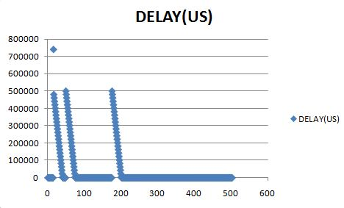

* Here, in our case, in total in entire simulation period 3 packet loss/error occurs.At these 3 instances, we can see there is sudden increment in delay as shown in the figure. Whenever, a packet is lost, then the node which has transmitted the packet eventually does not receive the final TCP_ACK. So, the node waits for the ACK upto predefined timeout and then this packet has to be retransmitted. Thus , until now the process of sending the packets and receiving TCP_ACKs which was going on parallely receives the ACK of recently retransmitted packet after a huge delay and so the ACKs of the subsequent packets which were already received parallely are parsed only after this. But as these ACKs were already received on the node side,the delay gradually goes on decreasing.