Ex -2

2.1.1

In TCP for establishment of connection, it uses 3 way handshaking which consists of:-

* TCP_SYN(Client to Server)
* TCP_SYNACK(SYN + ACK in response from Server to Client)
* TCP_ACK(ACK by Client to Server)

From the packet trace file, we can see that,

* is_Syn = True and is_Ack = False for TCP_SYN
* is_Syn = True and is_Ack = True for TCP_SYNACK because Server sends both, a SYN message and also an ACK message for acknowledging SYN sent by Client.
* is_Syn = False and is_Ack = True for TCP_ACK which is the acknowledgement by Client to SYN message of Server.

2.3

1. Sequence number of the 1st SYN control packet = 250000s

Acknowledgement number = 0 (because it is SYN and not ACK!)

Now, Server sends SYN +ACK in return. For this packet,

Sequence number = 250005 (Random)

Acknowledgement number = 250001 (250000 + ‘1’)

2. Sequence number of the 1st FIN control packet = 270006

Acknowledgment number = 0 (because it is SYN and not ACK!)

For ACK packet sent in response to FIN,

Sequence Number = 250751(Random)

Acknowledgment Number = 270006 (Same as Sequence Number of FIN packet)

3.

3 Way - Handshaking

Client (Node 2) Server (Node 1)

SYN

SEQ_NO. = 250000, ACK_NO. = 0

SYNACK

SEQ_NO. = 250005, ACK_NO = 250001

ACK

SEQ_NO. = 250001,

ACK_NO. = 250006

TERMINATION

Initiator Receiver

FIN

SEQ_NO. = 270006, ACK_NO. = 0

ACK (FIN) ACK_NO. = 270006

SEQ_NO = 250751

FIN SEQ_NO. = 250751, ACK_NO. = 0

ACK (FIN)

SEQ_NO. = 270007, ACK_NO = 250752

4.

* For termination of connection in TCP, when 1 node initiates the termination by sending FIN, then the 2nd node acknowledges it with ACK but unlike connection establishment (where SYN and ACK are sent together as SYNACK), here in termination the 2nd node doesn’t send the FIN along with ACK. This is because even when 1st node has closed the connection it can still receive from the 2nd node until the 2nd node too closes its connection by sending FIN.

5. Assumption – By 1 session we mean that when the connection is established through 3 way handshaking and it is terminated by a pair of FIN + ACK.

NO. OF SESSIONS = 4

6. Data Packets Transfer

Server (Node 1) Router Client (Node 2)

APP1_HTTP

SEQ_NO = 250006, ACK_NO = 0

APP1_HTTP

SEQ_NO = 251466, ACK_NO =0

APP1_HTTP

SEQ_NO = 250006, ACK_NO = 0

ACK

SEQ_NO = 250751, ACK_NO = 251466

ACK

SEQ_NO = 250751,

ACK_NO = 251466 APP1_HTTP ->

SEQ_NO = 251466, ACK_NO = 0

ACK -> SEQ_NO = 250751, ACK_NO = 252926

ACK -> SEQ_NO = 250751, ACK_NO = 252926

8.

Server Client

Node 1 Router 3 Node 2

3 Seq_no = 252927, Ack_no = 0

4 Seq_no. = 254387, Ack_no = 0

5 Seq_no = 255847, Ack_no = 0

4 Seq_no. = 254387, Ack_no = 0

6 Seq_no = 257307, Ack_no = 0

5 Seq_no = 255847, Ack_no = 0

3 Seq_no = 252927, Ack_no = 0

3 Seq_no = 252927, Ack_no = 0

6 Seq_no. = 257307, Ack_no = 0

6 Seq_no. = 257307, Ack_no = 0

9.

Seq. No. of SYN packet = 5460

Total Data = 5000 bytes

Max. Segment Size (MSS) = 1500 bytes

Therefore, total no. of segments transmitted = 4

Seq. No. of last packet = 5460 + (3 * 1500) + 1 = 9961

Seq. No. of FIN packet = 9961 + 1500 = 11461

3.2

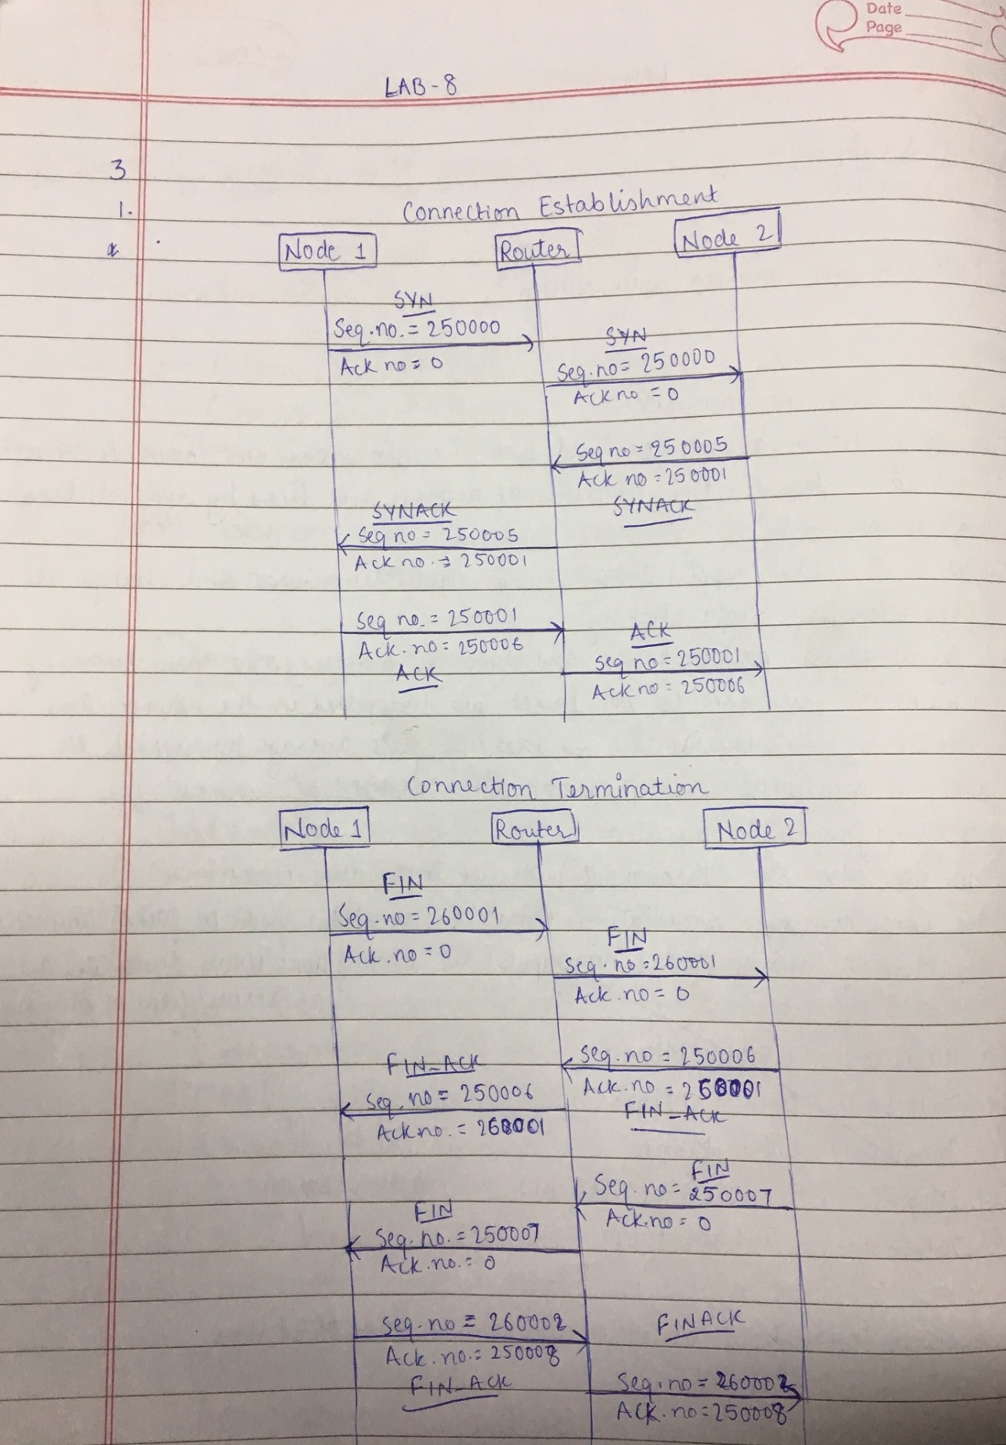

4.1    Fix throughput = 24.19558023 bits/ sec

Moving average throughput

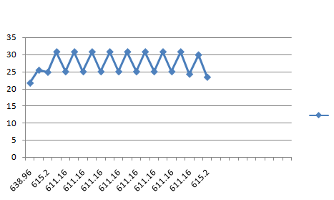

4.2

1. Maximum throughput value is 30.753 bits/sec

1. Average Throughput (Simulation time: 10 seconds): 0.052409 bits/sec
2. Average Throughput

|  |  |
| --- | --- |
| **SIMULATION TIME** | **AVERAGE THROUGHPUT** |
| 2  seconds | 21.90927518 bits/sec |
| 5  seconds | 0.116753777  bits/sec |
| 10 seconds | 0.097883096  bits/sec |

1. Average Throughput for DATABASE APPLICATION

|  |  |
| --- | --- |
| **SIMULATION TIME** | **AVERAGE THROUGHPUT** |
| 5  seconds | 0.064000 MBPS |
| 8  seconds | 0.070000 MBPS |
| 10 seconds | 0.072000 MBPS |

Average Throughput for HTTP APPLICATION

|  |  |
| --- | --- |
| **SIMULATION TIME** | **AVERAGE THROUGHPUT** |
| 5  seconds | 0.055424 MBPS |
| 8  seconds | 0.065765 MBPS |
| 10 seconds | 0.069212 MBPS |

Average Throughput for FTP APPLICATION

|  |  |
| --- | --- |
| **SIMULATION TIME** | **AVERAGE THROUGHPUT** |
| 5  seconds | 0 |
| 8  seconds | 0.100000 MBPS |
| 10 seconds | 0.080000 MBPS |

1. Total data size is 1000 bytes and segment size is 150 bytes.

Hence the data would be divided in 7 segments, first 6 segments of size 150 bytes and 7th segment of size 100 bytes.

Now since 2,4 and 5th got errored, they will be resent.

Hence total resent bytes = 450 bytes.

Therefore total time taken by the links at speed of 10 bytes/sec =

(1000 + 450) / 10 = 145 seconds.

Total data transferred from A to B = 1000 bytes.

Hence throughput    = 1000/145 bytes/sec

            = 6.89655 bytes/sec

            = 55.17 bits/sec