**Python Lab 4 Assignment**

1. Write a Python program to reverse the content of the string.

Do not use built in

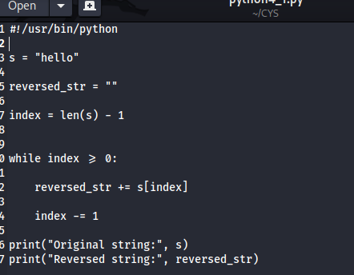

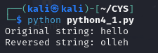

2. Create a program that performs basic string compression using the counts of repeated characters. For example, the string “aabcccccaaa” would become “a2b1c5a3”.

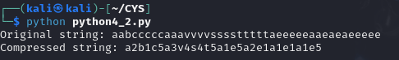

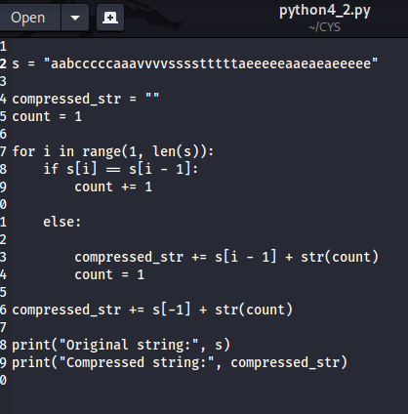

3. Get the Caesar cipher from the user Decrypt the cipher

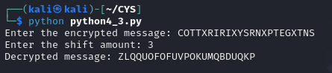

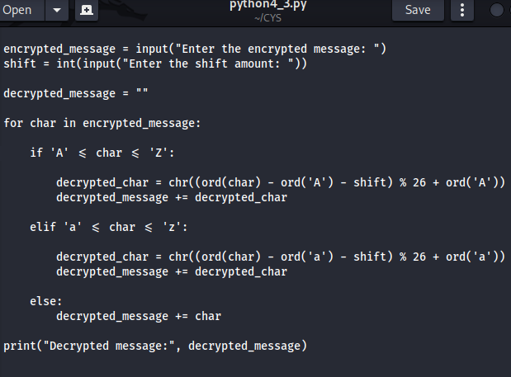

4. Get the cipher encrypted using shift cipher. Identify the key used to encrypt using brute force

ie all the values in the key space

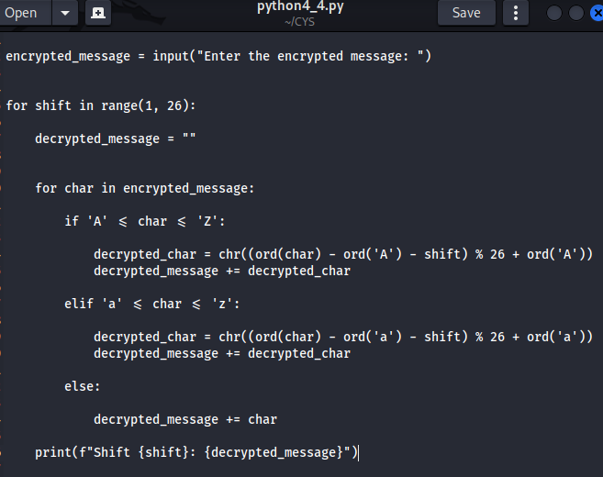

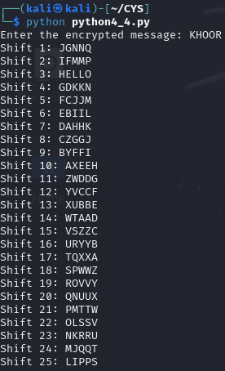

5. Find the k value , Provided cipher text and plain text

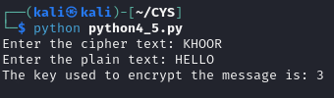

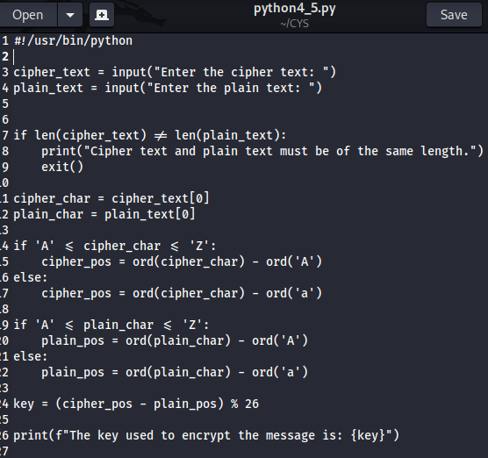

6. Encrypt and decrypt the string using Atbash cipher

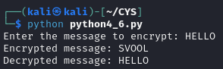

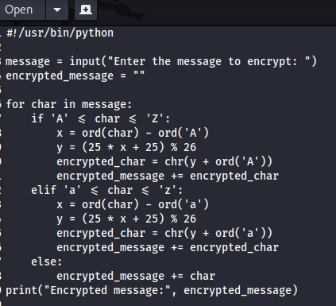

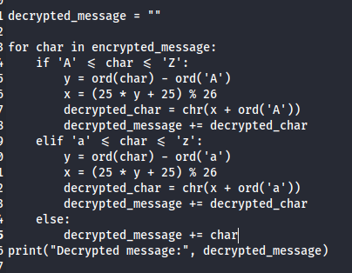

7. Encrypt and decrypt using Affine cipher

add validation

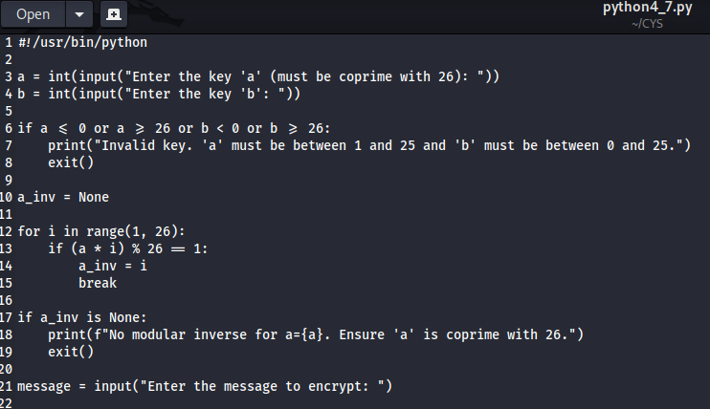

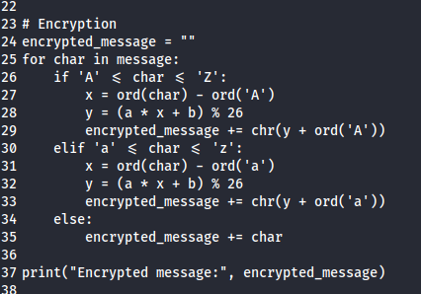

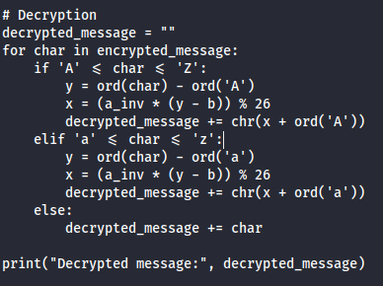

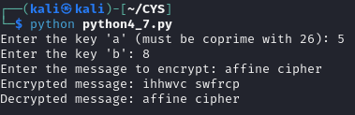

**"The only way to keep your data safe is to keep it encrypted. Data breaches are inevitable; encryption is a way to ensure that they are not devastating."**  
— **Pratik Sarkar , (MSIS - ME Cybersecurity )**