PYTHON LAB 10

1. Write a Python script to list all the prime numbers from 1 to 100 using Sieve of Eratosthenes.

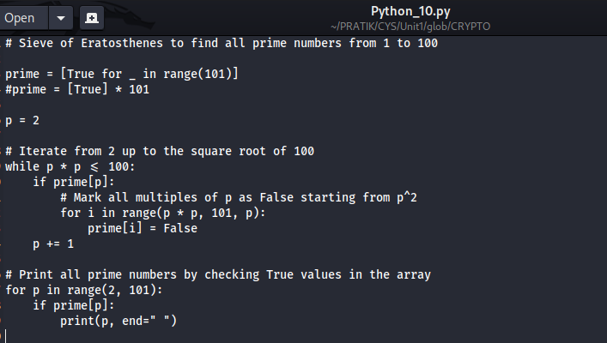

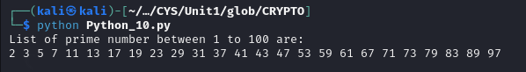

2. Write a Python script to implement RSA algorithm using build in functions (both encryption and decryption)

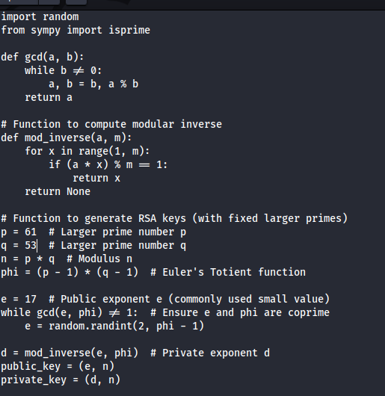

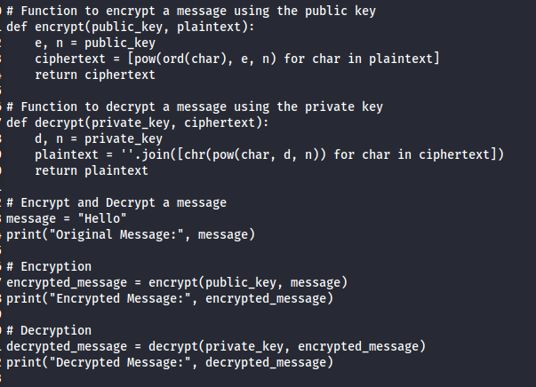

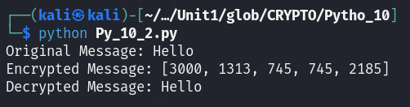

3. Write a Python script to implement RSA algorithm with out using build in functions (both encryption and decryption)





