PYTHON 7

1. Write a Python script to encrypt columnar transposition using keyword.

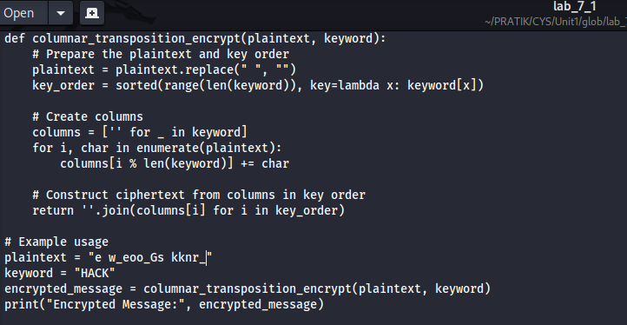



2. Write a Python script to encrypt double columnar transposition.

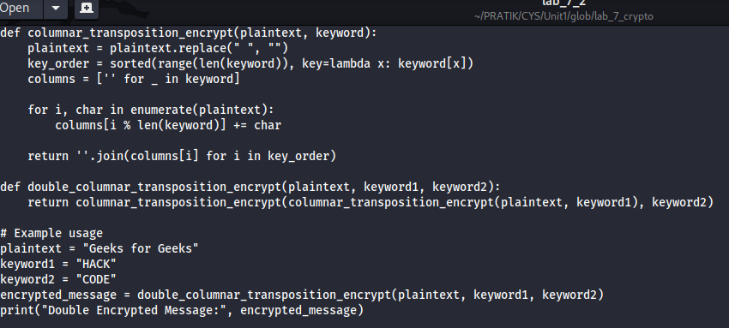

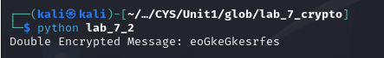

3. Write a Python script to encrypt the message “She is listening” using the 6-character keyword “PASCAL” with Vigenere cipher.

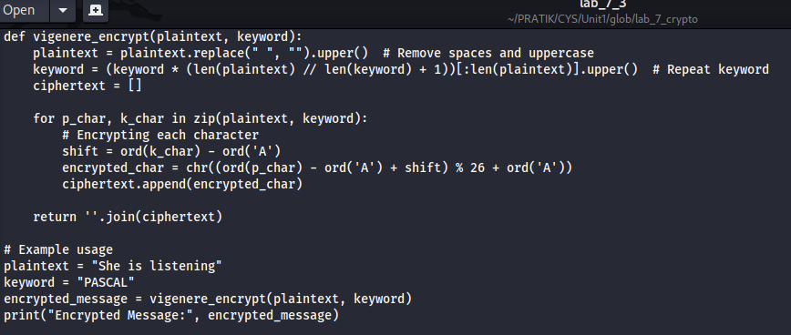



4. Write a Python script to encrypt and decrypt Hill cipher

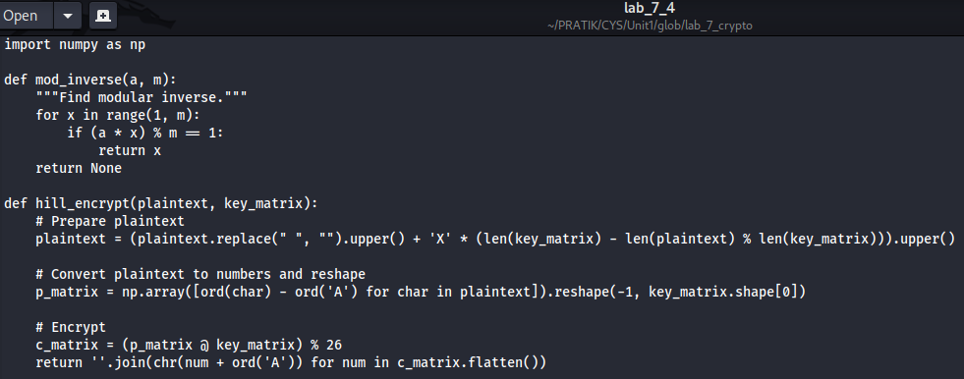

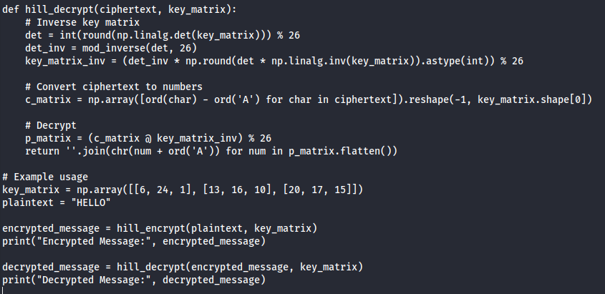

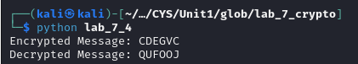

Bonus Point:

5. Write a Python script to perform Kasiski test.

