Linux Lab 4

1. write a shell script to get value the pattern and file name from the user and check the pattern exists or not. If the pattern exists print the relavent

message , if pattern not found print relevent message.

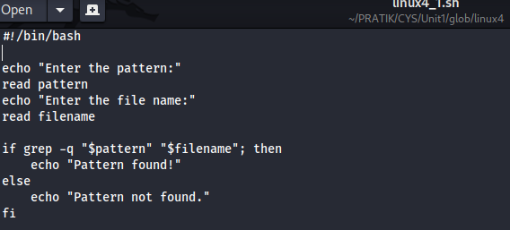

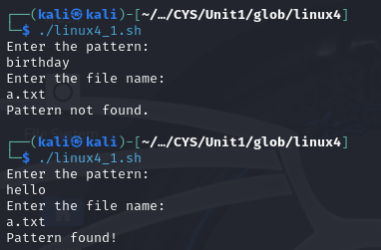

2. Modify the above script to pass the arguments from command line arguments.

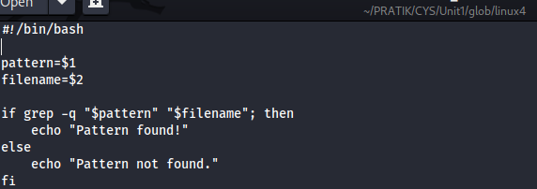

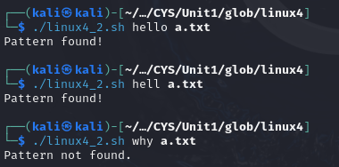

3. Modify the above script to pass the values inside the script.

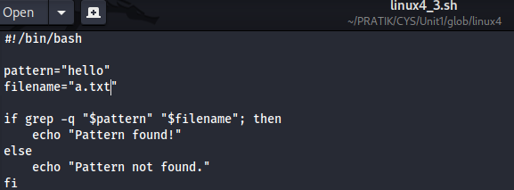

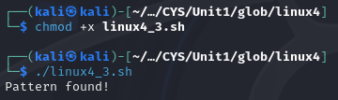

4. validate the script (script 1, script 2)

- the file exists or not

- arguments passed or not 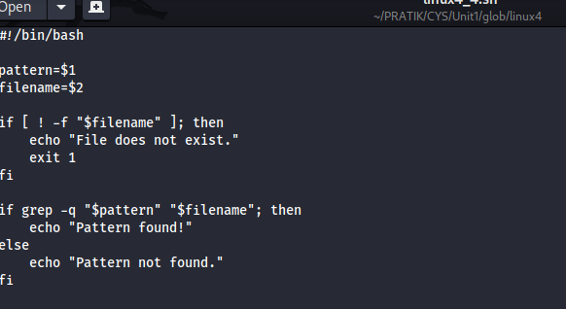

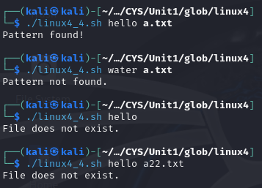

5. Apply grep commands

Note: Make sure to use the options -e -c -n -q -s -f -A -B -C -i -h, -l -o -w

Frame the questions (as per your choice)

i) to extract user information

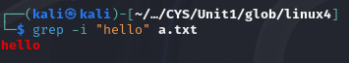

ii) to extract network information

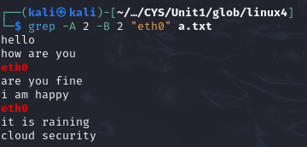

iii) to extract login details



iv) Using multiple options

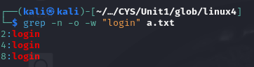

v) Check whether a pattern exist in file without showing in output



Vi) To search multiple patter using -e

