Python Lab 9

Concepts: Process, trap, kill,

1. Write a bash script that monitors a sensitive directory (of your choice) for changes using inotifywait (Linux command). Use trap to handle SIGINT (Ctrl+C) to safely exit the script without leaving any processes running.

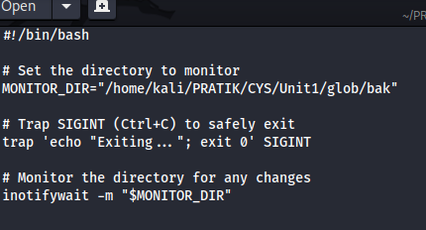

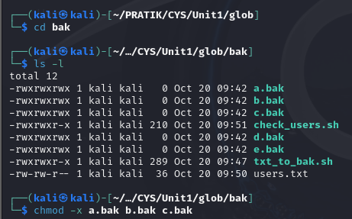

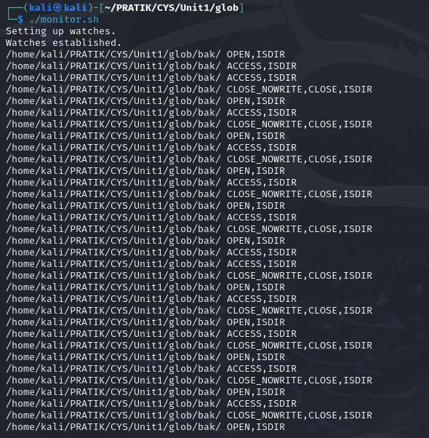

2. Write a bash script that starts a background process (of your choice), and use trap to catch SIGINT and terminate the process cleanly.

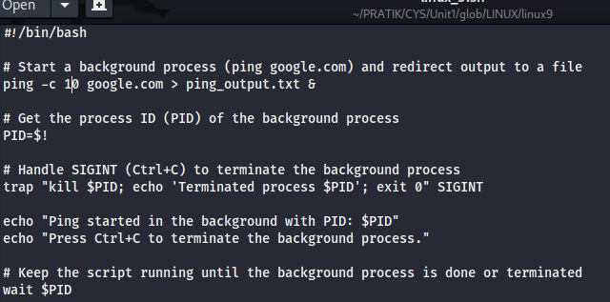

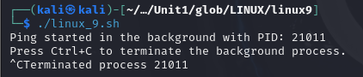

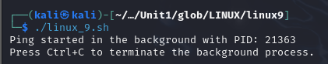

The process which was running in background

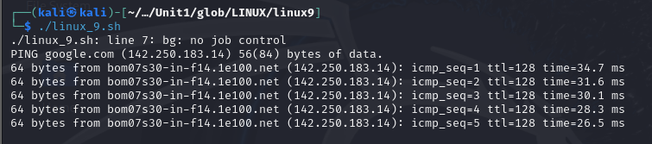

3. Write a script that kills any process exceeding a defined CPU or memory usage limit or matching a list of malicious process names. The script should log the terminated process details for auditing purposes.

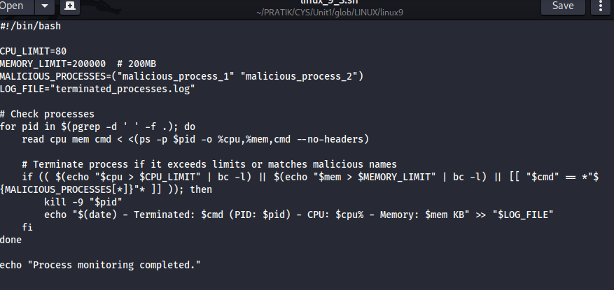

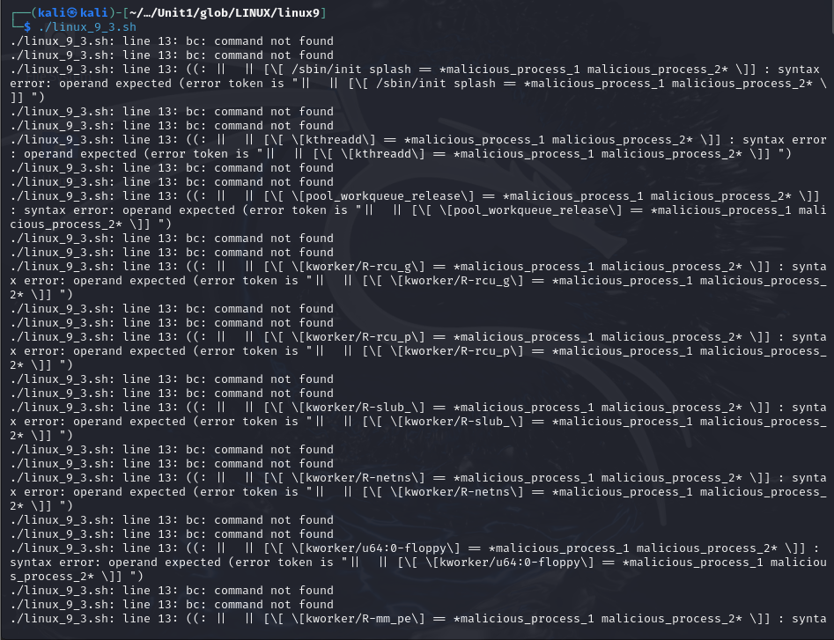

4. Write a script that monitors running processes and identifies any process that matches a list of known suspicious names (like netcat, nmap).

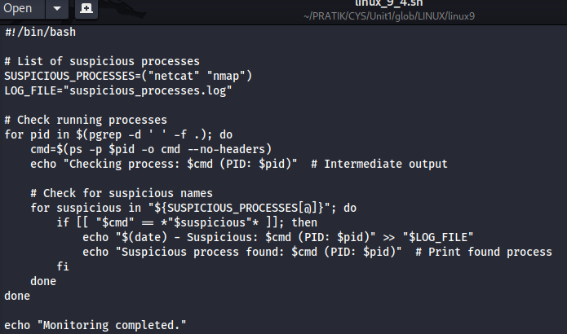

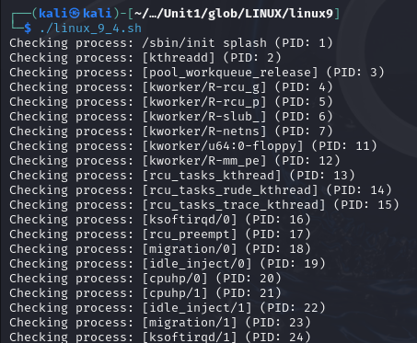

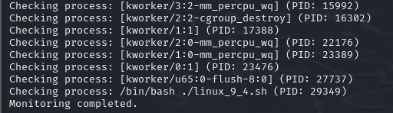

5. Create a script that runs a background process (such as a continuous ping to a specified IP address). Use trap to capture termination signals (SIGINT, SIGTERM) and ensure the background process is terminated safely when the script is interrupted. 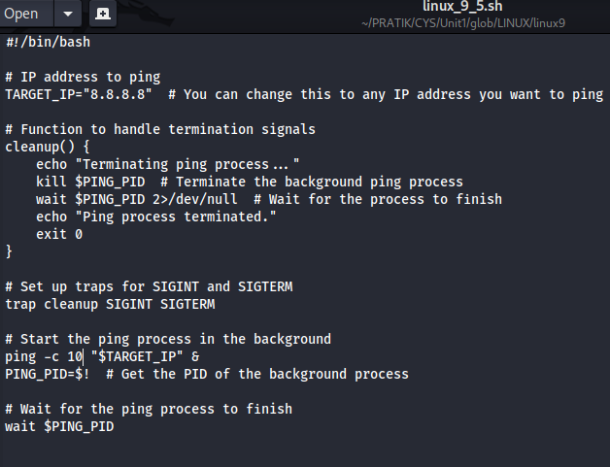

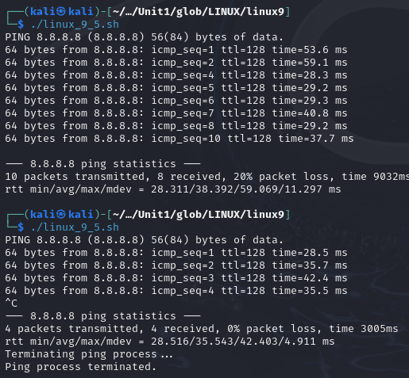

6. Write a script that checks /var/log/auth.log for failed login attempts and sends notification if any are found. Schedule this script to run every 15 minutes using cron command.

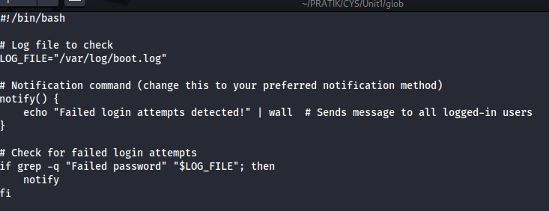



**Scheduling with Cron:**

To schedule the script to run every 15 minutes, follow these steps:

1. Open the crontab editor:

**crontab -e**

1. Add the following line to the crontab file:

**\*/15 * * * * /path/to/check_failed_logins.sh**

7. Write a script that removes all files older than 7 days from the /tmp directory, and use at to schedule the script to run at 2:00 AM the next day.

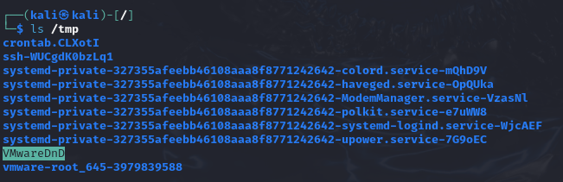

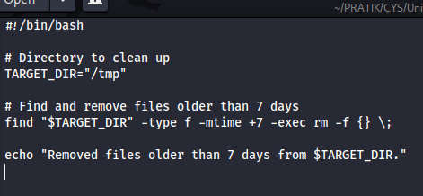

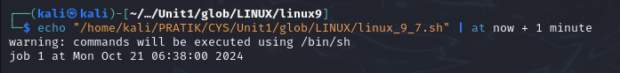

8. Write a script to check if disk usage exceeds 80%, and use at to schedule it to run at a specific time.

