**Task 1**

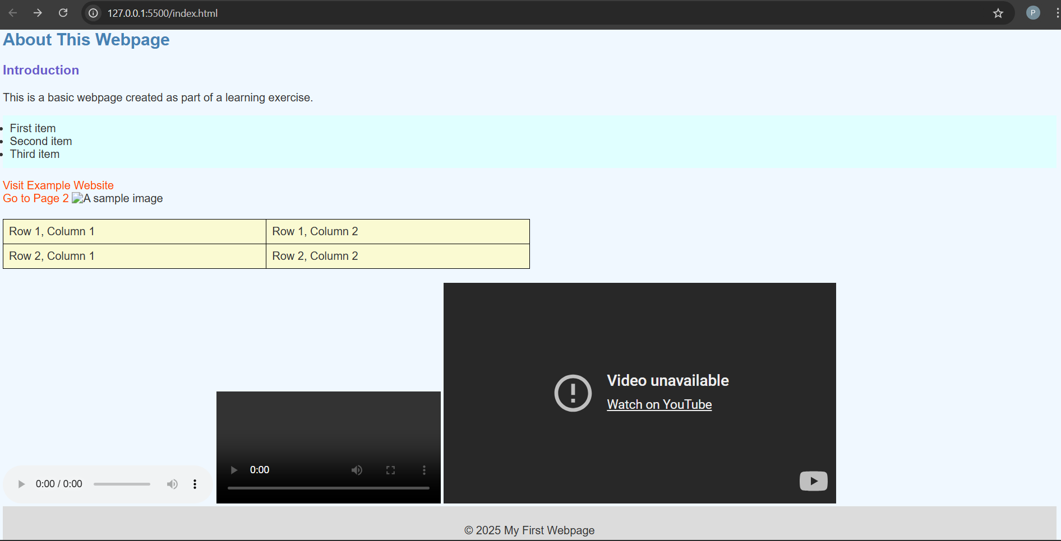

**Task 2 : Wikipedia -India (Inspect Page)**

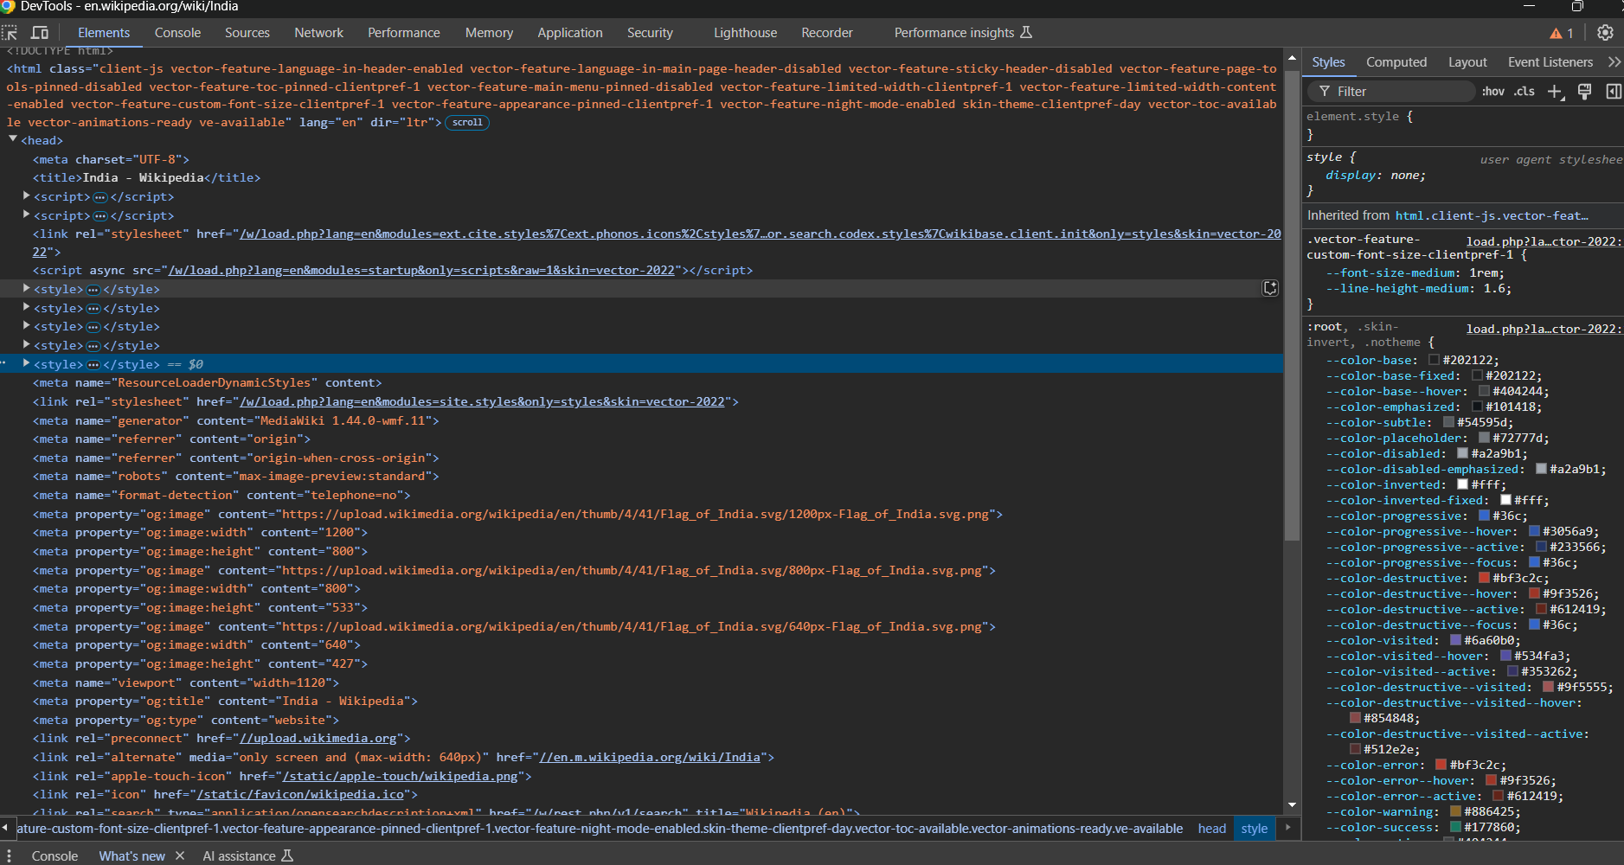

**1. Metadata:**

When looking at the source code, I found the <meta> tags, which contain information about the webpage:

**Charset**: The page uses <meta charset="UTF-8">, which makes sure that the text displays correctly, especially for different languages like Hindi.

**Viewport**: helps the page adjust its layout based on the device (like phones or tablets).

**Description**: tells search engines what the page is about, which helps the page appear in search results.

**2. Headings and Semantic Elements:**

The page has headings and other elements that structure the content:

**Headings**

**Semantic Elements**: There are other elements that help organize the page:

* + <header>: Contains the navigation bar (menu).
  + <footer>: At the bottom of the page, with links and copyright info.
  + <nav>: Used for the navigation links to different parts of the site.
  + <section>: Helps group related content together.

These headings and elements make the page more readable and easy to navigate for both users and search engines.

**3. Multimedia:**

**Images**: There are pictures, such as the Wikipedia logo, which are displayed using the <img> tag.

**Embedded Content**: I saw that the page uses <iframe> to embed content, like YouTube videos or interactive maps, to make the page more engaging.

Multimedia makes the page visually appealing and adds more interactive content for users.

**4. Security-Relevant Tags:**

The Wikipedia India page has some tags that help keep the site safe:

**Content Security Policy (CSP)**: There’s a tag that says which resources (like scripts and images) are allowed to load on the page.

**Sandboxed Iframes**: Iframes, which embed external content, use a sandbox attribute.

These security measures help protect the site from malicious attacks like Cross-Site Scripting (XSS) and keep the page safe for users.

**Task 3: Inspect the Source Code of My Webpage**

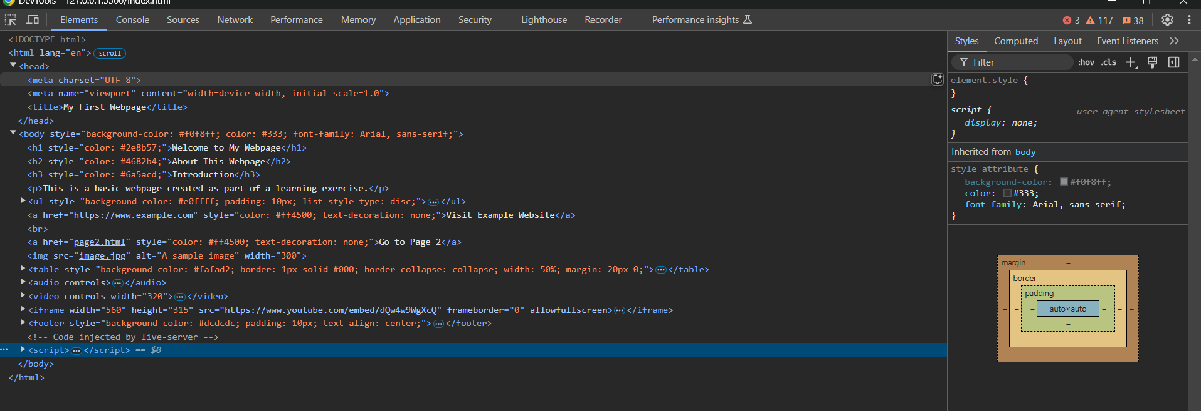

**Website Chosen:** The webpage I created in Task 1.

**HTML Structure:**

1. **Doctype Declaration (<!DOCTYPE html>):**

This tells the browser to render the page as HTML5, ensuring proper display.

1. **HTML Tag (<html>):**

It uses lang="en", indicating the content is in English, which helps with accessibility and search engines.

1. **Head Section (<head>):**

**Meta Tags:** <meta charset="UTF-8"> supports all characters, and <meta name="viewport" content="width=device-width, initial-scale=1.0"> makes the page mobile-responsive.

**Title Tag:** The title "My First Webpage" appears on the browser tab.

1. **Body Section (<body>):** The body has inline CSS for background color, font, and text color. The page uses headings (<h1>, <h2>, <h3>) with different colors to organize the content.

**Lists and Links:** The unordered list is styled with a background color, and links are styled in orange with no underlines.

**Multimedia Elements:** Includes an image, a table with rows and columns, an audio player, a video player, and an embedded YouTube video.

**Footer:** The footer includes copyright information and is styled with a background color.

**CSS Usage:**

**Inline CSS:** The styles are written directly within the HTML tags using the style attribute, which makes the page simple but can be hard to manage in larger projects.

**Colors and Readability:** The colors used (e.g., green for headings) help in making the content visually appealing and easy to read.

**Suggestions for Improvement:**

1. **CSS Organization:** It's better to move the styles to a separate CSS file for better organization and easier management as the project grows.
2. **Responsive Design:** The page is responsive, but adding more CSS rules (like media queries) would help adjust elements better on mobile screens.

**Task 4 : Apply Styles Using CSS**

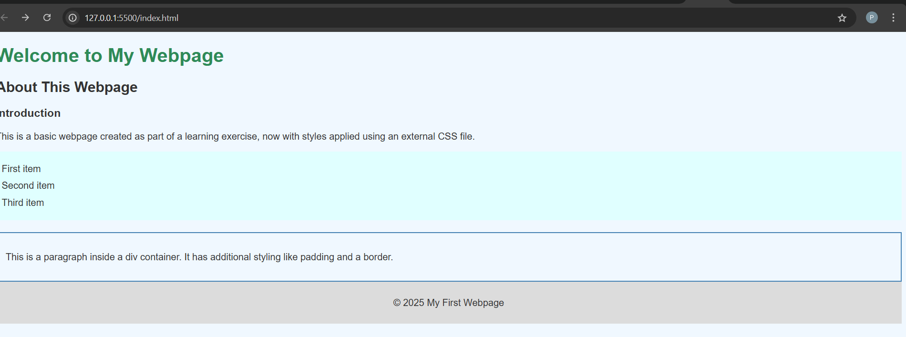

Index.html

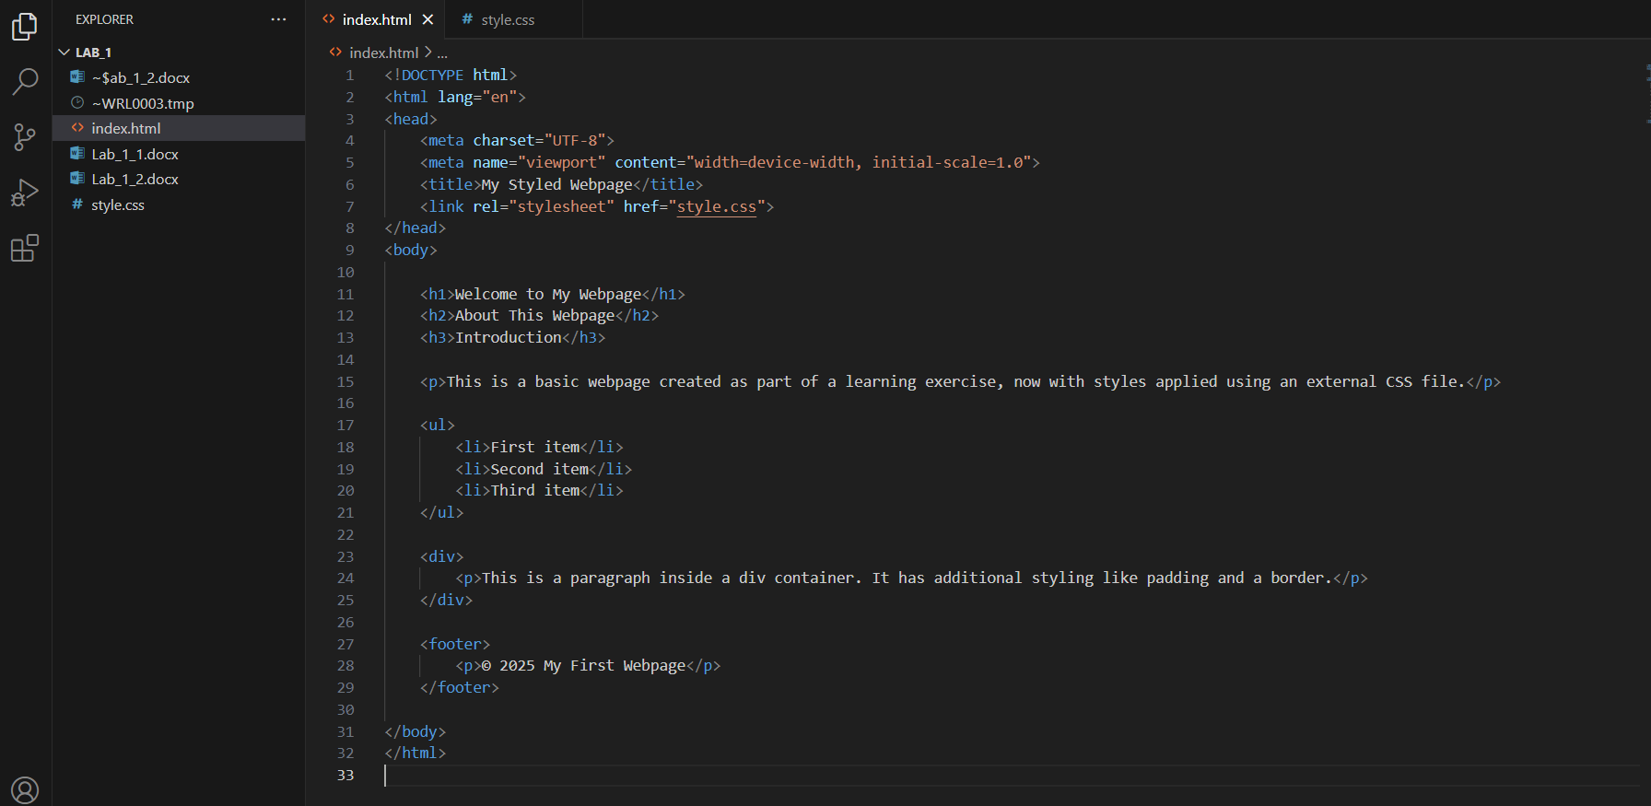

Style.css