SQL Assignment -12

Using the operators IN,ANY, and ALL.

Q1) Write a query that selects all customers whose rating are equal to or greater than any of ‘Serres’.

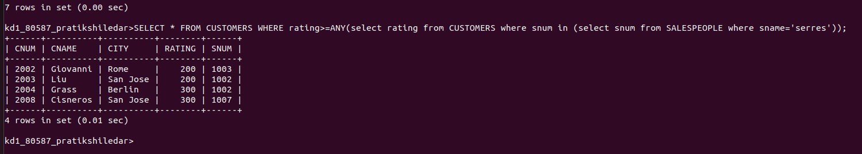

Q2) Write a query using any or all that will find all salespeople who have no customers located in their city.

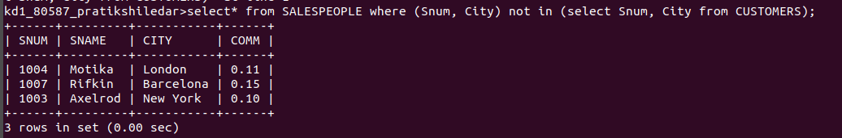

Q3) Write a query that selects all orders for amount greater than any for the customers in London.

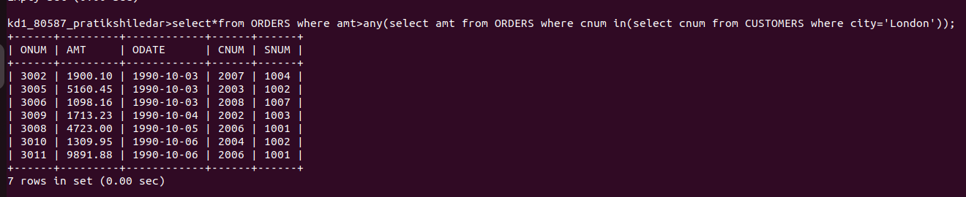

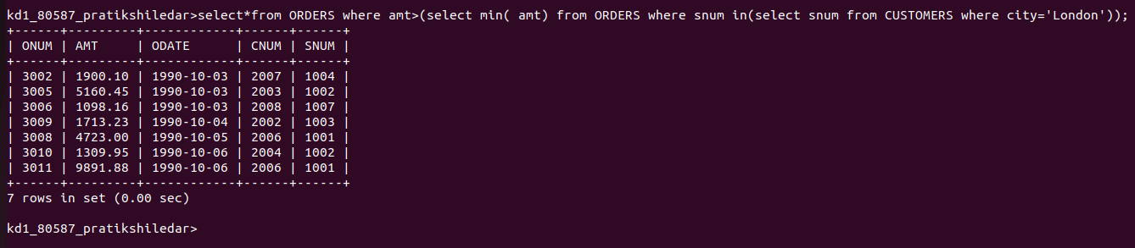
Q4) Write the above query using min or max.

