SQL Assignment-11

Subqueries

Q1) Write a query that uses a subquery to obtain all orders for the customer named Cisneros. Assume you do not know his customer number(cnum)

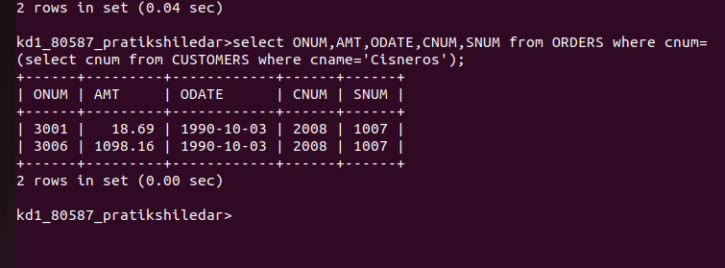
Q2) Write a query that produces the names annd rating of all customers who have above -average orders.

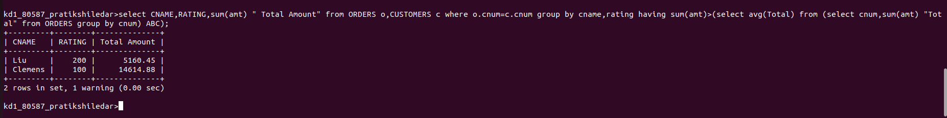

Q3) Write a query that selects the total amount in orders for each salesperson for whom this total is greater than the amount of the largest order in the table.

