SQL_AssignmentNo-7

1. Write a query that counts all orders for October 3.

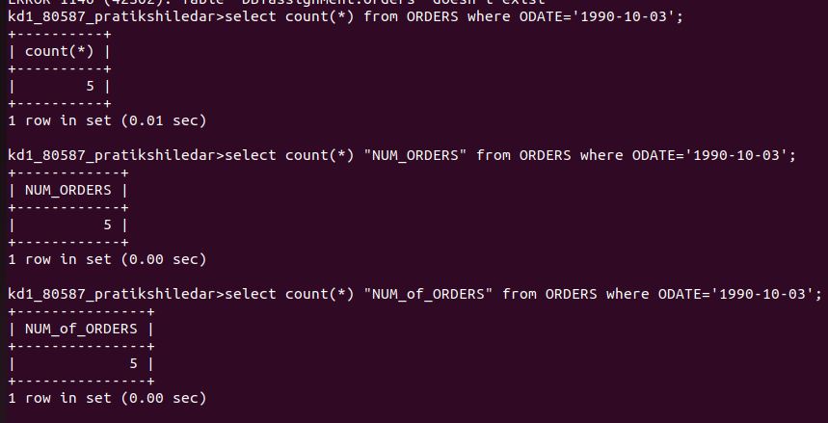

2. Write a query that counts the number of different non-NULL city values in the Customers table.

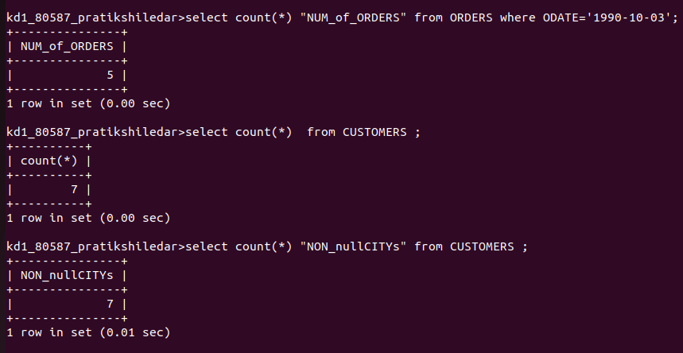

3. Write a query that selects each customer’s smallest order.

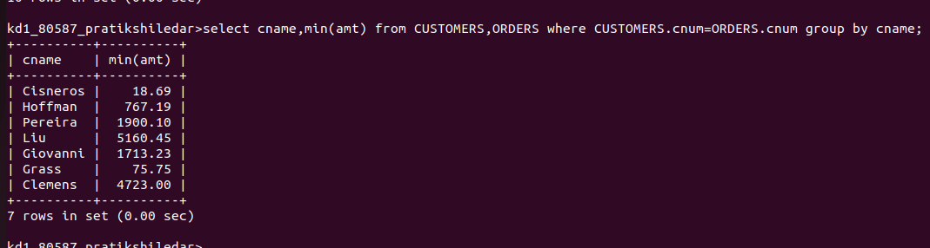

4. Write a query that selects the first customer,in alphabetical order, whose name begins with G.

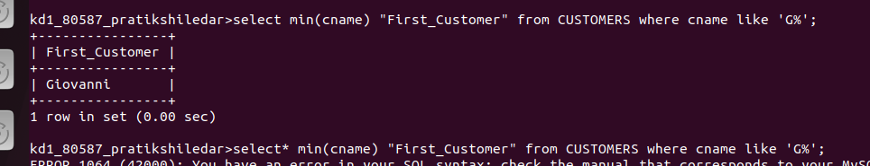

5. Write a query that selects the highest rating in each city.

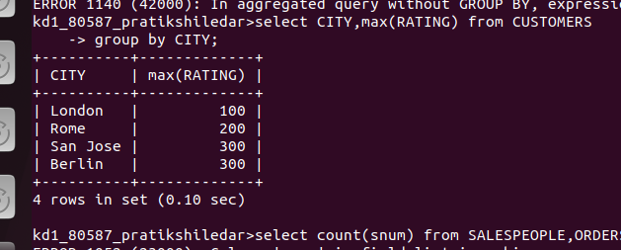
6. Write a query that counts the number of salespeople registering orders for each day. (If a salesperson has more than one order on a givingday, he or she should be counted only once.)

