SQL ASSIGNMENT NO-6

1) Write two different queries that would produce all orders taken on October 3rd or 4th , 1990.

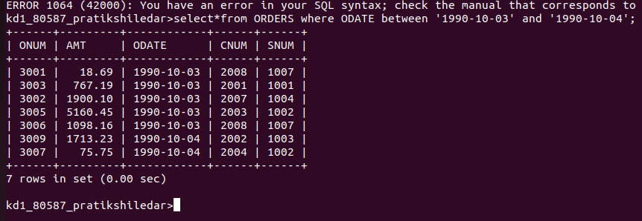

OR

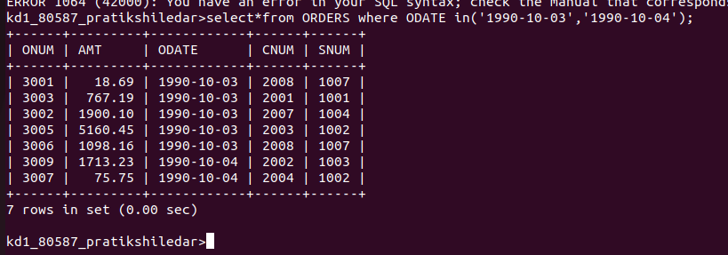

2) Write a query that selects all of the customers serviced by Peel or Motika.

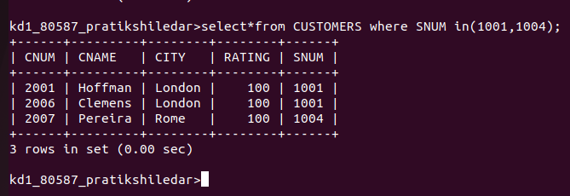

3) Write a query that will produce all the customers whose names begin with a letter from ‘A’ to ‘G’.

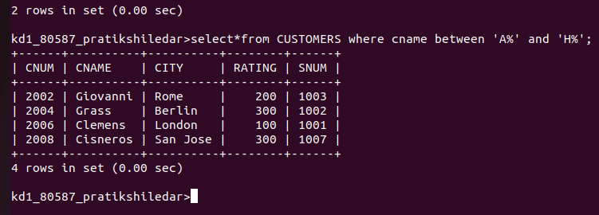

4) Write a query that selects all the customers whose names begin with the letter from ‘C’

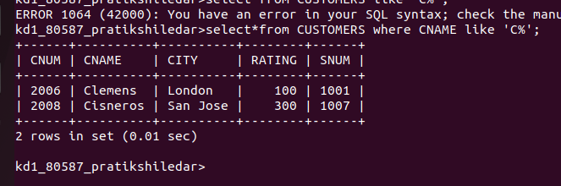

5) Write query that selects all orders except those with zeroes or nulls in the Amt field.

