1)Install MongoDB database server
Answer:
$ sudo apt-get install gnupg curl
$ curl -fsSL https://pgp.mongodb.com/server-7.0.asc | \sudo gpg -o /usr/share/keyrings/mongodb-server-7.0.gpg \--dearmor
------------------------------------------------------------------------------------------------------------------------
2) Create a directory/folder to store MongoDB datafiles
Answer:
$ echo "deb [ arch=amd64,arm64 signed-by=/usr/share/keyrings/mongodb-server-7.0.gpg ] https://repo.mongodb.org/apt/ubuntu jammy/mongodb-org/7.0 multiverse" | sudo tee /etc/apt/sources.list.d/mongodb-org-7.0.list
------------------------------------------------------------------------------------------------------------------------
3) Set necessary path environment variable
Answer:
title:'MySQL programming', authors:['Jack','Jill'], likes:200Answer:
$ echo "deb [ arch=amd64,arm64 signed-by=/usr/share/keyrings/mongodb-server-7.0.gpg ] https://repo.mongodb.org/apt/ubuntu jammy/mongodb-org/7.0 multiverse" | sudo tee /etc/apt/sources.list.d/mongodb-org-7.0.list
------------------------------------------------------------------------------------------------------------------------
4) Startup MongoDB database
Answer:
$ sudo systemctl start mongod
------------------------------------------------------------------------------------------------------------------------
5) Connect to MongoDB database through the MongoDB shell command line interface
Answer:
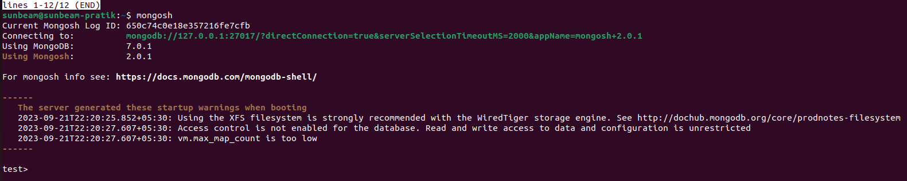

------------------------------------------------------------------------------------------------------------------------

6) View list of available databases
Answer:
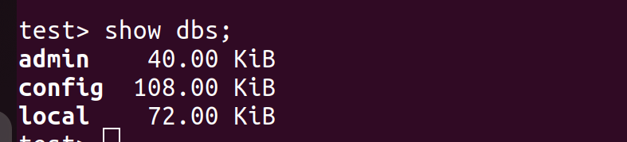
------------------------------------------------------------------------------------------------------------------------

7) Create a new database named CDAC and connect to it
Answer:
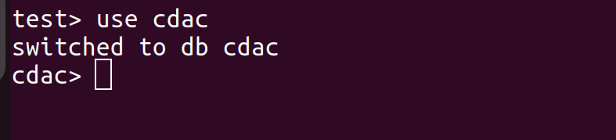
------------------------------------------------------------------------------------------------------------------------
8) View list of available collections in CDAC database
Answer:

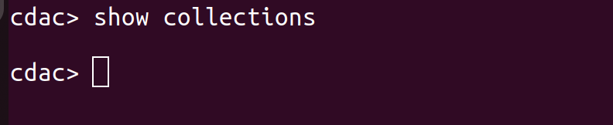
------------------------------------------------------------------------------------------------------------------------
9) Create a new collection by the name of LIBRARY
Answer :
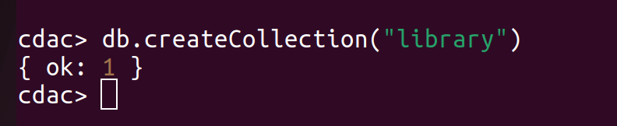
------------------------------------------------------------------------------------------------------------------------
10) Insert the following document in the LIBRARY collection:-
title:'MongoDB programming', author:'Sameer', likes:100
Answer:
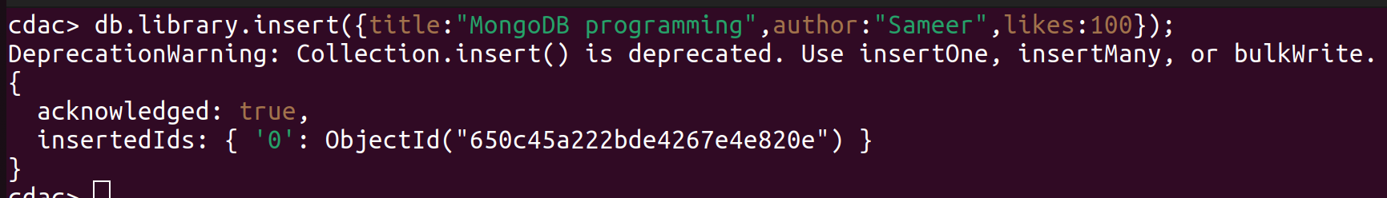
-----------------------------------------------------------------------------------------------------------------------
11) View the recently inserted document and note the _id field
Answer:

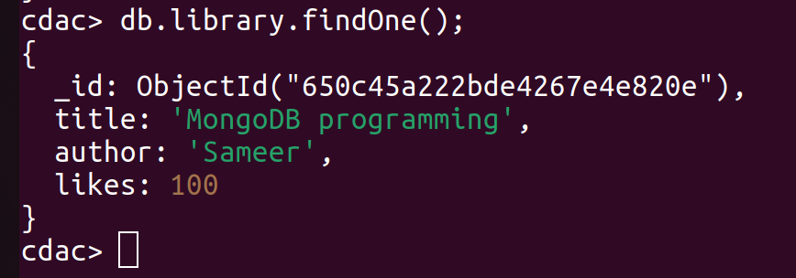
------------------------------------------------------------------------------------------------------------------------
12) Insert another document in the LIBRARY collection as follows:-
Answer:
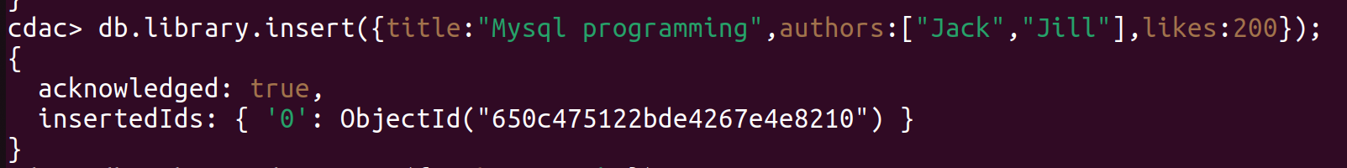
------------------------------------------------------------------------------------------------------------------------
13) View the inserted documents
Answer:
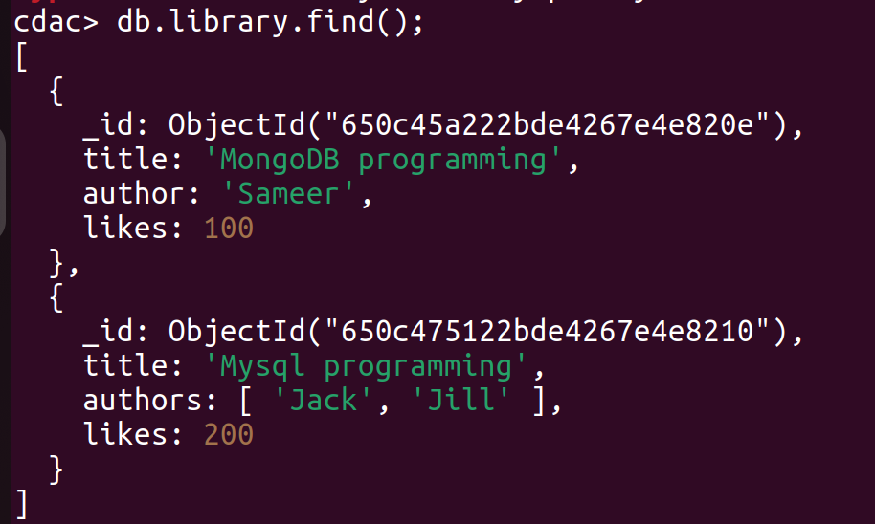
------------------------------------------------------------------------------------------------------------------------
14) View only the first inserted document
Answer:

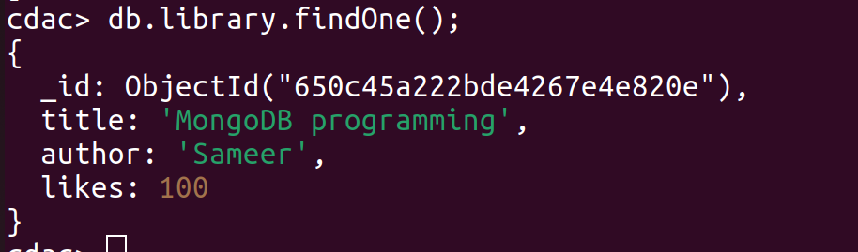
------------------------------------------------------------------------------------------------------------------------

15) View the documents using the pretty() method
Answer:

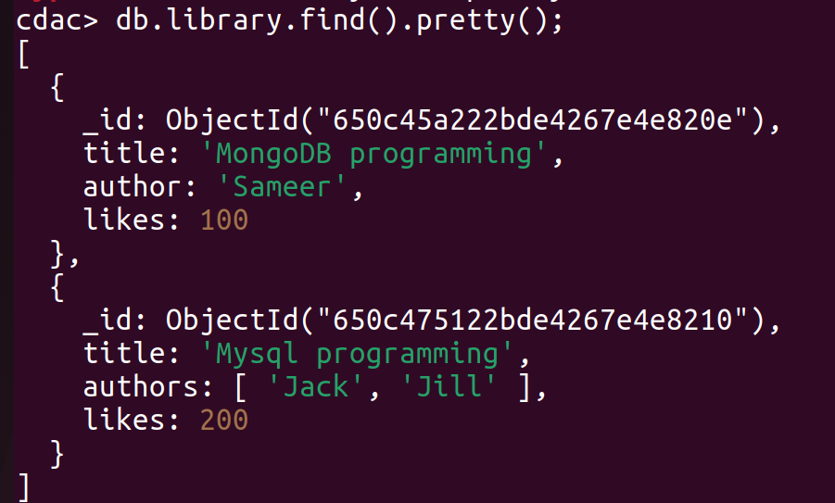
------------------------------------------------------------------------------------------------------------------------
16) Update the document where author name = Sameer and change it to Sameer Dehadrai
Answer:
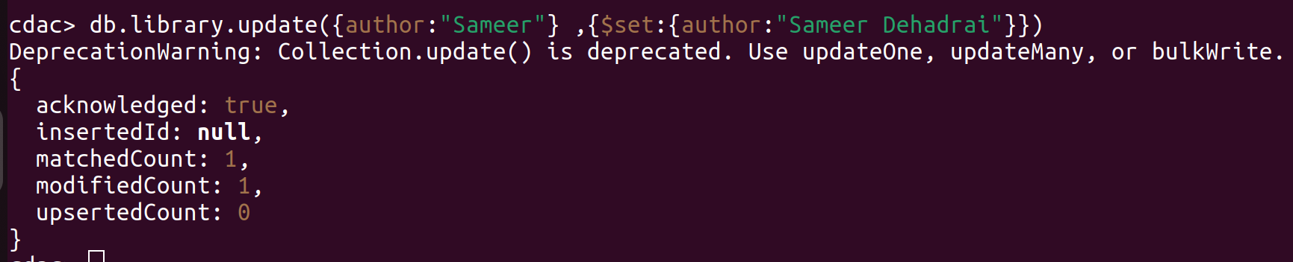
------------------------------------------------------------------------------------------------------------------------

17) Delete all documents that have 100 likes
Answer:
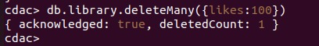

------------------------------------------------------------------------------------------------------------------------
18) Drop the LIBRARY collection
Answer :
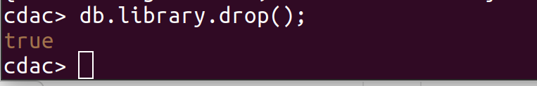
------------------------------------------------------------------------------------------------------------------------
19) Drop the CDAC database
Answer:
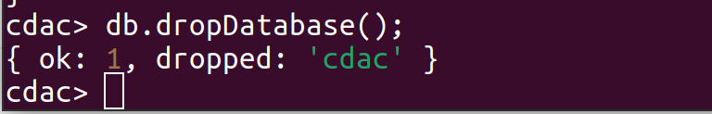
------------------------------------------------------------------------------------------------------------------------
20) Exit from MongoDB shell
Answer:
------------------------------------------------------------------------------------------------------------------------
21) Stop MongoDB server
Answer:

------------------------------------------------------------------------------------------------------------------------

