SQL ASSIGNMENT – 4

Q1. Write a select command that produces the order number, amount and date for all rows in the Orders table.
Ans:

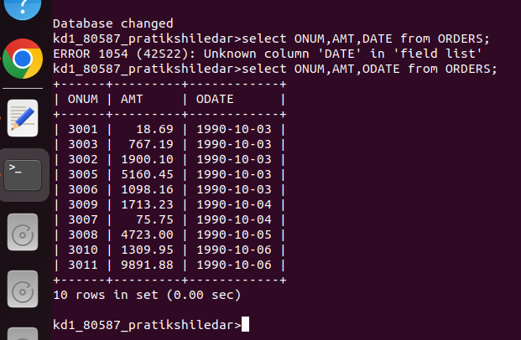

Q2. Write a query that produces all rows from the Customers table for which the salesperson’s number is 1001.
Ans:

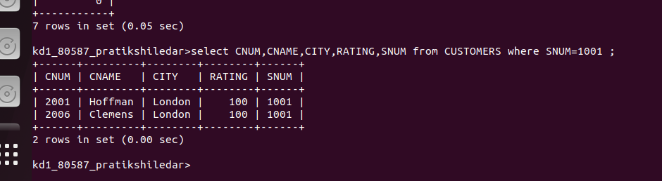

Q3. Write a query that displays the Salespeople table with the columns in the following order: city, sname, snum, comm.
Ans:

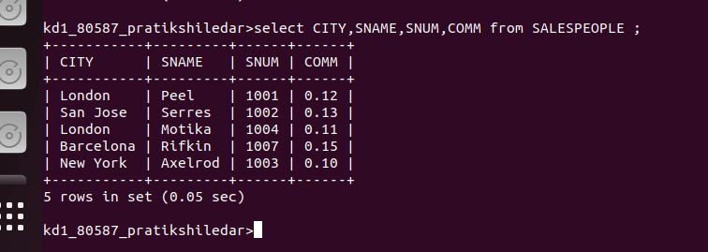

Q4. Write a select command that produces the rating followed by the name of each customer in San Jose.
Ans:

