1.) Write query that will give all orders for more than 1000 ?

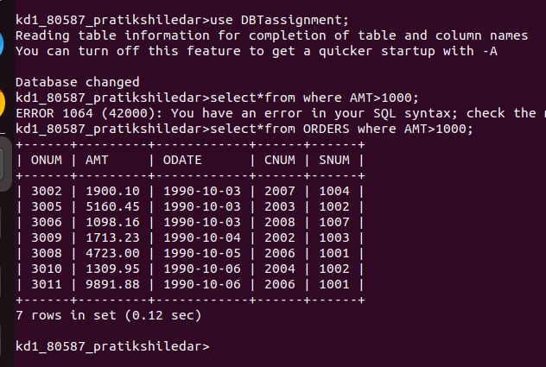

2.)Write a query that will give u thae name and cities of all salespeople in london with commision above 0.10?

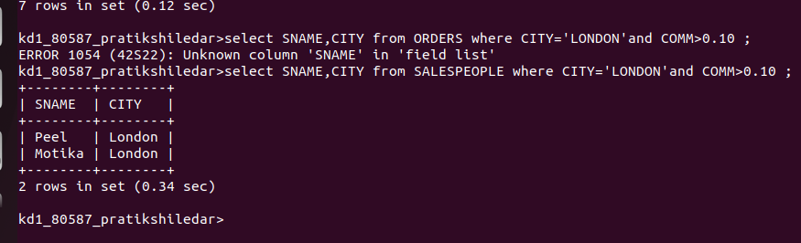

3.)write query on customer table whose output will exclude all customer with a rating <=100,unless they are loacted in rome?

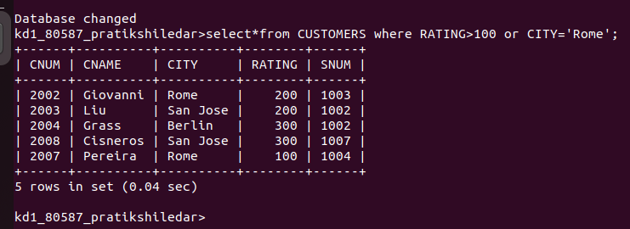

4.)what will be the output rom the following query :
select * from orders
where(amt<1000 or not (odate = '1990-10-03' and cnum>2003));

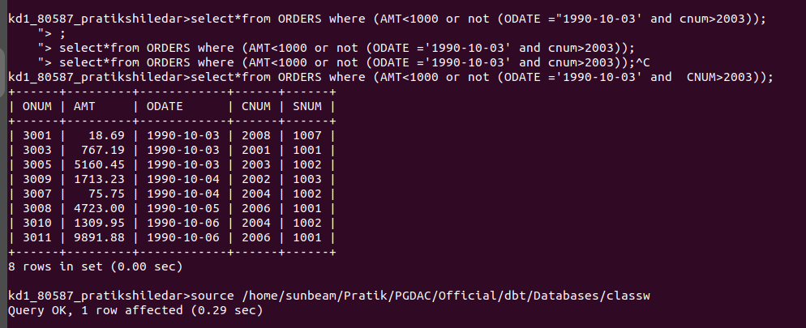

5.)what will be the output from the following query :
select * from orders
where not ((odate = '1990-10-03' or sum>1006) and amt >=1500));

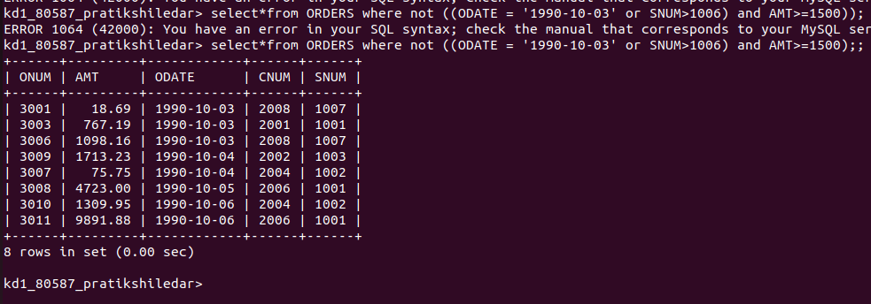

6.) what will be a simpler way to write this query/
select snum,sname,city,comm from salespeopple where (comm.0.12 or comm,0.14)?
