1. Differentiate in between free software, Open source software and proprietary software with respect to its properties.

|  |  |
| --- | --- |
| Open Source Software | Proprietary Software |
| Open-source software is computer software whose source code is available openly on the internet and programmers can modify it to add new features and capabilities without any cost. | Proprietary software is computer software where the source codes are publicly not available only the company which has created can modify it. |
| Here the software is developed and tested through open collaboration. | Here the software is developed and tested by the individual or organization by which it is owned not by the public |
| In open-source software the source code is public. | In proprietary software, the source code is protected. |
| Open-source software can be installed on any computer. | Proprietary software can not be installed into any computer without a valid license. |
| Open-source software is managed by an open-source community of developers. | Proprietary software is managed by a closed team of individuals or groups that developed it. |
| It is more flexible and provides more freedom which encourages innovation. | It is not much flexible so there is a very limited innovation scope with the restrictions. |
| Users can get open software free of charge. | Users must have to pay to get the proprietary software. |
| In open-source software faster fixes of bugs and better security are availed due to the community. | In proprietary software, the vendor is completely responsible for fixing malfunctions. |
| Examples are Android, Linux, Firefox, Open Office, GIMP, VLC Media player, etc. | Examples are Windows, macOS, Internet Explorer, Google Earth, Microsoft Office, Adobe Flash Player, Skype, etc. |

2. Enlist some examples along with its purpose and properties (at least 10) of FOSS and proprietary software with respect to database.

1 PostgreSQL

PostgreSQL is an object-relational database management system, founded on July 8, 1996. Developed by the PostgreSQL Global Development Group, it is written in C and works in most UNIX-like operating systems and Windows.

Features

a. PostgreSQL works with every significant language and middleware.

b. It bolsters simultaneous control.

c. Its server-side programming usefulness is extremely full-grown.

d. It has support for JSON licences.

2 MariaDB

MariaDB is a network created relational database management software system, written in C, C++, Bash and Perl. The stable version 10.3.12 of this free and open source database management software has the date January 7, 2019. MariaDB Corporation AB and MariaDB Foundation are the developers of this database.

Features

a. MariaDB is comparable to MySQL, with some additional features. It can be viewed as an evolved variant of MySQL.

b. Programming in MariaDB is covered by BSD, GPL, and LGPL licences.

c. The framework uses a rearranged and standard questioning language.

d. It supports an assortment of working frameworks and programming dialects.

e. It offers special help for PHP.

3 CockroachDB

CockroachDB is a distributed SQL (newSQL) database built on a transactional and strongly-consistent key-value store. It’s heavily inspired by Google’s Spanner and has many similarities with it.

Features

a. Distributed or replicated OLTP

b. Multi-data centre deployments

c. Multi-region deployments

d. Cloud migrations

e. Cloud-native infrastructure initiatives

4 Neo4j

Neo4j is a graph database management system. Its stable version 3.5.1 was released on December 20, 2018.

Features

a. It is ACID (atomicity, consistency, isolation, and durability) compliant.

b. It encourages versatility.

c. Replicates information with quality and security.

d. It works with Web applications for recovering chart information.

e. It bolsters enquiry information sent out to JSON and XLS design.

5 CouchDB

CouchDB has been developed by the Apache Software Foundation, and is written in Erlang language. The stable version 2.3.0 was released on December 6, 2018.

Features

a. It is ACID compliant.

b. Has a distributed design with replication.

c. CouchDB gives accessibility such as parcel resilience, ensuring competency.

d. The information in the CouchDB framework is stored as ‘records’.

6 RethinkDB

RethinkDB is an open source database that, in contrast to customary database frameworks, stores data in the JSON (JavaScript Object Notation) group. It’s viewed as a NoSQL (Not only SQL) database, just like MongoDB, Cassandra, and CouchDB.

Features

a. No mapping or table structure is required for putting away the data.

b. Distributed engineering helps it to scale (in groups).

c. It has:

Consistency (similar information can be viewed by all the customers of the framework)

Availability

Partition tolerance

7 Redis

Redis is an open source (BSD authorised), in-memory information structure store, used as a database, reserve and message dealer. It enhances information structures — for example, strings, hashes, records, sets, arranged sets with extend enquiries, bitmaps, hyperlogs, and geospatial files.

Features

a. In-memory data store

b. Flexible data structures

c. Simplicity and ease-of-use

d. Replication and persistence

e. High availability and scalability

8 SQLite

SQLite is a C programming library. The word ‘lite’ in the name indicates that the organisation, arrangement, and basic source of the database is lightweight. Created by D. Richard Hipp on August 17, 2000, the stable version of SQLite 3.26.0 was released on December 1, 2018.

Features

a. SQLite programming enhances cross-stage document design.

b. It needs less programming. The whole library is under 500 KiB in size.

c. It has a static composing group, which is usable in most SQL database motors.

d. SQLite utilises variable-length records.

e. The SQL explanations are compiled into virtual machine code.

9 Cassandra

Cassandra comes from the stable of the Apache Software Foundation, and is a free and open source DBMS written in Java. Authorised under Apache License 2.0, its stable version 3.11.3 was released on August 1, 2018.

Features

a. Apache Cassandra is a NoSQL database.

b. It supports replication and multi-server farm replication.

c. It is adaptable and reliable.

d. A distributed database, its conveyance plan relies on Amazon DynamoDB and information model on Google Cloud Bigtable.

e. Cassandra can run on sensitive equipment and perform quick writes to store a lot of information.

10 Timescale

New technologies require new sorts of databases. One of the best open source databases for the Internet of Things is Timescale.

Features

a. Hypertable abstraction layer

b. Automatic partitioning

c. Optimised time based constraint exclusion

d. Works across time-series and relational tables

e. Built-in flexible time bucketing

3. Enlist some examples of free open source exam software for online assessment

* [TCExam](https://www.techjockey.com/blog/7-free-open-source-exam-software#tcexam)
* [VirtualX](https://www.techjockey.com/blog/7-free-open-source-exam-software#virtualx)
* [Moodle](https://www.techjockey.com/blog/7-free-open-source-exam-software#moodle)
* [TAO](https://www.techjockey.com/blog/7-free-open-source-exam-software#tao)
* [Kaldin](https://www.techjockey.com/blog/7-free-open-source-exam-software#Kaldin)
* [Papershala](https://www.techjockey.com/blog/7-free-open-source-exam-software#papershala)
* [Edbase](https://www.techjockey.com/blog/7-free-open-source-exam-software#edbase)
* [Mettl](https://www.techjockey.com/blog/7-free-open-source-exam-software#mettl)
* [FlexiQuiz](https://www.techjockey.com/blog/7-free-open-source-exam-software#flexiquiz)
* [Eklavvya](https://www.techjockey.com/blog/7-free-open-source-exam-software#eklavya)
* [Think Exam](https://www.techjockey.com/blog/7-free-open-source-exam-software#think_exam)

4. Demonstrate any one exam software which is open source and freely available

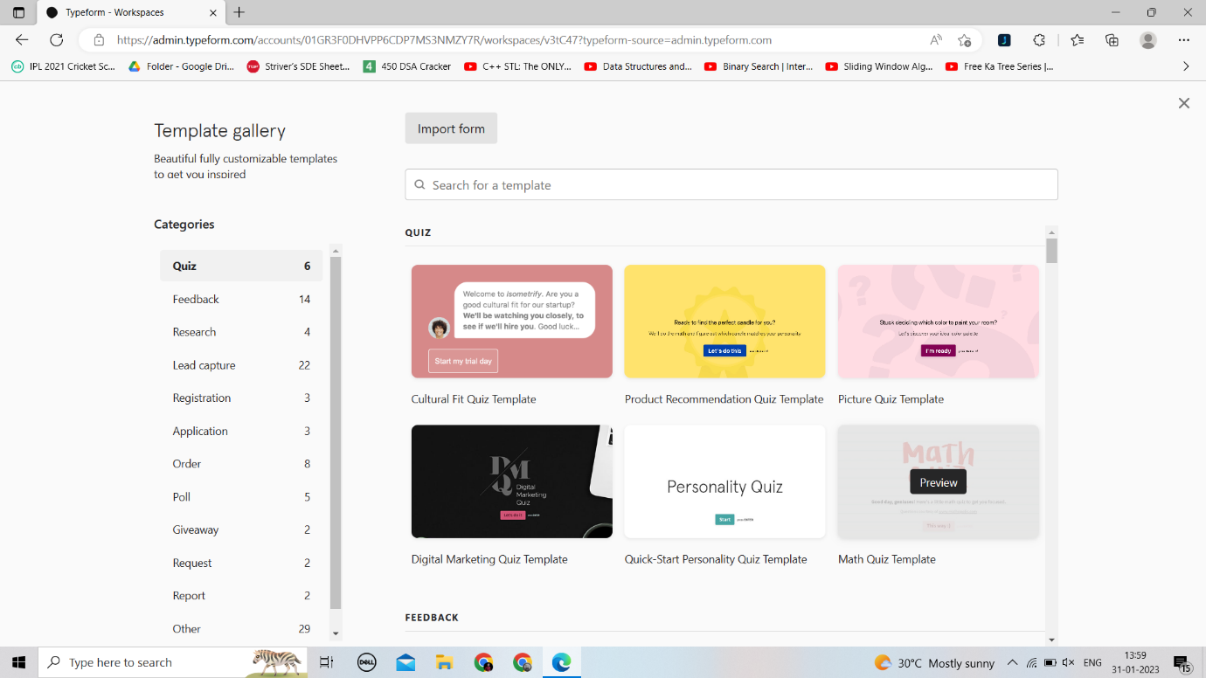

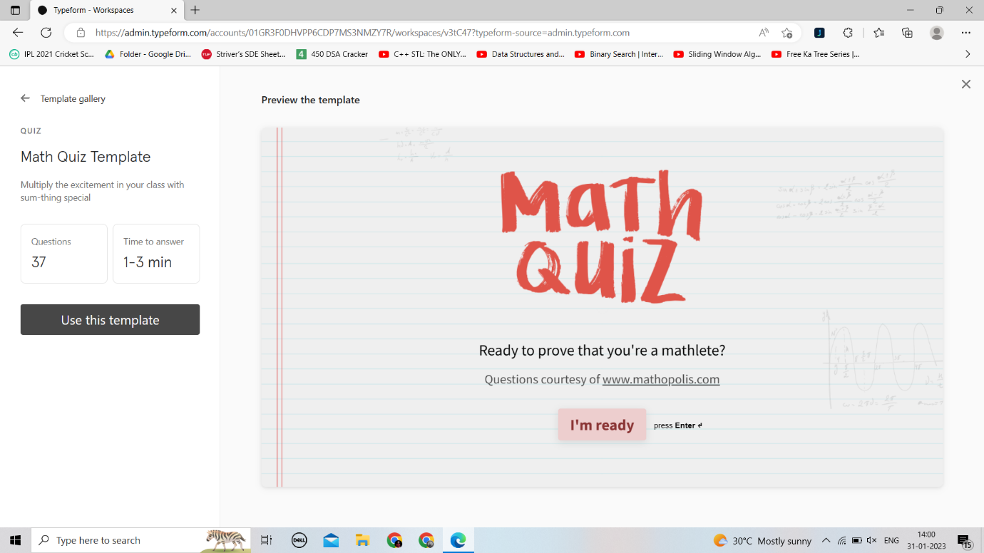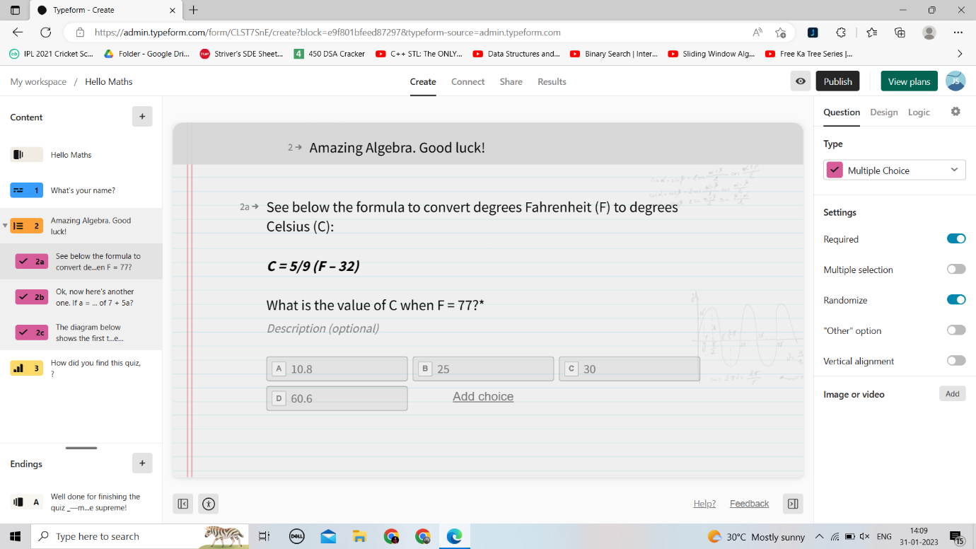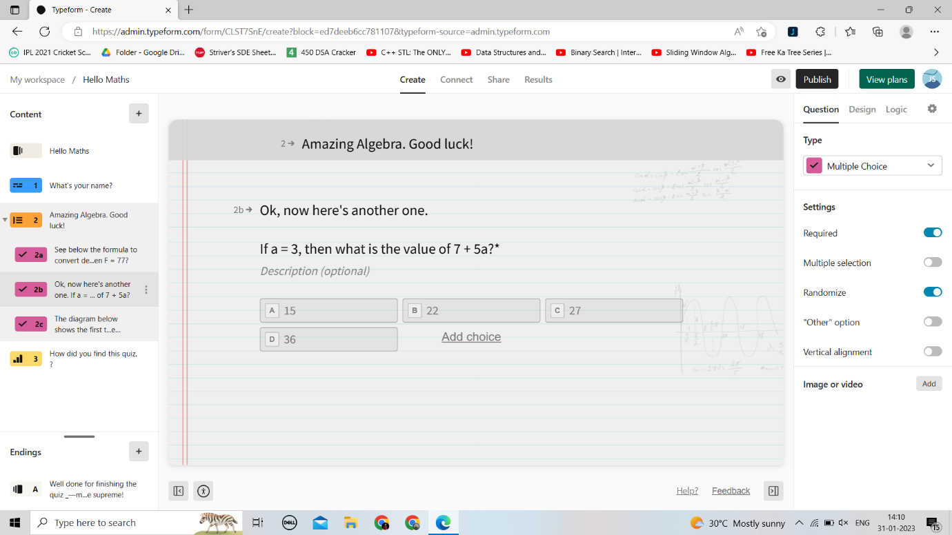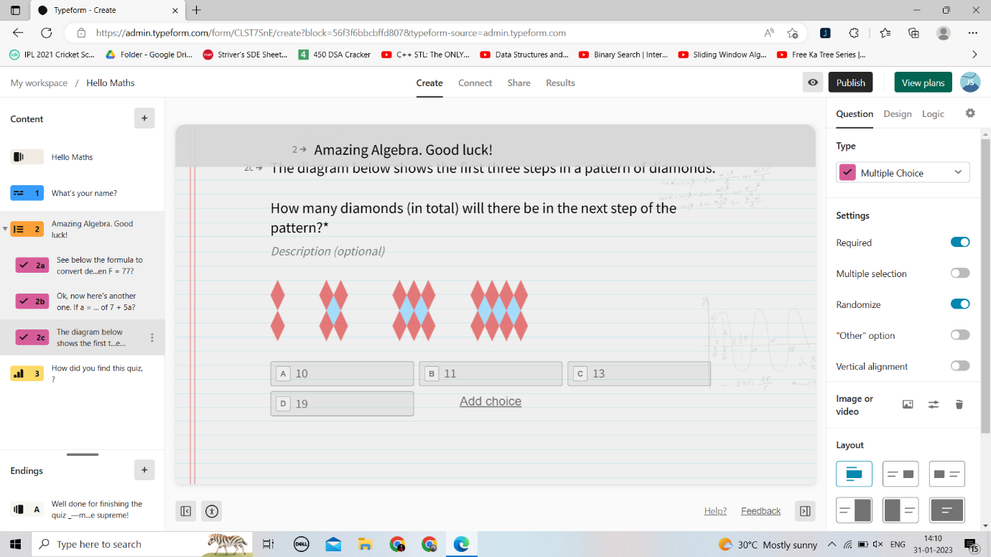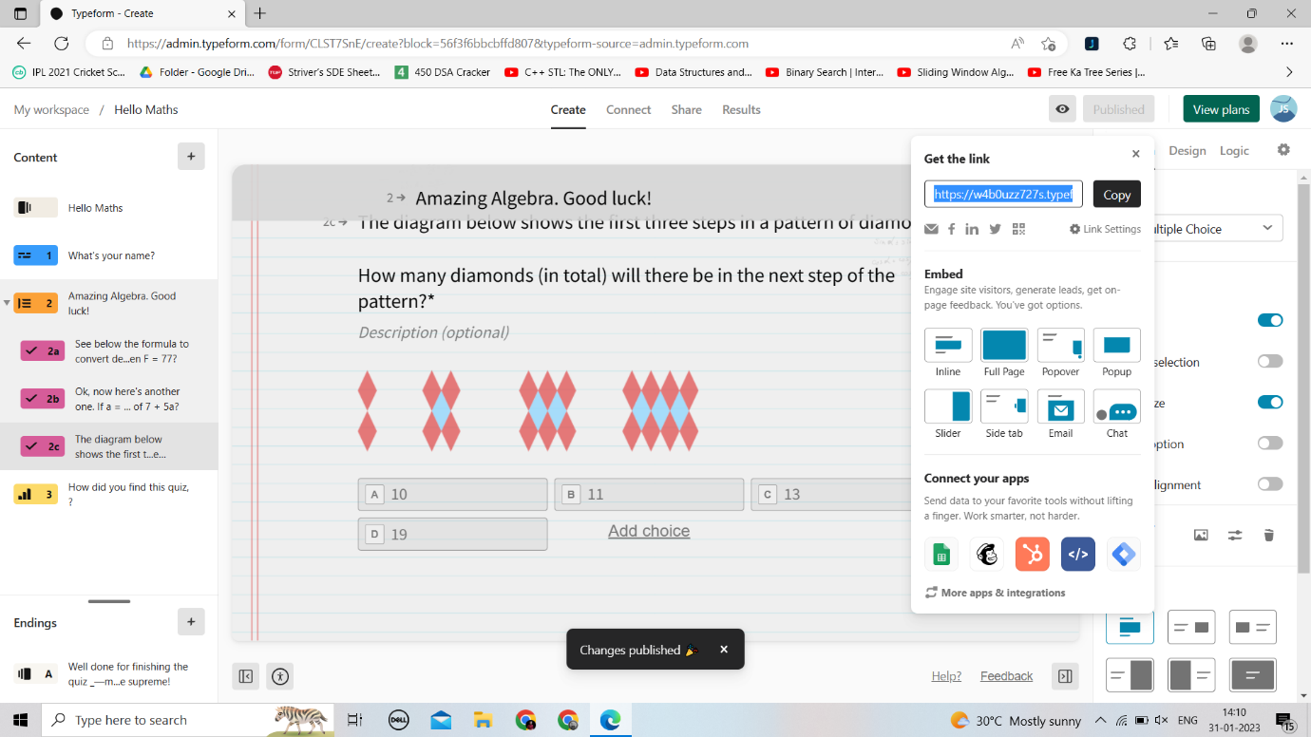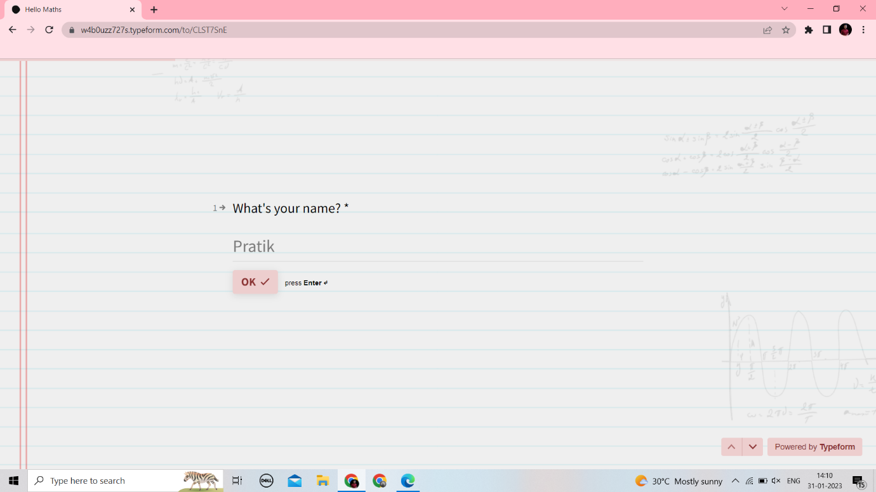

5. Demonstrate FOSS software related to database.

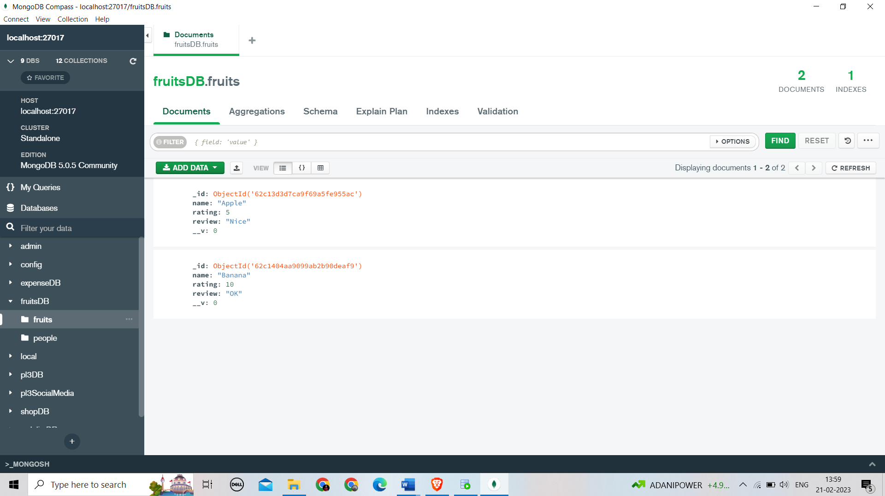

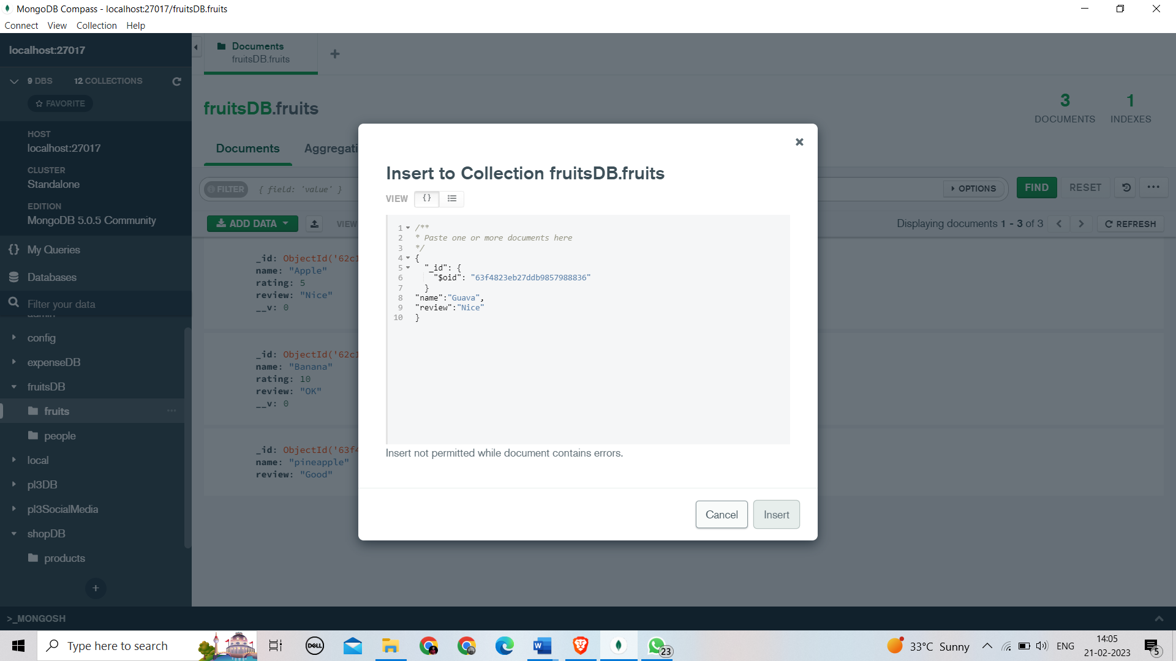

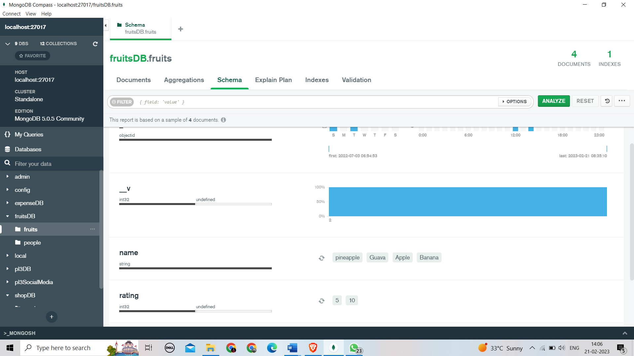

6. How does the Exam software work?

Popularly used by recruiters and educational institutions, exam software is used for setting up online exams. The best online examination software helps with the following procedures:

* **Students’ Registration**

Online exam software helps with the registration process of students and generates unique IDs for them.

* **Test Paper Creation**

You can create a subjective, objective, multiple-choice, and other types of questions online and ensure zero spam.

* **Take Tests Anytime, Anywhere**

Students can take tests from anywhere with a stable internet connection and a system. Similarly, teachers can invigilate directly through the system.

* **Automated Evaluation**

Teachers don’t need to evaluate answers manually, as the exam software helps analyse students’ performance digitally.

* **Track Students’ Progress**

YouTube broadcast software enables users to list their live streams as videos on their channels. This way the live stream can be seen even after it ended.

* **Data analysis**

The performance reports include detailed info about the strengths and weaknesses of every student. Accordingly, teachers can make the improvement plan.