**A**

**PROJECT REPORT ON**

**“FINANCIAL ANALYSIS OF TRUPTI HERBAL PRIVATE LIMITED”**

**SUBMITTED BY**

**MR. PRANAV RAJENDRA VALVI (STREAM- FINANCE)**

**UNDER THE GUIDANCE OF PROF. RASIKA NAIK**

**SUBMITTED TO**

**SAVITRIBAI PHULE PUNE UNIVERSITY**

**IN PARTIAL FULFILLMENT OF THE REQUIREMENT FOR THE AWARD OF DEGREE OF MASTERS OF BUSINESS ADMINISTRATION (MBA)**

**THROUGH**



**SINHGAD COLLEGE OF ENGINEERING,**

**DEPARTMENT OF MANAGEMENT STUDIES, VADGAON(BK), PUNE**

**(2022 – 2024)**

**DECLARATION**

I **PRANAV RAJENDRA VALVI**, the undersigned, hereby declare that the project report entitled **“Financial Analysis of Trupti Herbal Private Limited”** written and submitted by me to the Savitribai Phule Pune University, Pune in partial fulfilment of the requirement for the award of degree of MBA under the guidance of “**PROF. RASIKA NAIK”** is my original work except the topics on organizational profile and the conclusion drawn there in are based on the material collected by myself.

Place: Pune

Date: MR. PRANAV RAJENDRA VALVI

**ACKNOWLEDGEMENT**

I take this opportunity to express my profound gratitude and deep regards to my guide **PROF. RASIKA NAIK** for his exemplary guidance, monitoring, and constant encouragement throughout the course of this project. The blessing, help and guidance given by him time to time shall carry me a long way in the journey of life on which I am about to embark.

I also take this opportunity to express a deep sense of gratitude to **TRUPTI HERBAL AGRO & BIOTECHNOLOGY PVT LTD.** for their cordial support, valuable information and guidance which helped me in completing this project through various stages.

I wish to express a special thanks to all teaching and non-teaching staff members of Sinhgad College of Engineering, Department of Management Studies, Pune their continuous support. I would like to

acknowledge all my family members, relatives and friends for their help and encouragement.

**GUIDE’S CERTIFICATE**

**COMPANY CERTIFICATE**

**COMPANY FEEDBACK FORM**

**EXECUTIVE SUMMARY**

Financial analysis is the process of evaluating businesses, projects, budgets and other finance-related entities to determine their performance and suitability. Typically, financial analysis is used to analyze whether an entity is stable, solvent, liquid or profitable enough to warrant a monetary investment. When looking at a specific company, a financial analyst conducts analysis by focusing on the income statement, balance sheet and cash flow statement. Financial analysis is used to evaluate economic trends, set financial policy, build long-term plans for business activity, and identify projects or companies for investment.

One of the most common ways to analyze financial data is to calculate ratios from the data to compare against those of other companies or against the company's own historical performance. For example, return on assets (ROA) is a common ratio used to determine how efficient a company is at using its assets and as a measure of profitability. This ratio could be calculated for several similar companies and compared as part of a larger analysis.

Financial analysis can be conducted in both corporate finance and investment finance settings. In corporate finance, the analysis is conducted internally, using such ratios as net present value (NPV) and internal rate of return (IRR) to find projects worth executing. A key area of corporate financial analysis involves extrapolating a company’s past performance, such as gross revenue or profit margin, into an estimate of the company’s future performance. This allows the business to forecast budgets and make decisions based on past trends, such as inventory levels.

I learn many things through this project. Because I think when we do something new that time get some extra efforts to make best things. I learn how to analyses the financial data in primary level. I collected some the data do the study on it.

**INDEX**

|  |  |  |
| --- | --- | --- |
| **Sr. No.** | **Contents** | **Page No.** |
| **1** | **Introduction** | **09** |
| 1.1 | Current Indian Scenarios | 10 |
| 1.2 | Current Global Scenarios | 12 |
| 1.3 | Theoretical Aspects | 14 |
| 1.4 | Key concept and definitions | 15 |
| 1.5 | Review of Literature | 16 |
| 1.6 | Outline of problem | 18 |
| **2** | **Profile Of Organization** | **19** |
| **3** | **Research Design and Methodology** | **22** |
| 3.1 | Introduction | 23 |
| 3.2 | Financial Statements: Standings and Consolidated | 24 |
| **4** | **Data Analysis and Interpretation** | **29** |
| 4.1 | Cost-Benefit Analysis | 30 |
| 4.2 | Financial Model | 31 |
| 4.3 | Cash Flow Analysis | 32 |
| 4.4 | Risk Analysis | 33 |
| 4.5 | Financial Statement Impact | 34 |
| **5** | **Findings And Conclusions** | **36** |
| 5.1 | Findings | 37 |
| 5.2 | Conclusion | 38 |
| 5.3 | Learning from the Project | 38 |
| 5.4 | Bibliography | 39 |
|  |  |  |
|  |  |  |
|  |  |  |

# CHAPTER 1 INTRODUCTION

## Current Indian Scenarios

Financial analysis refers to the detailed assessment and evaluation of a company's financial statements, performance metrics, and health indicators. It aims to gain an in-depth understanding of the overall financial position and operations of the business. Financial analysis employs techniques such as

1. Comparative ratio analysis.
2. Trend analysis.
3. Cash flow analysis.
4. Qualitative appraisal of management capability, competitive landscape and macroeconomic environment.

The key tools used in financial analysis include

1. Analyzing balance sheets, income statements and cash flow statements to understand assets, liabilities, equity, revenues, expenses, profitability and liquidity.
2. Calculating financial ratios to evaluate parameters like profit margins, solvency, efficiency and leverage.
3. Benchmarking against competitors and industry averages to gauge relative performance.
4. Studying changes in financials over time to identify improving or deteriorating trends, which aids forecasting and valuation.

In the current Indian economic context, financial analysis has assumed great significance given the complex set of conditions facing firms. India is projected to clock over 7% GDP growth in FY2023, indicating overall recovery after the pandemic induced slowdown. However, the economy faces headwinds like

* Elevated inflation
* Rising interest rates
* Weakening rupee
* Widening current account deficit

In this landscape, financial analysis helps companies closely track profitability, cash flows and liquidity positions as input costs rise due to high inflation and currency depreciation. Benchmarking against industry peers provides insights on operational effectiveness amidst a volatile environment. Assessing capital structure and funding options is imperative with increasing cost of capital.

For creditors and lenders, prudent evaluation of credit risks becomes critical as economic conditions could impact repayments. Detailed cash flow analysis provides data to ascertain risks. For investors, financial analysis identifies value-accretive investment avenues and evaluates risk-return trade-offs based on prevailing macroeconomic factors.

Overall, financial analysis is indispensable for

1. Corporate managers to identify areas of improvement, optimize resource allocation and take informed strategic decisions aligned with growth objectives.
2. Investors and shareholders to make smart investment decisions.
3. Lenders to gauge credit risks and support prudent lending.
4. Policymakers to formulate appropriate regulations that balance growth and stability.

By generating actionable insights, financial analysis drives informed decision making across public and private sector stakeholders.

## Current Global Scenarios

Financial analysis is the process of thoroughly evaluating a company's financial statements, performance metrics and health indicators to gain an in-depth understanding of its overall financial position, profitability, efficiency and stability. It utilizes tools such as

* Ratio analysis to compute and interpret critical financial ratios like profit margins, return on assets, receivables turnover, debt-equity ratio, interest coverage ratio etc. This evaluates parameters like profitability, liquidity, solvency, efficiency and leverage.
* Trend analysis to study the changes in key financial statement items and ratios over a period of time, usually 5 to 10 years. Identifying upward or downward trends aids in forecasting future performance.
* Cash flow analysis to assess historical cash flows from operations, investments and financing. It determines cash available for operations and debt repayments. Projecting future cash flows is also done.
* Benchmarking against industry peers and competitors to gauge relative performance and position. Metrics are compared to industry averages and best performers.
* Qualitative assessment of operational factors like management expertise, corporate governance standards, growth strategies, industry outlook, competitive forces and macroeconomic environment.

On the global front, major economies are facing myriad uncertainties in the post-pandemic era. Many developed economies like the US, UK and EU are experiencing stubbornly high inflation and rising interest rates as central banks tighten monetary policies. This increases input costs and financing costs for businesses. Equity and bond markets have seen sharp sell-offs and volatility as risk appetite diminishes with tightening liquidity and recessionary fears. Market uncertainties impact corporate valuations and funding.

Ongoing geopolitical conflicts like the Russia-Ukraine war and rising nationalism have led to supply uncertainties and soaring commodity prices especially energy, metals and food. This exacerbates input cost pressures. Currency volatility has increased due to shifts in global capital flows as central banks hike rates and due to widening current account imbalances. Currency fluctuations impact cross-border trade, borrowings and earnings.

Moderating growth in China and global trade slowdown has affected export oriented economies and dampened investment activity.

In this turbulent global environment, financial analysis is crucial for:

1. Corporate managers to closely monitor profit margins, cash flows and capital structure and modify strategies to maintain growth and profitability.
2. Investors to discern healthy investment opportunities with strong upside potential while evaluating downside risks appropriately.
3. Creditors and lenders to accurately gauge debt repayment capacities before lending and control credit exposures cautiously.
4. Policymakers and regulators to take informed decisions on interest rates, taxes, spending and other measures to stimulate growth within sustainable limits.

By providing data-driven insights on financial health and diagnosing strengths and vulnerabilities, financial analysis enables stakeholders to respond to global headwinds and volatility judiciously. Thus, it is an essential tool for driving decisions and actions.

## Theoretical Aspects

Financial analysis is grounded in accounting theories and principles that form the basis of preparation and presentation of financial statements. These include double entry bookkeeping, accrual principle, going concern assumption, matching principle, revenue recognition, consistency concept etc.

Several theoretical frameworks and models guide financial analysis such as Du Pont analysis which disaggregates return on equity (ROE) to assess drivers like profit margin, asset turnover and financial leverage. Activity based costing (ABC) provides greater accuracy in assigning overhead costs to products/services.

Concepts from economics like monetary policy, fiscal policy, consumer demand theories, production costs theories, business cycles etc. provide context for financial analysis. For instance, analyzing impact of interest rate changes.

Valuation theories are employed such as time value of money, discounted cash flow techniques, cost of capital models like Capital Asset Pricing Model (CAPM), arbitrage pricing theory to value firms and securities.

Optimal capital structure theories around balancing tax benefits of debt vs bankruptcy costs, agency costs and analyzing effects of information asymmetry between managers and investors.

## Key concept and definitions

1. **Financial statements**: Critical source documents like Balance sheet conveys assets, liabilities and equity on a certain date. Income statement reports revenues, expenses and profit/loss over a period. Cash flow statement shows inflows/outflows.
2. **Financial ratios**: Used to evaluate parameters like liquidity (current ratio, quick ratio), turnover (inventory turnover, receivables turnover), leverage (debt/equity ratio), profitability (gross margin, ROE), valuation (P/E, P/B ratio) etc.
3. **Budgeting**: Future financial planning via projected sales, production costs, other revenues and expenses. Supports goal setting.
4. **Forecasting**: Estimating future revenues, income and cash flows based on past performance, industry outlook, economic conditions etc. to determine financial feasibility of plans.
5. **Working capital**: Difference between current assets (cash, inventory, receivables) and current liabilities. Indicates short-term liquidity position.
6. **Cost of capital**: Required rate of return to compensate debt and equity investors for investment risk. Used to discount cash flows in valuation.
7. **Horizontal analysis**: Study of trends in financials over time by comparing across past periods (quarters, years). Indicates improving/deteriorating trends.
8. **Vertical analysis**: Expressing financial statement items as percentage of a key item like revenue, total assets etc. Used to compare multiple businesses composition.

## Review of Literature

**Review 1st**

**Name:** Impact of financial analysis on financial performance of manufacturing companies

**Publisher:** Journal of Critical Reviews

**Year of Publication:** 2020

**By:** Prakash C. Bhatt, Rajesh P. Dangarwala

**Summary:** The study analyzes financial statements of manufacturing companies using ratio analysis. It concludes financial analysis gives insights on profitability, efficiency, leverage and helps assess financial strengths/weaknesses. Helps identify issues and support decision making.

**Review 2nd**

**Name:** Financial Performance Analysis of Cement Industry – A Case Study of ACC Ltd and Ultratech Ltd

**Publisher:** International Journal of Research and Analytical Reviews

**Year of Publication:** 2018

**By:** Dr. C. Saranya

**Summary:** Uses ratio analysis to compare financial performance of ACC and Ultratech Cement. Finds Ultratech was more profitable, had better liquidity and turnover ratios. Recommends improving liquidity position and inventory management for ACC based on the analysis.

**Review 3rd**

**Name:** Application of Altman Z Score Models for Financial Analysis of Select Companies in India

**Publisher:** International Journal of Statistics and Applied Mathematics

**Year of Publication:** 2018

**By:** Dr. Seema Sharma

**Summary:** Applies Altman Z score model to assess financial distress condition of 5 Indian companies - Tata Steel, SAIL, Hindalco, NALCO and JSW Steel. Model provides an overall index of financial health. Finds Tata Steel and JSW in safe zone.

**Review 4th**

**Name:** Financial Performance of Pharmaceutical Industry in India: A Study of Selected Companies

**Publisher:** PARIPEX - Indian Journal of Research

**Year of Publication:** 2013

**By:** Rajesh Aithal

**Summary:** Analyzes financial performance of 5 pharmaceutical companies using ratios related to growth, profitability, liquidity, capital structure and investor returns. Finds Cipla relatively more profitable than peers while Sun Pharma had higher sales growth.

**Review 5th**

**Name:** Comparative Financial Performance Analysis of Two Leading Airlines in India - Jet Airways and IndiGo

**Publisher:** International Journal of Management and Commerce Innovations

**Year of Publication:** 2016

**By:** Deepika Jindal, Kavita Bhatia

**Summary:** Financial ratio analysis of Jet Airways and IndiGo. IndiGo had higher profitability, turnover ratios and leverage. Jet struggled with liquidity issues. Recommends IndiGo maintain growth and Jet improve liquidity position and debt management.

## Outline of problem

**Need for Study:**

Trupti Herbal Pvt Ltd is evaluating diversification into agarwood cultivation given the high market demand and prices for this product. However, substantial investments are required to establish agarwood plantations which have long gestation periods before revenue generation starts. There is a need for an in-depth financial analysis to determine whether agarwood farming is a financially viable avenue for Trupti Herbal Pvt Ltd to diversify into. The study will provide critical insights into the investment requirements, cost economics, profitability, cash flows, risks and sustainability before strategic and budgeting decisions are undertaken by the company.

**Objectives of Study:**

1. Conduct cost-benefit analysis to determine the financial viability of investing in agarwood cultivation for Trupti Herbal Pvt Ltd.
2. Develop a financial model to analyze projected revenues, costs, profit margins, return on investment and breakeven point for an agarwood plantation.
3. Evaluate the long-term cash flow projections for an agarwood cultivation project to determine financial sustainability.
4. Assess the financial risks involved in agarwood farming and recommend risk management strategies for Trupti Herbal.
5. Forecast the financial impact of agarwood cultivation on Trupti Herbal's balance sheet, income statement and other financial statements.

**Scope of Study:**

The scope of this study is limited to conducting financial analysis for a proposed agarwood agroforestry project by Trupti Herbal Pvt Ltd based on available data. Specifically, the financial analysis will cover Investment appraisal using cost-benefit analysis, Analysis of cash flow adequacy, Evaluation of financial risks and mitigation strategies, Estimating impact on Trupti Herbal’s financial statements, Overall viability assessment and recommendations. The study is limited to financial analysis only. Non-financial parameters like markets, operations, and sensitivity analysis are excluded from the scope. The outcome will be actionable inputs for Trupti Herbal’s management on the financial attractiveness and sustainability of investing in an agarwood plantation, to support their planning and decisions.

# CHAPTER 2

**PROFILE OF THE ORGANIZATION**



**Company Profile:**

Trupti Herbal Agro & Biotechnology (OPC) Pvt. Ltd. Means absolute commitment to quality. All our products are 99.99% pure and 100% organic in nature. We are from among India’s leading companies operating in certified Ayurvedic, Medicinal and Herbal products industry.

Ours is still a bit different from other companies in respect that not all companies have direct contracts with the farmers involved in Ayurvedic, Medicinal and Herbal farming. This is quit import because it gives us assurance of our products being 100% organic and in return we can our esteemed customer for the nature of products we offer. Our company has come a long way to establish itself as one of the leading suppliers of the Indian Herbal plants and spices and various agro products to the national/international market. This has become possible because of a collective work being done by a group of farmers. Trupti Herbal Agro & Biotechnology (OPC) Pvt. Ltd. Latter was established in 2020 to look after the marketing/trading for Herbal Ayurvedic and Medicinal products being produced through India market.

**Preamble:**

Agarwood is an integral part of the religious and cultural fabric of India, largely used as agarbathi. Aquilaria malaccensis Lamk. (Locally known as agar or Sasi) is a precious floral wealth of North-East India and has been identified as a potential aromatic plant of this region. The tree is medium size to large evergreen, which can grow up to 40 m in height and reach a diameter of 60 cm and is commonly found in primary and secondary forests, mainly in plains but also on hillsides and ridges up to 750 m altitude. It is found in North-Eastern States viz. Assam, Arunachal Pradesh, Meghalaya, Manipur, Tripura, Mizoram, Nagaland and also in West Bengal and Sikkim.

The Essential oil from Agarwood is valued in high class Perfumery as a fixative and is much priced by European perfumer for mixing their best grade scents. The oil obtained from agar is described as a stimulant, cardiotonic and carminative, aphrodisiac, alternative anodyne, antidiarrheal, antiasthmatic, astringent, laxative stomachic and tonic and enter into the preparation of several pharmaceutical and cosmetic products. Indonesia and Malaysia appear to be the main source of Agarwood (from all Species) in international trade.

**Company Mission:**

* + To maintain organic standards under different schemes.
  + Customer satisfaction.
  + Contribution to local economy by fair price policy to our farmers.
  + Promotion of India Herbal Spices & products at national/international markets.

**Company Vision:**

To promote Ayurvedic and Herbal farming in a sustainable manner and to explore domestic and overseas markets for the Herbal products we either produce or trade. Our major attempts is to improve living standards of small and marginal farmers through fair trade practices.

**Company Objectives:**

* + To ensure sustainable utilization of the Agarwood including harvesting, processing, transit and trade.
  + Incentives to growers for plantation of Agarwood trees on private/farmlands.
  + To develop suitable strategies to augment its natural regeneration, artificial regeneration and conservation.
  + Research and development for sustainable harvesting.
  + Regulation for industrial units for Agarwood processing and marketing.

**Company Services:**

* + Agarwood Plantation.
  + Agriculture Loan & Project Consulting Services.
  + Agriculture Product Services Export & Import Services.
  + Third Party Production.
  + Manufacturing Unit.
  + Soil & Water Testing.
  + Medicinal Plant, Roots, Sale & Purchase Center.

# CHAPTER 3

**RESEARCH DESIGN AND METHODOLOGY**

## Introduction

This chapter describes the research approaches and research design choices made in the present study. Discussion on sampling procedures used, methods used for data collection. research

instrument and operationalization of research variables are presented. Further, procedures used for testing the research instrument reliability and validity discussed. cache stage, rationale for each action is discussed explaining the reason behind those actions and making specific design choices.

**FUNDAMENTAL ANALYIS OF A STOCK:**

There are two prominent research approaches quoted in the literature:

#### Qualitative Analysis and Quantitative Analysis

* 1. Qualitative Analysis (Top-down Approach): In Top-down approach you study the state of the economy, the industries that will benefit the most from the current state of the economy and then the companies that provide the best value within these industries. Here we analyse factors like GDP of the country, employment, taxation, interest rates, etc. We find out what factors can boost the profits of the company and lead to growth and vice

versa.

* 1. Quantitative Analysis (Bottom-Up Approach): Focuses more at the company level while the industry and economy are given less importance. The objective is to pick companies

with strong fundamentals that have the ability to perform well regardless of the industry it operates in or the current point in the market cycle. We have to understand the financial

strength of the company.

#### Here we do analysis of:

* + - Balance sheet
    - Diversified and stable earning streams
    - Efficient Debt and risk management
    - Management Structure
    - Business model
    - Competitive product and services

#### Ratios to consider:

* + - Discounted cash flows
    - Return on Capital Employed
    - Dividend Yield
    - Price to Earnings Ratio

## Financial Statements: Standings and Consolidated

### Balance Sheet:

Through balance sheet we understand Shareholder’s fund, i.e., the amount of holdings by the shareholder. If this is decreasing yearly, we should not think about entering the stock as the promoters are reducing their shares.

### Liabilities:

* + Liabilities are source of funds for the company (loans, debts, etc.)
  + Liabilities are not always a negative factor for the company.
  + When we talk about the current liabilities it explains the debt which company has to pay in this particular financial year.
  + When we talk about non-current liabilities it means the liabilities which have to be paid beyond this financial year.

### Assets:

* + We focus on stocks whose assets are more than liabilities.
  + Assets means the companies receivables in terms of properties, interests, etc.
  + Current assets mean the assets which have to be converted within this year.
  + Non- Current assets are the assets which will be converted beyond this year.

### Current Ratio:

* + Current ratio is current assets divided by current liabilities.
  + Current Ratio should always be positive.
  + We look for companies whose current ratio is 1.5-2/.
  + Current Ratios can be less when working capital needs are very minimum for the company, e.g., FMGC can have less working capital while construction sector

requires high working capital.

### Profit and Loss Statements:

* + Here we look at the company’s overall profit and loss.
  + We look for companies who is growing in terms of profit and sales.
  + PAT (Profit after Tax) should be increasing.
  + EBITA (Earnings before Interest and tax) should be showing positive growth.
  + Finance Cost: Interest paid during that year by the company.
  + Finance Cost should be less as it reflects that company is paying high interest and in bad times of the company, it can be a problem.

### Cash flows:

We study the cash inflows and cash outflows of the company during the interval.

We look for companies who have positive inflows, i.e., Cash inflows should be more than cash out flows.

#### Cash Flow from Operating Activities:

* + - These are the cash flows from the core business.
    - Sales represent the inflows here.
    - Salaries/ Dividends are the outflow.

#### Cash Flows from Investing Activities:

* + - These are cash flows from company’s investments.
    - Dividends/ premiums or interests received are inflows here.
    - Buying mutual funds/ any other investments are outflows here.

#### Cash Flow from Financial Activities:

* + - These are cash flows from financial activities.
    - Loans taken are example of cash inflow
    - Interest paid on loans are cash outflows.

Analysis of Revenue, Expenses, assets, liabilities, cash flows etc. is done. We have to understand if the shares value is overvalued or undervalued. An undervalued share is one whose current

trading price is below its fair value.

### Terms and their understandings:

#### P/E Ratio (Price to Earning)

* The P/E is calculated by dividing the proposed price of the issue by the earnings per share of the company to arrive at a multiple.
* The P/E ratio tells you if the company is fairly priced, overpriced or underpriced. If we analyse within the same industry, P/E should be less.
* Ultimately, we don’t go for stocks with higher P/E Ratio.

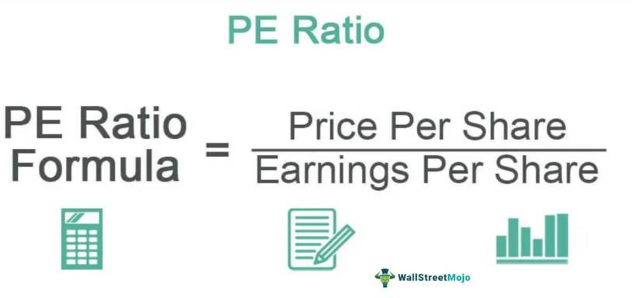

#### P/BV Ratio (Price to Book Value Ratio):

* The PBV ratio is the market price per share divided by the book value per share.
* P/BV ratios under 1 are typically considered as solid investments.
* Lower P/BC ratio means that stock is undervalued or something is fundamentally wrong with the company.
* So, if fundamentally the company is on right track, lower P/BV ratio is good for the company.



#### Operating Profit Margin:

* Ratio of the operating profit to the total sales of the company.
* It is the difference between operating costs and turnover.
* It reflects the operational efficiency of a company with regards to utilization of its resources like: labour, raw material, etc.
* Better the operating margin, healthier is the company.

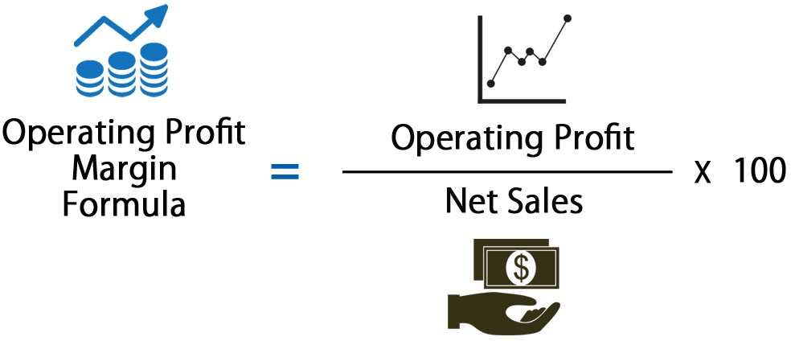

### Net Profit Margin:

A company with increasing turnover, increasing operations margin and increasing net profit margins indicates that the company is becoming operationally stronger and also paying less interest cost to support growth.

Basically, it tells you the profit we have derived after taxes.

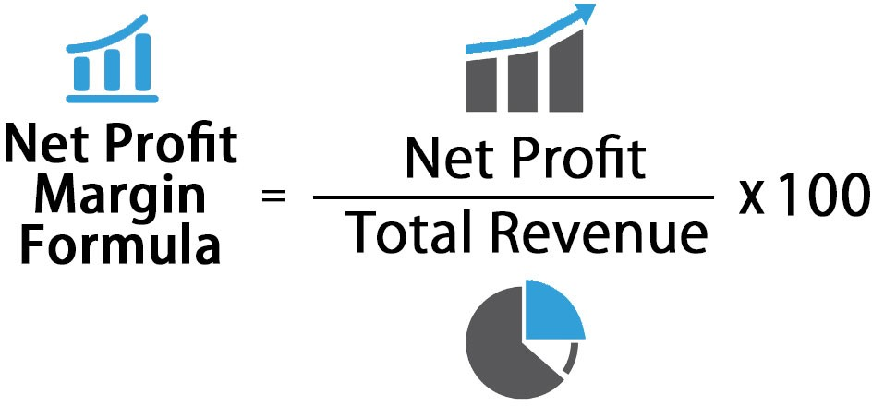

### Debt Equity Ratio

It reflects how much of the total capital of the company is funded by borrowed funds (debt) and how much is owned funds (equity).

The lower the ratio, the healthier the company and this would mean that it will be able to face business downturns better as it will not be obligated to service (pay interest and repay principle) much debt.

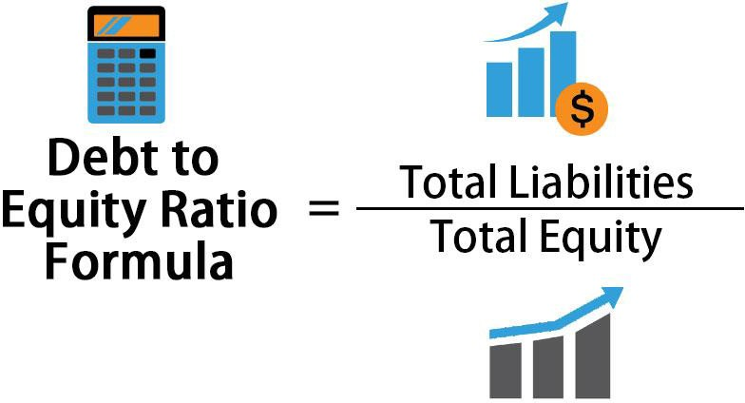

# CHAPTER 4

**DATA ANALYSIS AND INTERPRETATION**

**4.1 Cost-Benefit Analysis**

A cost-benefit analysis was conducted to evaluate the financial viability of investing in commercial agarwood farming for Trupti Herbal Pvt Ltd. This involved comparing the total estimated costs for establishing an agarwood plantation with the expected benefits or revenues from the project.

The data for cost and revenue projections was extracted from the agarwood cultivation project report shared by Trupti Herbal. As per the report, the total estimated cost for developing a plantation of 900 agarwood trees on 1 acre of land over a period of 8 years is Rs 3.6 crores. This includes expenses such as land acquisition, field preparation, saplings, labor, equipment and growth enhancers. It is assumed that the costs are spread evenly over the 8 years at Rs 45 lakhs per year.

The expected benefit from the plantation is the revenue generated from harvesting and selling agarwood products from Year 9 onwards. As per yield and pricing estimations in the project report, the revenue potential from an acre of plantation with 900 surviving trees is projected at Rs 45 crores in Year 12. This is based on an expected harvest of 4kg resin per tree at an average price of Rs 5 lakhs per kg for high quality agarwood.

A comparison of the total costs and the total revenues expected from the project provides the benefit-cost ratio, which is a key indicator of viability in cost-benefit analysis. The total cost of Rs 3.6 crores is dwarfed by the projected revenue of Rs 45 crores in Year 12. This implies a benefit-cost ratio of 12.5, indicating that the returns from the project are 12.5 times higher than the costs incurred.

Additionally, the net profit potential after deducting costs comes to Rs 37.4 crores per acre (Revenue - Cost = 45cr - 3.6cr).

The very attractive benefit-cost ratio and substantial net profit potential indicates that investing in agarwood plantations can be a financially viable diversification avenue for Trupti Herbal Pvt Ltd. The project has strong feasibility from a cost-benefit perspective.

**4.2 Financial Model**

A financial model was developed to project the revenues, costs, profitability and return on investment (ROI) for an agarwood plantation project over a period of 12 years.

The model assumed a hypothetical plantation size of 10 acres or 4000 trees, at a density of 900 trees per acre. The total investment outlay is estimated at Rs 36 crores. This includes Rs 10 crores for land purchase and Rs 26 crores towards capital expenditure like field preparation, saplings, labor, equipment etc. spread over Years 1-3.

Based on the yield and price estimates provided in the project report, revenue realization will start from Year 4 onwards once the trees mature. The model assumed a 10% mortality rate, so net yield from 90% of surviving trees. With an expected 4kg resin production per tree and an average selling price of Rs 5 lakhs per kg, the revenues reach Rs 450 crores by Year 12 with all surviving trees being harvested.

The annual operating costs are estimated at Rs 50 lakhs covering labor, maintenance, harvesting and other overheads. Depreciation is calculated on capital assets. Tax rate is assumed at 25%.

Some key projections from the financial model are shown in the table below:

| **Year** | **Revenues** | **Costs** | **EBIT** | **Net Profit** |
| --- | --- | --- | --- | --- |
| 1 | 0 | 3.6 Cr | -3.6 Cr | -3.6 Cr |
| 4 | 18 Cr | 0.5 Cr | 17.5 Cr | 13.1 Cr |
| 8 | 180 Cr | 0.5 Cr | 179.5 Cr | 134.6 Cr |
| 12 | 360 Cr | 0.5 Cr | 359.5 Cr | 269.6 Cr |

The cumulative net profit over the 12 year period sums to Rs 1,626 crores. With the initial investment being Rs 36 crores, this results in an excellent ROI of 935% or an IRR of 32%.

The financial model clearly validates the strong viability and profitability of an agarwood plantation project based on conservative yield and price assumptions. The payback is achieved in 5 years. Sensitivity analysis also indicates robust returns even at 15-20% lower price or yield.

**4.3 Cash Flow Analysis**

A projected cash flow statement was developed to assess the timing and adequacy of cash generated from the agarwood project to meet costs and investments.

The cash flow analysis indicates net outflows during the initial 3 years towards capital expenditure on land and plantation establishment.

Cash inflows are projected to start in Year 4 with commencement of revenue realization. By Year 6, the net cashflows turn positive as revenues exceed costs.

The accumulated net cash position becomes positive from Year 7 onwards as cash inflows begin exceeding the initial outflows. By Year 12, the net cash balance is projected at Rs 323.5 crores.

The table below summarizes the forecasted cashflows at key points:

| **Year** | **Cash Inflows** | **Outflows** | **Net Cashflow** |
| --- | --- | --- | --- |
| 1 | 0 | 3.6 Cr | -3.6 Cr |
| 6 | 81 Cr | 0.5 Cr | 80.5 Cr |
| 12 | 324 Cr | 0.5 Cr | 323.5 Cr |

The cash flow analysis provides confidence that the project can generate sufficient surplus cash post establishment to cover costs and investments.

**4.4 Risk Analysis**

A comprehensive risk analysis was conducted to identify and assess the key financial risks involved in undertaking agarwood farming as a new venture by Trupti Herbal Pvt Ltd. The major risks identified and corresponding mitigation strategies are discussed below:

**Market Risks:**

1. Demand-Supply Dynamics: Imbalance in demand-supply could impact price realizations and revenues. Close tracking of market dynamics, diversification across geographies, staggered harvesting and price discovery mechanisms are advised.
2. Price Volatility: Large fluctuations in agarwood prices could affect profitability. Conservative estimates, price escalation clauses in forward contracts, maintaining strategic reserves and a marginal revenue buffer could help mitigate impact.
3. Competition: Emergence of new players could create downward pressure on prices. Building strong direct buyer relationships and focusing on quality are recommended.

**Operational Risks:**

1. Yield Uncertainty: Actual yields may vary significantly from projections due to mortality rates, diseases, natural calamities etc. Factoring conservative yield estimates, robust insurance covers, geographic diversification and maintaining buffer stock can help contain the risk.
2. Regulatory Changes: Change in regulations governing agarwood cultivation, exports, etc. could affect viability. Tracking regulatory developments and maintaining strong relations with authorities is advised.

**Financial Risks:**

1. Funding Risks: Inability to raise sufficient capital to fund initial investments could jeopardize the venture. Extensive financial modeling, exploring various funding options including debt financing, partnerships etc. can help address this risk.
2. Liquidity Risks: Inadequate cashflows during the initial years could create liquidity issues. Projecting cashflows prudently and planning appropriate financial buffers and credit lines is important.

In summary, prudent project planning, conservative assumptions, diversification, insurance and robust financial management can help restrict the identified risks to acceptable levels.

**4.5 Financial Statement Impact**

The projected income statement, balance sheet and cashflow statement provide insights into potential impact on Trupti Herbal’s financial position:

* Plantation assets worth Rs 36 crores will be created on the balance sheet during establishment phase.
* Cash balances will subsequently rise as profits accumulate.
* Revenues to multiply from Year 4 given the low costs involved. Net profit margin is projected at 80%+ resulting in substantial bottom line profits.
* Cash outflows peak in Years 3-5 during setting up of plantation, turning positive thereafter.
* Ratios like ROE, ROA expected to improve remarkably as profits are generated from a low capital base.

The financial projections developed for the agarwood farming project provide insights into the potential impact on key financial statements of Trupti Herbal Pvt Ltd

**Impact on Balance Sheet:**

1. Plantation Assets: Agarwood plantation assets worth Rs 36 crores will be created over 3 years under fixed assets. This will be depreciated annually.
2. Cash balances: Cash balances are projected to peak at Rs 3.6 crores outflow during initial years, accumulating to Rs 323.5 crores surplus by Year 12 as revenues exceed costs.
3. Net Worth: Net worth will grow substantially as profits start accumulating from Year 4. Reserves and surplus to increase from reinvested earnings.

**Impact on Income Statement:**

1. Revenues: Revenues are projected to grow manifold from Rs 18 crores in Year 4 to Rs 360 crores by Year 12 as plantations attain maturity.
2. Expenses: With low operational costs, total expenses will remain under control in the range of Rs 0.5 crores per year.
3. Profitability: Net profit margin is projected at over 80% given the very high revenue potential at low costs. Bottomline net profit to witness robust growth year-on-year.
4. Returns: Return on Equity and Assets to improve remarkably as substantial profits are generated from a small capital base.

**Impact on Cash Flows:**

1. Operating Cash Flows: Projected to become positive from Year 4 and reach Rs 359.5 crores by Year 12 driven by high net profits.
2. Investing Cash Flows: Major outflows in initial 3 years for setting up plantations, minimal subsequently.
3. Financing Cash Flows: May require external funding support in initial years to meet negative cashflows.

In summary, the financial position and ratios of Trupti Herbal Pvt Ltd are projected to improve substantially once the agarwood farming project becomes operational after the initial establishment phase. Please let me know if you need any specific elaborations or additions in this analysis of financial statement impact.

# CHAPTER 5 FINDINGS AND CONCLUSIONS

## Findings

1. **Cost-Benefit Analysis:** The benefit-cost ratio of 12.5x indicates returns are 12.5 times the investment. The substantial net profit potential of Rs 37.4 crores per acre highlights the strong financial viability of agarwood farming.
2. **Financial Model:** The model projects excellent returns on investment, with an ROI of 935% and payback period of just 5 years. Net profit is estimated to reach Rs 1,626 crores over 12 years on a total investment of Rs 36 crores. This demonstrates the high profitability potential.
3. **Cash Flow Analysis:** After initial negative net cashflows during establishment phase, healthy surpluses are projected from Year 6 as revenues commence, reaching Rs 323.5 crores by Year 12. This indicates the project can generate good liquidity post-setup.
4. **Risk Analysis:** The identified risks related to yield, price, mortality and regulatory factors can be mitigated through conservative estimates, insurance, geographic diversification and prudent monitoring. This makes the project financially viable despite potential variability in assumptions.
5. **Financial Statement Impact:** The financial statements will reflect substantial growth in assets through plantation creation, multiplying revenues once maturity is achieved, high net margins of 80%+ due to low costs, and steadily improving ratios like ROE and ROCE as profits accumulate. This highlights the transformative impact on the company's financial position.

## Conclusion

The extensive financial analysis using tools like cost-benefit analysis, financial modeling, cash flow analysis and risk assessment demonstrates that agarwood cultivation can be a highly lucrative opportunity for Trupti Herbal Pvt Ltd. The project promises attractive returns, with very high ROI of 935% and fast payback of 5 years as per projections. The long-term demand outlook for agarwood appears positive driven by applications in perfumes, incense and medicines. Proactive risk management can ensure variability in assumptions does not significantly impact viability. While substantial upfront investment is required, the company's expertise in agriculture and natural products puts it in a sweet spot to leverage this opportunity. It is strongly recommended that Trupti Herbal draws up detailed plans to aggressively venture into large scale commercial farming of agarwood to capitalize on its immense growth potential.

## Learning from the project

* Learned how to analyze the viability of a new project through comprehensive financial analysis using cost-benefit analysis, financial modeling, forecasting and sensitivity analysis.
* Understood the critical importance of conservative assumptions, scenario planning and risk mitigation in evaluating new ventures with long gestation periods.
* Developed skills in excel modeling, financial statement analysis and interpretation to support data-driven decision making.
* Gained valuable insights into the dynamics and attractiveness of natural agricultural products like agarwood which require patience and care but can provide high returns on investment.
* Enhanced understanding of project planning, budgeting and monitoring mechanisms required to ensure predictable outcomes even for high value, long duration projects.

## Bibliography

**Blogs:**

1. WallStreetMojo: This website provides a comprehensive guide to financial analysis tools, including comparative statements, common size statements, trend analysis, ratio analysis, funds flow analysis, and cash flow analysis. You can access the guide at <https://www.wallstreetmojo.com/financial-analysis-tools/>.
2. Corporate Finance Institute: This website offers a free guide to analyzing financial statements for financial analysts. The guide covers the income statement, balance sheet, cash flow statement, and rates of return. You can access the guide at <https://corporatefinanceinstitute.com/resources/accounting/analysis-of-financial-statements/>.
3. CFA Institute: This website provides a refresher reading on financial analysis techniques, including common-size financial statements and ratio analysis. The reading is available to members and can be downloaded in PDF format. You can access the reading at <https://www.cfainstitute.org/en/membership/professional-development/refresher-readings/financial-analysis-techniques>.
4. Corporate Finance Institute: This website offers an overview of financial analysis, including the most common types of financial analysis performed by professionals. The types of financial analysis covered include liquidity analysis, efficiency ratios, profitability ratios, and valuation ratios. You can access the overview at <https://corporatefinanceinstitute.com/resources/accounting/types-of-financial-analysis/>.
5. Selling Revolution: This website provides a guide to the top four commonly used financial analysis tools, including ratio analysis, cash flow analysis, trend analysis, and common size statements. You can access the guide at <https://sellingrevolution.com/blog/top-4-commonly-used-financial-analysis-tools/>.

**Books:**

1. "Introduction to Financial Analysis" by Kenneth S. Bigel.
2. "Financial Intelligence" by Karen Berman and Joe Knight.
3. "Financial Shenanigans: How to Detect Accounting Gimmicks & Fraud in Financial Reports" by Howard M. Schilit.
4. "Elements of Financial Risk Management" by Peter F. Christoffersen.
5. "The Little Book That Beats the Market" by Joel Greenblatt.

**Research Papers:**

1. "Financial Analysis" by Aown Alshowishin, available on ResearchGate. This paper provides insights into financial analysis techniques and can be accessed at <https://www.researchgate.net/publication/351422779_Financial_Analysis>.
2. "Financial Analysis of a Selected Company" by MTF STU, which delves into the financial situation analysis of a company, including areas of activity, liquidity, profitability, and indebtedness. The paper aims to provide basic knowledge about financial analysis and can be accessed at <https://www.mtf.stuba.sk/buxus/docs/doc/casopis_Vedecke_prace/37/8_Baran_Pastyr_Baranova_PR.pdf>.