**Name : Pratik Bhoir**

**Roll No : 19102A0029**

**Branch/Div : CMPN/A**

**Subject : Audit Course Level 1 Task.**

**Project Name : The Pizza Treat**

|  |  |
| --- | --- |
| Front End Tools | HTML 5, CSS3 |
| Project Leader | Pratik Bhoir |
| Project Language | English |
| Country | India |
| Reference sites | www.w3schools.com |
| Github Repository Link | https://github.com/Pratikb07/Audit-Course |

**Project Description :** The Pizza treat is a webstite which provides pizzas at affordable prices online. This is a part of an Audit Course named “Industry Ready Web Developer” in which I have used Basic HTML and CSS to create a raw layout of the website and futher improvisations are needed to make it more dynamic and ready to use which will be done as we approach futher levels. Below attached are the screenshots of the work done till now.

**Screenshots:**

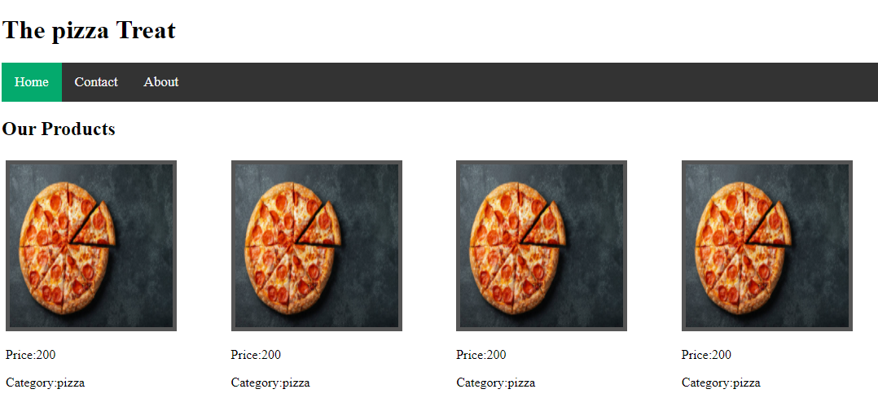

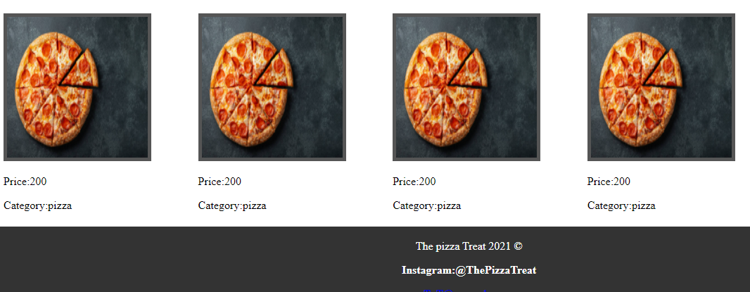

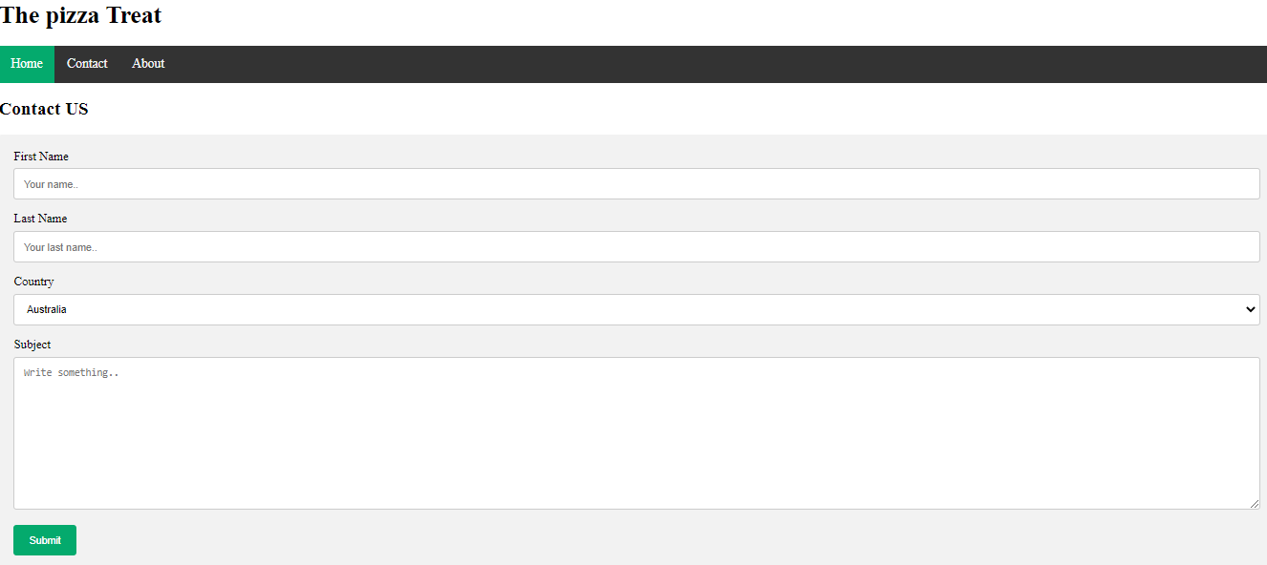

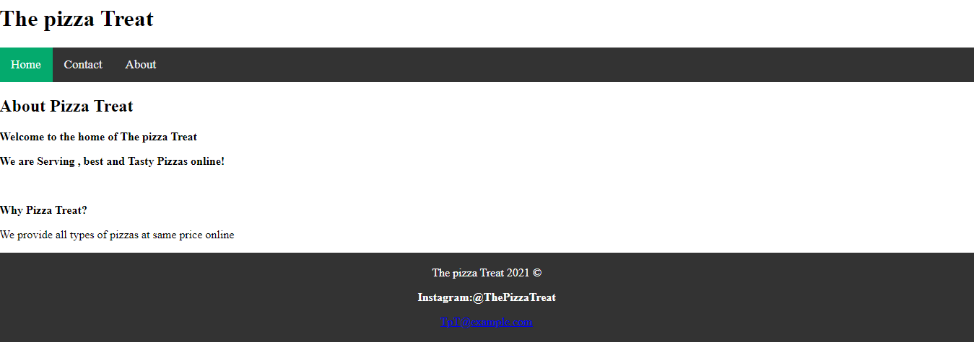

**Repository Link Here :https://github.com/Pratikb07/Audit-Course**